Report on implementation

Integrated Operational Programme

for the period
1 Oct 2013 – 31 Mar 2014

Intended for the 13th meeting of the IOP Monitoring Committee
held on 3 June 2014

CONTENTS

INTRODUCTION 7
1 PROGRAMME IDENTIFICATION 8
2 OVERVIEW OF PROGRAMME IMPLEMENTATION 10
2.1 Summary Tables on Progress Achieved in IOP Implementation 10
2.2 Progress in the Fulfilment of Indicators at the Programme Level 16
2.3 Core Activities in the Period from 1 Oct 2013 to 31 Mar 2014 17
2.3.1 IOP milestones in the period from 1 Oct 2013 to 31 Mar 2014 17
2.3.2 Overview of ongoing and newly published calls in the period from 1 Oct 2013 to 31 Mar 2014 18
2.3.3 Changes in the important IOP documents and amendments thereto 19
2.4 Main Problems Encountered in Programme Implementation and Measures Taken to Overcome Them 20
2.4.1 Addressing the error rate of IOP in the Annual Control Report for 2013 21
2.4.2 Sleeping and risky projects of IOP 23
2.4.3 Risk of non-fulfilment of n+3/n+2 rule in 2013 and n+2 rule in 2014 24
2.5 Major Projects of IOP 25
2.6 Measures Adopted in Response to the Conclusions of the Previous Monitoring Committee Meeting 27
2.7 Analysis of Risks in Relation to the Fulfilment of n+3/n+2 rule 27
2.7.1 Analysis of risks in relation to the fulfilment of n+3/n+2 rule by the Managing Authority and Intermediate Bodies 31
2.7.2 Forecast of the progress in IOP absorption (in EUR) 45
2.8 Analysis of Risks in Relation to Future Progress in Programme Implementation 58
2.9 Foreseen Timetable of the Announcement of Calls 62
2.10 Overview of Approved Projects 62
2.11 Progress in the Implementation of Financial Instruments 65
3 PROGRESS AT THE LEVEL OF PRIORITY AXIS 68
3.1 Priority axis 1a, 1b – Modernisation of public administration 68
3.1.1 Focus of priority axes/intervention areas 68
3.1.2 Progress achieved in implementation of priority axes/intervention areas 69
3.1.3 Fulfilment of indicators 70
3.1.4 Problems and measures taken 72
3.1.5 Example of a project 74
3.2 Priority axis 2 – Introducing ICT in territorial public administration 75
3.2.1 Focus of priority axes/intervention areas 75
3.2.2 Progress achieved in implementation of priority axes/intervention areas 76
3.2.3 Fulfilment of indicators 77
3.2.4 Problems and measures taken 78
3.2.5 Example of a project 79
3.3 Priority axis 3 – Improving public services quality and accessibility 80
3.3.1 Focus of priority axes/intervention areas 80
3.3.2 Progress achieved in implementation of priority axes/intervention areas 81
3.3.3 Fulfilment of indicators 83
3.3.4 Problems and measures taken 90
3.3.5 Example of a project 95
3.4 Priority axis 4a, 4b – National support of tourism 99
3.4.1 Focus of priority axes/intervention areas 99
3.4.2 Progress achieved in implementation of priority axes/intervention areas 100
3.4.3 Fulfilment of indicators 101
3.4.4 Problems and measures taken 103
3.4.5 Example of a project 104
3.5 Priority axis 5 – National support of territorial development 105
3.5.1 Focus of priority axes/intervention areas 105
3.5.2 Progress achieved in implementation of priority axes/intervention areas 106
3.5.3 Fulfilment of indicators 110
3.5.4 Problems and measures taken 114
3.5.5 Example of a project 116
3.6 Priority axis 6a, 6b – Technical assistance 118
3.6.1 Focus of priority axes/intervention areas 118
3.6.2 Progress achieved in implementation of priority axes/intervention areas 119
3.6.3 Fulfilment of indicators 121
3.6.4 Problems and measures taken 123
4 ADMINISTRATION OF THE PROGRAMME 123
4.1 Information on the Conduct and Results of Audits and Financial Controls 123
4.2 Implementation of the Communication Plan and Publicity Activities 137
4.3 Conducted Evaluations and Studies 139
4.3.1 Evaluations of the Managing Authority 139
4.3.2 Evaluation and Studies of the Intermediate Bodies 143
4.4 Other Activities of the Managing Authority and the Monitoring Committee 145
4.4.1 Activities of the Managing Authority 145
4.4.2 Activities of the Monitoring Committee 147
4.4.3 Activities of the Working Groups 147
4.5 Administrative Capacity of the Programme's Implementation Structure Bodies 149
5 MAIN CONCLUSIONS 154
LIST OF ABBREVIATIONS 154
ANNEXES 156
Annex No 1 – Publicity activities in the period from 1 Oct 2013 to 31 Mar 2014 157
Annex No 2 – Action Plans 165
Annex No 3 – Summary of measures adopted in response to conclusions from the 12th meeting of IOP MC 171

List of Tables:

Table No 1 - Allocation by year and objective (EUR) 8
Table No 2 - Intermediate Bodies of IOP by intervention area 9
Table No 3 - Status of IOP absorption cumulatively as of 31 Mar 2014 (in million CZK/EUR) 10
Table No 4 - Progress achieved in IOP absorption in the period from 1 Oct 2013 to 31 Mar 2014 (in million CZK/EUR) 13
Table No 5 - Overview of ongoing calls in the period from 1 Oct 2013 to 31 Mar 2014 18
Table No 6 - Overall impact of corrections in IOP (public funds) – status pursuant to the ACR 2013 22
Table No 7 - Individual corrections for audited projects at individual ministries 22
Table No 8 - Summary of sleeping and risky projects by aid beneficiary as of 6 Jan 2014 23
Table No 9 - Fulfilment of n+3/n+2 rule (in EUR) under CONV objective 28
Table No 10 - Fulfilment of n+3/n+2 rule (in EUR) under RCE objective 28
Table No 11 - Forecast of submitted applications for payment 45
Table No 12 - Forecast of approved applications for payment 46
Table No 13 - Comparison of the forecast and the actual value of submitted applications for payment by intervention area 50
Table No 14 - Comparison of the forecast and the actual value of submitted applications for payment by ministry 52
Table No 15 - Comparison of the forecast and the actual value of approved applications for payment by intervention area 54
Table No 16 - Comparison of the forecast and the actual value of approved applications for payment by ministry 57
Table No 17 - Cumulative progress at the level of Intervention area 1.1a and 1.1b (in million CZK/EUR) 69
Table No 18 - Output indicators 71
Table No 19 - Result indicators 71
Table No 20 - Cumulative progress at the level of Intervention area 2.1 (in million CZK/EUR) 76
Table No 21 - Overview of ongoing calls in the period from 1 Oct 2013 to 31 Mar 2014 in Priority axis 2 77
Table No 22 - Output indicators 77
Table No 23 - Result indicators 78
Table No 24 - Cumulative progress at the level of Intervention area 3.1 (in million CZK/EUR) 81
Table No 25 - Cumulative progress at the level of Intervention area 3.2 (in million CZK/EUR) 81
Table No 26 - Cumulative progress at the level of Intervention area 3.3 (in million CZK/EUR) 82
Table No 27 - Cumulative progress at the level of Intervention area 3.4 (in million CZK/EUR) 82
Table No 28 - Overview of ongoing calls in the period from 1 Oct 2013 to 31 Mar 2014 in Priority axis 3 83
Table No 29 - Output indicators 87
Table No 30 - Result indicators 88
Table No 31 - Cumulative progress at the level of Intervention area 4.1a and 4.1b (in million CZK/EUR) 100
Table No 32 - Overview of ongoing calls in the period from 1 Oct 2013 to 31 Mar 2014 in Priority axis 4a and 4b 101
Table No 33 - Output indicators 102
Table No 34 - Result indicators 102
Table No 35 - Cumulative progress at the level of Intervention area 5.1 (in million CZK/EUR) 106
Table No 36 - Cumulative progress at the level of Intervention area 5.2 (in million CZK/EUR) 106
Table No 37 - Cumulative progress at the level of Intervention area 5.3 (in million CZK/EUR) 107
Table No 38 - Overview of ongoing calls in the period from 1 Oct 2013 to 31 Mar 2014 in Priority axis 5 108
Table No 39 - Number of calls announced for IUDP 108
Table No 40 - Information on the status of absorption of IUDP allocation for Intervention area 5.2 109
Table No 41 - Output indicators 111
Table No 42 - Result indicators 112
Table No 43 - Cumulative progress at the level of Intervention area 6.1a and 6.1b (in million CZK/EUR) 119
Table No 44 - Cumulative progress at the level of Intervention area 6.2a and 6.2b (in million CZK/EUR) 120
Table No 45 - Overview of ongoing calls in the period from 1 Oct 2013 to 31 Mar 2014 in Priority axis 6 121
Table No 46 - Output indicators 122
Table No 47 - Result indicators 122
Table No 48 - Summary of checks of delegated activities conducted at IBs in the period from 1 Oct 2013 to 31 Mar 2014 127
Table No 49 - Overview of IOP MA checks completed in the previous periods 131
Table No 50 - Overview of bodies conducting the checks of projects 131
Table No 51 - Overview of checks conducted in the period from 1 Oct 2013 to 31 Mar 2014 broken down by intervention area 132
Table No 52 - Overview of checks conducted in the period from 1 Oct 2013 to 31 Mar 2014 broken down by check status 133
Table No 53 - Overview of checks conducted in the period from 1 Oct 2013 to 31 Mar 2014 broken down by number of checks per IB 133
Table No 54 - Overview of checks conducted in the period from 1 Oct 2013 to 31 Mar 2014 in IA 1.1 134
Table No 55 - Overview of checks conducted in the period from 1 Oct 2013 to 31 Mar 2014 in IA 3.1 and 3.3 134
Table No 56 - Overview of checks conducted in the period from 1 Oct 2013 to 31 Mar 2014 in IA 3.2 134
Table No 57 - Overview of checks conducted in the period from 1 Oct 2013 to 31 Mar 2014 by CRD 135
Table No 58 - Overview of verified expenditure in the period from 1 Oct 2013 to 31 Mar 2014 broken down by IB 137
Table No 59 - Total number of FTE implementing the IOP as of 30 Jun 2013 and turnover rate in the first half of 2013 140
Table No 60 - Total financial costs of administration for the monitored period of 1 year and performance of administration in the period from 7/2012 to 6/2013 140
Table No 61 - Financial costs of administration as against the allocation in the monitored period 141
Table No 62 - Overview of conducted education and training activities 146
Table No 63 - Status of administrative capacity of IOP implementation structure 149
Table No 64 - Monitoring of the status of administrative capacity in the programming period 2007 – 2013 151
Table No 65 - Monitoring of the turnover rate by post and implementation body 152

List of Charts:

Chart No 1 - Progress in IOP absorption as of 31 Mar 2014 16
Chart No 2 - Fulfilment of n+2 rule under CONV objective 30
Chart No 3 - Fulfilment of n+2 rule under RCE objective 31
Chart No 4 - Fulfilment of n+2 rule by the Ministry for Regional Development 32
Chart No 5 - Fulfilment of n+2 rule in Intervention area 2.1 33
Chart No 6 - Fulfilment of n+2 rule in Intervention area 3.4 34
Chart No 7 - Fulfilment of n+2 rule in Intervention area 4.1 35
Chart No 8 - Fulfilment of n+2 rule in Intervention area 5.1 36
Chart No 9 - Fulfilment of n+2 rule in Intervention area 5.2 37
Chart No 10 - Fulfilment of n+2 rule in Intervention area 5.3 38
Chart No 11 - Fulfilment of n+2 rule in Intervention area 6.1 38
Chart No 12 - Fulfilment of n+2 rule in Intervention area 6.2 39
Chart No 13 - Fulfilment of n+2 rule by the Minister of Interior 40
Chart No 14 - Fulfilment of n+2 rule by the Ministry of Labour and Social Affairs 41
Chart No 15 - Fulfilment of n+2 rule in Intervention area 3.1 42
Chart No 16 - Fulfilment of n+2 rule in Intervention area 3.3 43
Chart No 17 - Fulfilment of n+2 rule by the Ministry of Health 44
Chart No 18 - Rate of fulfilment of forecasts of submitted applications for payment by intervention area 49
Chart No 19 - Rate of fulfilment of forecasts of approved applications for payment by intervention area 54
Chart No 20 - Percentage of rejected projects by intervention area 63
Chart No 21 - Rejected projects by status 64
Chart No 22 - Comparison of physical and financial progress in intervention area 1.1 72
Chart No 23 - Comparison of physical and financial progress in intervention area 2.1 78
Chart No 24 - Comparison of physical and financial progress in intervention area 3.1 88
Chart No 25 - Comparison of physical and financial progress in intervention area 3.2 89
Chart No 26 - Comparison of physical and financial progress in intervention area 3.3 89
Chart No 27 - Comparison of physical and financial progress in intervention area 3.4 90
Chart No 28 - Comparison of physical and financial progress in intervention area 4.1 103
Chart No 29 - Comparison of physical and financial progress in intervention area 5.1 113
Chart No 30 - Comparison of physical and financial progress in intervention area 5.2 113
Chart No 31 - Comparison of physical and financial progress in intervention area 5.3 114

INTRODUCTION

The Integrated Operational Programme is implemented in the 2007-2013 programming period. The programme focuses on addressing common regional issues in the field of infrastructure for public administration, public services and territorial development: development of information technologies in public administration, improving the infrastructure for social services, public health, employment services and services in the field of security, risk prevention and management, support of tourism, cultural heritage, improving the environment in housing estates and development of systems for creation of territorial policies. The Managing Authority of IOP is the Ministry for Regional Development of the CR, the activities of Intermediate Bodies are performed by the Ministry of Interior of the CR, the Ministry of Labour and Social Affairs of the CR, the Ministry of Health of the CR and the Centre for Regional Development of the CR.

The total IOP allocation amounts to EUR 1 906.8 million, namely the ERDF contribution and national public funding. Major part of this allocation in the amount of EUR 1 872.2 million is channelled to the Convergence objective (assistance intended for the entire territory of the CR except for the City of Prague), and EUR 34.6 million goes to the Regional competitiveness and employment objective (assistance intended for the territory of the City of Prague).

Details concerning the progress and implementation of IOP in the period from 1 Oct 2013 to 31 Mar 2014 are presented in this Report on Implementation intended for the 13th meeting of the IOP Monitoring Committee, compiled by the IOP Managing Authority in cooperation with other actors involved in the programme.

1 PROGRAMME IDENTIFICATION

The Integrated Operational Programme is implemented in the Czech Republic based on the National Strategic Reference Framework 2007-2013 programming period.

The IOP opted for the strategy of assistance at national level with all-national impact on improving the quality of life of inhabitants and enhancing attractiveness of the CR for investors as a result of better effectiveness and accessibility of public administration and public services. Due to the system concept of the assistance, it is necessary for the selected areas to be targeted at the whole territory of the CR, the City of Prague inclusive. Therefore, the IOP is designed as a multi-objective programme in line with Article 32 (1) of the General Regulation and on the basis of discussions with the EC, apart from the main focus of assistance on support to regions under the Convergence objective it also facilitates the support granted under the Regional competitiveness and employment objective (RCE).

- Allocation by year and objective (EUR)
Year | ERDF  Convergence objective | ERDF  RCE objective | Total
2007 | 192 686 939 | 3 951 894 | 196 638 833
2008 | 202 164 946 | 4 030 931 | 206 195 877
2009 | 211 684 389 | 4 111 551 | 215 795 940
2010 | 221 648 970 | 4 193 781 | 225 842 751
2011 | 237 465 225 | 4 277 657 | 241 742 882
2012 | 247 398 119 | 4 363 210 | 251 761 329
2013 | 278 308 099 | 2 736 597 | 281 044 696
Total for 2007 - 2013 | 1 591 356 687 | 27 665 621 | 1 619 022 308
Source: Programming Document, December 2013

In accordance with Government Resolution No 175/2006, the Ministry for Regional Development was designated to act as the IOP Managing Authority. The MA fulfils its tasks in line with Article 60 of Council Regulation (EC) No 1083/2006. Pursuant to Article 59 (2), or Article 42 (1) of Council Regulation (EC) No 1083/2006, the MA delegates some of the tasks to the Intermediate Bodies.

Due to insufficient administrative capacity, i.e. understaffing of the MoLSA CR and MoI CR, the MRD CR in 2009 concluded with the MoLSA CR and MoI CR the Addenda to the Agreement on delegating the tasks of the IOP Managing Authority. The Addenda concerned the involvement of CRD CR in the administration of projects under Intervention areas 2.1, 3.1, 3.3 and 3.4. Since 1 Jul 2012 there has been a change in delegated activities under Intervention areas 2.1 and 3.4. The remaining administrative activities have been transferred from the Ministry of Interior of the CR to the Ministry for Regional Development of the CR and the Centre for Regional Development of the CR.

In the course of 2013, a modification was made in the Agreement on delegating the tasks of the Managing Authority of the Integrated Operational Programme to the Ministry of Culture of the CR as the Intermediate Body for Intervention area 5.1 National support for utilising the cultural heritage potential. The activities of the MoC CR were as of 1 Nov 2013 delegated to the Ministry for Regional Development of the CR and the Centre for Regional Development of the CR.

The powers with respect to the individual IOP intervention areas are listed in the table below.

- Intermediate Bodies of IOP by intervention area
Intervention area | Intermediate Body
1.1 a, b Developing information society in public administration | Ministry of Interior CR (SF Department)
2.1 Introducing ICT in territorial public administration | Ministry of Interior CR (SF Department) until 30 June 2012,  Centre for Regional Development CR from 1 July 2012
3.1 Social integration services | Ministry of Labour and Social Affairs CR (EU Funds Implementation Department and Programme Financing Department),  Centre for Regional Development CR
3.2 Public health services | Ministry of Health CR (EU Funds Department)
3.3 Employment services | Ministry of Labour and Social Affairs CR (EU Funds Implementation Department and Programme Financing Department),  Centre for Regional Development CR
3.4 Services in security, risk prevention and management | Ministry of Interior CR (SF Department) until 30 June 2012,  Centre for Regional Development CR from 1 July 2012
4.1 a, b National support of tourism | Centre for Regional development CR
5.1 National support for utilising the cultural heritage potential | Ministry of Culture CR (Strategy and Aid Policy Department) until 31 October 2013  Centre for Regional Development from 1 November 2013
5.2 Improving the environment in problematic housing estates | Centre for Regional Development CR
5.3 Modernisation and development of systems for creating territorial policies | Centre for Regional Development CR
6.1 a, b Activities connected with the IOP management and 6.2 a, b Other costs of the IOP technical assistance | Centre for Regional Development CR

2 OVERVIEW OF PROGRAMME IMPLEMENTATION

2.1 Summary Tables on Progress Achieved in IOP Implementation

In line with the NCA guidelines for elaboration of the Report on implementation, the Submitted project applications column includes all the applications registered in IS Monit7+ IOP as of 31 Mar 2014, namely also those that were rejected and will not be implemented. The Projects with issued Decision/signed Contract column represents the financial volume of projects for which the Decision on providing a grant or the Statement of expenditure were issued, and does not comprise projects not completed due to the project withdrawal by the beneficiary or by the MA/IB.

The Approved projects in this Report shall mean the projects with the issued Decision or Statement of expenditure (stated in the relevant tables). In the whole Report (except for Chapter 2.6 Analysis of risks in relation to the fulfilment of n+3/n+2 rule), the total volume of public funds includes the EU share and the national public funds. In case the value of the amount of funds in EUR included in aggregate payment claims accounted for by the PCA is lower than the amount of funds paid to beneficiaries, it is caused by the exchange rate. The aggregate payment claims are converted with the use of the exchange rate valid at the time when the payment claim is accounted for, whereas the value of reimbursed applications is converted at the exchange rate of April 2014 (i.e. EUR 1 = CZK 27.423).

- Status of IOP absorption cumulatively as of 31 Mar 2014 (in million CZK/EUR)
PA/IA | 2007-2013 allocation |  | Submitted applications |  |  |  | Projects with issued Decision/signed Contract |  |  |  | Funds paid to beneficiaries |  |  | Funds included in aggregate payment claims accounted for by the PCA |  |  | Certified expenditure submitted to the EC
 | CZK (a) | EUR | num-ber | CZK (b) | CZK (e) | % (e/a) | EUR | CZK (f) | % (f/a) | EUR | CZK (d) | % (d/a) | EUR | CZK (e) | % (e/a) | EUR | CZK (f) | % (f/a) | EUR
1 | 9 679,73 | 368,61 | 101 | 13 225,25 | 137% | 482,27 | 68 | 8 170,45 | 84% | 297,94 | 5 224,94 | 54% | 190,53 | 5 161,18 | 53% | 203,84 | 4 976,31 | 51% | 196,89
1.1a | 8 988,32 | 342,28 | 101 | 12 280,59 | 137% | 447,82 | 68 | 7 586,85 | 84% | 276,66 | 4 851,73 | 54% | 176,92 | 4 792,52 | 53% | 189,28 | 4 620,86 | 51% | 182,83
1.1b | 691,41 | 26,33 | 0 | 944,66 | 137% | 34,45 | 0 | 583,60 | 84% | 21,28 | 373,21 | 54% | 13,61 | 368,66 | 53% | 14,56 | 355,45 | 51% | 14,06
2 | 4 613,76 | 174,72 | 5 854 | 5 788,32 | 125% | 211,08 | 5 544 | 4 194,92 | 91% | 152,97 | 2 405,73 | 52% | 87,73 | 2 322,38 | 50% | 91,16 | 2 273,60 | 49% | 89,36
2.1 | 4 613,76 | 174,72 | 5 854 | 5 788,32 | 125% | 211,08 | 5 544 | 4 194,92 | 91% | 152,97 | 2 405,73 | 52% | 87,73 | 2 322,38 | 50% | 91,16 | 2 273,60 | 49% | 89,36
3 | 19 268,81 | 723,08 | 882 | 26 846,39 | 139% | 978,97 | 466 | 15 330,25 | 80% | 559,03 | 7 543,12 | 39% | 275,07 | 7 368,14 | 38% | 289,11 | 6 967,97 | 36% | 274,09
3.1 | 1 735,04 | 64,29 | 474 | 3 779,86 | 218% | 137,84 | 130 | 1 734,47 | 100% | 63,25 | 381,65 | 22% | 13,92 | 401,34 | 23% | 15,65 | 377,11 | 22% | 14,77
3.2 | 7 656,79 | 292,33 | 249 | 11 309,38 | 148% | 412,40 | 193 | 7 400,83 | 97% | 269,88 | 4 611,85 | 60% | 168,17 | 4 421,96 | 58% | 174,37 | 4 224,02 | 55% | 166,74
3.3 | 1 258,28 | 47,30 | 29 | 2 181,82 | 173% | 79,56 | 18 | 1 213,75 | 96% | 44,26 | 554,68 | 44% | 20,23 | 554,87 | 44% | 21,65 | 538,51 | 43% | 21,05
3.4 | 8 618,70 | 319,16 | 130 | 9 575,34 | 111% | 349,17 | 125 | 4 981,20 | 58% | 181,64 | 1 994,94 | 23% | 72,75 | 1 989,97 | 23% | 77,44 | 1 828,33 | 21% | 71,53
4 | 2 034,44 | 76,74 | 182 | 4 342,37 | 213% | 158,35 | 88 | 1 844,00 | 91% | 67,24 | 909,37 | 45% | 33,16 | 901,41 | 44% | 35,42 | 879,95 | 43% | 34,63
4.1a | 1 889,12 | 71,26 | 91 | 4 032,23 | 213% | 147,04 | 44 | 1 712,30 | 91% | 62,44 | 844,41 | 45% | 30,79 | 837,03 | 44% | 32,89 | 817,10 | 43% | 32,16
4.1b | 145,32 | 5,48 | 91 | 310,14 | 213% | 11,31 | 44 | 131,70 | 91% | 4,80 | 64,95 | 45% | 2,37 | 64,39 | 44% | 2,53 | 62,85 | 43% | 2,47
5 | 13 458,14 | 520,76 | 2 187 | 23 221,05 | 173% | 846,77 | 1 997 | 15 874,70 | 118% | 578,88 | 9 808,48 | 73% | 357,67 | 9 634,14 | 72% | 381,31 | 9 281,76 | 69% | 368,29
5.1 | 6 683,11 | 251,45 | 51 | 15 815,05 | 237% | 576,71 | 22 | 6 327,70 | 95% | 230,74 | 2 854,29 | 43% | 104,08 | 2 869,29 | 43% | 112,38 | 2 855,79 | 43% | 111,84
5.2 | 6 304,66 | 251,03 | 1 436 | 6 819,01 | 108% | 248,66 | 1 383 | 9 073,04 | 144% | 330,86 | 6 507,57 | 103% | 237,30 | 6 320,51 | 100% | 251,61 | 5 989,89 | 95% | 239,44
5.3 | 470,37 | 18,27 | 700 | 586,99 | 125% | 21,41 | 592 | 473,96 | 101% | 17,28 | 446,62 | 95% | 16,29 | 444,35 | 94% | 17,32 | 436,08 | 93% | 17,01
6 | 1 063,02 | 40,82 | 121 | 1 690,06 | 159% | 61,63 | 114 | 1 117,17 | 105% | 40,74 | 658,41 | 62% | 24,01 | 644,10 | 61% | 25,55 | 605,90 | 57% | 24,01
6.1a | 830,74 | 31,97 | 48 | 1 259,89 | 152% | 45,94 | 46 | 886,42 | 107% | 32,32 | 540,00 | 65% | 19,69 | 525,95 | 63% | 20,86 | 492,50 | 59% | 19,50
6.2a | 213,10 | 8,11 | 73 | 399,66 | 188% | 14,57 | 68 | 210,57 | 99% | 7,68 | 106,52 | 50% | 3,88 | 106,52 | 50% | 4,23 | 102,46 | 48% | 4,07
6a | 1 043,83 | 40,09 | 121 | 1 659,54 | 159% | 60,52 | 114 | 1 097,00 | 105% | 40,00 | 646,52 | 62% | 23,58 | 632,47 | 61% | 25,09 | 594,96 | 57% | 23,58
6.1b | 15,27 | 0,59 | 0 | 23,16 | 152% | 0,84 | 0 | 16,30 | 107% | 0,59 | 9,93 | 65% | 0,36 | 9,67 | 63% | 0,38 | 9,06 | 59% | 0,36
6.2b | 3,92 | 0,15 | 0 | 7,35 | 188% | 0,27 | 0 | 3,87 | 99% | 0,14 | 1,96 | 50% | 0,07 | 1,96 | 50% | 0,08 | 1,88 | 48% | 0,07
6b | 19,19 | 0,74 | 0 | 30,51 | 159% | 1,11 | 0 | 20,17 | 105% | 0,74 | 11,89 | 62% | 0,43 | 11,63 | 61% | 0,46 | 10,94 | 57% | 0,43
Total | 50 117,91 | 1 904,73 | 9 327 | 75 113,44 | 150% | 2 739,07 | 8 277 | 46 531,49 | 93% | 1 696,81 | 26 550,04 | 53% | 968,17 | 26 031,36 | 52% | 1 026,40 | 24 985,48 | 50% | 987,28
Source MSC2007 as of 3 Apr 2014;
CZK/EUR exchange rate:
- For conversion of allocation in column a) the amounts are not directly converted at the valid exchange rate since the data are made more accurate through the aggregate payment claims accounted for in IS Viola using the same algorithm as in b) – d) columns;
- For conversion of b) – d) columns: 27.423, or the exchange rate valid at the time of accounting for of the application for payment in IS Viola is used;
- For conversion of e) – f) columns the exchange rate valid at the time of accounting for of the aggregate payment claim in IS Viola is used.
Source of funding – total eligible expenditure

Cumulatively as of 31 Mar 2014, altogether 9 327 project applications were submitted in IOP in the total amount of EUR 2 739.07 million, which represents 150 % of the total programme allocation. A markedly excessive number of project applications in Intervention area 5.1 (237 %) was caused by the fact that a number of projects submitted under the continuous call No 01 for activities a) and b) was following their rejection in formal requisites and eligibility checks redrafted and submitted again. A high share of submitted projects is reported also by Intervention area 3.1 (218 %), 4.1a and 4.1.b (213 %), 6.2a and 6.2b (188 %), and 3.3 (173 %).

A total of 8 277 projects in the amount of EUR 1 696.81 million were approved, which represents 93 % of the total programme allocation. The share of approved funds in projects under Intervention area 5.2 in the volume of 144 % is brought about by a change in calculation of the EU share. Following the approval of revision of the IOP Programming Document in December 2013, the EU share is calculated from the total amount of funds, not from the public funds only. The MA adjusted the distribution of allocation between the sources of funding in financial tables so that the ratio between the EU and national financing is maintained at 85 %. At the level of projects, the structure of funds remained the same, with the share of private financing higher than that in the financial table of programme allocation.

In IA 6.1a and 6.1b, 107 % of the allocation for the intervention area was approved, in IA 5.3 it was 101 % and in IA 3.1 100 %, and there are no plans to publish further calls. The share of approved funds in IA 6.1a and 6.1b is closely related to the failure to absorb the funds of the DAB project covered from the MRD CR IOP TA, withdrawal of the project of the MoI CR IOP TA and the failure to absorb the funds of the MoC CR IOP TA project due to the transfer of agenda from the MoC CR to the MRD CR, or CRD CR.

The beneficiaries were paid a total of EUR 968.17 million, representing 53 % of the total allocation. The largest share of reimbursed funds as against the allocation is seen in Intervention area 5.2 (103 %), 5.3 (95 %) and 6.1a and 6.1b (65 %). The lowest share of funds was reimbursed in Intervention areas 3.1 (22 %), 3.4 (23 %), and 5.1 (43 %).

The PCA accounted for a total of EUR 1026.40 million in aggregate payment claims, which represents 40 % of the programme allocation. The trend is the same as in the volume of funds paid to beneficiaries. The largest volume of funds accounted for in the aggregate payment claims is exhibited by Intervention areas 5.2 (100 %), 5.3 (94 %), 6.1a and 6.b (63 %) and 3.2 (58 %). The lowest share is seen in Intervention areas 3.1 and 3.4 (23 % each), 5.1 (43 %), 3.3, 4.1a and 4.1b (44 % each) and 2.1, 6.2a and 6.2b (50 %).

The certified expenditure submitted to the EC as of 31 Apr 2014 totals EUR 987.28 million, which represents 50 % of the total programme allocation. The highest volume of expenditure was certified in Intervention area 5.2 (EUR 239.44 million, which accounts for 95 % of the allocation for this intervention area).

- Progress achieved in IOP absorption in the period from 1 Oct 2013 to 31 Mar 2014 (in million CZK/EUR)
PA/IA | 2007-2013 allocation |  | Submitted applications |  |  |  | Projects with issued Decision/signed Contract |  |  |  | Funds paid to beneficiaries |  |  | Funds included in aggregate payment claims accounted for by the PCA |  |  | Certified expenditure submitted to the EC (85 % of total eligible expenditure – private financing included in co-financing)
 | CZK (a) | EUR | num-ber | CZK (b) | CZK (e) | % (e/a) | EUR | CZK (f) | % (f/a) | EUR | CZK (d) | % (d/a) | EUR | CZK (e) | % (e/a) | EUR | CZK (f) | % (f/a) | EUR
1 | 8 228,53 | 313,32 | 0 | 0,00 | 0% | 0,00 | 1 | 99,63 | 1% | 3,63 | 877,33 | 11% | 31,99 | 1 300,39 | 16% | 49,40 | 1 946,38 | 24% | 75,14
1.1a | 7 640,78 | 290,94 | 0 | 0,00 | 0% | 0,00 | 1 | 92,52 | 1% | 3,37 | 814,66 | 11% | 29,71 | 1 207,51 | 16% | 45,87 | 1 807,35 | 24% | 69,78
1.1b | 587,75 | 22,38 | 0 | 0,00 | 0% | 0,00 | 0 | 7,12 | 1% | 0,26 | 62,67 | 11% | 2,29 | 92,89 | 16% | 3,53 | 139,03 | 24% | 5,37
2 | 3 921,70 | 148,51 | 15 | 274,25 | 7% | 10,00 | 1 | -41,09 | -1% | -1,50 | 520,58 | 13% | 18,98 | 472,52 | 12% | 18,27 | 1 244,34 | 32% | 48,49
2.1 | 3 921,70 | 148,51 | 15 | 274,25 | 7% | 10,00 | 1 | -41,09 | -1% | -1,50 | 520,58 | 13% | 18,98 | 472,52 | 12% | 18,27 | 1 244,34 | 32% | 48,49
3 | 16 380,66 | 614,62 | 24 | 3 469,97 | 21% | 126,53 | 43 | 1 251,74 | 8% | 45,65 | 1 016,48 | 6% | 37,07 | 1 560,48 | 10% | 60,11 | 2 476,41 | 15% | 96,28
3.1 | 1 475,69 | 54,64 | 0 | 0,00 | 0% | 0,00 | 14 | 42,78 | 3% | 1,56 | 57,94 | 4% | 2,11 | 84,34 | 6% | 3,23 | 265,89 | 18% | 10,35
3.2 | 6 509,54 | 248,48 | 19 | 774,06 | 12% | 28,23 | 27 | 1 181,74 | 18% | 43,09 | 248,30 | 4% | 9,05 | 266,97 | 4% | 10,30 | 766,59 | 12% | 29,82
3.3 | 1 069,53 | 40,21 | 2 | 22,91 | 2% | 0,84 | 1 | -28,68 | -3% | -1,05 | 249,46 | 23% | 9,10 | 295,26 | 28% | 11,43 | 386,41 | 36% | 15,02
3.4 | 7 325,90 | 271,29 | 3 | 2 673,00 | 36% | 97,47 | 1 | 55,90 | 1% | 2,04 | 460,79 | 6% | 16,80 | 913,90 | 12% | 35,14 | 1 057,52 | 14% | 41,08
4 | 1 729,43 | 65,23 | 6 | 93,06 | 5% | 3,39 | 10 | 41,48 | 2% | 1,51 | 434,56 | 25% | 15,85 | 468,75 | 27% | 18,17 | 557,53 | 32% | 21,72
4.1a | 1 605,89 | 60,57 | 3 | 86,42 | 5% | 3,15 | 5 | 38,52 | 2% | 1,40 | 403,52 | 25% | 14,71 | 435,27 | 27% | 16,87 | 517,70 | 32% | 20,17
4.1b | 123,53 | 4,66 | 3 | 6,65 | 5% | 0,24 | 5 | 2,96 | 2% | 0,11 | 31,04 | 25% | 1,13 | 33,48 | 27% | 1,30 | 39,82 | 32% | 1,55
5 | 11 607,35 | 442,64 | 21 | 212,89 | 2% | 7,76 | 178 | 328,68 | 3% | 11,99 | 984,87 | 8% | 35,91 | 1 227,33 | 11% | 46,60 | 4 479,33 | 39% | 150,90
5.1 | 5 680,64 | 213,74 | 0 | 0,00 | 0% | 0,00 | 0 | -130,71 | -2% | -4,77 | 487,52 | 9% | 17,78 | 813,05 | 14% | 30,85 | 1 264,17 | 22% | 48,47
5.2 | 5 526,89 | 213,38 | 21 | 212,89 | 4% | 7,76 | 170 | 455,43 | 8% | 16,61 | 483,17 | 9% | 17,62 | 400,22 | 7% | 15,22 | 3 200,15 | 58% | 101,84
5.3 | 399,81 | 15,53 | 0 | 0,00 | 0% | 0,00 | 8 | 3,96 | 1% | 0,14 | 14,18 | 4% | 0,52 | 14,05 | 4% | 0,54 | 15,02 | 4% | 0,59
6 | 903,57 | 34,70 | 12 | 121,35 | 13% | 4,43 | 7 | 65,14 | 7% | 2,38 | 91,93 | 10% | 3,35 | 110,37 | 12% | 4,28 | 207,19 | 23% | 8,07
6.1a | 706,13 | 27,18 | 6 | 111,06 | 16% | 4,05 | 4 | 61,27 | 9% | 2,23 | 87,25 | 12% | 3,18 | 101,62 | 14% | 3,95 | 181,14 | 26% | 7,05
6.2a | 181,13 | 6,90 | 6 | 8,10 | 4% | 0,30 | 3 | 2,69 | 1% | 0,10 | 3,02 | 2% | 0,11 | 6,76 | 4% | 0,26 | 22,30 | 12% | 0,88
6a | 887,26 | 34,07 | 12 | 119,16 | 13% | 4,35 | 7 | 63,96 | 7% | 2,33 | 90,27 | 10% | 3,29 | 108,38 | 12% | 4,20 | 203,45 | 23% | 7,92
6.1b | 12,98 | 0,50 | 0 | 2,04 | 16% | 0,07 | 0 | 1,13 | 9% | 0,04 | 1,60 | 12% | 0,06 | 1,87 | 14% | 0,07 | 3,33 | 26% | 0,13
6.2b | 3,33 | 0,13 | 0 | 0,15 | 4% | 0,01 | 0 | 0,05 | 1% | 0,00 | 0,06 | 2% | 0,00 | 0,12 | 4% | 0,00 | 0,41 | 12% | 0,02
6b | 16,31 | 0,63 | 0 | 2,19 | 13% | 0,08 | 0 | 1,18 | 7% | 0,04 | 1,66 | 10% | 0,06 | 1,99 | 12% | 0,08 | 3,74 | 23% | 0,15
Total | 42 771,23 | 1 619,02 | 78,00 | 4 171,52 | 10% | 152,12 | 240 | 1 745,58 | 4% | 63,65 | 3 925,74 | 9% | 143,16 | 5 139,84 | 12% | 196,83 | 10 911,18 | 26% | 400,59
Source MSC2007 as of 3 Apr 2014;
CZK/EUR exchange rate:
- For conversion of allocation in column a) the amounts are not directly converted at the valid exchange rate since the data are made more accurate through the aggregate payment claims accounted for in IS Viola using the same algorithm as in b) – d) columns;
- For conversion of b) – d) columns: 27.423, or the exchange rate valid at the time of accounting for of the application for payment in IS Viola is used;
- For conversion of e) – f) columns the exchange rate valid at the time of accounting for in IS Viola is used.
Source of funding – EU share

In the period from 1 Oct 2013 to 31 Mar 2014, 78 project applications in the amount of EUR 152.12 million were submitted (10 % of the programme allocation). The largest volume of funds was requested in Intervention area 3.4 (EUR 2 673 million – 36 % of the allocation), 3.2 (EUR 774.06 million – 12 % of the allocation), and 2.1 (EUR 274.25 million – 7 % of the allocation). Projects for a largest share of the allocation were submitted in Intervention areas 3.4 (36 %) and 6.1 (16 %). No project applications were received in Intervention areas 1.1, 3.1, 5.1 and 5.3.

240 projects in the volume of EUR 63.65 million (4 % of the programme allocation) were approved. The volume of approved funds increased the most in Intervention area 3.2 (by EUR 1 181.74 million – 18 % of the allocation). The amount of projects with the issued Decision/signed Contract covers the Decisions/Statement of expenditure issued due to the savings on the part of the beneficiary, the amounts can thus be lower than the data given in the previous Report on Implementation. Such situation occurred in Intervention area 2.1 (decrease by EUR 1.5 million), 3.3 (decrease by EUR 1.05 million) and 5.1 (decrease by EUR 4.77 million).

In the monitored period, the beneficiaries were paid a total of EUR 143.16 million (9 % of the programme allocation). Funds were reimbursed in all the intervention areas. The largest volume of funds was paid to beneficiaries in Intervention areas 1.1 (EUR 29.71 million), 2.1 (EUR 18.98 million) and 5.1 (EUR 17.78 million). The lowest volume of funds was reimbursed in Intervention areas 5.3 (EUR 0.52 million) and 6.2 (EUR 0.11 million).

In the monitored period, the aggregate payment claims accounted for by the PCA amounted to EUR 196.83 million (12 % of the allocation). The trend reflects the progress made in reimbursement of funds to beneficiaries. In Intervention areas 1.1a and 1.1b the aggregate payment claims covered EUR 74.8 million, whereas in Intervention area 5.3 it was EUR 0.59 million, which is caused by the almost absorbed allocation for this intervention area, and in Intervention area 6.2 it was EUR 0.9 million.

The certified expenditure represents EUR 400.59 million, i.e. by 26 % more than in the previous monitoring period. The largest volume of funds was certified in Intervention area 1.1 (EUR 75.1 million), 5.2 (EUR 101.84 million), and 2.1 (EUR 48.49 million). In the monitored period, the PCA relaunched the certification of expenditure, suspended due to high error rate in the ACR 2012.

Progress in absorption of IOP from 1 Oct 2013 to 31 Mar 2014 is illustrated in Chart No 1. The blue part of the bars indicates the status of absorption as of 30 Oct 2013, while the red part shows the progress in the period from 1 Oct 2013 to 31 Mar 2014. The total heights of bars represent the cumulative status of absorption as of 31 Mar 2014.

- Progress in IOP absorption as of 31 Mar 2014
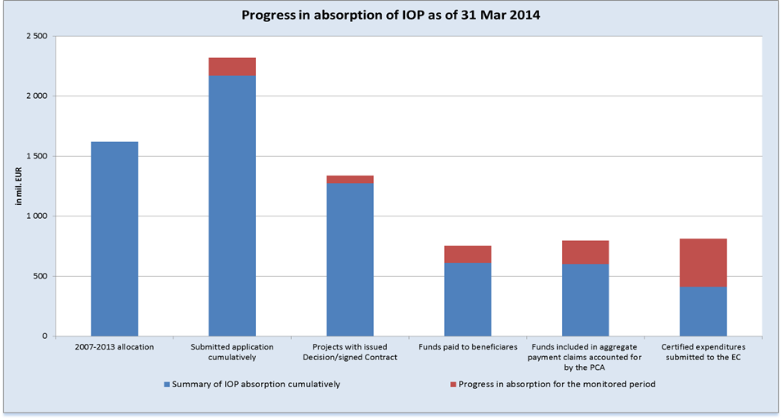
Source: MSC2007 as of 3 Apr 2014;
CZK/EUR exchange rate:
- For conversion of allocation in the bar “2007-2013 allocation“ the amounts are not directly converted at the valid exchange rate since the data are made more accurate through the aggregate payment claims accounted for in IS Viola based on the same algorithm as in bars “Submitted applications“, “Projects with issued Decision/signed Contract“ and “Funds paid to beneficiaries“;
- For conversion of bars “Submitted applications“, “Projects with issued Decision/signed Contract“, “Funds paid to beneficiaries“: 27.423, or the exchange rate valid at the time of accounting for of the application for payment in IS Viola is used;
- For conversion of bars “Funds included in aggregate payment claims accounted for by the PCA“, “Certified expenditure submitted to the EC“, the exchange rate valid at the time of accounting for in IS Viola is used.
Source of funding – EU share

2.2 Progress in the Fulfilment of Indicators at the Programme Level

In line with the NCA guidelines for elaboration of the report on implementation, this chapter shall give the indicators monitored by the Managing Authority, i.e. not the indicators monitored by external sources.
In the IOP at the level of the programme, 3 impact indicators are defined. Their achieved values are not generated at the project level and are monitored by an external source.
Due to the referred to facts no indicator is given in this chapter.

2.3 Core Activities in the Period from 1 Oct 2013 to 31 Mar 2014

2.3.1 IOP milestones in the period from 1 Oct 2013 to 31 Mar 2014

Date | Activity
30 Oct 2013 | On 30 Oct 2013 and 1 Nov 2013, the IOP Managing Authority submitted to the EC two major projects of the FRS CR and P CR aimed to increase the operational capability of these IRS units during extraordinary natural disasters, floods in particular
1 Nov 2013 | Change in delegated activities in Intervention area 5.1. from MoC to MRD and CRD pursuant to Government Resolution No 567 of 31 July 2013 and Addendum No 1 to the Agreement on delegating the tasks of the IOP MA to the MoC.
1 Nov 2013 | Revision of the Handbook for Applicants and Beneficiaries for calls No 1-3 of the MoC for Intervention area 5.1
14 Nov 2013 | Seminar for beneficiaries in Intervention area 5.1 of IOP concerning the transfer from MoC to MRD and CRD
15 Nov 2013 | Revision of the Handbook for Applicants and Beneficiaries for calls of the MoI SFD No 3, 7, 10, 14 and 15
29 Nov 2013 | Revision of the 4th call for Intervention area 3.3 a) and b) – extension of the deadline for submission of applications until 31 Mar 2014, extension of the deadline for closing the project implementation until 30 Nov 2015
9 Dec 2013 | Publishing of the call No 21 intended for developing and upgrading of IRS radio communication network Pegas. Activities supported under this call are logically linked to the implementation of “Integrated operational centres of IRS“ supported under call No 11.
20 Dec 2013 | Publishing of the 17th call for activity 3.2 c) Quality and cost management of the public health system (innovative equipment for measuring and evaluating the quality and cost of the care). The date of closing of the call is set at 14 Mar 2014.
20 Dec 2013 | Publishing of the 18th call for activity 3.2 a) Controlled modernisation and replacement of medical equipment (medical devices) of national networks of health care facilities, including the technical infrastructure (it concerns specifically the support of trauma network). The date of closing of the call is set at 14 Mar 2014.
1 Jan 2014 | Revision of the Handbook for Applicants and Beneficiaries for call No 1- 3 of the MoC for Intervention area 5.1
16 Jan 2014 | Revision of the call No 7 in activity 3.1 a) – extension of project implementation until 30 Nov 2015
29 Jan 2014 | Revision of the Handbook for Applicants and Beneficiaries for call No 7, activity 3.1 a) – Change in the public procurement methodology
14 Feb 2014 | Publishing of the call No 22 Consolidation of IT and new services of TC of municipalities in Intervention area 2.1
17 Feb 2014 | EC reply to the enquiries concerning the 1st interruption of the process of approval of major projects
6 Mar 2014 | Revision of the Handbook for Applicants and Beneficiaries in call No 1, 2, 3 for activity 3.1 a), b) and c) – Change in the public procurement methodology
6 Mar 2014 | Revision of the Handbook for Applicants and Beneficiaries for activity 3.3 c) – Change in the public procurement methodology
6 Mar 2014 | 2nd interruption of the process of approval of major projects
7 Mar 2014 | Extension of the call No 21 intended for developing and upgrading of IRS radio communication network Pegas for activity 3.4 a) and 3.4 d) until 25 Apr 2014
7 Mar 2014 | Publishing of the call No 23 – Voice and data communication for IRS units for activity 3.4 a) and 3.4 d)
1 Mar 2014-30 Mar 2014 | Meetings between the MA and the beneficiaries – consultations on proposals for new projects for the continuous call No 12 under Priority axes 4a National support of tourism and 4b National support of tourism.  Supported activities: a) Establishment of the national information system, c) Support for nationwide marketing and creation of source databases, e) Support of the CR presentation as the tourist destination

2.3.2 Overview of ongoing and newly published calls in the period from 1 Oct 2013 to 31 Mar 2014

In the period from 1 Oct 2013 to 31 Mar 2014, project applications were submitted under 12 calls, no calls were opened for Intervention areas 1.1, 3.1, 5.1 and 5.3. Six new calls were published for Intervention areas 2.1, 3.2. and 3.4. As of 31 Mar 2014, a total of 22 project applications in the amount of EUR 147.8 million were submitted under these calls. Altogether 1 525 projects in the amount of EUR 375.4 million were approved. The amount allocated to all the calls that were under way in the monitored period equals EUR 516.7 million.

Detailed information on the calls is given under individual priority axes in Chapter 3.

- Overview of ongoing calls in the period from 1 Oct 2013 to 31 Mar 2014
Order of the call | Num-ber of the call | Submission of project applications |  | Type of the call | IA | Allocation for the call  in EUR | Submitted applications for support |  | Projects with issued Decision/
 |  |  |  |  |  |  |  |  | signed Contract
 |  | Opening date of the call | Closing date of the call |  |  | in EUR | number | in EUR | number | in EUR
5 | 1 | 5.6.2008 | 30.9.2015 | continuous | 6.1. | 29 218 512 | 48 | 47 623 001 | 45 | 42 411 393
 |  |  |  |  |  | 537 236 |  | 875 536 |  | 779 722
 |  |  |  | Call total |  | 29 755 749 | 48 | 48 498 537 | 45 | 43 191 116
16 | 7 | 22.5.2009 | 31.12.2015 | continuous | 5.2. | 175 558 219 | 1 435 | 238 212 709 | 1 382 | 208 531 354
22 | 4 | 11.11.2009 | 31.5.2014 | continuous | 3.3. | 46 177 308 | 20 | 71 997 839 | 16 | 55 293 713
37 | 10 | 27.9.2010 | 30.9.2015 | continuous | 6.2. | 11 458 354 | 49 | 5 747 397 | 45 | 4 470 068
 |  |  |  |  |  | 210 683 |  | 105 664 |  | 82 181
 |  |  |  | Call total |  | 11 669 037 | 49 | 5 853 061 | 45 | 4 552 249
44 | 12 | 7.9.2011 | 31.12.2015 | continuous | 4.1. | 55 598 605 | 27 | 66 735 035 | 18 | 47 817 958
 |  |  |  |  |  | 4 172 213 | 27 | 8 976 033 | 18 | 3 677 610
 |  |  |  | Call total |  | 59 770 818 | 54 | 75 711 068 | 36 | 51 495 568
63 | 19 | 31.7.2013 | 29.11.2013 | time-limited | 2.1. | 12 216 023 | 15 | 11765582 | 0 | 0
65 | 20 | 7.10.2013 | 20.12.2013 | time-limited | 3.4. | 102 104 073 | 2 | 102 275 608 | 0 | 0
66 | 21 | 10.12.2013 | 25.4.2014 | time-limited | 3.4. | 19 180 979 | 1 | 12 398 352 | 1 | 12 396 943
67 | 17 | 20.12.2013 | 14.3.2014 | time-limited | 3.2. | 5 280 239 | 8 | 4 662 619 | 0 | 0
68 | 18 | 20.12.2013 | 14.2.2014 | time-limited | 3.2. | 21 426 324 | 11 | 28 545 181 | 0 | 0
69 | 22 | 14.2.2014 | 30.6.2014 | time-limited | 2.1. | 9 116 435 | 0 | 0 | 0 | 0
71 | 23 | 28.2.2014 | 30.5.2014 | time-limited | 3.4 | 24 432 046 | 0 | 0 | 0 | 0
CONV total |  |  |  |  |  | 511 767 119 | 1 616 | 589 963 322 | 1 507 | 370 921 429
RCE total |  |  |  |  |  | 4 920 132 | 27 | 9 957 233 | 18 | 4 539 513
IOP total |  |  |  |  |  | 516 687 251 | 1 643 | 599 920 555 | 1 525 | 375 460 942
Source: IS Monit7+ as of 1 Apr 2014; CZK/EUR exchange rate: 27.423; Source of funding – public funds total

2.3.3 Changes in the important IOP documents and amendments thereto

Update of the IOP OM and IB OM, MA OM
On 1 Nov 2013, the IOP MA issued the revision 1.5 of the IOP Operational Manual which was triggered by a change in the IOP implementation structure in accordance with the Resolution of the Government of the Czech Republic No 567 of 31 July 2013 and the Addendum No 1 to the Agreement on delegating the tasks of the IOP MA to the Ministry of Culture as the IB, CES No 4317/C/1, by which the Managing Authority as of 1 Nov 2013 delegates the activities related to the administration of IOP projects in Intervention area 5.1 to the Centre for Regional Development of the CR. Since the revision concerned only the areas of activity of the MA and MoC CR, the revision of the OM of the other IBs was not commenced. In the context of the transfer of delegated activities in Intervention area 5.1, the validity of the MoC IB OM was terminated as of 31 Oct 2013.
In the course of March 2014, the MA revised the Manual for implementation of JESSICA financial instrument, which reflects experience from the implementation of the financial instrument. The new version of the manual 1.5 took effect on 1 April 2014.

Methodological Guidelines and Binding Opinions of IOP MA

Methodological Guideline No 41 Update of chapter C Checks of the IOP Operational Manual

The MG updates the whole chapter C. 6 Irregularities in response to the issuance of an update of the Methodology of financial flows and controls of the programmes co-financed from the Structural Funds, the Cohesion Fund and the European Fisheries Fund for the programming period 2007-2013 effective from 1 Sep 2013.

Methodological Guideline No 43 Update of Annexes A.3-8 Working procedures in IOP

The Methodological Guideline specifies the entire content of the annex in response to progress achieved in implementation of the programme.

Methodological Guideline No 44 Update of IOP OM chapter B. 3.4 Certification of expenditure under the Structural Funds

The MG updates some parts of chapter B. 3.4 and the respective annexes in response to the issuance of an update of the Methodology of certification of expenditure for the programming period 2007-2013 effective from 1 Sep 2013.

Methodological Guideline No 45 Update of chapter C. 5. 1. 2 Checklists of the IOP Operational Manual

By issuing the MG, the MA responds to the communication from the National Authority for the Coordination of NSRF (NCA) of 14 August 2013 concerning the standardised checklists for the performance of verifications pursuant to Article 13 of Commission Regulation (EC) No 1828/2006, used by the IOP MA ever since 31 August 2012. According to the NCA opinion, the standardised checklists do not have to be used separately any more provided the relevant questions are incorporated in the individual checklists of the MA/IB. At the same time, the MA made a revision of checklists for ex-ante, interim and ex-post on-the-spot checks (verifications) pursuant to Article 13, which follows up on the EC audit finding of April 2013.

Methodological Guideline No 45 Update of Chapter A. 1. 3. 6 Eligible expenditure

The Methodological Guideline facilitates the extension of project implementation until 31 Dec 2015 and is one of the tools instrumental to the absorption of the whole programme allocation.

Methodological Guideline No 47 Update of Chapter A. 3. 6. 2. 8. Providing and publishing information on assistance

The Methodological Guideline specifies the responsibility of IOP implementation structure bodies for transmission of information on MoF CR assistance pursuant to Act No 171/2012 Coll. of 26 April 2012, amending Act No 218/2000 Coll., on budgetary rules.

Methodological Guidelines No 43 and 44 were incorporated in the revision 1.5 of IOP OM.

Binding Opinion No 8 Binding Opinion on reducing the risk of a failure to absorb the allocation in IA 5.2

The IOP Managing Authority issued the Binding Opinion No 8 in order to ensure the verifiability of procedures during controls of tenders implemented within the IOP, which also specifies the procedure of beneficiaries in cases where tenders were conducted prior to the date of effect of the Binding procedures or before the contracting entity had an objective opportunity to learn about the duty to follow them.

Binding Opinion No 9 Binding opinion on reducing the risk of a failure to absorb the allocation in IA 5.2
Through this opinion, the IOP MA adopted measures to reduce the risk of a failure to absorb the allocation for Intervention area 5.2 Improving the environment in problematic housing estates and to safeguard the observance of 3E principle.

Binding Opinion No 10 Binding opinion on reducing the risk of a failure to absorb the allocation in IA 5.2
Through this opinion, the IOP MA adopted additional measures to reduce the risk of a failure to absorb the allocation for Intervention area 5.2 Improving the environment in problematic housing estates as a follow-up to the previous Binding Opinion No 9 and the change in the exchange rate.

2.4 Main Problems Encountered in Programme Implementation and Measures Taken to Overcome Them

Transfer of IA 5.1 from MoC CR
On account of unsatisfactory state of play of the implementation in Intervention area 5.1 National support for utilising the cultural heritage potential under the responsibility of the MoC CR, the IOP MA pursuant to the Government Resolution No 567 of 31 July 2013 transferred the delegated activities of the MoC CR Intermediate Body to the MRD and CRD CR. As of 1 Nov 2013 the duty of the Intermediate Body has been performed by the CRD CR. This change is described in detail in Addendum No 1 to the Agreement on delegating the tasks of the IOP Managing Authority to the MoC CR as the Intermediate Body in the framework of IOP implementation for the period 2007-2013. The funds for prefinancing of the Structural Funds and the state budget funds for co-financing were transferred from the MoC CR, concurrently the posts covered from the IOP Technical assistance and the funds to cover the labour costs as well as the property acquired thanks to the Technical assistance funds were transferred from the MoC CR.

The reasons behind the adoption of this measure are the following:
- Until May 2013, the MoC CR IB approved only 29.6 % of the allocation in Intervention area 5.1 and reimbursed 26.5 % of the allocation,
- The MoC CR IB extended the deadlines in many procedures, mainly in the controls of award procedures, approval of extra work, approval of the notification of a change (modification), or approval of invoices,
- In the 1st quarter of 2013, the MoC CR IB refused to reimburse the invoices to beneficiaries with reference to the amendment to Act No 218/2000 Coll. This step caused huge difficulties to beneficiaries, resulted in suspension of financing, termination of contracts by contractors, going past the due dates, or sanctions. Despite the arguments raised by the IOP MA and MoF CR, this situation prevailed until the end of March 2013.

Situation following the transfer of activities (after 1 Nov 2013):
- On 1 Nov 2013, the MA issued the revision of the Handbook for Applicants and Beneficiaries for all three calls published by the MoC CR, which simplified the payment procedures and described in detail among other things also the key issues such as state aid and revenues in projects,
- CRD CR set up a team of employees at the CRD Headquarters in Prague devoted exclusively to projects in Intervention area 5.1,
- Situation in IA 5.1 became stable in the 1st quarter of 2014,
- MA is preparing a new call for the residual financial allocation in IA 5.1.

2.4.1 Addressing the error rate of IOP in the Annual Control Report for 2013

In 2013, the audit of operations was conducted by the Audit Authority of the Ministry of Finance of the CR (hereinafter referred to as the” AA”) in 69 projects under IOP. Of the total number of 69 audits, 46 were closed with no corrections. Altogether 23 projects with a finding were reported in the ACR 2013 and the irregularities were registered in MSC2007 system. These irregularities were in accordance with the current version of the Methodology of financial flows and controls of programmes co-financed from the Structural Funds, Cohesion Fund and the European Fisheries Fund for the programming period 2007-2013 registered as “confirmed irregularity“.
The European Commission, the Directorate-General for Regional and Urban Policy, in its letter of January 2014 Ref. Ares(2014)19937 – 07/01/2014 sent through SFC2007, notifies of the interruption of the payment deadline pursuant to Article 91 of Council Regulation (EC) No 1083/2006, concerning the application for payment of support from ERDF on co-financing of expenditure incurred in IOP, which had been forwarded to the European Commission on 20 December 2013. The EC requires a formal consent of the Czech Republic with the execution of the appropriate financial correction by the Member State in response to the detected deficiencies in the management and control system of IOP. In February 2014, the IOP MA sent the consent with the execution of the respective financial correction by the Member State in response to the detected deficiencies in the management and control system of IOP in 2012 and 2013. To be specific, approved was the 5 % error rate of IOP for 2012 resulting from the Annual Control Report for 2012 and the subsequent agreement between the Ministry of Finance of the CR and the European Commission, and also the 2.08 % error rate of IOP resulting from the Annual Control Report for 2013. These data will, together with the information from the statement of amounts used by the European Commission for the calculation of multi-annual error rate in IOP and for the determination of the amount of financial correction that shall be applied in the IOP in the following statement of expenditure to be sent to the EC.

The essential issue having an effect on the IOP error rate is constituted by updating of the Methodology of financial flows and controls of the programmes co-financed from the Structural Funds, the Cohesion Fund and the European Fisheries Fund for the programming period 2007-2013 (version effective from 1 Jul 2012). The MFFC stipulates that in case an irregularity is identified within an audit of operations, this irregularity is considered to be a confirmed irregularity without the IOP MA/IBs having an opportunity to refute it. The IOP MA and individual IBs have for a long time pointed at the quality of findings presented in audit reports (DAB, or AA), because these findings are not always grounded in the violation of a specific provision of the Act or Conditions for the Decision on providing a grant. The findings are often not confirmed by the Financial Administration Authority or by the OPC, which gives rise to a problem for the grant provider who shall in accordance with the MFFC recover the amount quantified in the final audit report (or the difference between the violation of budgetary discipline confirmed by the FAA and the amount quantified in the final audit report). This step of the grant provider, however, is not yet supported by the national legislation.

The error rate of IOP, ensuing from the ACR for 2013, was set by the AA at 2.46 %, which represents the share of ineligible expenditure reported by the AA in the total volume of audited certified expenditure included in the sample of audit of operations in the period from 1 Jul 2012 to 30 Jun 2013. At the same time, the AA quantified the extrapolated correction at 2.08 %.

- Overall impact of corrections in IOP (public funds) – status pursuant to the ACR 2013
Type of correction | Amount
Total certified expenditure | CZL 6 492 013 235.77
Total audited expenditure | CZK 3 810 301 084.46
Individual corrections in audited projects | CZK 93 689 505.90
Extrapolated correction | CZK 55 779 612.74
Source: ACR for 2013

The IOP MA divided the individual corrections among the respective IOP IBs (grant providers).

- Individual corrections for audited projects
at individual ministries
Ministry | Individual corrections for audited projects (CZK)
MoI | 62 992 230,75
MoH | 24 739 382,65
MoC | 1 038 907,19
MoLSA | 0
MRD | 4 918 985,30
Source: ACR for 2013

The highest value of individual corrections was reported in IA 1.1 of IOP. In this intervention area a total of 12 projects were audited, of which in 9 projects ineligible expenditure was identified. The most serious problem was the violation of Act No 137/2006 Coll., on Public Contracts – unsuitably set technical qualification requirements, disregarding the 3E principle, non-transparent process of assessment of qualification criteria of the public contract.
In Intervention area 3.1 and 3.3 of IOP, 3 projects were audited with no impact on eligibility of expenditure.
In Intervention area 3.2 of IOP, 9 projects were audited, in 4 projects ineligible expenditure was identified. Contributing the most to the individual error rate in this intervention area are the findings identified in 2 projects where the AA auditors claim that the contracting entity failed to appropriately examine the existence of due competition among the respective bidders. A correction of 25 % of the value of the public contract was applied to this error. Neither the IOP MA, nor the IBs agree with this finding, but the AA did not take into the account the arguments presented in the challenge procedure.

In the IAs that fall under the competence of the MRD CR (or the CRD CR), altogether 10 irregularities were registered and also in this case the most frequently identified findings consisted in the violation of provisions of Act No 137/2006 Coll., on Public Contracts – discriminatory behaviour of the contracting entity during the assessment and evaluation of received bids, inappropriately set evaluation criteria, setting out the qualification requirement in contradiction to the Public Procurement Act.

2.4.2 Sleeping and risky projects of IOP

The IOP MA in cooperation with the Intermediate Bodies in July 2012 started to implement a special system of monitoring and management of sleeping projects (the dates of implementation are at the edge of feasibility) and high-risk projects (difficult communication with the beneficiary, serious shortcomings in observing the deadlines), and started to hold discussions with problem beneficiaries on crisis timetables of implementation.

The evaluation of projects that face difficulties was a component part of the new Crisis plan for IOP laid down by Government Resolution No 144/2014, the results of which will be each month communicated to the Government. In March 2014, in cooperation with the IBs and CRD CR, the criteria for evaluation of the rate of risk in projects were revised so as to reflect the achieved progress in implementation of IOP and also in closure of the programming period 2007–2013. These criteria took effect on 1 Apr 2014.

The table below illustrates the development in the number of projects and their financial volume ascertained by the last inquiry.

- Summary of sleeping and risky projects by aid beneficiary as of 6 Jan 2014
 | sleeping |  | high-risk |  | total
 | number | volume in million CZK | number | volume in million CZK | number | volume in million CZK
Status of projects based on the survey as of 30 Nov 2012 | 4 | 1 111 | 40 | 2 833 | 44 | 3 944
Status of projects based on the survey after the adoption of measures as of 25 Mar 2013 | 2 | 253 | 11 | 1 138 | 13 | 1 391
Newly identified projects from the survey as of 25 Mar 2013 | 2 | 428 | 5 | 1 274 | 7 | 1 702
Total as of 25 Mar 2013 | 4 | 682 | 16 | 2412 | 20 | 3095
Status of projects based on the survey after the adoption of measures as of 28 Jun 2013 | 1 | 99 | 8 | 1 546 | 9 | 1 645
Newly identified projects from the survey as of 25 Aug 2013 | 0 |  | 9 | 2 552 | 9 | 2 552
Total as of 28 Jun 2013 | 1 | 99 | 17 | 4099 | 18 | 4198
Status of projects based on the survey after the adoption of measures as of 28 Jun 2013 | 0 | 0 | 11 | 2 879 | 11 | 2 879
Newly identified projects from the survey as of 30 Sep 2013 | 5 | 1 100 | 7 | 1 477 | 12 | 2 577
Total as of 30 Sep 2013 | 5 | 1 100 | 18 | 4 057 | 23 | 5 157
Status of projects based on the survey after the adoption of measures as of 30 Sep 2013 | 3 | 697 | 7 | 1 372 | 10 | 2 069
Newly identified projects from the survey as of 6 Jan 2014 | 0 | 0 | 9 | 1931 | 9 | 1 931
Total as of 6 Jan 2014 | 3 | 697 | 16 | 3 303 | 19 | 4 000
Source: Managing Authority of the Integrated Operational Programme, 6 Jan 2014

2.4.3 Risk of non-fulfilment of n+3/n+2 rule in 2013 and n+2 rule in 2014

Risk of non-fulfilment of n+3/n+2 rule in 2013

In 2013, the so far largest volume of expenditure had to be certified due to the concurrence of n+3 and n+2 rule. The absorption forecast made at the beginning of 2013 estimated the loss of allocation in the amount of CZK 5 billion. Thanks to the adoption of multiple measures, the loss of allocation was successfully reduced to EUR 1 to 2.17 million under the Regional competitiveness and employment objective. Under the Convergence objective, there was no loss of allocation. The final amount of loss will be known only after the application of Article 95 of the General Regulation is considered by the European Commission.

For more on fulfilment of n+3/n+2 rule in 2013 see Chapter 6 Analysis of risks in relation to the fulfilment of n+3/n+2 rule.

Measures taken to minimise the loss of allocation in 2013:
- Redesign of procedures with the view to shorten the deadlines and eliminate the duplicate activities,
- Use of good and bad practice examples from the administration of applications for payment,
- Consultations on the applications for payment and monitoring reports prior to their submission to Intermediate Bodies,
- Cutting short the stages so that at least some of the expenditure can be checked, reimbursed and certified in 2013,
- Effective control of tenders, AP and Notifications of a change (modification) in order to eliminate delays in administration of applications for payment in the critical months of the 2nd and 3rd quarter 2013,
- Monthly meetings with representatives of financial sections of Intermediate Bodies so as to identify the causes of delays in administration and to propose solutions.

Risk of non-fulfilment of n+2 rule in 2014

In 2014, in order to fulfil the n+2 rule, expenditure in the amount of approximately EUR 251 million shall be certified. The target is decreased by the allocation of two major projects, which are currently in the approval process. On 6 March 2014, the interruption letter was sent by the European Commission, to which the MA will reply in April. In the event the major projects are not approved by the European Commission, it will be necessary to certify the expenditure equalling the allocation to these projects, i.e. roughly EUR 100 million, in order to achieve the n+2 target.

Based on the forecasts from February 2014, the IOP MA assumes that expenditure in a total volume of EUR 199.5 million will be certified this year. The forecasts correspond to the experience with the accomplishment of plans from the timetable of projects gained in previous years. Therefore, in 2014 there is a risk of a loss of allocation in the amount of EUR 51.9 million.

The IOP MA applies similar measures as in 2013 to minimise the loss of allocation.

Since the beginning of 2014, the IOP MA has been conducting analyses concerning the full absorption of the programme, it has been taking into account the available allocation, the amount of potential future savings in projects, the risks of CZK/EUR exchange rate depreciation, the risk of a loss of allocation in 2014 and the possibility to use 10% flexibility between priority axes that can be applied in the period of programme closure. Based on these factors, it determines the rate of overcommitment of the programme with the view to fully absorb the programme allocation. In accordance with the conclusions of analyses of full absorption and as a follow-up to the decisions of individual Intermediate Bodies concerning the over-commitment, the MA publishes additional calls and, where additional funds are released, increases the allocation to the already ongoing call. For more information see Chapter 2.8 Foreseen Timetable of the Announcement of Calls.

2.5 Major Projects of IOP

Originally, the intention was to implement the project “National Centre for Crisis Readiness”, which was however withdrawn by the MoI CR in 2012 and also removed from the IOP Programming Document during its revision in 2013. In response to floods in July 2013, two major projects of the Fire Rescue Service of the CR and the Police of the CR for addressing the natural disasters, floods in particular, were submitted. These project applications were approved by the Monitoring Committee within the revision of the IOP Programming Document 2013 on 26 Sep 2013 and subsequently approved by the EC on 16 Dec 2013.

On 31 Oct and 1 Nov 2013, the IOP MA forwarded the applications for approval of projects called “Preparedness of the Fire Rescue Service of the Czech Republic for floods” CCI 2013CZ161PR007 and ”Increasing flood preparedness of the Police of the CR to save lives and property“ CCI 2013CZ161PR006 to the EC. On 18 Nov 2013, the EC changed the status of projects into Admissible – the projects were considered admissible, and on 19 Dec 2013 the EC sent the interruption letter with enquiries to be answered. The IOP MA sent the replies to enquires on 17 Feb 2014.

Bellow you will find the individual enquiries regarding the problematic areas commented upon by the EC and a brief summary of IOP MA replies:

- Modernisation of FRS equipment was not listed among the priorities of the IOP Programming Document and the role of the Police CR is not stressed with respect to flood protection measures
- Revision of the IOP was submitted before the approval of the new Concept of the protection of population up to 2020 with the outlook to 2030,
- Previous versions of the Concept were included in the IOP PD revision of 2011.

- What are the roles of the two submitted major projects in the existing relevant strategies related to floods, none of the existing national strategies defines the need to upgrade the FRS and Police CR equipment as a priority
- The Flood Protection Plan integrates the actions taken in the field of prevention and actions taken to reduce the risks in the course of floods, but does not specify the actual equipment of individual units necessary for the performance of their activities. It is essential that the tasks of the flood authorities and other actors involved in flood protection ensue from their statutory power,
- The strategies and Acts unquestionably refer to the role of the Police CR.

- Even though the EC articulated its understanding that the IOP focuses on public services and not on environmental actions, the basic elements of environmental actions are natural water retention, green infrastructure and ecosystem–based approaches
- IOP does not focus on environmental measures. As early as during its preparation, a demarcation line was clearly defined between the IOP (response to extraordinary events - emergencies, increasing the preparedness of IRS for extraordinary events regardless they occurred or not) and the OP Environment (flood prevention, environmental actions).

- What can be the contribution of the two submitted major projects to the comprehensive approach to reduce the floods occurrence/damages in future, and their link to environmental actions
- Despite the implementation of a multitude of environmental and preventive actions, the year 2013 showed that the rescue and liquidation (clearance) works cannot be disregarded,
- Preventive actions cannot always prevent the occurrence of floods, hence it is necessary to be prepared for the necessity to perform the rescue and clearance works.

- Timing of the major projects. It is not clear why the need to execute the intended actions (purchases) was not indicated in the earlier stages of IOP implementation. For this reason the EC requests that the Czech authorities provide the following supplementary information.
- In 1997 and 2002 at least 500-year floods happened, whereas in 2010 and 2013 more than 100-year floods occurred. Nobody expected that more than 100-year floods would occur so frequently within 15 years, definitely not that they would occur repeatedly after 3 years only. Apart from that, every year the so called flash floods occur that are associated with torrential rains and locally (in smaller river basins) can reach the degree of a 100-year flood,
- IOP MA believes, based on the conclusions of the European Council of 28-29 June 2013 concerning particularly the immediate relief that the immediate relief can be ensured by effective intervention of rescue forces during the floods,
- Preventive actions are important, but are not financed from IOP. Hence, the major projects shall be assessed from the IOP perspective, where there is an intervention area directly targeted at the support of IRS and its activities,
- Timely performed liquidation (clearance) works (removal of drifted debris from stream beds, etc.) constitute a preventive action preventing the occurrence of secondary flooding.

The IOP MA is convinced that the projects are certainly very meaningful and will substantially increase the effectiveness of the IRS intervention during floods both in the CR and outside its borders when used as a form of assistance. Timely information on the imminent danger can help the neighbouring countries, namely the FRG, Slovakia and also Hungary. The same applies to floating objects that may pose a risk to inhabitants as well as property in areas downstream of the river Elbe and Morava/Danube. The MRD CR in cooperation with the MoI CR modified the supported IRS activities in the follow-up IROP so as to avoid repeated purchasing of similar equipment.

Subsequently, on 6 March 2014, the EC sent the second interruption letter with more enquiries concerning the major projects, to which the MA replied only after the end of the monitored period. If the major projects are not approved by the European Commission, it will be necessary to certify expenditure in the volume of allocation of these projects amounting to approximately EUR 100 million in order to achieve the n+2 target.

In preparation of the projects neither the MA nor the applicants used the JASPERS financial instrument due to their narrow focus on IRS units, and the division of projects into stages implemented in more programming period was not considered either.

Brief information on projects:

- “Increasing flood preparedness of the Police of the CR to save lives and property“ - CCI 2013CZ161PR006 – Total eligible expenditure of CZK 1.35 billion – the purpose of the project is to increase the efficiency of interventions of the Police of the CR during natural disasters, extensive floods in particular,

- “Preparedness of the Fire Rescue Service of the Czech Republic for floods“ - CCI 2013CZ161PR007 – Total eligible expenditure of CZK 1.45 billion - the purpose of the project is to increase the efficiency of interventions of the Fire Rescue Service of the CR during natural disasters, extensive floods in particular.

2.6 Measures Adopted in Response to the Conclusions of the Previous Monitoring Committee Meeting

The previous, i.e. the 12th meeting of the IOP Monitoring Committee, was held on 26 November 2013. The meeting arrived at a number of conclusions and assigned multiple tasks to the MA and individual IBs, which are attached to this Report as Annex No 3.

2.7 Analysis of Risks in Relation to the Fulfilment of n+3/n+2 rule

Fulfilment of n+3/n+2 rule

In order to fulfil the n+3 rule the allocation for 2008 – 2010 shall be certified by the end of 2011 – 2013 period, while for the fulfilment of n+2 rule the allocation for 2011-2013 period shall be certified by the end of 2013-2015 period. In 2013, both the targets for n+3 and n+2 rule shall be achieved, i.e. the allocation for 2010 and 2011 shall be absorbed.
In 2010, the n+3 rule was cancelled and the allocation for 2007 was spread over the following years of the programming period. The specific amounts of allocations (“Total EU allocation for 2007-2013 – annual“ column) and targets (“a” column – “n+3/n+2 targets - aggregate“) are given in the two tables below in a breakdown by objective. For the fulfilment of n+3/n+2 rule, the advance payments can be considered (”b” column in the tables – “Advance payments from the EC – annual“), by which the target for the given year is reduced.

In IOP 10 interim applications for payment were submitted to the EC, 7 interim payments were reimbursed by the EC and the 8th interim application for payment was withdrawn due to the high error rate stated in the Annual Control Report of the AA for 2011.

After the clarification of the situation and reduction of the error rate the MA elaborated a justification of the error rate reduction and in November 2012 the 9th interim application for payment covering the expenditure for the period from 16 Sep 2011 to 19 Oct 2012 was sent to the EC.

In 2013, the IOP MA dealt with a high error rate resulting from the ACR 2012, in consequence of which on 1 Oct 2012 the PCA suspended the certification of IOP expenditure. In December 2013, upon the agreement with the MA, the PCA relaunched the certification. The MA through the PCA requested that the 10th interim payment in the amount of EUR 400 320 077 is reimbursed by the EC. The EC will reimburse the payment claim after 31 March 2014, which is why it is not included in the table.

The n+3 rule, or n+3/n+2 rule for the Convergence objective were fulfilled in 2011, 2012 and 2013. The target for the fulfilment of n+2 rule in 2014 under the Convergence objective is EUR 1 280.94 million, whereas the applications for payment sent to the EC, the advance payments inclusive, as of 31 Mar 2014 amount to EUR 939.2 million.

- Fulfilment of n+3/n+2 rule (in EUR) under CONV objective
Financing plan – year | Total EU allocation for 2007-2013 – annual | n+3/n+2 targets – aggregate | EC advance payments – annual | Interim / final applications for payment submitted to the EC – annual | Advance payments from EC + payment claims from the CR – annual | Advance payments from EC + payment claims - aggregate | Difference between the targets and the payments – aggregate | Allocation to major projects to be deducted under the n+3/n+2 rule | Difference between the payments, with the inclusion of major projects, and the targets
 |  | a | b | c | d=b+c | e | f=e-a | g | h=f+g
2007 | 192 686 939 |  |  |  | 0 | 0
2008 | 202 164 946 |  | 77 650 533 |  | 77 650 533 | 77 650 533
2009 | 211 684 389 |  | 62 120 427 | 5 008 671 | 67 129 098 | 144 779 631
2010 | 221 648 970 |  |  | 80 625 348 | 80 625 348 | 225 404 979
2011 | 237 465 225 | 234 279 436 |  | 133 186 699 | 133 186 699 | 358 591 678 | 124 312 242 |  | 124 312 242
2012 | 247 398 119 | 478 078 315 |  | 187 337 383 | 187 337 383 | 545 929 061 | 67 850 746 |  | 67 850 746
2013 | 278 308 099 | 1 001 421 489 |  | 393 274 551 | 393 274 551 | 939 203 612 | -62 217 877 | 97 501 024 | 35 283 147
As of 31 Mar 2014 |  | 1 280 934 098 |  | 393 274 551 | 0 | 939 203 612 | -341 730 486 | 97 501 024 | -244 229 462
2014 |  | 1 280 934 098
2015 |  | 1 591 356 687
Total | 1 591 356 687 | 1 591 356 687 | 139 770 960 | 799 432 652 | 939 203 612 | 939 203 612
Source: IOP MA, MSC2007 as of 3 Apr 2014

The n+3 rule under the Regional competitiveness and employment objective in 2011 and 2012 was fulfilled, the n+3/n+2 rule in 2013 under this objective was not fulfilled, the shortfall equalled EUR 2.18 million. In case the Article 95 of the General Regulation is applied, the loss could be lower. The target for the fulfilment of n+2 rule in 2014 for the Regional competitiveness and employment objective is EUR 24.27 million, with the applications for payment sent to the EC, including the advance payments, as of 31 Mar 2014 amounting to EUR 17.07 million.

- Fulfilment of n+3/n+2 rule (in EUR) under RCE objective
Financing plan – year | Total EU allocation for 2007-2013 – annual | n+3/n+2 targets – aggregate | EC advance payments – annual | Interim /final applications for payment submitted to the EC – annual | Advance payments from EC + payment claims from the CR – annual | Advance payments from EC + payment claims - aggregate | Difference between the targets and the payments – aggregate
 |  | a | b | c | d=b+c | e | f=e-a
2007 | 3 951 894 |  |  |  | 0 | 0
2008 | 4 030 931 |  | 1 468 975 |  | 1 468 975 | 1 468 975
2009 | 4 111 551 |  | 1 175 180 | 3 569 | 1 178 749 | 2 647 724
2010 | 4 193 781 |  |  | 850 986 | 850 986 | 3 498 710
2011 | 4 277 657 | 4 689 580 |  | 2 137 974 | 2 137 974 | 5 636 684 | 947 104
2012 | 4 363 210 | 9 459 780 |  | 4 390 225 | 4 390 225 | 10 026 909 | 567 129
2013 | 2 736 597 | 19 248 516 |  | 7 045 526 | 7 045 526 | 17 072 436 | -2 176 080
As of 31 Mar 2014 |  | 24 270 375 |  | 0 | 0 | 17 072 436 | -7 197 939
2014 |  | 24 270 375
2015 |  | 27 665 621
Total | 27 665 621 | 27 665 621 | 2 644 155 | 14 428 281 | 17 072 436 | 17 072 436
Source: IOP MA, MSC2007 as of 3 Apr 2014

The Managing Authority on a monthly basis monitors the fulfilment of n+3/n+2 rule by objective, grant provider and intervention area. The progress and the volume of absorbed funds in the monitored stages of administration are compared against the targets for 2014, 2015, against the targets less the advance payments from the EC.

In the following charts the given volumes of funds are broken by the stage of project administration:

- Committed allocation is the allocation for the ongoing calls and financial requirements of projects submitted in the already closed calls,
- Submitted projects comprise the funds of submitted project applications which were not rejected,
- Recommended for financing covers the funds of projects recommended for financing by the Selection Committee,
- The bar Implementation of a project stage completed gives cumulative sums total of all the amounts under the completed project stages,
- The Aggregate payment claims bar covers the applications for payment included in the aggregate payment claim,
- The bar Certified gives the current volume of certified expenditure,
- The last three bars represent the forecast of certified expenditure in 2014 and 2015, the forecasts are based on the planned timetables of projects modified in cooperation with the IBs.
- The lines represent the targets for individual years less the received advance payments.

In case the value of funds included in aggregate payment claims accounted for by the PCA given in the chart is lower than the value given for projects with completed implementation of the stage, it is caused by the exchange rate. The aggregate payment claims are converted with the use of the exchange rate valid at the time when the payment claim is accounted for, whereas in completed stages the exchange rate of April 2014 is used (i.e. EUR 1 = CZK 27.423).

Chart No 2 illustrates the fulfilment of n+2 rule under the Convergence objective. The volume of funds in individual stages of project administration and particularly the forecast of certified expenditure in individual years are compared against the targets for the given year.

Projects in the amount of EUR 1 494 million were submitted, of which EUR 1 348 million was recommended for financing, projects in the volume of EUR 1 333 million are under implementation. The amount of EUR 783 million was included in the aggregate payment claims and EUR 799 million was certified. The value of certified expenditure higher than the value of aggregate payment claims is brought about by a change in the calculation of the EU share. Following the approval of revision of the IOP Programming Document by the EC in December 2013, the EU share is calculated from the total amount of funds, not from the public funds only. The MA adjusted the distribution of allocation between the sources of finance in financial tables so that the ratio between the EU and national financing is maintained at 85 %. At the level of projects, the structure of funds remained the same, with the share of private financing higher than that in the financial table of programme allocation. By the end of 2014, expenditure in the amount of EUR 996 million is expected to be certified and the target for this year is EUR 1 043 million. The forecasts indicate a risk of a loss of EUR 47 million.

The IOP MA seeks to reduce the loss to minimum. To that end it has adopted several measures. The pivotal measure is the planned implementation of major projects. This measure is described in more detail in Chapter 2.4.3.3 Reallocation of IOP funds for the implementation of major projects.

- Fulfilment of n+2 rule under CONV objective
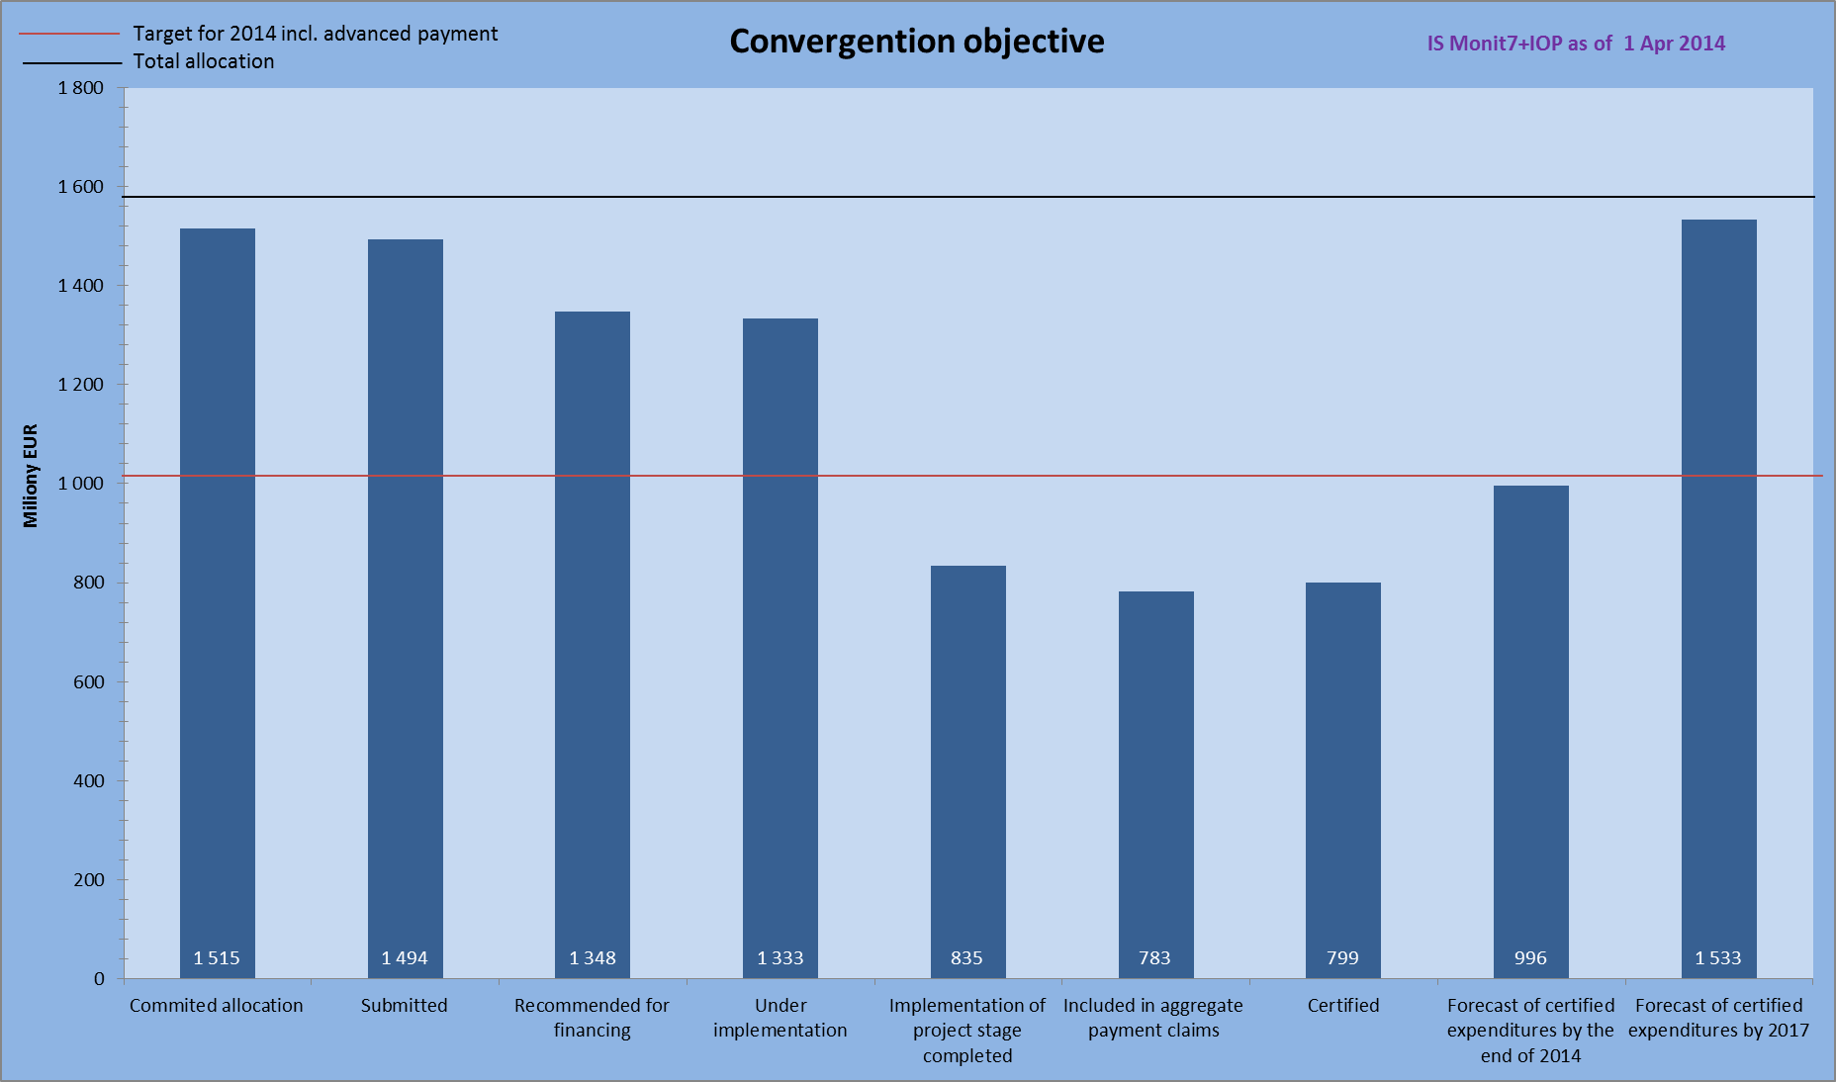
Source: IS Monit7+ as of 1 Apr 2014; CZK/EUR exchange rate: 27.423; data in “Planned certification” bars are as of 4 Jan 2014
Source of funding: EU share
Note: The “Planned certification” bars take into account the IOP MA and IB data received from beneficiaries that were not entered in IS at the time of data generation.
- red line – target for 2014 less the received advance payments
- black line – total allocation

Chart No 3 illustrates the fulfilment of n+2 rule under the Regional competitiveness and employment objective. As of 31 Mar 2014, project applications in the volume of EUR 25 million were submitted, EUR 24 million was recommended for financing. The amount of stages with completed implementation equals EUR 16 million, of which EUR 15 million was included in aggregate payment claims of beneficiaries. The certified expenditure totals EUR 14 million, by the end of 2014 the certification of expenditure in the amount of EUR 17 million is anticipated. The target for 2014 is EUR 21 million. The predicted loss of EUR 4.5 million is addressed by the IOP MA through the adopted measures.

- Fulfilment of n+2 rule under RCE objective
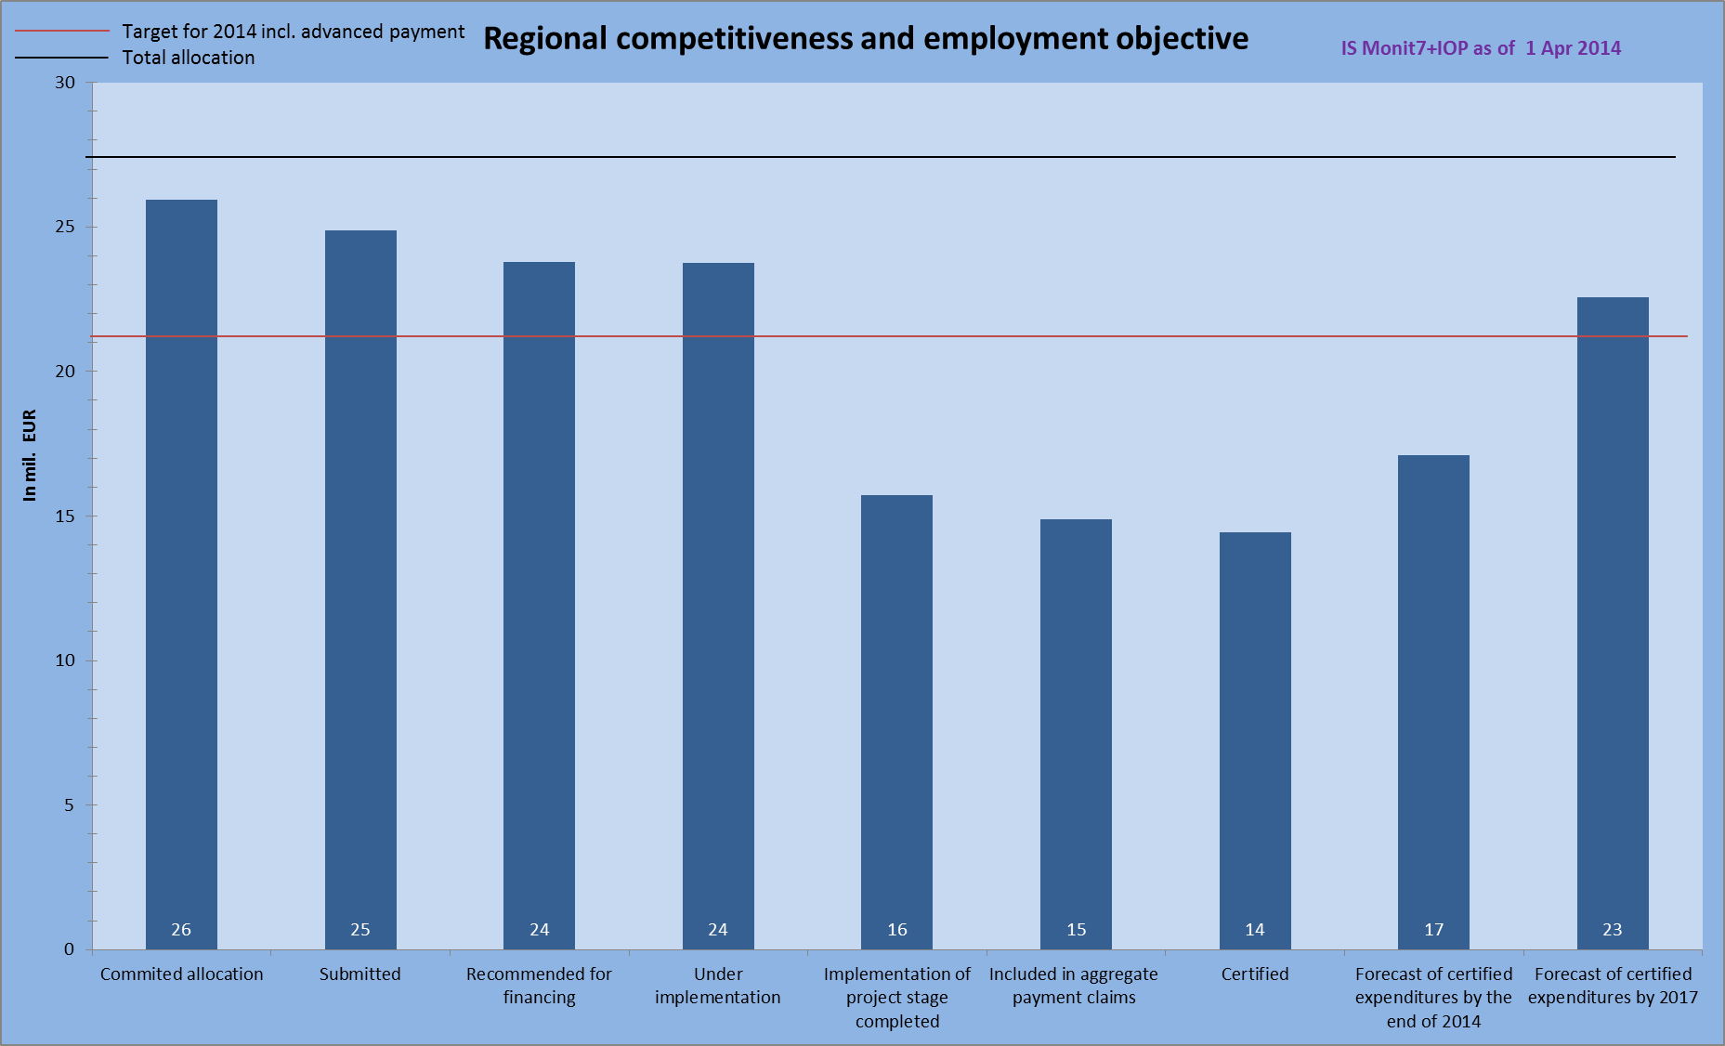
Source: IS Monit7+ as of 1 Apr 2014; CZK/EUR exchange rate: 27.423; data in “Planned certification” bars are as of 4 Jan 2014
Source of funding: EU share
Note: The “Planned certification” bars take into account the IOP MA and IB data received from beneficiaries that were not entered in IS at the time of data generation.
- red line – target for 2014 less the received advance payments
- black line – total allocation

2.7.1 Analysis of risks in relation to the fulfilment of n+3/n+2 rule by the Managing Authority and Intermediate Bodies

The n+2 rule shall be fulfilled at the level of objectives. For the purpose of monitoring the absorption of funds and programme management, the MA monitors the fulfilment of n+2 rule also by individual ministry and intervention area.

Ministry for Regional Development

The Ministry for Regional Development is responsible for Intervention areas 2.1, 3.4, 4.1, 5.1, 5.2, 5.3, 6.1 and 6.2. In these intervention areas, projects in the total amount of EUR 883 million were received and projects in the amount of EUR 770 million were implemented. Of EUR 485 million earmarked to stages that have already been implemented, a total of EUR 446 million was included in aggregate payment claims. The certified expenditure amounts to EUR 474 million and certification of EUR 621 million is anticipated in 2014. The target for 2014 is EUR 611 million.

- Fulfilment of n+2 rule by the Ministry for Regional Development 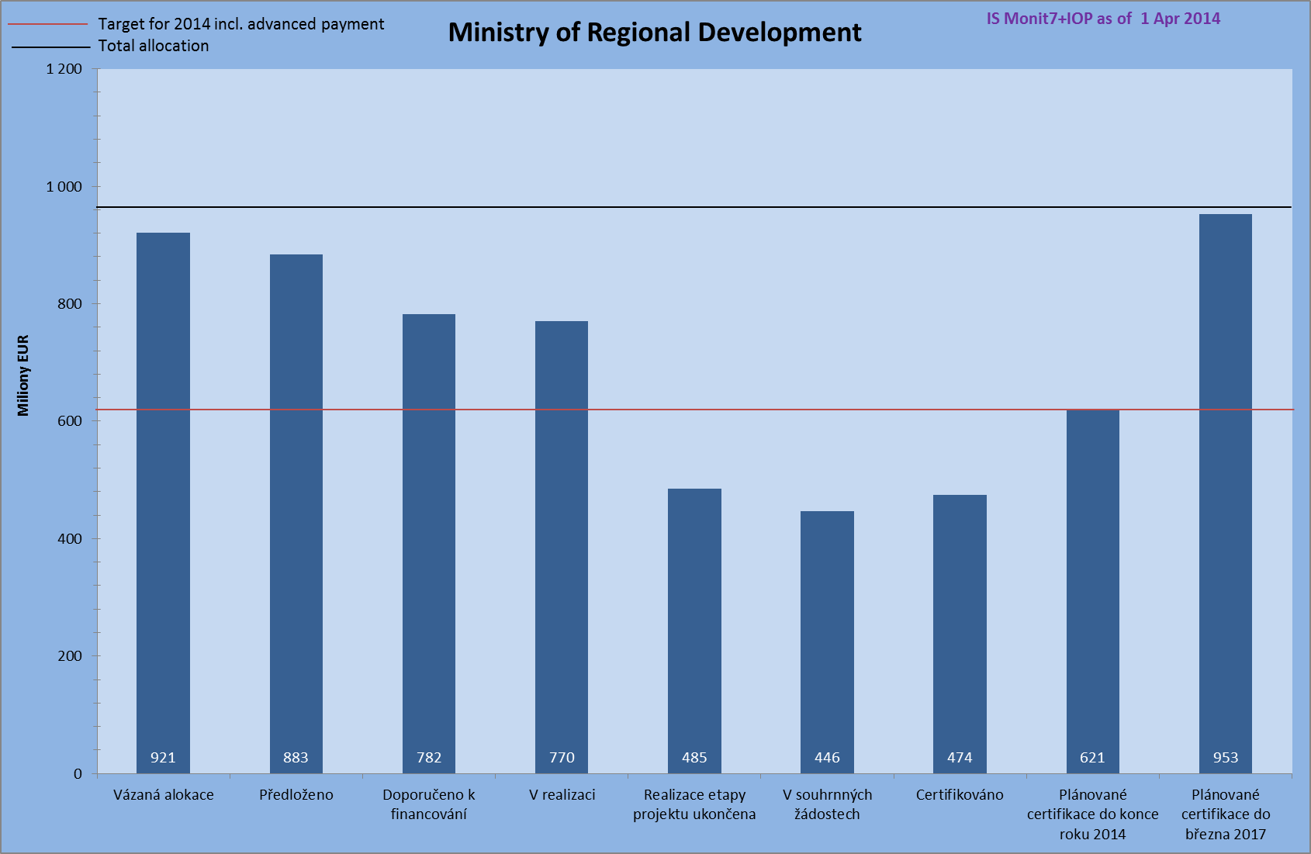
Source: IS Monit7+ as of 1 Apr 2014; CZK/EUR exchange rate: 27.423; data in “Planned certification” bars are as of 4 Jan 2014
Source of funding: EU share
Note: The “Planned certification” bars take into account the IOP MA and IB data received from beneficiaries that were not entered in IS at the time of data generation.
- red line – target for 2014 less the received advance payments
- black line – total allocation

In Intervention area 2.1 the main problem are delays in the implementation of projects. Despite all the efforts and the CRD CR intensive work with beneficiaries no improvements have so far been achieved in the field of public contracts that constitute a major cause of delays.

Project applications amounting to EUR 140 million were submitted. Projects in the total volume of EUR 130 million are under implementation. EUR 77.4 million was included in aggregate payment claims and expenditure in the volume of EUR 76 million was certified. By the end of 2014 the certification of EUR 89 million is anticipated, with the target being EUR 102 million.

- Fulfilment of n+2 rule in Intervention area 2.1
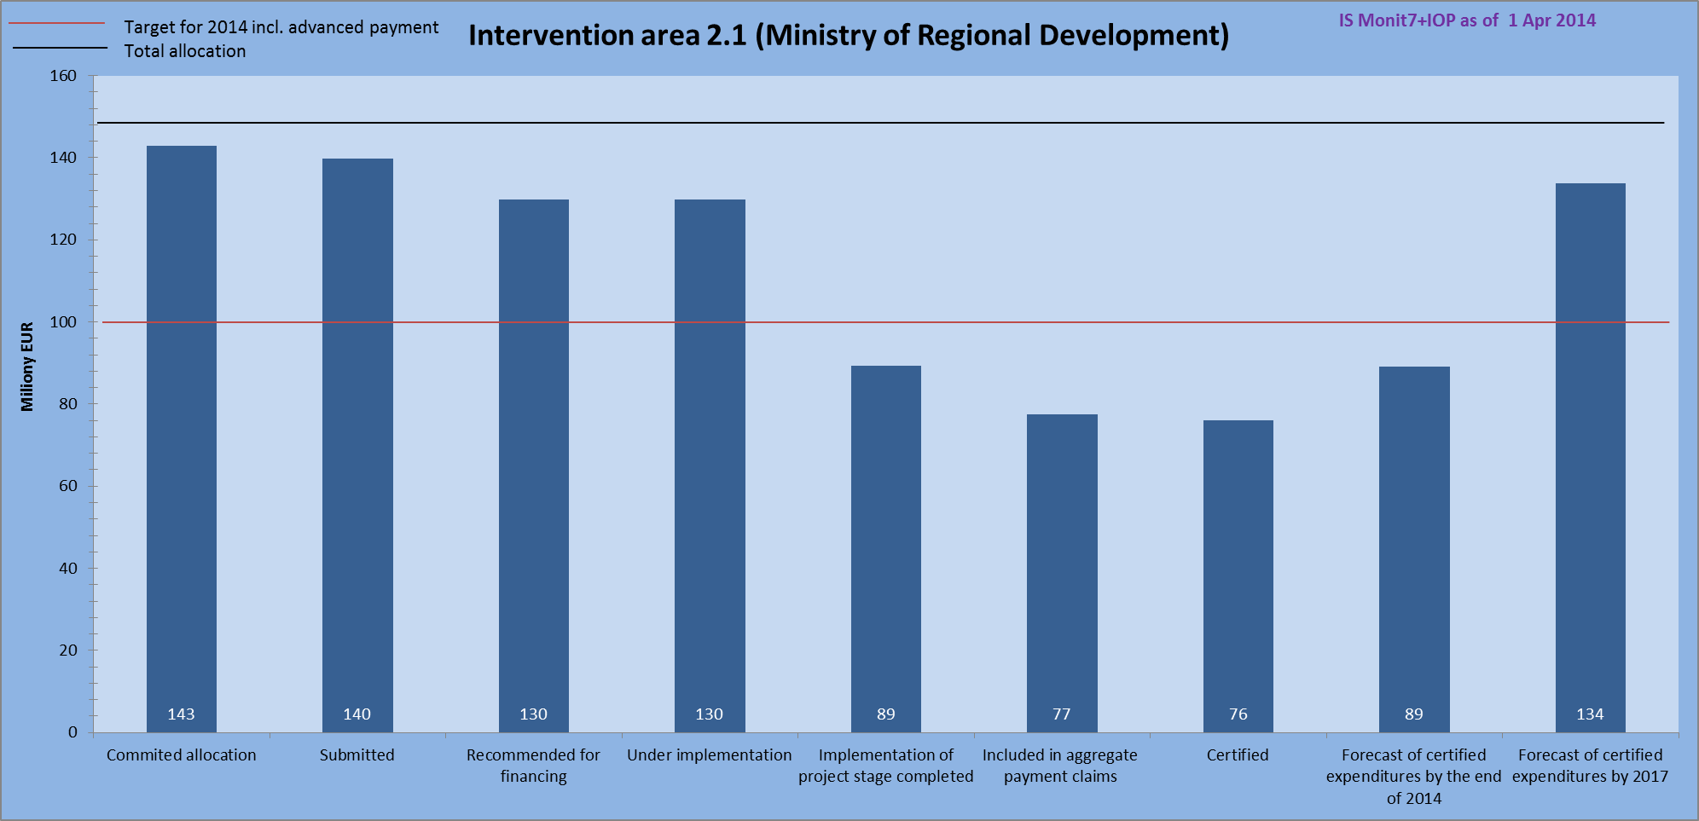
Source: IS Monit7+ as of 1 Apr 2014; CZK/EUR exchange rate: 27.423; data in “Planned certification” bars are as of 4 Jan 2014
Source of funding: EU share
Note: The “Planned certification” bars take into account the IOP MA and IB data received from beneficiaries that were not entered in IS at the time of data generation.
- red line – target for 2014 less the received advance payments
- black line – total allocation

In Intervention area 3.4, the submitted projects altogether claimed the amount of EUR 242 million, projects in the amount of EUR 156 million are under implementation. A total of EUR 66 million was included in the aggregate payment claim, the certified expenditure accounts for EUR 61 million. In 2014, the certified expenditure is anticipated to reach EUR 86 million and the target for 2014 is EUR 117 million.

Despite all the efforts exerted by the IOP MA and CRD CR, the absorption was affected by the complexity of contract award and tender procedures and primarily by appeals filed by unsuccessful bidders, which immensely protracted the procedures. The IOP MA and CRD CR adopted such measures as the division of projects into stages in order to increase the absorption in 2014.

- Fulfilment of n+2 rule in Intervention area 3.4
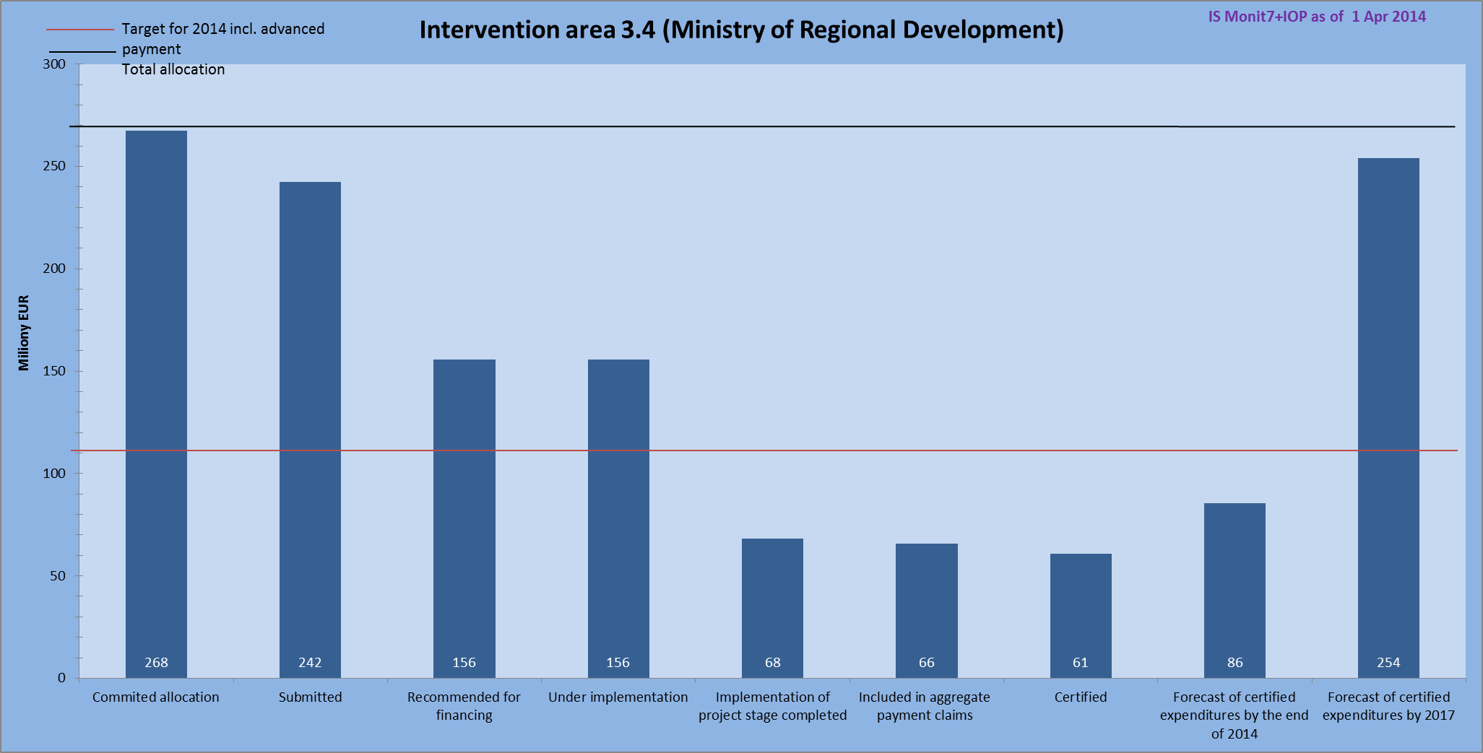
Source: IS Monit7+ as of 1 Apr 2014; CZK/EUR exchange rate: 27.423; data in “Planned certification” bars are as of 4 Jan 2014
Source of funding: EU share
Note: The “Planned certification” bars take into account the IOP MA and IB data received from beneficiaries that were not entered in IS at the time of data generation.
- red line – target for 2014 less the received advance payments
- black line – total allocation

In Intervention area 4.1, the submitted project applications amounted to EUR 58 million and projects in the amount of EUR 58 million are under implementation. Funds in the amount of EUR 30 million were included in the aggregate payment claim, the certified expenditure reached EUR 29 million. In 2014, the expenditure in the volume of EUR 37 million is foreseen to be certified and the target for 2014 is EUR 47 million.

The IOP MA regularly monitors the observance of set out forecasts that have to be fulfilled at all costs in order to eliminate the risk of a loss of allocation. At regular meetings with the largest beneficiaries (Tourism Department of the MRD CR and CzechTourism) the IOP MA always consults the fulfilment of the given forecasts and puts an emphasis on the observance of the latest deadline for submission of applications for payment in 2014, which is the end of August 2014. If the forecasts for 2014 are not fulfilled despite the adopted measures, there will be a loss of allocation in IA and it will be difficult to finance the projects that will be submitted in the 4th quarter of 2014.
- Fulfilment of n+2 rule in Intervention area 4.1
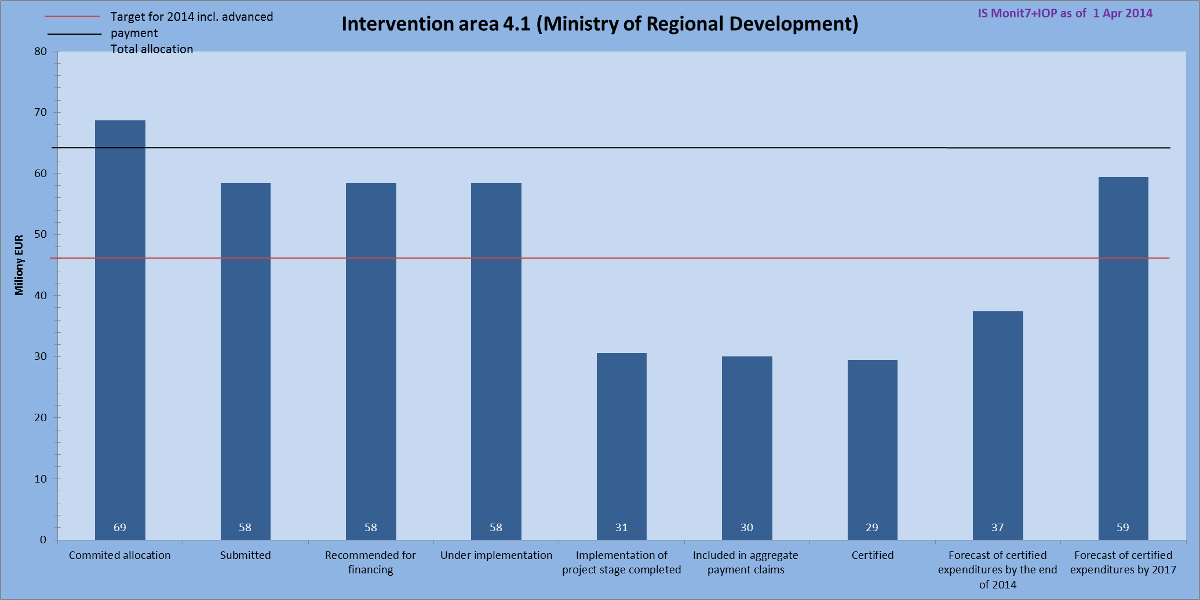
Source: IS Monit7+ as of 1 Apr 2014; CZK/EUR exchange rate: 27.423; data in “Planned certification” bars are as of 4 Jan 2014
Source of funding: EU share
Note: The “Planned certification” bars take into account the IOP MA and IB data received from beneficiaries that were not entered in IS at the time of data generation.
- red line – target for 2014 less the received advance payments
- black line – total allocation

As of 1 Nov 2013, the Ministry for Regional Development is responsible for Intervention area 5.1, under which the project applications totalling EUR 201 million have been submitted. The same amount is covered by projects recommended for financing by the Selection Committee that are currently under implementation. The amount covered by completed stages is EUR 101 million, of which EUR 96 million has already been included in aggregate payment claims. Expenditure in the amount of EUR 132 million is expected to be certified by the end of 2014.
For the sake of fulfilment of n+3/n+2 rule the Ministry of Culture in 2013 adopted a crisis plan consisting of measures such as continuous bilateral meetings with beneficiaries on addressing the topical issues of beneficiaries, evaluation of applications for changes (modifications) in projects regarding the extension of project implementation period, facilitation of continuous invoicing of aggregated items of construction works, control of individual steps made by beneficiaries in the course of contract award procedures, more intensive communication between the project and financial managers and the implementation team of individual projects.

At the time of transfer of Intervention area 5.1 to MRD CR and CRD CR in autumn 2013, the MA organised trilateral meetings on each of 21 projects under IA 5.1, which were attended by the project team of the beneficiary, the MA and the CRD CR, and on the agenda of which were thorough discussions on the state of play of project implementation, risks posed to the timetable and absorption. The MA prepared a revision of the Handbooks for Applicants and Beneficiaries which shall take effect on 1 Nov 2014, in which it modified and simplified inter alia the system of approval of invoices, the system of extra work, approval of monitoring reports with the view to speed up the administrative processes.

In the course of February and March 2014, the CRD CR carried out monitoring visits to projects so as to verify the achieved progress and talk over the feasibility of the financing plan and timetable of tenders until the end of the period.

In this intervention area the forecasts of submitted applications for payment were fulfilled to the degree of 54.3 %. The main reason for their non-fulfilment are delays in stages, or postponed completion of projects resulting from repeated tenders especially for construction works and purchase of movables.

- Fulfilment of n+2 rule in Intervention area 5.1
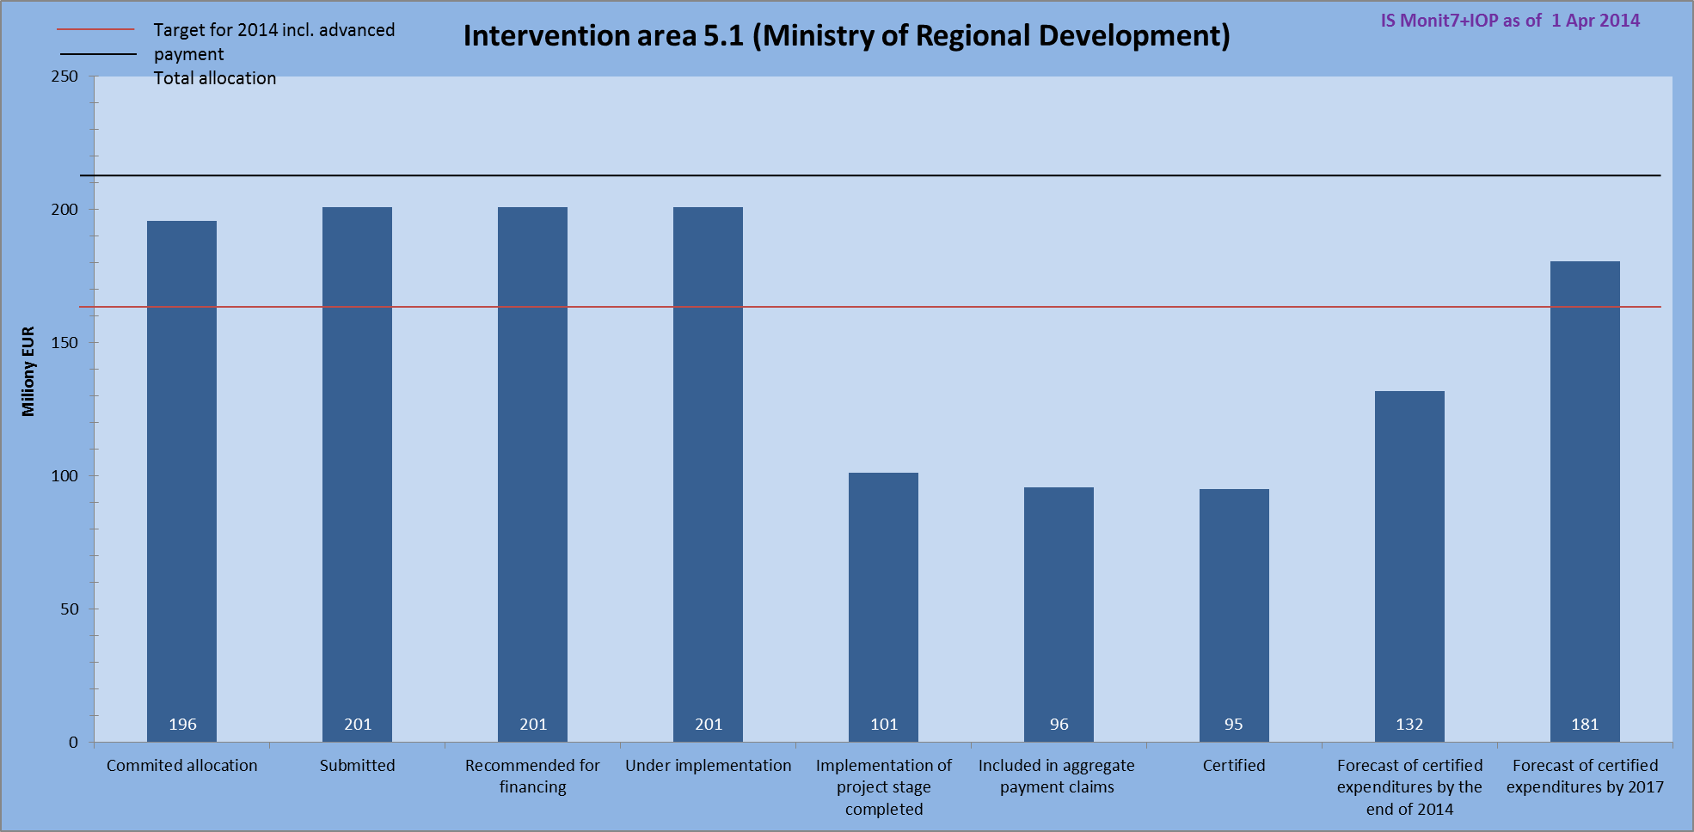
Source: IS Monit7+ as of 1 Apr 2014; CZK/EUR exchange rate: 27.423; data in “Planned certification” bars are as of 4 Jan 2014
Source of funding: EU share
Note: The “Planned certification” bars take into account the IOP MA and IB data received from beneficiaries that were not entered in IS at the time of data generation.
- red line – target for 2014 less the received advance payments
- black line – total allocation

In Intervention area 5.2, the project applications in the total amount of EUR 191 million were submitted, EUR 188 million were recommended for financing. The stages, the implementation of which was completed, total EUR 155 million. The aggregate payment claims included EUR 141 million. The certified expenditure reached EUR 178 million, by the end of 2014 its volume is foreseen to reach EUR 237 million. The target for 2014 is EUR 138 million. There is no risk of non-fulfilment of n+2 rule in 2014.
- Fulfilment of n+2 rule in Intervention area 5.2
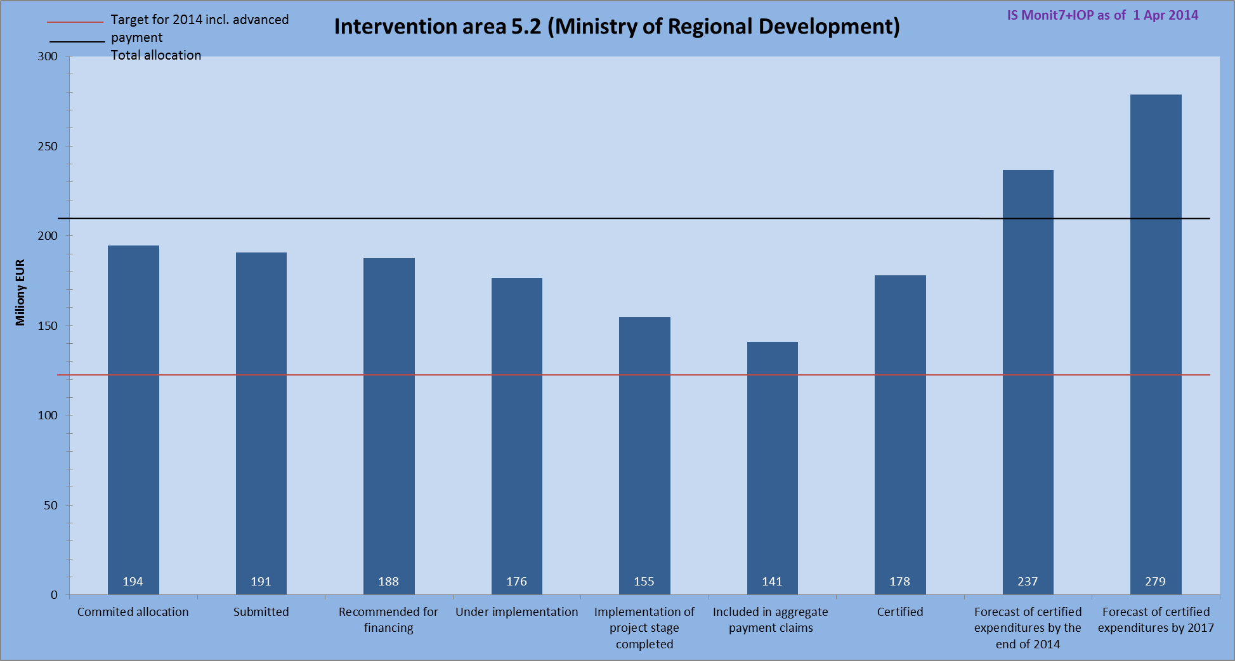
Source: IS Monit7+ as of 1 Apr 2014; CZK/EUR exchange rate: 27.423; data in “Planned certification” bars are as of 4 Jan 2014
Source of funding: EU share
Note: The “Planned certification” bars take into account the IOP MA and IB data received from beneficiaries that were not entered in IS at the time of data generation.
- red line – target for 2014 less the received advance payments
- black line – total allocation

In Intervention area 5.3, the submitted project applications amounted to EUR 16 million, projects in the amount of EUR 15 million were recommended for financing. The volume of funds of completed stages accounts for EUR 14 million, the amount of EUR 15 million is included in aggregate payment claims. In the monitored period, administration and reimbursement of projects from the 17th call was under way, the certified expenditure equalled EUR 14.5 million, by the end of 2014 it is anticipated to reach EUR 14.6 million. The target for 2014 is EUR 13.2 million. The allocation to this intervention area for 2014 has been fulfilled, there is no risk of non-fulfilment of n+2 rule.
- Fulfilment of n+2 rule in Intervention area 5.3
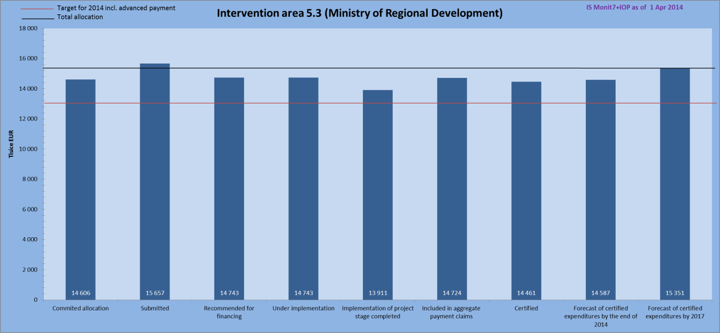
Source: IS Monit7+ as of 1 Apr 2014; CZK/EUR exchange rate: 27.423; data in “Planned certification” bars are as of 4 Jan 2014
Source of funding: EU share
Note: The “Planned certification” bars take into account the IOP MA and IB data received from beneficiaries that were not entered in IS at the time of data generation.
- red line – target for 2014 less the received advance payments
- black line – total allocation

In Intervention area 6.1, the submitted project applications totalled EUR 29 million, projects in the total amount of EUR 27 million are under implementation. The completed stages represent EUR 21 million, whereas EUR 18 million was included in aggregate payment claims. The expenditure in the amount of EUR 17 million was certified, by the end 2014 it is anticipated to reach EUR 21 million. The target for 2014 is EUR 20 million.

- Fulfilment of n+2 rule in Intervention area 6.1
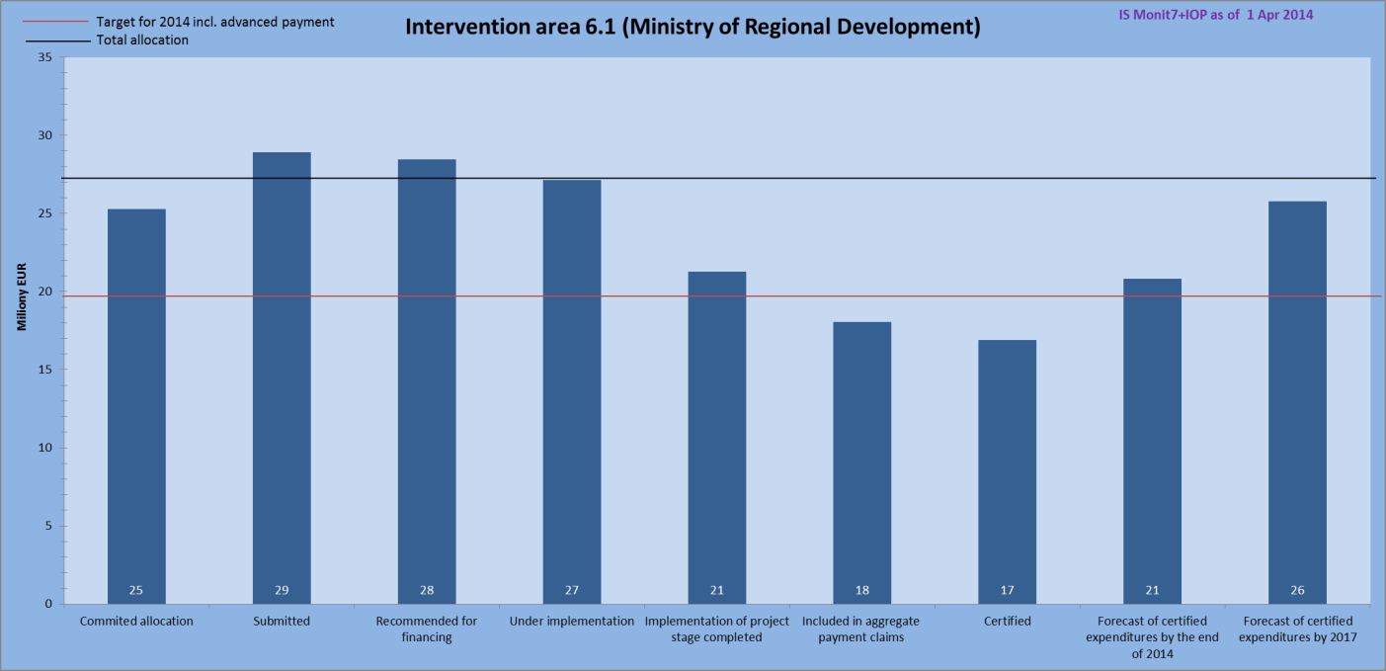
Source: IS Monit7+ as of 1 Apr 2014; CZK/EUR exchange rate: 27.423; data in “Planned certification” bars are as of 4 Jan 2014
Source of funding: EU share
Note: The “Planned certification” bars take into account the IOP MA and IB data received from beneficiaries that were not entered in IS at the time of data generation.
- red line – target for 2014 less the received advance payments
- black line – total allocation

In Intervention area 6.2, project applications in the amount of EUR 7 million were received and all of them proceeded to the stage of implementation. The stages, the implementation of which was completed, equal EUR 5 million, EUR 4 million was included in the aggregate payment claim. By the end of 2014, the certified expenditure is foreseen to reach EUR 4.4 million. The target for 2014 is EUR 6.5 million.

The objective of this priority axis is not to absorb the allocation, but to achieve responsible and effective programme administration, to safeguard efficient management and monitoring of programme implementation and to maximize the quality and effectiveness of implementation and to support the management activities in the framework of IOP, to enhance programme effectiveness and to make preparations for the next programming period.

- Fulfilment of n+2 rule in Intervention area 6.2
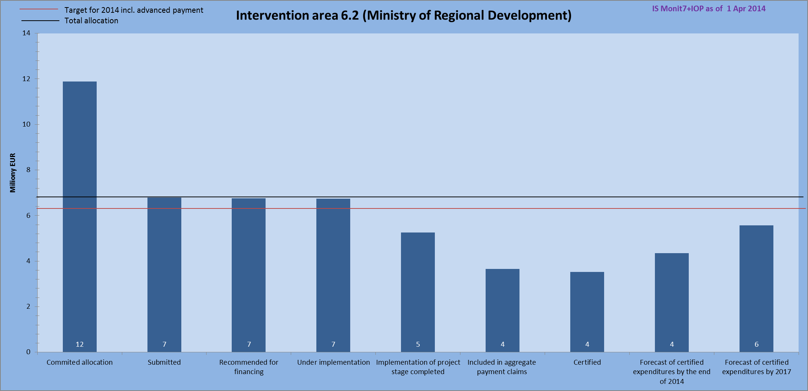
Source: IS Monit7+ as of 1 Apr 2014; CZK/EUR exchange rate: 27.423; data in “Planned certification” bars are as of 4 Jan 2014
Source of funding: EU share
Note: The “Planned certification” bars take into account the IOP MA and IB data received from beneficiaries that were not entered in IS at the time of data generation.
- red line – target for 2014 less the received advance payments
- black line – total allocation

Ministry of Interior

In Intervention area 1.1, the amount of submitted projects was EUR 281 million, projects in the volume of EUR 266 million are under implementation. Funds totalling EUR 173 million were included in aggregate payment claims, the certified expenditure reached EUR 167 million. In 2014, the volume of certified expenditure is anticipated to reach EUR 191 million and the target for 2014 is EUR 224 million.

The main risk factor threatening the fulfilment of n+2 rule is the extension of project timetables. These delays in project implementation are caused primarily by complications in contract award procedures and internal processes at beneficiaries, particularly in the set out system of approving and signing the documents which is lengthy and ineffective, or in frequent changes of staffing in project management.

In case of projects considered to be high-risk or sleeping, the MoI CR IB adopted measures to address the risks and to meet the expected deadlines. Moreover, crisis timetables have been set, regular meetings of working teams and meetings with beneficiaries attended by the IOP MA representatives have been held. They seek to speed up the absorption of allocation as much as possible or make the beneficiary withdraw from implementation of sleeping projects so that the funds can be used in a more effective way.

The MoI CR IB provides long-term and intensive assistance to beneficiaries during the preparation and elaboration of monitoring reports, applications for payment and during public procurement procedures in order to reduce their error rate and cut short the period necessary for administrative controls.

Preliminary consultations were held with the IOP MA on requests for extending the implementation period.

The new call No 17 sets out an obligation to submit the elaborated conditions of tender together with the project application so as to accelerate the administration and absorption.

- Fulfilment of n+2 rule by the Minister of Interior
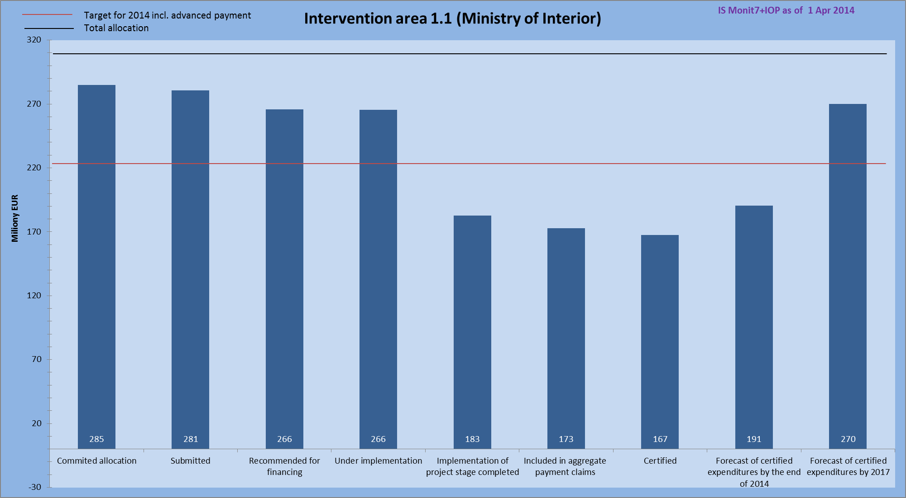
Source: IS Monit7+ as of 1 Apr 2014; CZK/EUR exchange rate: 27.423; data in “Planned certification” bars are as of 4 Jan 2014
Source of funding: EU share
Note: The “Planned certification” bars take into account the IOP MA and IB data received from beneficiaries that were not entered in IS at the time of data generation.
- red line – target for 2014 less the received advance payments
- black line – total allocation

Ministry of Labour and Social Affairs

The Ministry of Labour and Social Affairs is responsible for Intervention areas 3.1 and 3.3. In total, the project applications in the amount of EUR 95 million were submitted, EUR 93 million was recommended for financing by the Selection Committee. The completed project stages equal EUR 30 million, of which EUR 31 million was included in aggregate payment claims. Expenditure in the amount of EUR 30 million was certified and by the end of 2014 the certified expenditure is anticipated to reach EUR 39 million. The target for 2014 is EUR 49 million.

- Fulfilment of n+2 rule by the Ministry of Labour and Social Affairs
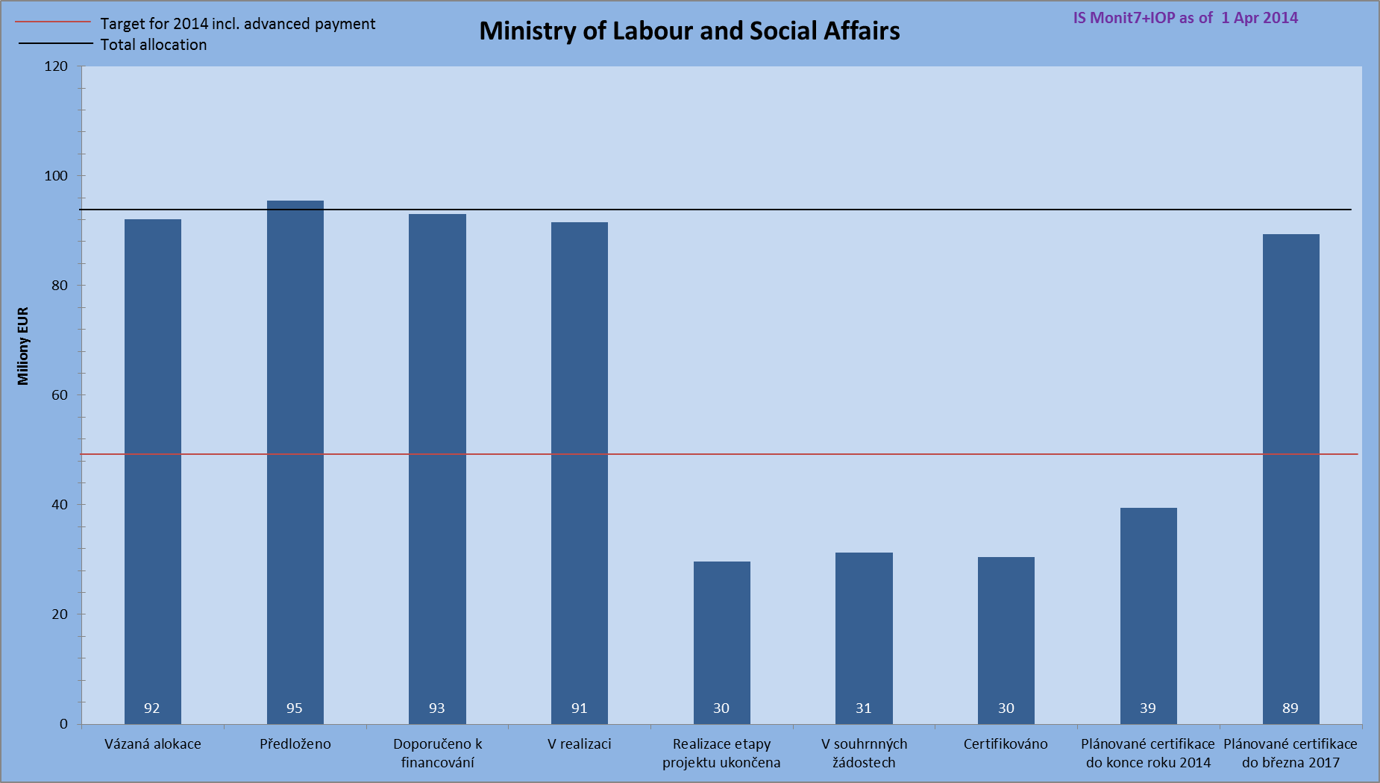
Source: IS Monit7+ as of 1 Apr 2014; CZK/EUR exchange rate: 27.423; data in “Planned certification” bars are as of 4 Jan 2014
Source of funding: EU share
Note: The “Planned certification” bars take into account the IOP MA and IB data received from beneficiaries that were not entered in IS at the time of data generation.
- red line – target for 2014 less the received advance payments
- black line – total allocation

The MoLSA CR IB adopted measures aiming to maximise the absorption in 2014 and 2015 and at the same time not to undertake commitments that would have to be covered from the CR budget. In 2015, there should be no risk of non-fulfilment of n+2 rule.

In Intervention area 3.1, the project applications in the amount of EUR 57 million were submitted, of which EUR 54 million was recommended for financing by the Selection Committee. The completed stages represent EUR 12 million, EUR 13 million was included in aggregate payment claims. By the end of 2014, expenditure in the amount of EUR 20.5 million is expected to be certified. The target for 2014 is EUR 21.3 million.

- Fulfilment of n+2 rule in Intervention area 3.1
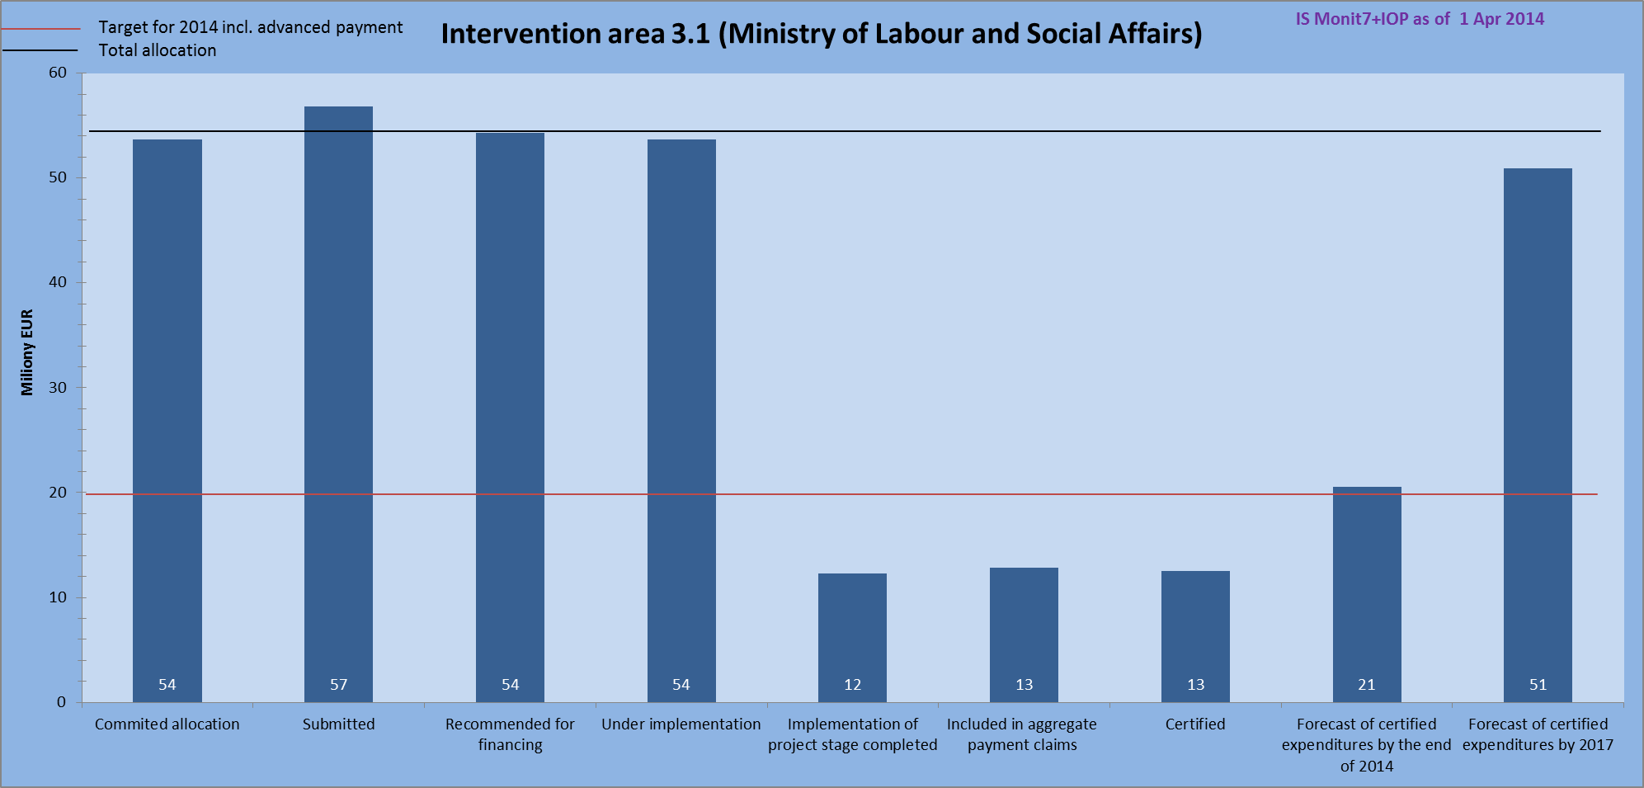
Source: IS Monit7+ as of 1 Apr 2014; CZK/EUR exchange rate: 27.423; data in “Planned certification” bars are as of 4 Jan 2014
Source of funding: EU share
Note: The “Planned certification” bars take into account the IOP MA and IB data received from beneficiaries that were not entered in IS at the time of data generation.
Note:
- red line – target for 2014 less the received advance payments
- black line – total allocation

In Intervention area 3.3, the submitted project applications amounted to a total of EUR 39 million, the same amount was recommended for financing by the Selection Committee. The completed stages represent EUR 17 million, EUR 18.5 million was included in aggregate payment claims. By the end of 2014, the expenditure in the amount of EUR 19 million is anticipated to be certified. The target for 2014 is EUR 28 million.

Based on the to-date progress in absorption, problems in the fulfilment of n+2 rule and a failure to absorb the allocated funds in 2014 are expected. The target for 2014, i.e. EUR 27 506 422, will most likely not be achieved, the volume of certified expenditure by the end of 2014 is currently estimated at EUR 20 566 212. A factor influencing the non-fulfilment of n+2 rule are above all the postponements in the timetable of implementation of individual projects (longer periods for elaboration of project documents or preparation and implementation of tenders for construction suppliers). Several measures have been adopted to improve the prevailing situation – regular division of projects into stages, consultations with beneficiaries during the compilation of applications for payment and the resulting shortening of the administration of applications for payment.

- Fulfilment of n+2 rule in Intervention area 3.3
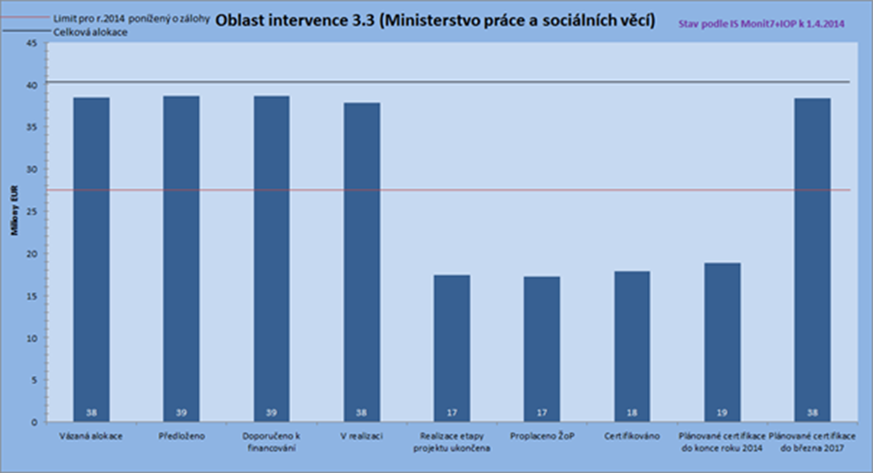
Source: IS Monit7+ as of 1 Apr 2014; CZK/EUR exchange rate: 27.423; data in “Planned certification” bars are as of 4 Jan 2014
Source of funding: EU share
Note: The “Planned certification” bars take into account the IOP MA and IB data received from beneficiaries that were not entered in IS at the time of data generation.
- red line – target for 2014 less the received advance payments
- black line – total allocation

Ministry of Health

The Ministry of Health is responsible for Intervention area 3.2. The submitted project applications amounted to a total of EUR 259 million, of which projects in the amount of EUR 230 million were recommended for financing by the Selection Committee. The amount covered by completed stages is EUR 154 million and EUR 148 million was included in aggregate payment claims. The certified expenditure equals EUR 142 million and by the end of 2014 it is anticipated to reach EUR 163 million. The target for 2014 is EUR 181 million.

The Ministry of Health has adopted several measures in order to accelerate the absorption of funds. Therefore, the n+3 rule for 2014 should be fulfilled to the maximum degree. Due to the possibility to extend the project implementation (on account of cancellations of parts of contract award procedures, lots of additional enquiries, objections of bidders) and the likelihood of major savings, there is a risk of a failure to fulfil the n+2 rule in 2014 to the degree of 100 %.
Ranking among the adopted measures are more effective communication with beneficiaries, cutting short the deadlines for submission and administration of monitoring reports and applications for payment, introduction of checks of project documentation and tenders prior to the submission of the monitoring report, division of projects into stages. In the newly published calls No 13 and 14, majority of contract award procedures was successfully advertised before the end of March 2014. Unless unexpected delays occur (numerous additional enquiries, objections of bidders, etc.) the tenders will be completed in the course of 2014.
Preconditions for the achievement of absorption target in 2015 have been created in projects with issued Decision, with funds committed under the current calls No 17 and 18 (the Decisions will be issued in the course of May 2014).

- Fulfilment of n+2 rule by the Ministry of Health
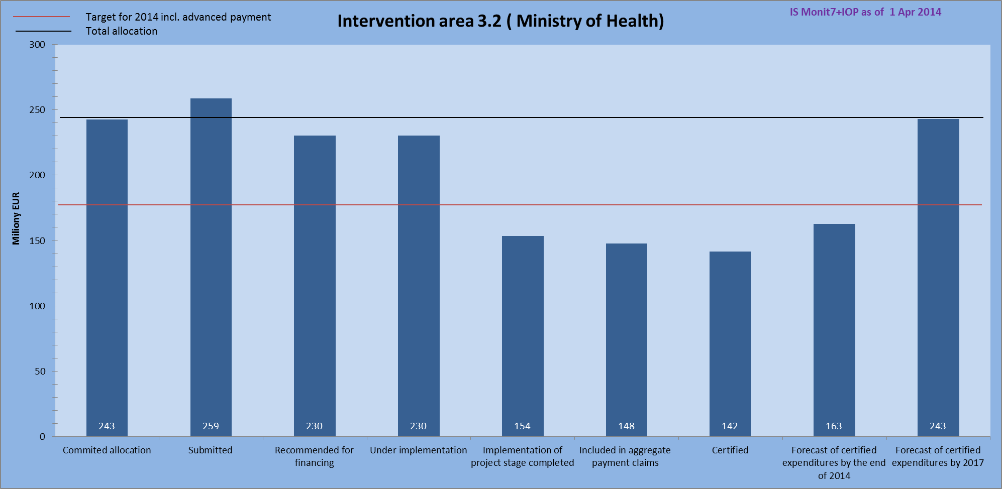
Source: IS Monit7+ as of 1 Apr 2014; CZK/EUR exchange rate: 27.423; data in “Planned certification” bars are as of 4 Jan 2014
Source of funding: EU share
Note: The “Planned certification” bars take into account the IOP MA and IB data received from beneficiaries that were not entered in IS at the time of data generation.
- red line – target for 2014 less the received advance payments
- black line – total allocation

2.7.2 Forecast of the progress in IOP absorption (in EUR)

The table below illustrates the anticipated development in submission of applications for payment in the period from April 2014 to December 2014. Taken into account in the forecasts are also the IOP MA and IB data obtained from beneficiaries that were not entered into the IS at the time of data generation.

The largest volume of applications for payment is expected to be submitted in July 2014 (EUR 76.64 million) – mostly in Intervention areas 5.1 (EUR 28.62 million), 1.1 (EUR 21.01 million), and 5.2 (EUR 9.9 million).

- Forecast of submitted applications for payment
Priority axis /  Intervention area | Submitted applications for payment - forecast (EUR)
 | April 14 | May 14 | June 14 | July 14 | August 14 | September 14 | October 14 | November 14 | December 14
1a | 3 806 031 | 1 911 960 | 2 062 237 | 19 513 489 | 3 244 459 | 7 205 692 | 6 454 973 | 54 178 | 253 958
1b | 292 772 | 147 074 | 158 634 | 1 501 038 | 249 574 | 554 284 | 496 536 | 4 168 | 19 535
1 | 4 098 802 | 2 059 033 | 2 220 871 | 21 014 527 | 3 494 033 | 7 759 976 | 6 951 509 | 58 345 | 273 493
2.1 | 4 183 139 | 306 190 | 1 626 689 | 1 259 301 | 9 126 814 | 3 573 203 | 4 991 014 | 0 | 2 141 747
2 | 4 183 139 | 306 190 | 1 626 689 | 1 259 301 | 9 126 814 | 3 573 203 | 4 991 014 | 0 | 2 141 747
3.1 | 317 631 | 2 127 657 | 69 003 | 6 205 448 | 2 919 822 | 2 627 739 | 524 350 | 162 019 | 3 038 249
3.2 | 8 726 789 | 5 148 030 | 4 268 946 | 2 378 617 | 2 083 245 | 2 515 441 | 2 108 848 | 6 568 735 | 3 866 410
3.3 | 200 698 | 21 616 | 21 486 | 632 790 | 0 | 0 | 0 | 0 | 1 284 005
3.4 | 0 | 6 154 317 | 1 084 856 | 1 909 966 | 16 637 254 | 1 116 047 | 6 678 215 | 7 903 918 | 0
3 | 9 245 118 | 13 451 620 | 5 444 291 | 11 126 821 | 21 640 320 | 6 259 226 | 9 311 414 | 14 634 673 | 8 188 664
4.1a | 1 205 987 | 171 281 | 1 787 072 | 2 126 101 | 2 383 519 | 6 569 763 | 0 | 0 | 231 733
4a | 1 205 987 | 171 281 | 1 787 072 | 2 126 101 | 2 383 519 | 6 569 763 | 0 | 0 | 231 733
4.1b | 92 768 | 13 176 | 137 467 | 163 546 | 183 348 | 505 322 | 0 | 0 | 17 826
4b | 92 768 | 13 176 | 137 467 | 163 546 | 183 348 | 505 322 | 0 | 0 | 17 826
5.1 | 14 707 502 | 0 | 1 683 783 | 28 620 014 | 0 | 972 966 | 14 106 855 | 0 | 3 100
5.2 | 1 124 958 | 2 298 044 | 3 856 867 | 9 896 904 | 3 824 171 | 5 871 417 | 8 171 455 | 177 950 | 6 763 105
5.3 | 37 869 | 50 041 | 62 219 | 514 096 | 0 | 0 | 0 | 0 | 0
5 | 15 870 328 | 2 348 085 | 5 602 868 | 39 031 013 | 3 824 171 | 6 844 384 | 22 278 309 | 177 950 | 6 766 205
6.1a | 966 351 | 0 | 141 687 | 1 035 638 | 0 | 639 161 | 327 190 | 0 | 77 004
6.2a | 56 181 | 21 856 | 0 | 850 645 | 0 | 0 | 0 | 0 | 0
6a | 1 022 532 | 21 856 | 141 687 | 1 886 283 | 0 | 639 161 | 327 190 | 0 | 77 004
6.1b | 17 768 | 0 | 2 605 | 19 042 | 0 | 11 752 | 6 016 | 0 | 1 416
6.2b | 1 033 | 402 | 0 | 15 641 | 0 | 0 | 0 | 0 | 0
6b | 18 801 | 402 | 2 605 | 34 683 | 0 | 11 752 | 6 016 | 0 | 1 416
Convergence | 35 333 135 | 18 210 993 | 16 664 845 | 74 943 009 | 40 219 283 | 31 091 430 | 43 362 900 | 14 866 800 | 17 659 310
RCE | 404 341 | 160 651 | 298 706 | 1 699 267 | 432 921 | 1 071 358 | 502 552 | 4 168 | 38 777
IOP | 35 737 476 | 18 371 644 | 16 963 550 | 76 642 275 | 40 652 204 | 32 162 788 | 43 865 453 | 14 870 968 | 17 698 087
Source: Forecast for the NCA as of 4 Jan 2014
Source of funding: EU share (85 % of total eligible expenditure – with private financing included in co-financing)

The following table shows the forecasts of approved applications for payment. Included in the forecasts are also the IOP MA and IB data obtained from beneficiaries which were not entered into the IS at the time of data generation.

The largest volume of applications for payment is expected to be submitted in September. According to the forecasts, the amount of EUR 52.22 million should be approved. The largest volumes of funds should be approved in Intervention areas 5.1 (EUR 25.25 million), 5.2 (8.73 million), and 3.1 (EUR 5.48 million).

- Forecast of approved applications for payment
Priority axis /  Intervention area | Approved applications for payment - forecast (EUR)
 | April 14 | May 14 | June 14 | July 14 | August 14 | September 14 | October 14 | November 14 | December 14
1a | 1 831 571 | 2 695 516 | 804 707 | 1 199 636 | 14 029 168 | 2 855 479 | 5 346 070 | 4 736 957 | 40 196
1b | 122 485 | 188 838 | 53 814 | 80 225 | 938 187 | 190 957 | 357 513 | 268 130 | 2 688
1 | 1 954 055 | 2 884 353 | 858 521 | 1 279 861 | 14 967 355 | 3 046 436 | 5 703 583 | 5 005 087 | 42 884
2.1 | 396 773 | 0 | 3 691 005 | 270 168 | 1 435 314 | 1 111 148 | 8 053 071 | 3 152 826 | 4 403 836
2 | 396 773 | 0 | 3 691 005 | 270 168 | 1 435 314 | 1 111 148 | 8 053 071 | 3 152 826 | 4 403 836
3.1 | 239 275 | 1 240 668 | 280 263 | 1 877 344 | 60 885 | 5 475 396 | 2 576 313 | 2 318 593 | 462 662
3.2 | 1 072 512 | 1 170 798 | 7 990 881 | 4 542 380 | 3 460 758 | 2 287 006 | 1 862 461 | 1 944 886 | 2 295 226
3.3 | 0 | 1 398 113 | 177 086 | 19 073 | 18 959 | 558 344 | 0 | 0 | 0
3.4 | 4 120 750 | 0 | 0 | 5 430 280 | 957 226 | 1 685 264 | 14 679 930 | 984 747 | 5 892 543
3 | 5 432 537 | 3 809 579 | 8 448 230 | 11 869 076 | 4 497 828 | 10 006 010 | 19 118 704 | 5 248 226 | 8 650 431
4.1a | 0 | 1 189 635 | 1 064 106 | 151 131 | 1 576 828 | 1 875 972 | 2 103 105 | 5 796 850 | 0
4a | 0 | 1 189 635 | 1 064 106 | 151 131 | 1 576 828 | 1 875 972 | 2 103 105 | 5 796 850 | 0
4.1b | 0 | 91 510 | 81 854 | 11 625 | 121 294 | 144 306 | 161 777 | 445 872 | 0
4b | 0 | 91 510 | 81 854 | 11 625 | 121 294 | 144 306 | 161 777 | 445 872 | 0
5.1 | 0 | 0 | 12 977 208 | 0 | 1 485 691 | 25 252 954 | 0 | 858 500 | 12 447 225
5.2 | 1 353 722 | 349 695 | 992 610 | 2 027 686 | 3 403 118 | 8 732 562 | 3 374 269 | 5 180 662 | 7 210 107
5.3 | 56 721 | 17 066 | 33 414 | 44 154 | 54 899 | 453 614 | 0 | 0 | 0
5 | 1 410 443 | 366 761 | 14 003 231 | 2 071 840 | 4 943 707 | 34 439 129 | 3 374 269 | 6 039 162 | 19 657 332
6.1a | 0 | 0 | 852 663 | 0 | 125 018 | 913 798 | 0 | 563 966 | 288 697
6.2a | 124 271 | 0 | 49 571 | 19 285 | 98 891 | 651 678 | 0 | 0 | 0
6a | 124 271 | 0 | 902 234 | 19 285 | 223 909 | 1 565 476 | 0 | 563 966 | 288 697
6.1b | 0 | 0 | 15 678 | 0 | 2 299 | 16 802 | 0 | 10 370 | 5 308
6.2b | 2 285 | 0 | 911 | 355 | 1 818 | 11 982 | 0 | 0 | 0
6b | 2 285 | 0 | 16 589 | 355 | 4 117 | 28 784 | 0 | 10 370 | 5 308
Convergence | 9 195 595 | 8 061 492 | 28 913 514 | 15 581 136 | 26 706 755 | 51 853 213 | 37 995 218 | 25 537 988 | 33 040 491
RCE | 124 769 | 280 348 | 152 258 | 92 205 | 1 063 598 | 364 047 | 519 290 | 724 371 | 7 996
IOP | 9 320 365 | 8 341 840 | 29 065 771 | 15 673 340 | 27 770 353 | 52 217 260 | 38 514 508 | 26 262 359 | 33 048 487
Source: Forecast for the NCA as of 4 Jan 2014
Source of funding: EU share

2.7.2.1 Submitted applications for payment – forecast and comparison with the actual values

The forecasts of submitted applications for payment in Intervention area 1.1 were in the monitored period fulfilled to the degree of 80 %. The difference between the anticipated volume of submitted applications for payment and the actual value is caused by repeatedly extended and merged project stages. The reasons behind continue to be the protractions in contract award procedures or changes in staffing in project management. In order to minimise the risks, the MoI CR IB has adopted a number of measures, e.g. regular meetings with beneficiaries, consultations on draft monitoring reports and applications for payment before they are passed on to administration, control of tender documentation, which focus on close cooperation with beneficiaries and provision of assistance to them.

The forecasts of submitted applications for payment in Intervention area 2.1 were not fulfilled on account of delays in implementation of public contracts.
In the monitored period, in Intervention area 3.1, the anticipated volume of submitted applications for payment in the amount of EUR 4.5 million (EU share) was not achieved. The failure to fulfil the forecasts is caused by frequent changes in projects, especially the postponements in implementation of projects, prolongation of project stages and implementation of tenders.

The Ministry of Health in Intervention area 3.2 fulfils the forecasts to the degree of around 40.4 %. The rate of fulfilment of forecasts decreased especially because of the fact that, in order to fulfil the n+3/n+2 rule, measures have been put in place that have a positive impact on absorption of funds, but at the same time make the forecasts of submitted applications for payment more difficult. Among these measures is, for example, the division of projects into stages, when the beneficiary applies for the division of project into stages during the project implementation. This step brings about changes in submission of project applications as against the forecast. In some cases, the deadline of project implementation and the deadline for submission of applications for payment are postponed (particularly in relation to contract award procedures -additional enquiries, objections of bidders, or insufficient number of bids).

The biggest issue in Intervention area 3.2 is the time necessary for approval of applications for payment submitted by beneficiaries before the end of the previous calendar year or in the course of January. At the turn of the year, for technical reasons funds cannot be paid to beneficiaries, therefore the applications for payment are included in aggregate payment claims with a month delay.

In Intervention area 3.3, in the monitored period of 2013 the forecasts of submitted applications for payment were fulfilled to the degree of 98.6%, whereas in the monitored period of 2014 the fulfilment reached 102.2%. For the sake of ensuring continuous certification of expenditure, the projects are continuously divided into stages, the beneficiaries are offered intensive support during the elaboration of applications for payment to prevent errors in submitted applications for payment and prolongation of the process of administration.

In Intervention area 3.4, as of 31 March, the submitted applications for payment fulfilled the forecast mainly thanks to the completion of projects from the 13th call. The fulfilment of forecasts in the next period is at risk, because of the prevailing problems with public contracts in almost all the projects.
In Intervention area 4.1, in the monitored period the forecasts were fulfilled to the degree of approximately 70 %. The difference between the forecasts and the actually submitted applications for payment in the IA is roughly CZK 2 million.
In Intervention area 5.1, the forecasts of submitted applications for payment were fulfilled to the degree of 54.3 %. The main reason of non-fulfilment of forecasts is the postponements in stages or postponed completion of projects. Contract award and tender procedures, especially for construction works, and purchase of movables are repeated.
In Intervention area 5.2, the forecast was fulfilled to approximately 80 %. It is caused by postponements in implementation of some projects. It concerns minor changes that will not impact the overall absorption of allocation.
The rate of fulfilment of forecasts in Intervention area 5.3 is fairly good. In the first part of the monitored period, from October to December 2013, the forecasts were fulfilled to the degree of 97.4 %, in the second part of the monitored period, from January to March 2014, the forecasts of submitted applications were fulfilled to the degree of 70.4 %. The given rate of fulfilment of forecasts and absorption corresponds with the nature of projects in this IA, where the project expenditure is usually reimbursed in a lump sum only after the full completion of the project. A large share of projects is implemented as one-stage projects and potential delays in implementation have an impact on fulfilment of forecasts.

- Rate of fulfilment of forecasts of submitted applications for payment by intervention area
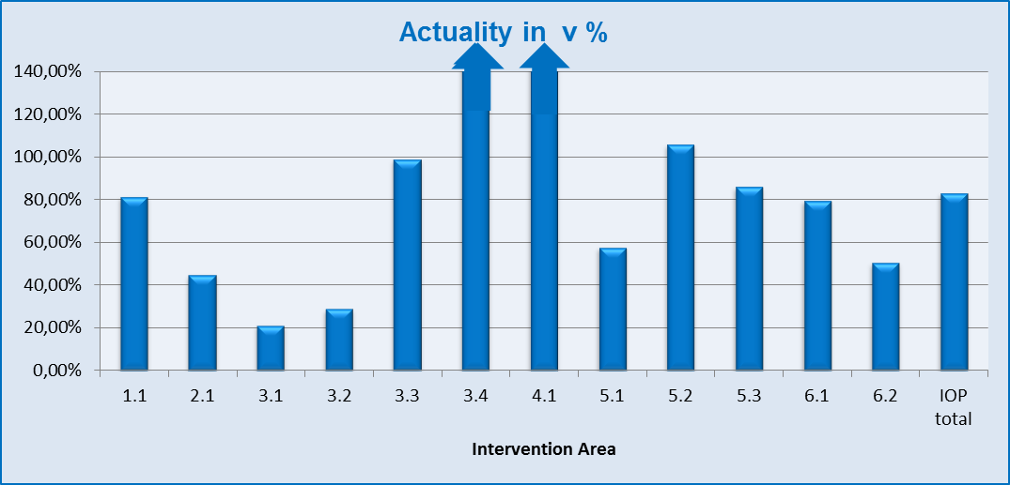
Source: IS Monit7+IOP as of 1 Apr 2014
Source of data for the forecasts: October – December: forecasts for NCA as of 4 Jul 2013, January –March: forecasts for NCA as of 4 Jan 2014

- Comparison of the forecast and the actual value of submitted applications for payment by intervention area
Priority axis / | Submitted applications for payment – forecast and actual (in EUR) EU source |  |  |  |  |  |  |  |  | Submitted applications for payment – forecast and actual (in EUR) EU source – 85% of total eligible expenditure
Intervention area | October 13 |  | November 13 |  | December 13 | SUM TOTAL (October-December | Difference between the actual and the forecast | Rate of fulfilment of the forecast |  | January 14 | February14 | March 14 | SUM TOTAL (January-March | Difference between the actual and the forecast | Rate of fulfilment of the forecast
1.1a | 3 085 418 |  | 2 890 277 |  | 1 701 959 | 7 677 655 |  |  |  | 4 121 568 | 786 279 | 1 023 152 | 5 930 999 | -1 573 899 | 73,5%
Actual | 5 107 840 |  | 492 667 |  | 1 146 678 | 6 747 185 |  |  |  | 4 146 779 | 0 | 210 321 | 4 357 100
1.1b | 237 340 |  | 222 329 |  | 130 920 | 590 589 | -71 575 | 87,9% |  | 317 044 | 60 483 | 78 704 | 456 231 | -121 069 | 73,5%
Actual | 392 911 |  | 37 897 |  | 88 206 | 519 014 |  |  |  | 318 983 | 0 | 16 179 | 335 162
2.1 | 6 917 167 |  | 2 056 851 |  | 66 940 | 9 040 958 | -6 944 571 | 23,2% |  | 3 824 325 | 1 337 260 | 0 | 5 161 585 | -891 616 | 82,7%
Actual | 1 210 034 |  | 788 789 |  | 97 564 | 2 096 387 |  |  |  | 3 824 325 | 445 643 | 0 | 4 269 969
3.1 | 2 406 549 |  | 113 900 |  | 259 183 | 2 779 633 | -2 163 082 | 22,2% |  | 201 385 | 408 809 | 1 406 091 | 2 016 285 | -1 605 150 | 20,4%
Actual | 356 972 |  | 155 327 |  | 104 251 | 616 550 |  |  |  | 184 967 | 51 991 | 174 177 | 411 135
3.2 | 12 811 572 |  | 1 262 429 |  | 120 123 | 14 194 123 | -10 950 021 | 22,9% |  | 2 816 940 | 2 557 588 | 2 269 210 | 7 643 738 | -4 556 908 | 40,4%
Actual | 1 186 060 |  | 1 269 204 |  | 788 839 | 3 244 103 |  |  |  | 2 718 975 | 255 880 | 111 975 | 3 086 830
3.3 | 8 481 305 |  | 15 066 |  | 0 | 8 496 372 | -116 700 | 98,6% |  | 0 | 0 | 1 584 528 | 1 584 528 | 34 071 | 102,2%
Actual | 0 |  | 8 379 672 |  | 0 | 8 379 672 |  |  |  | 0 | 0 | 1 618 599 | 1 618 599
3.4 | 1 072 953 |  | 0 |  | 0 | 1 072 953 | 15 277 668 | 1523,9% |  | 126 849 | 102 121 | 7 022 846 | 7 251 816 | -275 028 | 96,2%
Actual | 458 594 |  | 15 435 862 |  | 456 166 | 16 350 621 |  |  |  | 126 849 | 0 | 6 849 938 | 6 976 788
3 | 24 772 380 |  | 1 391 395 |  | 379 306 | 26 543 081 | 2 047 865 | 107,7% |  | 3 145 175 | 3 068 517 | 12 282 675 | 18 496 367 | -6 403 015 | 65,4%
Actual | 2 001 625 |  | 25 240 065 |  | 1 349 255 | 28 590 946 |  |  |  | 3 030 792 | 307 871 | 8 754 689 | 12 093 351
4.1a | 380 361 |  | 104 140 |  | 0 | 484 501 | 4 124 004 | 951,2% |  | 1 606 029 | 758 967 | 1 348 253 | 3 713 249 | -1 038 890 | 72,0%
Actual | 4 340 980 |  | 0 |  | 267 524 | 4 608 504 |  |  |  | 1 608 820 | 0 | 1 065 539 | 2 674 359
4.1b | 29 259 |  | 8 011 |  | 0 | 37 269 | 317 231 | 951,2% |  | 123 541 | 58 362 | 103 712 | 285 615 | -79 895 | 72,0%
Actual | 333 921 |  | 0 |  | 20 579 | 354 500 |  |  |  | 123 755 | 0 | 81 965 | 205 720
5.1 | 9 035 299 |  | 0 |  | 492 062 | 9 527 361 | -4 366 741 | 54,2% |  | 7 591 487 | 4 782 483 | 0 | 12 373 970 | -4 846 626 | 60,8%
Actual | 5 160 620 |  | 0 |  | 0 | 5 160 620 |  |  |  | 7 527 344 | 0 | 0 | 7 527 344
5.2 | 8 003 010 |  | 2 039 276 |  | 1 242 249 | 11 284 535 | 2 278 064 | 120,2% |  | 2 210 156 | 4 200 288 | 396 322 | 6 806 765 | -1 170 851 | 82,8%
Actual | 7 291 861 |  | 1 627 279 |  | 4 643 460 | 13 562 600 |  |  |  | 3 576 890 | 1 207 536 | 851 488 | 5 635 914
5.3 | 205 401 |  | 37 716 |  | 0 | 243 117 | -6 369 | 97,4% |  | 94 157 | 64 284 | 19 341 | 177 783 | -51 709 | 70,9%
Actual | 100 508 |  | 117 412 |  | 18 828 | 236 748 |  |  |  | 94 157 | 22 503 | 9 413 | 126 074
5 | 17 243 710 |  | 2 076 992 |  | 1 734 312 | 21 055 013 | -2 095 046 | 90,0% |  | 9 895 800 | 9 047 054 | 415 663 | 19 358 518 | -6 069 186 | 68,6%
Actual | 12 552 989 |  | 1 744 691 |  | 4 662 287 | 18 959 967 |  |  |  | 11 198 391 | 1 230 039 | 860 901 | 13 289 332
6.1a | 12 661 |  | 110 885 |  | 0 | 123 547 | 257 027 | 308,0% |  | 1 331 999 | 696 292 | 0 | 2 028 290 | -689 315 | 66,0%
Actual | 233 808 |  | 146 766 |  | 0 | 380 574 |  |  |  | 1 338 975 | 0 | 0 | 1 338 975
6.2a | 0 |  | 0 |  | 0 | 0 | 20 019 | - |  | 109 386 | 234 514 | 0 | 343 900 | -189 796 | 44,8%
Actual | 0 |  | 20 019 |  | 0 | 20 019 |  |  |  | 154 104 | 0 | 0 | 154 104
6a | 12 661 |  | 110 885 |  | 0 | 123 547 | 277 046 | 324,2% |  | 1 441 385 | 930 806 | 0 | 2 372 191 | -879 111 | 62,9%
Actual | 233 808 |  | 166 785 |  | 0 | 400 593 |  |  |  | 1 493 080 | 0 | 0 | 1 493 080
6.1b | 233 |  | 2 039 |  | 0 | 2 272 | 4 726 | 308,0% |  | 24 491 | 12 803 | 0 | 37 294 | -12 674 | 66,0%
Actual | 4 299 |  | 2 699 |  | 0 | 6 998 |  |  |  | 24 620 | 0 | 0 | 24 620
6.2b | 0 |  | 0 |  | 0 | 0 | 368 | - |  | 2 011 | 4 312 | 0 | 6 323 | -3 490 | 44,8%
Actual | 0 |  | 368 |  | 0 | 368 |  |  |  | 2 833 | 0 | 0 | 2 833
6b | 233 |  | 2 039 |  | 0 | 2 272 | 5 094 | 324,2% |  | 26 503 | 17 115 | 0 | 43 617 | -16 164 | 62,9%
Actual | 4 299 |  | 3 067 |  | 0 | 7 366 |  |  |  | 27 453 | 0 | 0 | 27 453
Forecast TOTAL |  | 52 678 528 |  | 8 862 920 | 4 013 438 | 65 554 885 | -3 270 422 |  | 95,0% | 24 501 369 | 16 064 843 | 15 252 159 | 55 818 371 | -17 072 846 | 69,4%
Actual TOTAL |  | 26 178 408 |  | 28 473 961 | 7 632 093 | 62 284 463 |  |  |  | 25 772 378 | 1 983 553 | 10 989 593 | 38 745 525
Source: IS Monit7+IOP as of 1 Apr 2014
Source of data for the forecasts: October – December: forecasts for NCA as of 4 Jul 2013, January –March: forecasts for NCA as of 4 Jan 2014
Source of funding: EU share

- Comparison of the forecast and the actual value of submitted applications for payment by ministry
IOP | Submitted applications for payment – forecast and actual (in EUR)
 | October 13 | November 13 | December 13 | SUM TOTAL | Difference between the actual and the forecast | Rate of fulfilment of the forecast | January 14 | February14 | March 14 | SUM TOTAL | Difference between the actual and the forecast | Rate of fulfilment of the forecast | Ministry
Forecast | 3 322 758 | 3 112 606 | 1 832 879 | 8 268 244 | -1 002 044 | 87,88% | 4438611,895 | 846 762 | 1 101 856 | 6 387 230 | -1 694 969 | 73,46% | MoI
Actual | 5 500 751 | 530564,2709 | 1 234 884 | 7 266 199 |  |  | 4465761,727 | 0 | 226499,785 | 4 692 262
Forecast | 10 887 855 | 128 966 | 259 183 | 11 276 005 | -2 279 782 | 79,78% | 201385,4064 | 408 809 | 2 990 619 | 3 600 813 | -1 571 080 | 56,37% | MoLSA
Actual | 356 972 | 8534998,942 | 104 251 | 8 996 222 |  |  | 184967,0423 | 51 991 | 1792775,84 | 2 029 734
Forecast | 12 811 572 | 1 262 429 | 120 123 | 14 194 123 | -10 950 021 | 22,86% | 2816940,69 | 2 557 588 | 2 269 210 | 7 643 738 | -4 556 908 | 40,38% | MoH
Actual | 1 186 060 | 1269204,463 | 788 839 | 3 244 103 |  |  | 2718975,214 | 255 880 | 111974,97 | 3 086 830
Forecast | 25 656 343 | 4 358 918 | 1 801 252 | 31 816 513 | 10 961 425 | 134,45% | 17044431,64 | 12 251 685 | 8 890 474 | 38 186 590 | -9 249 891 | 75,78% | MRD
Actual | 19 134 626 | 18139193,56 | 5 504 119 | 42 777 939 |  |  | 18402674,41 | 1 675 682 | 8858342,71 | 28 936 700
Source: IS Monit7+IOP as of 1 Apr 20140
Source of data for the forecasts: October – December: forecasts for NCA as of 4 Jul 2013, January – March: forecasts for NCA as of 4 Jan 2014
Source of funding: EU share

2.7.2.2 Approved applications for payment – forecast and comparison with the actual values

In Intervention area 1.1, the actual status of approved applications for payment exceeded the forecast value (by more than 100 %). It is obvious that the measures listed in Chapter 2.6.2.1 start to yield positive results as indicated by a marked over-fulfilment of forecasts in approved applications for payment.

The forecast of approved applications for payment in Intervention area 2.1 fails to be fulfilled due to postponements in the implementation of public contracts.
In Intervention area 3.1, a higher rate of non-fulfilment of forecasts of approved applications for payment can be seen mainly in the period from October to December 2013, which was brought about by frequent changes in projects. In the second part of the monitored period, the forecasts were fulfilled to the degree of more than 84 %, and as against the first half of the period an increase by 64 % was reported. This increase is particularly the result of acceleration of administration of applications for payment, intensive support to beneficiaries during the elaboration of the applications for payment, and cutting short the process of administration.

In terms of the forecasts and actual value of approved applications for payment in Intervention area 3.2, the Ministry of Health CR fulfils the forecasts to the degree of 92.7 %. In order to achieve a higher rate of fulfilment of forecasts, the MoH cut short the deadlines for submission of the monitoring reports and applications for payment to 10 calendar days after the completion of the stage/implementation of the project, and recommended the beneficiaries to start working on the monitoring report before the completion of a stage/project and to continuously consult it with the MoH CR.

In Intervention area 3.3, the forecasts of approved applications for payment are fulfilled to the degree of 80.1 %.

In the first part of the monitored period, from October to December 2013, the forecast of approved applications for payment was fulfilled to the degree of 47.4 %. In the second part of the monitored period, from January to March 2014, the forecast of approved applications for payment was fulfilled to the degree of 147.6 %. The stated rate of fulfilment of forecasts and absorption corresponds with the nature of projects in this IA, where the project expenditure is usually reimbursed in a lump sum only after the full completion of projects.
- Rate of fulfilment of forecasts of approved applications for payment by intervention area
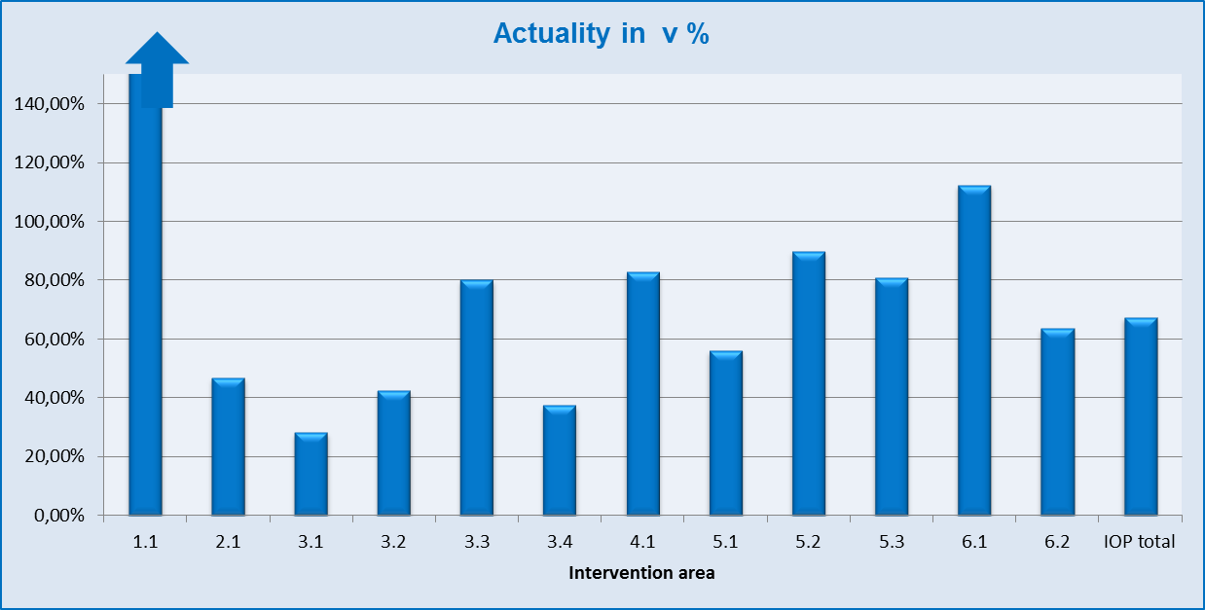
Source: IS Monit7+IOP as of 1 Apr 2014
Source of data for the forecasts: October – December: forecasts for NCA as of 4 Jul 2013, January – March: forecasts for NCA as of 4 Jan 2014

- Comparison of the forecast and the actual value of approved applications for payment by intervention area
Priority axis /  Intervention area | Approved applications for payment – forecast and actual (in EUR) - EU source |  |  |  |  |  | Approved applications for payment – forecast and actual (in EUR) - total public funds
 | October 13 | November 13 | December 13 | SUM TOTAL (October-December | Difference between the actual and the forecast | Rate of fulfilment of the forecast | January 14 | February14 | March 14 | SUM TOTAL (January-March | Difference between the actual and the forecast | Rate of fulfilment of the forecast
1.1a | 5 377 070 | 2 931 147 | 2 745 763 | 11 053 981 | 14 044 563 | 227,05% | 362611,9021 | 2 099 443 | 2 392 918 | 4 854 973 | 572 749 | 111,80%
Actual | 4 924 336 | 12170124,5 | 8 004 084 | 25 098 544 |  |  | 483482,6237 | 3 587 470 | 1356768,92 | 5 427 722
1.1b | 413 621 | 225 473 | 211 213 | 850 306 | 1 080 351 | 227,05% | 27893,22351 | 138 979 | 160 024 | 326 897 | 90 620 | 127,72%
Actual | 378 795 | 936163,4322 | 615 699 | 1 930 657 |  |  | 37190,97142 | 275 959 | 104366,841 | 417 517
2.1 | 9 082 897 | 4 275 009 | 6 917 167 | 20 275 073 | -13 836 261 | 31,76% | 49345,99767 | 615 475 | 4 157 566 | 4 822 387 | 497 855 | 110,32%
Actual | 4 227 068 | 2206493,309 | 5 251 | 6 438 812 |  |  | 65794,73435 | 973 751 | 4 280 696 | 5 320 242
3.1 | 2 000 248 | 1 093 011 | 2 406 550 | 5 499 809 | -4 380 568 | 20,35% | 56298,8346 | 231 383 | 478792,802 | 766 474 | -120 438 | 84,29%
Actual | 299 679 | 302931,0433 | 516 630 | 1 119 240 |  |  | 93831,41888 | 445 075 | 107 131 | 646 037
3.2 | 3 650 930 | 1 363 200 | 11 928 603 | 16 942 732 | -12 158 684 | 28,24% | 516564,2516 | 1 031 556 | 3196600,02 | 4 744 720 | -346 354 | 92,70%
Actual | 1 595 168 | 2 785 038 | 403 842 | 4 784 048 |  |  | 764200,9992 | 1 067 413 | 2 566 753 | 4 398 367
3.3 | 1 670 348 | 9568506,382 | 112 418 | 11 351 272 | -2 254 668 | 80,14% | 0 | 0 | 0 | 0 | 0 | -
Actual | 120 385 | 8 976 219 | 0 | 9 096 604 |  |  | 0 | 0 | 0 | 0
3.4 | 31 833 286 | 16597592,6 | 1 072 953 | 49 503 832 | -33 318 258 | 32,70% | 2478377,028 | 0 | 202 032 | 2 680 409 | 628 739 | 123,46%
Actual | 3 125 580 | 10 713 300 | 2 346 695 | 16 185 574 |  |  | 3304502,863 | 4 646 | 0 | 3 309 149
3 | 39 154 811 | 28 622 310 | 15 520 524 | 83 297 645 | -52 112 178 | 37,44% | 3051240,114 | 1 262 939 | 3 877 425 | 8 191 604 | 161 948 | 101,98%
Actual | 5 140 812 | 22777487,4 | 3 267 167 | 31 185 467 |  |  | 4162535,281 | 1 517 133 | 2673883,6 | 8 353 552
4.1a | 2 754 140 | 12 342 015 | 380 361 | 15 476 515 | -1 567 292 | 89,87% | 76862,55204 | 175 711 | 2 086 761 | 2 339 334 | -1 499 585 | 35,90%
Actual | 11 373 095 | 2536128,432 | 0 | 13 909 223 |  |  | 102483,5357 | 558 390 | 178 875 | 839 749
4.1b | 211 857 | 949 386 | 29 259 | 1 190 501 | -120 562 | 89,87% | 5912,437177 | 13 516 | 160 503 | 179 931 | -115 336 | 35,90%
Actual | 874 853 | 195 086 | 0 | 1 069 940 |  |  | 7883,346096 | 42 953 | 13759,5814 | 64 596
5.1 | 17 422 107 | 852 387 | 9 035 299 | 27 309 792 | -9 975 973 | 63,47% | 0 | 0 | 10 628 076 | 10 628 076 | -6 698 117 | 36,98%
Actual | 12 176 926 | 5156892,9 | 0 | 17 333 819 |  |  | 0 | 0 | 3929958,83 | 3 929 959
5.2 | 4 391 749 | 1 929 719 | 8 003 010 | 14 324 477 | -6 500 634 | 54,62% | 995309,3367 | 7 883 071 | 3 358 859 | 12 237 239 | 3 818 643 | 131,21%
Actual | 3 021 732 | 4769155,453 | 32 956 | 7 823 843 |  |  | 3136679,612 | 9 759 148 | 3 160 054 | 16 055 882
5.3 | 105 639 | 59 042 | 205 401 | 370 083 | -194 493 | 47,45% | 0 | 101 975 | 83 080 | 185 055 | 88 141 | 147,63%
Actual | 106 690 | 68 900 | 0 | 175 590 |  |  | 0 | 218 419 | 54 777 | 273 196
5 | 21 919 495 | 2841147,688 | 17 243 710 | 42 004 352 | -16 671 100 | 60,31% | 995309,3367 | 7 985 045 | 14070015 | 23 050 370 | -2 791 333 | 87,89%
Actual | 15 305 348 | 9 994 948 | 32 956 | 25 333 252 |  |  | 3136679,612 | 9 977 567 | 7 144 790 | 20 259 036
6.1a | 0 | 793807,9114 | 12 661 | 806 469 | 1 811 580 | 324,63% | 17540,72848 | 107 875 | 1789667,95 | 1 915 083 | -1 476 089 | 22,92%
Actual | 1 144 387 | 1 473 663 | 0 | 2 618 049 |  |  | 23387,6464 | 36 105 | 379 501 | 438 994
6.2a | 0 | 12 783 | 0 | 12 783 | 29 826 | 333,32% | 0 | 0 | 179 170 | 179 170 | -99 821 | 44,29%
Actual | 17 784 | 24 825 | 0 | 42 609 |  |  | 0 | 64 329 | 15 021 | 79 349
6a | 0 | 806591,1376 | 12 661 | 819 253 | 1 841 406 | 324,77% | 17540,72848 | 107 875 | 1968838,32 | 2 094 254 | -1 575 910 | 24,75%
Actual | 1 162 170 | 1 498 488 | 0 | 2 660 659 |  |  | 23387,6464 | 100 434 | 394 522 | 518 344
6.1b | 0 | 14595,61852 | 233 | 14 828 | 33 309 | 324,63% | 322,5185561 | 1 983 | 32906,3371 | 35 212 | -27 141 | 22,92%
Actual | 21 042 | 27 096 | 0 | 48 138 |  |  | 430,0248964 | 664 | 6 978 | 8 072
6.2b | 0 | 235,0431263 | 0 | 235 | 548 | 333,32% | 0 | 0 | 3 294 | 3 294 | -1 835 | 44,29%
Actual | 327 | 456 | 0 | 783 |  |  | 0 | 1 183 | 276 | 1 459
6b | 0 | 14 831 | 233 | 15 063 | 33 858 | 324,77% | 322,5185561 | 1 983 | 36200,7139 | 38 507 | -28 976 | 24,75%
Actual | 21 369 | 27552,46039 | 0 | 48 921 |  |  | 430,0248964 | 1 847 | 7 254 | 9 531
Forecast TOTAL | 78 913 890 | 53 007 910 | 43 060 889 | 174 982 690 | -67 307 215 | 61,53% | 4 587 039 | 12 400 966 | 28 910 252 | 45 898 256 | -4 687 968 | 89,79%
Actual  TOTAL | 43 407 846 | 52 342 472 | 11 925 156 | 107 675 474 |  |  | 8 019 868 | 17 035 504 | 16 154 917 | 41 210 288
Source: IS Monit7+IOP as of 1 Apr 2014
Source of data for the forecasts: October – December: forecasts for NCA as of 4 Jul 2013, January – March: forecasts for NCA as of 4 Jan 2014
Source of funding: EU share
- Comparison of the forecast and the actual value of approved applications for payment by ministry
IOP | Approved applications for payment – forecast and actual (in EUR)
 | October 13 | November 13 | December 13 | SUM TOTAL | Difference between the actual and the forecast | Rate of fulfilment of the forecast | January 14 | February14 | March 14 | SUM TOTAL | Difference between the actual and the forecast | Rate of fulfilment of the forecast | Ministry
Forecast | 5 790 690 | 3 156 620 | 2 956 976 | 11 904 287 | 15 124 914 | 227,05% | 390505,1256 | 2 238 422 | 2 552 942 | 5 181 869 | 663 369 | 112,80% | MoI
Actual | 5 303 131 | 13106287,93 | 8 619 782 | 27 029 201 |  |  | 520673,5952 | 3 863 429 | 1461135,76 | 5 845 239
Forecast | 3 670 596 | 10 661 518 | 2 518 967 | 16 851 081 | -6 635 237 | 60,62% | 56298,8346 | 231 383 | 478 793 | 766 474 | -120 438 | 84,29% | MoLSA
Actual | 420 065 | 9279149,582 | 516 630 | 10 215 844 |  |  | 93831,41888 | 445 075 | 107130,912 | 646 037
Forecast | 3 650 930 | 1 363 200 | 11 928 603 | 16 942 732 | -12 158 684 | 28,24% | 516564,2516 | 1 031 556 | 3 196 600 | 4 744 720 | -346 354 | 92,70% | MoH
Actual | 1 595 168 | 2785038,289 | 403 842 | 4 784 048 |  |  | 764200,9992 | 1 067 413 | 2566752,69 | 4 398 367
Forecast | 65 801 674 | 37 826 572 | 25 656 343 | 129 284 590 | -63 638 209 | 50,78% | 3623670,599 | 8 899 605 | 22 681 917 | 35 205 192 | -4 884 546 | 86,13% | MRD
Actual | 36 089 483 | 27171996,06 | 2 384 902 | 65 646 381 |  |  | 6641161,762 | 11 659 587 | 12019897,6 | 30 320 646
Source: IS Monit7+IOP as of 1 Apr 2014
Source of data for the forecasts: October – December: forecasts for NCA as of 4 Jul 2013, January – March: forecasts for NCA as of 4 Jan 2014
Source of funding: EU share

2.8 Analysis of Risks in Relation to Future Progress in Programme Implementation

The IOP MA coordinates the management of risks faced by the IBs and MA in IOP implementation. It shares the information with the NCA in the form of a summary report on IOP risk management, namely always following the approval of the Catalogue of IOP Risks. It continuously monitors the measures adopted to eliminate the risks, and their effectiveness.

The most significant risks related to programme implementation and the implemented and proposed measures to eliminate them are summarised in the table below.

Name of the risk | Description of the risk | Measures implemented to eliminate the risk and risk development | Proposed measures to eliminate the risk in the future
Non-adherence to the Agreements on delegating activities to IBs and Binding procedures pursuant to the IOP OM and IB manuals.  Failure to observe the deadlines set in guidance documents. | The non-compliance with the stipulated MA procedures can have serious implications for programme implementation. It can result in improper decisions, disputes and complaints.  The failure to meet the set procedures compromises the planning of follow-up activities and complicates financial management of the programme. It results in errors made in the programme and the failure to fulfil the forecasts. It can lead to additional costs at beneficiaries. | Starting from 1 Oct 2013, 26 checks of delegated activities were planned, of which 13 were commenced, 13 were completed, of which 7 with no finding and 6 with a finding. | To verify the observance of agreements and conduct of delegated activities of IBs, to impose remedial measures and to monitor their fulfilment.To that end to carry out at least 4 checks of delegated activities in each IB in line with the focus stated in the Annual plan of controls of IOP MA. To use oexternal assistance in the field of controls of physical implementation of projects through the NCA project (to request its relaunch),  to continue to use expert assistance in the field of performance of controls of delegated activities.
 |  | External assistance through the NCA project called “Controls” is used . 4 opinions were drawn up , 7 controls were carried out and 3 opinions elaborated under another framework agreement. | Use of externnal assistance in control of physical implementation of projects through the NCA project (to request its relaunch),  To continue to use expert assistance in the field of performance of controls of delegated activities.
 |  | Description of activities were specified with the view to simplify administration. | To focus on specifying and simplifying descriptions of the performance of activities and removing redundant and duplicate steps.
Insufficient audit trail | Incomplete procedures for retaining information and documentation, absence of or non-adherence to the binding procedures of archiving documents and audit trail, a failure to enter the data in information systems.  Insufficient documents of handing over the agenda between the officers and also between the implementation bodies.  E-mail correspondence not appropriately archived.  A risk of loss of important documents. | Setting out and adhering to the archiving procedures and safeguarding the audit trail was reflected in the guidance documents of IBs. | To verify the observance of procedures of archiving and ensuring the audit trail as a part of on-the-spot checks of delegated activities in proportion to the subject of the check. To obligatorily include the check of completeness, accuracy and timeliness of data entered into IS Monit in the checks of delegated activities.
Lack of submitted quality projects | The failure to fully absorb is  one of the main risks faced  by the programme, which  may be the consequence of  multiple other risks:  - delays in publishig of calls,  - delays in project implementation (postponing the stages and completion of projects),  - problematic management of risky and sleeping projects,  - insufficient administrative capacity,  - errors in project implementation,  - deficiencies in project management and non-compliance with the timetable,  - a risk ensuing from the CZK/EUR exchange rate fluctuations (incorrect forecast of absorption capacity),  - irregularities,  - errors in project administration,  - ineligible expenditure,  - loss of allocation due to non-fulfilment of n+2 rule. | Pursuant to Government Resolution No 144 of 5 Mar 2014, works on the preparation of Analysis of absorption of the European Funds and crisis plans were launched. The Minister for Regional Development on behalf of the MRD regularly, as at the last day of the month, submits information to the Government. | To prepare measures preventing the loss of allocation and measures for addressing the potential loss.
 |  | Updating and publishing of the timetable of calls is done in accordance with Government Resolution No 144 of 5 Mar 2014, the works on the preparation of Analysis of absorption of the European Funds and crisis plans were launched. | To continue to implement measures with an emphasis laid on clarity and unambiguity of documents for the call, and a timely preparation of the call.
 |  | Monitoring and evaluating the absorption capacity is done in accordance with Government Resolution No 144 of 5 Mar 2014, the works on the preparation of Analysis of absorption of the European Funds and crisis plans were launched. | To continue to implement measures. To set priorities for administration.
 |  | Absorption forecasts are monitored and evaluated in accordance with Government Resolution No 144 of 5 Mar 2014. The works on the preparation of Analysis of absorption of the European Funds and crisis plans were launched. | To continuously monitor and evaluate the absorption forecasts and their fulfilment (monthly).
 |  | In November 2013, 2 seminars for managers and 1 seminar for beneficiaries under IA 5.2 were held, in March 2014 a seminar for applicants under IA 3.4 took place. | To continue to implement the measure with attention paid to the simplification of requirements for applicants and beneficiaries in the Handbook for applicants and beneficiaries and in calls.
 |  | Frequently addressed or mistakenly addressed situations were continuously published on the IBs' websites. | To check the updatedness of published FAQ.
 |  | In March, a document Ref No 9044/2013-26- on problematic projects of IOP was submitted to the Government | To identify sleeping projects and to lay down the procedure to accelerate the project implementation or its withdrawal so that the released allocation can be used.
Failure to fulfill the monitoring indicators of IOP | A failure to achieve the planned values of monitoring indicators may result in financial corrections.  A failure to achieve the indicative targets measured by result indicators may lead to problems in programme closure. According to the Report on Implementation as of 31 Mar 2014, it concerns the following indicators: IA 4.1b indicator No 413320 “Number of newly classified and certified entities operating in tourism“  IA 3.2 (activity 3.2c)  Indicator No 80704 “Number of programmes introducing the standards and standard procedures for quality and cost management“ | Internal analysis of the MA aimed to determine the achieved values of monitoring indicators and to identify the causes of erroneous values. The indicator with an unclear way of measurement was revised. | To utilise the up-to-date version of the document “Analysis of full absorption of IOP“, or documents such as the “crisis action plan“ for publishing of calls, exploitation of projects from the pipeline and other measures.
 |  | Internal analysis of the MA to determine the achieved values of monitoring indicators and identification of causes of erroneous values.  Revision of indicators with unclear way of measurement was conducted. | To use the current version of the “Analysis and full absorption of IOP”, or the documents such as “Crisis action plan” for the publishing of calls, releasing projects from the pipeline, and other measures.
 |  |  | To verify the status of fulfilment of result indicators according to the Report on Implementation as of 31 Mar 2014.
Ineffective check of economy and efficiency of expenditure | Insufficient legislation and non-existence or unclear way of checking the effectiveness, efficiency and economy of expenditure. Difficult setting of prices usual for the assessment of economy in projects.  Insufficient exploitation of information from the application for support and progress of implementation for the 3E evaluation. | The specifications and modifications were reflected in guidance documents of IBs in the second half of 2013. | To use information from the final reports from evaluations, controls and audits for control of effectiveness, efficiency and economy or for setting the procedures and methods for their monitoring.
 |  | Outsourcing of experts is used for the evaluation and proposals in the field of 3E. | To conduct the 3E evaluation primarily during the assessment of project applications, to use this information for revision of procedures for controls of public contracts and eligibility of expenditure with respect to effectiveness, efficiency and economy. Another aim is to assess the necessity of potential additional specifications in checklists.
Violation of rules governing the award of public contracts | Violation of rules governing the award of public contracts represents one of the most frequent errors in project implementation and the largest volume of ineligible expenditure. Assessment of correctness of the procedure in the award of public contracts by the Office for the Protection of Competition may cause major delays in project implementation since it can take a few months before the OPC opinion is issued. No control of all the contracts is done prior to the award of the public contract, errors and irregularities impacting the absorption and error rate of the programme are not discovered in time. According to the findings of the system audit of 2013, the prevaling part of errors is identified in tender documentation (discriminatory criteria, measurability of criteria for the award of the contract) and in erroneous evaluation procedures. | Conducted checks of control procedures.  IOP MA, except for checks of delegated activities in public contracts performs also the checks of projects, during which the correctness of the procedure pursued by the IB during the evaluation of the public contract is verified. | Measures to increase the risk shall focus primarily on the stage of preparation and approval of tender documentation.  Checks of delegated activities at all IBs shall concentrate on procedures pursued during the controls of public contracts and on their observance.
 |  | It was accomplished, proposals for modifications were forwarded within the comment procedure concerning the Methodology of financial flows and controls. | To evaluate the impact of the measure on the scope of violation (in the framework of controls).
 |  | In accordance with Government Resolution No 144 of 5 Mar 2014, the IOP MA provides weekly update of information to the Deputy Minister for Regional Development. Unit 264 keeps records of public contracts in IOP projects investigated by the OPC. | To continue to implement the measure.
 |  | The checklists of the European Commission were incorporated in the programme documents. | To evaluate the effectiveness and usability of checklists.
 |  | Training of controllers, sharing the examples of best practice, activity of the Working Group for public contracts.  5 in-house training courses were held that were attended by 29 persons, 15 outsourced training courses were attended by 45 persons. | To include the topic of the amendment to the Public Procurement Act in the system of IOP education. To continue to implement the measure.
A failure to absorb the allocation for JESSICA FI | Implementation of JESSICA FI is preconditioned by a transfer of allocation to the users' accounts before the end of 2015. The timely provision of the loan is at risk. | The MA continuously monitored the individual steps of SHDF in preparation of the financial instrument. | To continuously monitor the onset of absorption of the financial instrument.
Major projects were not approved by the EC in 2013 | Following the changes in the PD – reconsideration and reallocation of funds in priority axes, the failure to have the major projects approved would result in a loss of allocation. | MA coordinated the preparation of applicants and organised an extraordinary meeting of IOP MC with the view to approve the revision of IOP PD, and approved the submission of applications for major projects to the EC.  MA in cooperation with applicants prepared explanatory information in response to the EC letter requiring additional information. | Together with major project holders to continuously monitor the observance of the set out timetables aiming at settling the EC enquiries.

2.9 Foreseen Timetable of the Announcement of Calls

In accordance with Government Resolution No 536/2008, in the course of April the Structural Funds Department of the MoI CR plans to publish call No 17 Strategic projects for Intervention area 1.1a, 1.1b. – Developing information society in public administration, namely in the volume of CZK 650 million. In the second half of April 2014, the MRD CR plans to publish call No 24 for Intervention area 5.1 in the volume of at least CZK 400 million.

An overview of ongoing calls of IOP is available on: http://www.strukturalni-fondy.cz/cs/Jak-na-projekt/Prehled-otevrenych-vyzev-%e2%80%93-archiv (overview of open calls).

2.10 Overview of Approved Projects

The list of supported projects and beneficiaries is updated by the MA at a monthly interval and published on the website: http://www.strukturalni-fondy.cz/cs/Microsites/Integrovany-OP/Zadatele-a-prijemci/Seznam-podporenych-projektu

More detailed information on approved projects is derived from IS Monit7+ and made available on www.risy.cz portal run by the Centre for Regional Development of the CR, which also facilitates the search for individual projects based on various parameters.

In accordance with amendment to Act No 218/2000 Coll. on budgetary rules, the providers of support shall transmit the data on project applications submitted after 1 Aug 2012 to the publicly accessible DOTINFO information system (www.dotinfo.cz), where the MA and IBs register the required data.

Information on rejected projects

The Chart No 20 gives the number and share of rejected projects by individual stage of administration.

- Percentage of rejected projects by intervention area
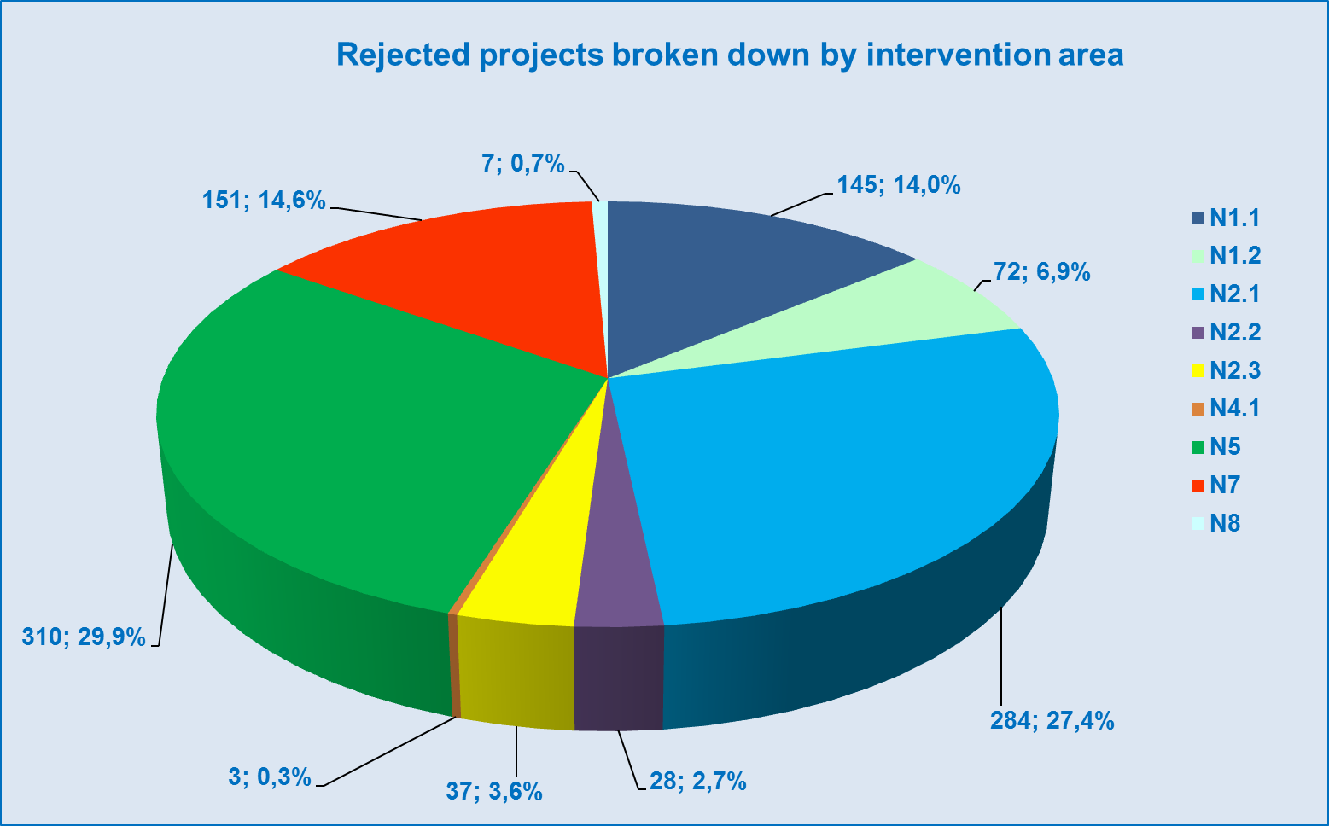
Source: IS Monit7+ as of 1 Apr 2014

N1.1 Project application failed to meet at least one of the eligibility criteria
N1.2 Project application failed to meet formal requisites
N2.1 Project failed to meet evaluation requirements
N2.2 Letter on rejection of project application based on ex-ante check was sent
N2.3 Project was not recommended for financing by the Selection Committee
N4.1 Issuance of Decision on providing a grant/Statement of expenditure was denied
N5 Project application was withdrawn by the applicant
N7 Project was not completed/project was withdrawn
N8 Contract was terminated by the MA/IB

- Rejected projects by status
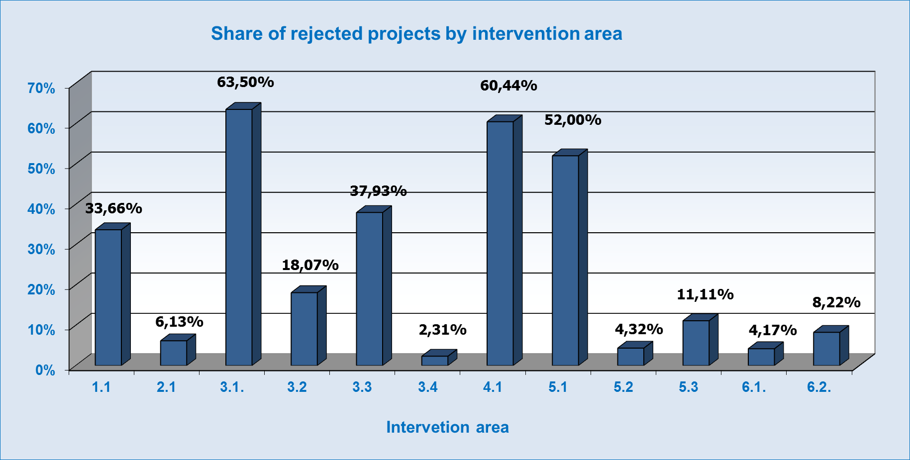
Source: IS Monit7+ as of 1 Apr 2014

In Intervention area 1.1, the largest share of rejected projects concerns the high-risk or sleeping projects. In the monitored period, 3 projects were withdrawn from implementation, of which one was for a long time registered as a high-risk project.

Additional 4 projects, submitted under the call No 16, were withdrawn from implementation prior to the issuance of guidance documents. The released funds were allocated to the prepared call No 17.

Rejection of majority of projects in Intervention area 2.1 relates to public procurement issues. The beneficiaries declare that the tender could not be completed within the deadline or at all due to obstructive behaviour of some bidders. Another issue is the lengthy investigation at the Office for the Protection of Competition.

Since the beginning of publishing of calls in Intervention area 3.1, cumulatively 301 projects of the total of 474 submitted project applications have been rejected, which represents 63.5 %. As compared to the previous monitored period, there was an increase by 34 rejected projects. The most frequent reason for rejection of the application is the failure to meet the evaluation requirements (40 %). In the monitored period the number of project applications rejected for not meeting the evaluation requirements grew by 25. The highest share of rejected applications is reported by activity 3.1 c). It is caused primarily by underestimating the time necessary for implementation of individual activities of the project, inappropriate description of the financial part of the project, risk of a failure to ensure the project sustainability, and insufficient description of experience from work with the target group. In spite of intensive communication between the MoLSA CR and individual applicants, the number of rejected applications did not significantly decrease. Another reason for rejection, constituting 11.4 % of rejections, is the project withdrawal by the applicant. In the monitored period the number of applications rejected for this reason rose by 1 %, 5 project applications were withdrawn by the applicants.

In Intervention area 3.2, the number of projects in negative status since the beginning of the programming period is 45 projects, which represents 18.07 % of the total number of 249 projects. In the monitored period, 1 project in negative status was identified, which was not recommended for financing by the Selection Committee under the 16th call. The Selection Committee found the content of the project relevant, recommended that the project is redrafted and submitted again in the next call.

In Intervention area 3.3, 29 projects have been submitted ever since the beginning of publishing of the calls, of which 11 project applications have been rejected, 1 project has failed to meet the eligibility criteria, 6 project applications have been rejected for not meeting the evaluation requirements, which represents 21 % of submitted project applications. It concerned projects in activity 3.3 c). The total share of rejected applications in the total number of submitted projects is 38 %.
In the monitored period, from 1 Oct 2013 to 31 Mar 2014, 2 projects were rejected. One of them is the project in activity 3.3 c) Information and education centre of Karlovy Vary Region, which was withdrawn by the applicant on 9 Jan 2014, and another project which was not completed is the project in activity 3.3 a) and b) – LO CR Olomouc.
In Intervention area 3.4, no project was rejected in the monitored period.
Intervention area 4.1 has for a long time shown a high share of rejected projects. The most frequent reason for project rejection is the failure to meet the evaluation requirements. In the monitored period, no project submitted under the continuous call for IA 4.1 was rejected.
The share of rejected projects in Intervention area 5.1 is the third highest. This was brought about mainly by rejection of projects from the 1st continuous call of the MoC CR. In the monitored period, one project was withdrawn by the beneficiary, namely the project CZ.1.06/5.1.00/03.08093 Stone and light – revitalisation of the interior of the church of Saint Barbara in Kutná Hora, with the total eligible expenditure amounting to CZK 153 million. No call was published and no project withdrawn in the monitored period.

The percentage of rejected projects in Intervention area 5.2 is 4.32%. It is an acceptable percentage. The most frequent reason for project rejection is the applicant's withdrawal of the project on account of the failure to secure co-financing.

In Intervention area 5.3, altogether 78 projects were withdrawn in the monitored period, of which 30 project applications failed to meet the eligibility criteria, 21 project applications were rejected based on the ex-ante check which revealed an error in the contract award procedure, 14 project applications were withdrawn by the applicant (the applicants corrected the errors in project application and some of them submitted the redrafted application again), 5 projects were not completed, and 3 project applications failed to meet formal requisites. In 5 projects, funds were not paid to beneficiaries after the project implementation on the grounds of a conducted interim control, which revealed a non-compliance with public procurement legislation, or due to the failure to complete the project within the deadline set by the call (status N8 Contract was terminated by the MA/IB).

2.11 Progress in the Implementation of Financial Instruments

Under the Integrated Operational Programme, a pilot testing is under way of JESSICA financial instrument for support of regeneration of residential buildings with the total allocation of CZK 609 869 489. A part of the allocation can, in dependence on absorption capacity, be used to build modern social housing by regenerating the existing apartments.

Implementation

The implementation structure of JESSICA FI in IOP is composed of the IOP Managing Authority (hereinafter referred to as the “IOP MA“), the Holding Fund of the State Housing Development Fund (hereinafter referred to as the “HF SHDF“), and the Administrator of the Urban Development Fund (hereinafter referred to as the “Administrator”). The IOP MA is responsible for the overall management and control of operations during the implementation of JESSICA FI. The HF, as a separate accounting unit of the SHDF, was set up in accordance with Article 44 of Council Regulation (EC) No 1083/2006. The Administrator shall be a financial institution selected in a contract award procedure advertised by the HF SHDF, and shall accomplish the tasks defined in the Contract on the administration of funds (hereinafter referred to as the “Contract”), concluded with the HF SHDF.

In the monitored period, major progress was achieved in the implementation of this financial instrument in IOP. The winner of the repeated contract award procedure for the UDF Administrator was Komerční banka, a. s. (hereinafter referred to as “KB“). The contract on administration of funds between the SHDF and KB was signed on 31 Oct 2013, by which the implementation structure of JESSICA FI in IOP was completed. In accordance with the signed Contract, the Administrator has drawn up the Business plan of UDF, setting out the internal processes of the Administrator leading to the provision of soft loans from JESSICA FI. The submitted Business plan of UDF was commented upon and finalised and on 20 Dec 2013 approved by the IOP MA.

On 7 and 13 Nov 2013, another round of seminars for IUDP managers in IOP took place in Prague and Olomouc, on the occasion of which the representatives of IOP MA, HF SHDF and KB spoke about the implementation of JESSICA financial instrument. The managers were informed about the state of play of the project and introduced to the selected UDF administrator, and had an opportunity to ask questions and raise comments.

On 21 Jan 2014, the Administrator launched the receipt of applications for soft loans from JESSICA FI. Information of the launch of receipt of applications was made public through a press release published together with the SHDF. The IOP MA posted the information on the launch of receipt of applications under JESSICA FI on the MRD CR website and it was also published in “IOP pod lupou“ quarterly. Before 31 March 2014, the UDF Administrator received 13 applications for a loan in the total amount of almost CZK 83 million. The loan agreement was signed with two applicants for a total of CZK 6.2 million, no application was rejected as yet.

Monitoring

In the monitored period, the HF SHDF forwarded two quarterly monitoring reports to the IOP MA. The IOP MA checked among other things also the eligible expenditure and all the tenders. Based on the monitoring reports, the IOP MA continuously follows the absorption of allocation and elaborates the risk analysis.

At the end of February and at the beginning of March 2014, key changes in staffing occurred at the SHDF. The newly appointed Minister for Regional Development, Mgr. et Mgr. Věra Jourová with effect from 27 Feb 2014 revoked the mandate of Ing. Miroslav Kalous acting as the Head of the SHDF and with effect from 28 Feb 2014 appointed JUDr. Ing. Eva Helclová to act as the Director of the SHDF. The new Director of the SHDF by Decision No 2/2014 with effect from 2 Mar 2014 removed Ing. Miroslav Beneš from his office of the Director of the HF SHDF and with effect from 3 Mar 2014 appointed Ing. Michal Pluta.

Documents

In the course of the monitored six months, the MA made two revisions of the Manual for the implementation of JESSICA financial instrument (hereinafter referred to as the “Manual“). The first revision consisted primarily in adding new annexes to the Manual and updating of the list of approved IUDPs, whereas the second revision of the Manual took place at the beginning of the year in relation to the applicability of the amendment to the Public Procurement Act. In the monitored period, the IOP MA also issued two methodological guidelines concerning the update of annexes to the Manual, which did not require an immediate revision. The methodological guidelines were incorporated in the following revisions of the Manual.
On 10 Feb 2014, the IOP MA following two rounds of comments, approved the modified proposal for the Management and control system of the HF submitted on 7 Jan 2014, which responded to the inclusion of KB in the implementation structure of JESSICA FI.

Summary

From the date of approval of inclusion of JESSICA FI in Intervention area 5.2 of IOP with the use of reallocation from OPTA on 31 May 2011 to the launch of receipt of applications for soft loans from this instrument on 21 Jan 2014, almost 32 months elapsed. 18 months elapsed from the commencement of preparation of tender documentation for the tender for the UDF Administrator on 5 Apr 2012 to signing of the Contract with the winner of the tender on 31 Oct 2013. The tender for the Administrator as such took 8 months, starting from the publishing of the tender on 28 Feb 2013, via repeatedly held tender due to legislative reasons, until its successful closing by signing the Contract with the winner on 31 Oct 2013. Until now, two months after the launch of receipt of applications was announced, the Administrator has received applications totalling around 15 % of the total allocation and an additional increase in the number of applications is by the HF SHDF anticipated in April.

3 PROGRESS AT THE LEVEL OF PRIORITY AXIS

The IOP MA monitors the commitments of approved projects and the values of monitoring indicators achieved as of 31 Mar 2014. The commitments are calculated from the target values of projects starting with status P4.1 in IS Monit7+ (Project with issued Decision/Statement of expenditure). The achieved values are calculated based on projects starting with status P4.5 in IS Monit7+ (Project under implementation), with the exception of the “Number of projects” type of indicators, in which the values are aggregated starting with status P5 (Project implementation was completed). The baseline values from 2005 are taken over from the Programming Document.

The charts “Comparison of physical and financial progress by individual intervention area” give the comparison of physical and financial progress. The violet bar expresses the commitment of approved projects, i.e. the total target value of the indicator, which is stated by beneficiaries in their applications and which the beneficiaries undertake to fulfil by project implementation, it is expressed in % of the total value set in the IOP Programming Document and the same value is given in the tables of indicators. The blue bar covers the funds of projects for which the Decision on providing a grant is issued, expressed as a percentage of the allocation for the activity under which the relevant indicator falls.

3.1 Priority axis 1a, 1b – Modernisation of public administration

3.1.1 Focus of priority axes/intervention areas

Priority axes 1a and 1b aim to achieve faster and more reliable provision of state administration services to the public, and, by implementing electronic administration, to enable citizens and business entities to communicate simply and quickly with state administration authorities.

Specific goals:

- To improve the level of services of electronic public administration (eGovernment)
- To increase the use of the Internet by citizens for communication with public administration
- To reduce the administrative burden of citizens, entrepreneurs and public sector

Supported activities:

- Creation, development and maintenance of national basic and other relevant registers of the public administration, including safe and protected access system,
- Construction of public administration communication infrastructure,
- Creation of access points for communication with the public administration information systems,
- Computerisation of public administration services.

Beneficiaries:
  - Government agencies and semi-budgetary organisations established by them.

3.1.2 Progress achieved in implementation of priority axes/intervention areas
In Intervention areas 1.1a and 1.1b, implementation of 3 projects was successfully completed. In two, for a long time unresolved projects, the implementation was terminated (cassation proceedings at the Supreme Administrative Court was closed, the administrative proceedings at the OPC was closed). The administration of the applications for payment concerning the key tenders for basic register projects was completed.

Sleeping, high-risk and risky projects falling under the MoI CR budgetary chapter were more closely monitored. The MoI CR IB and management of individual projects are requested to provide regular as well as ad hoc reports on the state of play of activities of projects, absorption of funds, physical and temporal consistency across all the ministerial projects, including the verification of compliance of information with the data on projects administered by the MoI CR IB.
The MoI CR IB in relation to launch of preparation for the busy period starting in June 2014, when submission of a larger number of applications for payment is anticipated, follows for a long time adopted procedure to reduce the error rate and to cut short the duration of administration of applications for payment and monitoring reports.

- Cumulative progress at the level of Intervention area 1.1a and 1.1b (in million CZK/EUR)
1.1a | 2007-2013 allocation |  | Submitted applications |  |  |  | Projects with issued Decision/signed Contract |  |  |  | Funds paid to beneficiaries |  |  | Funds included in aggregate payment claims accounted for by the PCA |  |  | Certified expenditure submitted to the EC
 | CZK (a) | EUR | num-ber | CZK (b) | % (b/a) | EUR | num-ber | CZK (c) | % (c/a) | EUR | CZK (d) | % (d/a) | EUR | CZK (e) | % (e/a) | EUR | CZK (f) | % (f/a) | EUR
Current MC | 7640,78 | 290,94 | 101 | 10347,87 | 135% | 377,34 | 68 | 6446,26 | 84% | 235,07 | 4115,03 | 54% | 150,06 | 4066,69 | 53% | 160,61 | 3920,80 | 51% | 155,13
Previous MC | 7890,97 | 310,60 | 101 | 10347,87 | 131% | 377,34 | 67 | 6353,75 | 81% | 231,69 | 3300,37 | 42% | 120,35 | 2859,19 | 36% | 114,74 | 2113,45 | 27% | 85,67
1.1b | 2007-2013 allocation |  | Submitted applications |  |  |  | Projects with issued Decision/signed Contract |  |  |  | Funds paid to beneficiaries |  |  | Funds included in aggregate payment claims accounted for by the PCA |  |  | Certified expenditure submitted to the EC
 | CZK (a) | EUR | num-ber | CZK (b) | % (b/a) | EUR | num-ber | CZK (c) | % (c/a) | EUR | CZK (d) | % (d/a) | EUR | CZK (e) | % (e/a) | EUR | CZK (f) | % (f/a) | EUR
Current MC | 587,75 | 22,38 | 0 | 795,99 | 135% | 29,03 | 0 | 495,87 | 84% | 18,08 | 316,54 | 54% | 11,54 | 312,82 | 53% | 12,35 | 301,60 | 51% | 11,93
Previous MC | 607,00 | 23,89 | 0 | 795,99 | 131% | 29,03 | 0 | 488,75 | 81% | 17,82 | 253,87 | 42% | 9,26 | 219,94 | 36% | 8,83 | 162,57 | 27% | 6,59
Source: Current MC – MSC2007 as of 3 Apr 2014
Previous MC – MSC2007 as of 2 Oct 2013
CZK/EUR exchange rate: Current MC – 27.423
Previous MC – 25.690
Source of funding –public funds total

Overview of ongoing calls

In Intervention area 1.1a and 1.1b no call was under way in the monitored period.

3.1.3 Fulfilment of indicators

The data on fulfilment of indicators are set as at the date of completion of project implementation. In ratio indicators the resulting value is the average of values stated by beneficiaries in their final monitoring reports. The numerical indicator No 150106 gives the sum total of the achieved target values determined in projects.

In ratio indicators, the target value oscillates at the time of completion of projects. It is caused by the way it is calculated, the number of completed projects increases and the sum total of target values of individual projects does not grow evenly.

Indicator No 150106 “Number of created basic registers of public administration” - The original target value of the indicator was set at 4. The creation of basic registers in line with Act No 111/2009 Coll. necessitated the setting up of the information system of basic registers (ISZR), which helped increase the awareness of citizens, entrepreneurs and institutions of basic registers of public administration and their access thereto. This project was approved and is now completed. For this reason the original value grew to the current value of 5.

Indicator No 150112 “Share of digitized documents” - The indicator is being fulfilled by 5 projects, of which three are in status P7 and the reported values are 100; 45 and 1 %. The resulting value as of 2 Apr 2014 is 48.67 %.

Indicator No 150113 “Share of authorities with electronic records management system and electronic document circulation” - The achieved value as of 2 Apr 2014 is 51%.

Indicators No 150109, 150110, 150111, 150112 and 150113 - The allocation to Intervention area 1.1 is fully committed in issued guidance documents. The applicants could choose any of the indicators, therefore some of the indicators are being fulfilled by more projects, which brought about an increase in the total amount allocated to the fulfilment of the target value of the given indicator.
The values in column “Projects with issued Decision/Statement of expenditure” in the Chart No 22 in indicators 150109, 150110 and 150111 thus exceed 100 %. On the very contrary, in indicator No 150112, which is less often chosen by the applicants, the financial allocation to this indicator has not been absorbed.

On the other hand, the values of physical progress are lower since the target values were set by applicants in individual projects.

Indicator No 152105 “Reduction of administrative burden of citizens, entrepreneurs and public sector”
The indicator is being fulfilled by fourteen projects. Twelve of the projects have already reported the achieved value in the monitoring reports. Two more projects will be completed in 2014 and 2015. The allocation is evenly absorbed.

Physical progress – the applicants will not achieve the target value of the indicator. The contribution of projects to reducing the administrative burden will be lower than expected at the time when the target value was set.

- Output indicators
Code | Name of the indicator | Unit of measurement | Baseline value | Target value | Commitment of approved projects  CONV | Commitment of approved projects RCE | Value achieved as of  2 Apr 2014
150106 | Number of created basic registers of public administration | Number | 0 | 4 | 5 | 5 | 5
150109 | Share of registers connected to central registers | % | 0 | 75 | 21,40 | 21,40 | 11,63
150110 | Share of authorities using the shared CIPA | % | 0 | 80 | 18,85 | 18,85 | 25,78
150111 | Share of ministerial and agenda portals interconnected to the Public Administration Portal | % | 19 | 75 | 59,80 | 59,80 | 75,00
150112 | Share of digitized documents | % | 0 | 20 | 26,62 | 26,62 | 48,67
150113 | Share of authorities with electronic records management system and electronic document circulation | % | 20 | 100 | 71,00 | 71,00 | 51,00
Source: MSC2007 as of 3 Apr 2014
* Indicator No 150108 is not monitored

- Result indicators
Code | Name of the indicator | Unit of measurement | Baseline value | Target value | Commitment of approved projects  CONV | Commitment of approved projects RCE | Value achieved as of  2 Apr 2014
152105 | Reduction of administrative burden of citizens, entrepreneurs and public sector | % | 100 | 75 | 89,5 | 89,5 | 92,67
Source: MSC2007 as of 3 Apr 2014

In the “Comparison of physical and financial progress” charts the violet bar expresses the commitment of approved projects, i.e. the total target value of the indicator, stated by beneficiaries in their applications for support and expressed in % of the total value set in the IOP Programming Document, the same value is given in the tables of indicators. The blue bar covers the funds of projects for which the Decision on providing a grant is issued, expressed as a percentage of the allocation for activity under which the relevant indicator falls.

- Comparison of physical and financial progress in intervention area 1.1
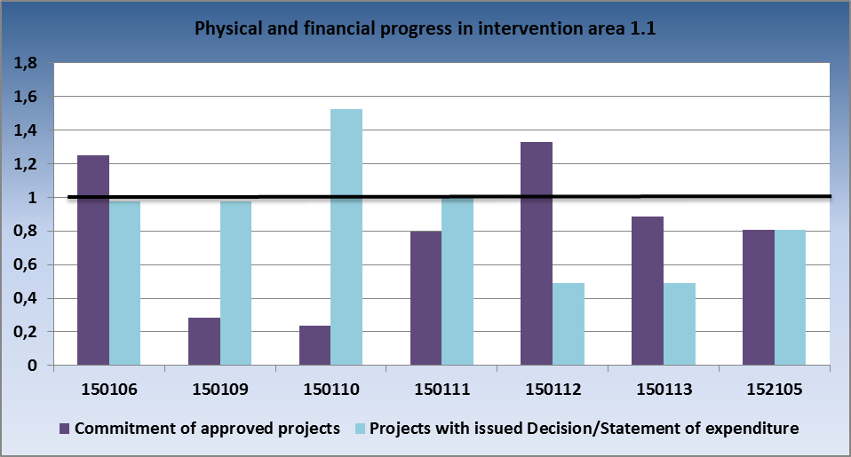
Source: IS Monit7+ as of 1 Apr 2014

3.1.4 Problems and measures taken

Problem
Sleeping, high-risk and risky projects
In Intervention area 1.1 there are still projects that face difficulties in implementation, resulting in delays in the timetable and subsequently in a failure to fulfill the financing plan and to absorb the allocated funds.

Measures taken
In the course of the monitored period, the MoI IB continued to apply measures adopted in 2012 based on the meetings of the WG for evaluation of projects convened under the auspices of the Deputy Minister of Interior for Financial Affairs and Operations, who is responsible for the IOP Intermediate Body – the MoI Structural Funds Department. Close attention continued to be paid to sleeping and high-risk projects to which large amounts of funds have been committed, however not yet absorbed.

The MoI IB adopted and applied measures arising from a long-term and thorough monitoring of the reported status of individual sleeping, high-risk or risky projects. Within the monitoring, attention was paid to the issues faced by individual projects and to potential risks ensuing from them (especially for the planned absorption), and to a summary of particular measures to address them, including the foreseen deadlines for their resolution. It also contained information on activities that should result in a change in the project status (including activities of technically and physically interlinked projects). Moreover, the crisis timetables were set and their observance was checked, regular monthly meetings of the working teams (the so called task force) took place, which e.g. at the time of approaching closure of a stage focused on the specification of requirements related to the elaboration of the application for payment and the monitoring report, etc. Ranking among other measures is the organisation of bilateral meetings at the level of directors and tripartite meetings attended by the IOP MA representatives as well as forwarding information to top officials of the MoI CR or representatives of projects.

The MoI CR IB, with the support of the IOP MA, sought to ensure the maximum acceleration of the absorption of allocation or withdrawal of sleeping projects from implementation so that the funds could be possibly more effectively used in other projects, not only in Intervention area 1.1 administered by the MoI CR IB.

At the end of 2013 and at the beginning of 2014, three problematic projects in the total value exceeding CZK 440 million were withdrawn from implementation. At the same time, additional 4 projects, submitted in the 16th call, totalling more than CZK 575 million were withdrawn in the course of evaluation or immediately after.

Problem
Low absorption of funds, the risk of non-fulfilment of n+3/n+2 rule
In the course of project implementation, the beneficiaries often moved the planned funds to next periods and at the same time applied for an extension of the deadlines for completion of project implementation. It means that the actual volume of submitted and thus also approved applications for payment is often lower than planned. This problem is closely related to the existence of the above mentioned sleeping and risky projects. Oftentimes, the reason is the referred to delays caused by investigations of public contracts in projects by the Office for the Protection of Competition (see the next point) and changes in staffing of the project or at the ministry that usually brought about changes in project management policy.

Measures taken
The MoI CR IB continued to apply measures adopted in the previous periods. The representatives of the beneficiary and project/financial managers of the MoI CR IB regularly (at least once a month) met at working meetings where they strived to identify the potential risks threatening the fulfilment of n+3/n+2 rule and to seek ways how to eliminate them. Concurrently, tripartite meetings were initiated, which were also attended by the IOP MA representatives.
For each project there are project cards containing information on the absorption of funds, course of implementation and risks, which are regularly updated and forwarded to the top officials of the ministry.

The MoI CR IB continued to provide assistance to beneficiaries in the course of preparation and elaboration of the applications for payment (AP) and monitoring reports (MR) so as to reduce their error rate and duration of administration. In cooperation with the beneficiaries a system was set for sending the documents on completed public contracts immediately after the contract is signed, not as late as with the AP or MR so that the documents can be checked prior to the submission and administration of the AP and MR and protractions in administration avoided.

There were preliminary consultations with the IOP MA concerning the requests for extending the implementation period.

To accelerate the administration and the planned absorption, a measure has been adopted for the prepared call No 17 consisting in the submission of tender documentation together with the project application.

Problem
Ongoing investigations of the Office for the Protection of Competition (OPC) and their impact on progress achieved in implementation and absorption of projects
Extension of project implementation and postponement of expenditure to next stages/years were often caused by complications in contract award procedure, appeals filed by unsuccessful bidders or identified errors of the contracting entity, when an OPC decision is pending and oftentimes issued after a very long time.

Measures taken
Information on the individual contract award procedures and control findings are provided to the MoI CR IB on regular meetings with working teams of projects and through status reports which are sent by the beneficiaries every month. Upon request the information is forwarded to the IOP MA which makes use of it during the preparation of supporting documents for the meetings with the EC concerning the application of Article 95 of the Regulation.

The measures to eliminate the risk comprised also a consistent control of documentation on public contracts conducted by the MoI CR IB at least prior to the publishing of a call for tender, and subsequently before and after the contract with the contractor is signed. If these findings give rise to any problems in the implementation of contract award procedure, the alternative solutions are discussed with the MoI CR IB lawyer in order to as much as possible prevent any potential negative impacts on the planned timetable of projects.

Problem
High error rate identified in control of public contracts
Public administration check No 5/2012/I, carried out by the IOP MA, identified a high error rate in the control of public contracts.

Measures taken
The MoI CR IB started a repeated control of all the public contracts that were subject to its control from the beginning of the programming period to 1 Apr 2012, and adopted additional measures.

- Regular improving of qualification of public contracts controllers through their participation in educational events,
- Provision of information to beneficiaries on the most frequent errors in the award of public contracts at all the seminars held for beneficiaries,
- Control of the public contract before the contract with the contractor is signed – introduced by the IOP MA, it is the most effective measure preventing the ineligible expenditure, all the identified errors of contracting entities are detected before the contract is signed and can thus be remedied.

So far 146 public contracts have been checked and 33 contracts still remain to be checked. In 29 checked contracts a suspected violation of rules for the award of public contracts was identified, which was later verified through the public administration checks. By these checks a total of 11 findings were confirmed and are being addressed as a suspected irregularity.

3.1.5 Example of a project
Intervention area: 1.1 Developing information society in public administration
Name of the project, registration number: Integration of agenda information systems of the State Phytosanitary Administration with the information system of basic registers, Reg. No CZ.1.06/1.1.00/14.08494
Beneficiary: Central Institute for Supervising and Testing in Agriculture
Project funding: CZK 5 795 900 (SF contribution - CZK 4 926 515)

The project deals with the technical, financial, organisational and procedural aspects of the integration of specialised agenda information systems (AIS) (Monitoring, PPP - Plant Protection Products, External quarantine, Register of entities) of the State Phytosanitary Administration with the information system of basic registers (ISZR).

With regard to the current state of play, in compliance with the current concept of the SPA and of the superior authority of the Ministry of Agriculture, this aim was achieved by changing and modifying the internal logic of specialised AIS and by providing the communication environment (integration communication platform), including the ensurance of audit records (logs) and other requested functionalities for communication with basic registers. The project was implemented from 1 Jan 2013 to 31 Dec 2013.

3.2 Priority axis 2 – Introducing ICT in territorial public administration

3.2.1 Focus of priority axes/intervention areas
Priority axis 2 is focused on modernisation of the territorial public administration, mainly on creating the conditions for application of e-Government at the local level, on optimisation of processes in the local self-governing bodies, mainstreaming electronic communication between the individual levels of public administration by ensuring mutual compatibility of information systems and data consistency, by providing as much information as possible free of charge via the Internet.

Specific goals:

- To increase the level of services of electronic public administration at regional and local level,
- To decrease the administrative burden of citizens, entrepreneurs and public sector.

Supported activities:

- Data sharing with central registers in public administration and creation of other relevant registers for needs of territorial (local) public administration,
- Construction of the territorial public administration communication infrastructure:
- Creation of access points for communication with the public administration information systems
- Computerisation of public administration services, particularly by means of computerisation of procedures of individual agendas performed by the local public administration bodies.

Beneficiaries:
- Regions and municipalities and organisations established and founded by them, unions of municipalities.

3.2.2 Progress achieved in implementation of priority axes/intervention areas

In Intervention area 2.1, delays still occur in public contracts and therefore also in the whole implementation of projects. At present, the projects submitted in the call No 19 for Regions are under evaluation and the call No 22 is open for municipalities. This is why the commitment of the entire allocation for Intervention area 2.1 can be expected in the near future.

- Cumulative progress at the level of Intervention area 2.1 (in million CZK/EUR)
2.1. | 2007-2013 allocation |  | Submitted applications |  |  |  | Projects with issued Decision/signed Contract |  |  |  | Funds paid to beneficiaries |  |  | Funds included in aggregate payment claims accounted for by the PCA |  |  | Certified expenditure submitted to the EC
 | CZK (a) | EUR | num-ber | CZK (b) | % (b/a) | EUR | num-ber | CZK (c) | % (c/a) | EUR | CZK (d) | % (d/a) | EUR | CZK (e) | % (e/a) | EUR | CZK (f) | % (f/a) | EUR
Current MC | 3921,70 | 148,51 | 5 854 | 4920,07 | 125% | 179,41 | 5 544 | 3565,68 | 91% | 130,03 | 2089,22 | 53% | 76,19 | 1974,02 | 50% | 77,49 | 1932,56 | 49% | 75,96
Previous MC | 4368,85 | 170,83 | 5 839 | 4645,82 | 106% | 169,41 | 5 543 | 3606,77 | 83% | 131,52 | 1568,65 | 36% | 57,20 | 1501,50 | 34% | 59,22 | 688,22 | 16% | 27,47
Source: Current MC – MSC2007 as of 3 Apr 2014
Previous MC – MSC2007 as of 2 Oct 2013
CZK/EUR exchange rate: Current MC – 27.423
Previous MC – 25.690
Source of funding –public funds total

Overview of ongoing calls

In February, the 22nd call for regional eGovernment services with the volume of EUR 9.12 million was published. No project was submitted before the end of March 2014. Project applications are expected to be submitted at the end of June 2014.

- Overview of ongoing calls in the period from 1 Oct 2013 to 31 Mar 2014 in Priority axis 2
Order of the call | Num-ber of the call | Submission of project applications |  | Type of the call | IA | Allocation for the call  in EUR | Submitted applications for support |  | Projects with issued Decision/
 |  |  |  |  |  |  |  |  | signed Contract
 |  | Opening date of the call | Closing date of the call |  |  | in EUR | number | in EUR | number | in EUR
63 | 19 | 31.7.2013 | 29.11.2013 | time-limited | 2.1. | 12 216 023 | 15 | 11765581,99 | 0 | 0
69 | 22 | 14.2.2014 | 30.6.2014 | time-limited | 2.1. | 9 116 435 | 0 | 0 | 0 | 0
PA 2 total |  |  |  |  |  | 21 332 458 | 15 | 11 765 582 | 0 | 0
Source: IS Monit7+IOP as of 1 Apr 2014
CZK/EUR exchange rate: 27.423
Source of funding – public funds total

3.2.3 Fulfilment of indicators
The dates of fulfilment of monitoring indicators are set in projects as at the end of project implementation, therefore the postponement of the date of project completion results in the postponement of the date of fulfilment of the monitoring indicator.

- Output indicators
Code | Name of the indicator | Unit of measurement | Baseline value | Target value | Commitment of approved projects | Value achieved as of 2 Apr 2014
150105 | Number of contact points of public administration (Czech Point) | Number | 1300 | 6244 | 6572 | 6559
150117 | Share of local public administration registers connected to central registers | % | 0 | 75 | 16 | 0
150115 | Share of local networks connected to CIPA | % | 10 | 85 | 78,88 | 27,5
150116 | Share of regional portals integrated into the Public Administration Portal | % | 0 | 75 | 56,67 | 11,1
150114 | Number of new fully digitised agendas of local public administration | Number | 0 | 126 | 118 | 53
150112 | Share of digitised documents | % | 0 | 20 | 23,16 | 9,11
150113 | Share of authorities with electronic records management system and electronic document circulation | % | 20 | 100 | 56,2 | 52,91
Source: MSC2007 as of 3 Apr 2014

- Result indicators
Code | Name of the indicator | Unit of measurement | Baseline value | Target value | Commitment of approved projects | Value achieved as of 2 Apr 2014
152105 | Reduction of administrative burden of citizens, entrepreneurs and public sector | % | 100,00 | 75,00 | N/A | 100,00
Source: MSC2007 as of 3 Apr 2014

In the “Comparison of physical and financial progress” charts the violet bar expresses the commitment of approved projects, i.e. the total target value of the indicator, stated by beneficiaries in their applications for support and expressed in % of the total value set in the IOP Programming Document, the same value is given in the tables of indicators. The blue bar covers the funds of projects for which the Decision on providing a grant is issued, expressed as a percentage of the allocation for activity under which the relevant indicator falls.

- Comparison of physical and financial progress in intervention area 2.1
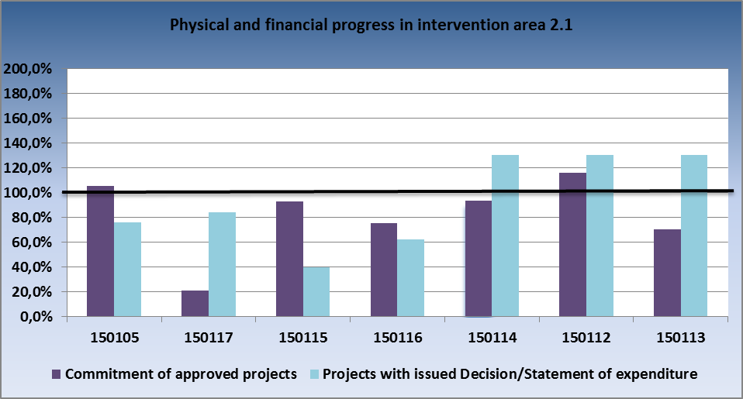
Source: IS Monit7+ as of 1 Apr 2014

3.2.4 Problems and measures taken

Problem
There are frequent changes in timetables of projects and public contracts (records management system, Internal Integration of the Authority and Integration with the Information System of Public Administration, Technology Centres of Regions – repeated conduct of public contracts, cancellation of public contracts), and transfers of funds to later stages.

Measures taken
Measures have been taken in the form of consultations on contracts, eligibility of expenditure and submission of the AP and MR. Links between the eligible expenditure from public contracts and the stage are monitored, risky and sleeping projects were identified, progress in implementation and acting upon the corrective measures is monitored. The project Prevention of the National Coordination Authority is utilised for consultations with beneficiaries and elimination of errors in applications for payment and monitoring reports.

Problem
Frequent technical and technological issues emerged during the implementation of projects, the expenditure was classified as ineligible (service, warranties, publicity) and the observance of the limits for expenditure set in the call was a challenge.

Measures taken
Material changes are consulted with experts.

3.2.5 Example of a project

Intervention area: 2.1 Introducing ICT in territorial public administration
Name of the project, registration number: Internal integration of Nový Bor authority, CZ.1.06/2.1.00/06.06833
Beneficiary: Town of Nový Bor
Project funding: total budget - CZK 1 529 000 (SF contribution - CZK 1 299 650, SB contribution - CZK 0)

The aim of the project is to integrate the intelligent forms solutions supporting and accelerating the approval processes with the existing information systems of the Municipal Authority of Nový Bor and to create an Office Desk that will serve as a presentation layer of aggregated data from the information systems and forms. The project contributes to effective and fast processing of agendas, reducing the costs and speeding up the processing of agenda.

3.3 Priority axis 3 – Improving public services quality and accessibility

3.3.1 Focus of priority axes/intervention areas

Activities of Priority Axis 3 follow from the interventions into the quality and effectiveness of the public administration functioning. The common goal is to improve the organisation, financing and the evaluation process of public services. The priority axis is focused on four intervention areas:
- 3.1 – Social integration services
- 3.2 – Public health services
- 3.3 – Employment services
- 3.4 – Services in security, risk prevention and management

Specific goals:

- reinforcing social integration by transforming residential social welfare facilities into other types of social services, while improving the quality and accessibility of social services to allow the clients return to the labour market and to the society in general
- innovation and modernisation of the infrastructure for care for the population’s health, with an emphasis put on the extension of national networks of specialised facilities, prevention of health risks and higher effectiveness, quality and availability in the system of providing public health services,
- enhancement of quality of employment services and support of development of new tools and institutions of employment services, including education of employees and clients of the employment services,
- better quality in the field of prevention and risk management through modernisation of infrastructure.

Beneficiaries:

- government agencies and semi-budgetary organisations established by them,
- regions and municipalities and organisations established by them,
- non-governmental non-profit organisations,
- entrepreneurs (persons registered in the Commercial Register, persons doing business based on a trade licence or based on special regulations).

3.3.2 Progress achieved in implementation of priority axes/intervention areas

In Intervention area 3.1, in the course of the monitored period the allocation for the IA was reduced by revision of the Programming Document. As of 1 Apr 2014, a total of 474 project applications in the amount of EUR 117.1 million were submitted, which represents 218 % of the allocation. In the monitored period funds amounting to EUR 12.1 million were paid to beneficiaries. As compared to the previous period, the volume of certified expenditure substantially increased to EUR 12.55 million, i.e. 22 % of the allocation.

- Cumulative progress at the level of Intervention area 3.1 (in million CZK/EUR)
3.1. | 2007-2013 allocation |  | Submitted applications |  |  |  | Projects with issued Decision/signed Contract |  |  |  | Funds paid to beneficiaries |  |  | Funds included in aggregate payment claims accounted for by the PCA |  |  | Certified expenditure submitted to the EC
 | CZK (a) | EUR | num-ber | CZK (b) | % (b/a) | EUR | num-ber | CZK (c) | % (c/a) | EUR | CZK (d) | % (d/a) | EUR | CZK (e) | % (e/a) | EUR | CZK (f) | % (f/a) | EUR
Current MC | 1475,69 | 54,64 | 474 | 3210,61 | 218% | 117,08 | 130 | 1452,62 | 98% | 52,97 | 329,85 | 22% | 12,03 | 329,16 | 22% | 12,83 | 320,54 | 22% | 12,15
Previous MC | 2032,92 | 79,20 | 474 | 3210,61 | 158% | 117,08 | 116 | 1409,84 | 69% | 51,41 | 271,91 | 13% | 9,92 | 244,82 | 12% | 9,60 | 54,65 | 3% | 2,20

In Intervention area 3.2, the following progress was achieved in the monitored period:
1) Number of submitted project applications increased by 19. In the monitored period, the MoH CR discontinued the receipt of applications in two calls. In the 17th call, 8 projects were registered on quality and cost management of public health and 11 projects in the 18th call focused on modernisation and replacement of medical equipment of specialised traumatology centres. These applications are right now subject to evaluation.
2) Volume of funds paid to beneficiaries increased by 2 % (an increase by EUR 9.054 million).
3) Share of funds included in the aggregate payment claims accounted for by the PCA grew by 2 % (an increase by EUR 10.297 million).

- Cumulative progress at the level of Intervention area 3.2 (in million CZK/EUR)
3.2. | 2007-2013 allocation |  | Submitted applications |  |  |  | Projects with issued Decision/signed Contract |  |  |  | Funds paid to beneficiaries |  |  | Funds included in aggregate payment claims accounted for by the PCA |  |  | Certified expenditure submitted to the EC
 | CZK (a) | EUR | num-ber | CZK (b) | % (b/a) | EUR | num-ber | CZK (c) | % (c/a) | EUR | CZK (d) | % (d/a) | EUR | CZK (e) | % (e/a) | EUR | CZK (f) | % (f/a) | EUR
Current MC | 6509,54 | 248,48 | 249 | 9585,40 | 147% | 349,54 | 193 | 6240,77 | 96% | 227,57 | 3906,13 | 60% | 142,44 | 3741,22 | 57% | 147,53 | 3590,41 | 55% | 141,06
Previous MC | 6332,16 | 248,48 | 230 | 8811,34 | 139% | 321,31 | 166 | 5059,02 | 80% | 184,48 | 3657,83 | 58% | 133,39 | 3474,24 | 55% | 137,24 | 2823,83 | 45% | 111,91

In Intervention area 3.3, as of 1 Apr 2014, cumulatively 29 project applications in the total amount of EUR 67.63 million were submitted. 2 new project applications totalling EUR 0.84 million were submitted in the monitored period. The amount of issued Decisions decreased by EUR 1.05 million due to the savings in conducted tenders. The volume of funds paid to beneficiaries rose, the funds amounting to EUR 9.10 million were reimbursed. In total, the volume of funds paid to beneficiaries equalled EUR 17.29 million, which represents 44 % of the allocation. The certified expenditure for IA 3.3 in total amounts to EUR 17.90 million, i.e. 43 % of the allocation.

- Cumulative progress at the level of Intervention area 3.3 (in million CZK/EUR)
3.3. | 2007-2013 allocation |  | Submitted applications |  |  |  | Projects with issued Decision/signed Contract |  |  |  | Funds paid to beneficiaries |  |  | Funds included in aggregate payment claims accounted for by the PCA |  |  | Certified expenditure submitted to the EC
 | CZK (a) | EUR | num-ber | CZK (b) | % (b/a) | EUR | num-ber | CZK (c) | % (c/a) | EUR | CZK (d) | % (d/a) | EUR | CZK (e) | % (e/a) | EUR | CZK (f) | % (f/a) | EUR
Current MC | 1069,53 | 40,21 | 29 | 1854,55 | 173% | 67,63 | 18 | 1031,68 | 96% | 37,62 | 474,09 | 44% | 17,29 | 474,09 | 44% | 18,49 | 457,73 | 43% | 17,90
Previous MC | 1194,35 | 46,59 | 27 | 1831,64 | 153% | 66,79 | 17 | 1060,36 | 89% | 38,67 | 224,64 | 19% | 8,19 | 178,83 | 15% | 7,06 | 71,32 | 6% | 2,87

In Intervention area 3.4, the FRS completed projects of the 13th call. It resulted in a more significant absorption of funds. Despite all the efforts exerted by the IOP MA, the implementation continues to be slow and the projects of call No 11 continue to be extended.

- Cumulative progress at the level of Intervention area 3.4 (in million CZK/EUR)
3.4. | 2007-2013 allocation |  | Submitted applications |  |  |  | Projects with issued Decision/signed Contract |  |  |  | Funds paid to beneficiaries |  |  | Funds included in aggregate payment claims accounted for by the PCA |  |  | Certified expenditure submitted to the EC
 | CZK (a) | EUR | num-ber | CZK (b) | % (b/a) | EUR | num-ber | CZK (c) | % (c/a) | EUR | CZK (d) | % (d/a) | EUR | CZK (e) | % (e/a) | EUR | CZK (f) | % (f/a) | EUR
Current MC | 7325,90 | 271,29 | 130 | 8112,50 | 111% | 295,83 | 125 | 4234,02 | 58% | 154,40 | 1695,70 | 23% | 61,83 | 1691,47 | 23% | 65,82 | 1554,08 | 21% | 60,80
Previous MC | 4378,06 | 170,83 | 127 | 5439,51 | 124% | 198,36 | 124 | 4178,12 | 95% | 152,36 | 1234,91 | 28% | 45,03 | 777,57 | 18% | 30,68 | 496,56 | 11% | 19,71

The following is applicable to all the tables above:
Source: Current MC – MSC2007 as of 3 Apr 2014
Previous MC – MSC2007 as of 2 Oct 2013
CZK/EUR exchange rate: Current MC – 27.423
Previous MC – 25.690
Source of funding –public funds total

Overview of ongoing calls

In priority axis 3, altogether 6 calls with the total allocation of EUR 218.6 million were under way, in which 42 project applications in the volume of EUR 219.8 million were submitted, 17 projects in the amount of EUR 67.7 million were approved.

In Intervention area 3.1, no call took place in the monitored period.

In Intervention area 3.2, 2 calls were under way. Call No 17 was published for the allocation of EUR 5.3 million and 8 project applications in the amount of EUR 4.6 million were submitted. In call No 18, 11 projects were submitted, amounting to EUR 28.5 million. All the project applications are now under evaluation.

In Intervention area 3.3, one call for the volume of EUR 46.2 million took place. The closing of call No 4 is scheduled for 31 May 2015, 20 project applications in the amount of EUR 71.9 million were submitted and 16 projects in the volume of EUR 55.3 million were approved.

In Intervention area 3.4, three calls with the total allocation of EUR 145.7 million were under way. In the monitored period, three project applications in the amount of EUR 114.7 million were submitted and one project in the volume of EUR 12.4 million was approved.

- Overview of ongoing calls in the period from 1 Oct 2013 to 31 Mar 2014 in Priority axis 3
Order of the call | Num-ber of the call | Submission of project applications |  | Type of the call | IA | Allocation for the call | Submitted applications for support |  | Projects with issued Decision/
 |  |  |  |  |  |  |  |  | signed Contract
 |  | Opening date of the call | Closing date of the call |  |  | in EUR | number | in EUR | number | in EUR
67 | 17 | 20.12.2013 | 14.3.2014 | time-limited | 3.2. | 5 280 239 | 8 | 4 662 619 | 0 | 0
68 | 18 | 20.12.2013 | 14.2.2014 | time-limited | 3.2. | 21 426 324 | 11 | 28 545 181 | 0 | 0
22 | 4 | 11.11.2009 | 31.5.2014 | continuous | 3.3. | 46 177 308 | 20 | 71 997 839 | 16 | 55 293 713
65 | 20 | 7.10.2013 | 20.12.2013 | time-limited | 3.4. | 102 104 073 | 2 | 102 275 608 | 0 | 0
66 | 21 | 10.12.2013 | 25.4.2014 | time-limited | 3.4. | 19 180 979 | 1 | 12 398 352 | 1 | 12 396 943
71 | 23 | 28.2.2014 | 30.5.2014 | time-limited | 3.4. | 24 432 046 | 0 | 0 | 0 | 0
PA 3 total |  |  |  |  |  | 218 600 970 | 42 | 219 879 599 | 17 | 67 690 656
Source: IS Monit7+ as of 1 Apr 2014
CZK/EUR exchange rate: 27.423
Source of funding – public funds total

3.3.3 Fulfilment of indicators

Intervention area 3.1
On 16 Dec 2013, the revision of the Programming Document was approved, a component part of which was the reduction of allocation for IA 3.1 and changes in the values of monitoring indicators. The target value of indicator No 330300 was decreased from the original value of 294 to 127. Indicator No 330300 “Number of projects focused on social inclusion“ reflects the fulfilment under all 3 activities of IA 3.1. Since as of 2 Apr 2014 altogether 124 projects in activities 3.1 a), b), c) reached the status of commitment of approved projects, we assume that this indicator will be fulfilled.

Indicator No 75713 “Facilities with transformation in progress” gives the number of social service facilities with transformation in progress. Following the revision of the Programming Document the target value was decreased from 30 to 20. As of 2 Apr 2014, 21 facilities reached the status of commitment, which is why the MoLSA CR anticipates that the indicator will be fulfilled. As compared to the previous monitored period the number of facilities in which the transformation was launched grew by 6.
The target value of indicator No 75714 “Number of supported organisations” in activity 3.1 b) remained unchanged at 30. As of 2 Apr 2014, the achieved value of the indicator giving the number of supported organisations that implement projects focused on inclusion of Roma localities in the market is 14. Judging from the current state of play of implemented projects this indicator should be fulfilled.
The new target value of indicator No 75802 “Number of supported entities“ linked to activity 3.1 c) was substantially decreased following the revision of the Programming Document, namely from 250 to 52. The achieved value corresponds to 33 supported entities, 44 projects are at the status of commitment. Activity 3.1 c) reported a high percentage of project applications rejected during evaluation. The MoLSA CR adopted measures to support absorption capacity, increased the number of seminars for applicants and beneficiaries in IA 3.1 c), and intensified the work with beneficiaries in the form of one-to-one consultations. These measures, however, did not result in a lower number of rejected applications. Activity 3.1 c) also contributes to a high share of rejected applications on the grounds of withdrawal of beneficiaries from project implementation. At present, in activity 3.1 c) intensive works are taking place on the preparation of project pipeline, the MoLSA CR anticipates that 25 projects will be included in the pipeline and in May 2014 submitted to the Selection Committee for approval. As long as the projects from the pipeline are implemented, the indicator will most likely be fulfilled.

In indicator No 75711 “Alternative social services” the achieved value as of 2 Apr 2014 as compared to the previous monitored period increased by 7 alternative social services. The projects show the potential to fulfil the target value of the indicator.

In indicator No 75712 “Number of newly established social services and activities”, linked to activity 3.1 b), the number of newly established social services grew by 18 as against the previous monitored period. The MoLSA CR expects that the indicator will be fulfilled.

The value of indicator No 75603 “Efficiency of support” remains at 60 % and shows a moderate overfulfilment.

Intervention area 3.2
Indicator No 080101 “Number of projects on the support of health – health risk prevention” -The indicator is currently fulfilled to the degree of about 71 % (32 projects focused on health risk prevention of the target value of 45 projects have been implemented). In activity 3.2 b), a gradual increase of absorption capacity was seen in health risk prevention and epidemiology, which resulted in a larger number of announced calls under which a larger number of projects with a lower financial volume was submitted. Since the indicator gives the number of implemented projects on health risk prevention and currently the commitment of approved projects is 57 projects (126 %), the target value of indicator will be achieved or slightly exceeded.

Indicator No 080102 “Projects on the support of health – modernising medical equipment” - At present, the target value of indicator is fulfilled to the degree of 122 % (61 projects focusing on the modernisation of medical equipment of the target value of 50 projects have already been implemented).

Activity 3.2 a) reports the highest absorption capacity. The publishing of calls reflected the requirements for material equipment of centres. The reason for the publishing of a larger number of calls, under which funds are allocated to smaller projects of individual networks, was also the necessity to fulfil the target value of result indicator No 080721, in which the unit of measurement is the percentage expressing an increase in the number of material fit-out of standardised specialised workplaces to 60 % of the standard. The indicator No 080102 gives the number of implemented projects on modernisation of equipment and devices and the commitment of approved projects has currently reached 110 projects, therefore the value of the indicator will be considerably exceeded (the indicator will be fulfilled to the degree of 220 %).

Indicator No 080702 “Number of projects focused on the introduction of standards and standard procedures of quality and cost management” - The target value of indicator is currently fulfilled to the degree of 73 % (11 projects focusing on introducing the standards and standard procedures of quality and cost management of the target value of 15 projects have already been implemented). Since the commitment of 17 approved projects is registered, the target value of the indicator will be fulfilled.

Indicator No 80721 “Increase in the standard (fit-out) of specialised workplaces in national networks”
At present, the indicator is fulfilled to the degree of 117 % (fit-out of specialised workplaces reaches the level of 70.13 %, the target value is 60%).
The activity 3.2a) reports the highest absorption capacity following the material replacement or purchase of medical equipment for individual hospitals - specialised centres in the national networks (traumatology, oncology, cardiology, neurology, etc.). With respect to the duration of the programming period and requirements for material fit-out of centres spread into individual years and thus also with respect to the ensurance of quality care, the announcement of calls was adapted to these requirements. The subject matter of projects is the purchase of medical equipment and devices set by the standard fit-out (which represents 100 % of the fit-out). Included in the result indicator is the average achievement of the standard fit-out for each national network of workplaces (e.g. oncology, traumatology, stroke, cerebrovascular, etc.). The fit-out of the workplace changes over the years, hence it is impossible now to determine precisely the achieved target value that is set at 60 %. It can be assumed, however, that the target value of this indicator will be achieved or slightly exceeded at the end of the programming period.

Indicator No 080712 “Number of prevention programmes available to citizens”
The indicator is currently fulfilled to the level of 62 % (28 prevention programmes of the target value of 45 programmes have been introduced). In activity 3.2 b) a gradual increase in absorption capacity has been reported in the field of prevention of health risks and epidemiology, which resulted in a higher number of announced calls, in which projects for a lower volume of funds were submitted. Since each of the implemented projects usually results in one prevention programme and the commitment of approved projects has currently reached 63 programmes, the target value of the indicator will be achieved or slightly exceeded.

Indicator No 080704 “Number of programmes introducing the standards and standard procedures for quality and cost management“
The indicator is currently fulfilled to the degree of 54 % (13 prevention programmes of the target value of 24 programmes have been introduced). At present, the registered commitment is 20 programmes. The commitment is therefore lower than the target value. This is why the 17th call directed at the support of projects in 3.2c. was announced, which shall help fulfil the indicator.

Intervention area 3.3
In Intervention area 3.3 a), the implementation of the project called “LO CR – Karlovy Vary – construction of a new seat of the office“ was successfully completed, therefore the achieved value of indicator No 74521 “Number of supported employment services institutions” is 1. In the monitored period, no other project was completed, the achieved value of the indicator did not change. The commitment of approved projects as of 2 Apr 2014 represents 12 projects. The MoLSA CR is aware of problems in implementation of some projects that indicate a risk of a withdrawal of implementation. As of 10 Oct 2013, the project called “LO CR - Olomouc - Tabulový vrch II premises“ was withdrawn. Another project which is most likely to be withdrawn is the project called “LO CR Liberec – construction, purchase, reconstruction of the office building“. The proposal to terminate the project was submitted by the GD LO CR on the grounds of cancellation of the public contract for selection of the supplier of project documentation and a building contractor because there were barriers in the contract award procedure which caused its discontinuation. Repeated publishing of the public contract and completion of the project before 30 Nov 2015 were considered unrealistic. Starting from 6 Nov 2013, the project called “LO CR Prague – purchase of an office building” has been implemented in activity 3.3 a). With respect to this project, however, objections were made by the European Commission. Specifically, with regard to an inadequate benefit of the purchase of the building in Prague (i.e. in the region ineligible under IOP) for the region under the Convergence objective (for more see point 5 – Specific problems in implementation - IA 3.3). Unless serious difficulties occur in the course of implementation of other projects, the MoLSA CR expects that the MI will be fulfilled.

Indicator No 74532 “Number of newly built and supported existing training centres of employment services” in activity 3.3 b) includes 1 successfully completed project called “LO CR – Hradec Králové – reconstruction of a training centre“ and the achieved value of this indicator is therefore 1. As of 2 Apr 2014, there are 4 projects in the status of commitment of approved projects, which represents an increase by 2 new projects under implementation as compared to the previous monitored period. Optimally, 3 training centres of employment services could be built and unless problems occur in project implementation, the achievement of the target value of MI can be foreseen.

In the monitored period, the value of indicator No 74533 “Number of newly built and supported existing information and education centres of employment services” as compared to the previous period remained unchanged. The value of the indicator is 1 and is linked to the successfully completed project in activity 3.3 c) “Building an information and education centre of the South Bohemian Region“. In activity 3.3 c), another project called “Information and education centre of Plzeň Region” is in the status of commitment. The target value of the indicator is expected to be achieved unless serious complications occur.

Result indicator No 74514 “Quality increase in working and client environment of the employment services institutions” is reported as a percentage for the programming period and its target value equals the overall increase by 18 %. By successful completion of implementation of the project called “LO CR – Karlovy Vary” in 2012, the indicator was fulfilled to the degree of 1.73 %. The achieved value of the indicator remains the same as in the previous period. As of 2 Apr 2014, 12 projects with the total increase of quality in working and client environment of the employment services by 27.19 % are in the status of commitment. An increase was reported as against the previous period. In the light of current status of implementation of individual projects, the MoLSA CR anticipates the fulfilment of the target value of the indicator to the degree of 18 %, unless serious problems occur in the implementation of individual projects.

Indicators No 74512 and 74513 will be gradually fulfilled in the period from the date of completion of project implementation throughout the period of obligatory project sustainability. In the monitored period, progress was made in the fulfilment of indicator No 74512, in which the achieved value increased from zero to 0.61%. The MoLSA CR expects that the target value of the indicator showing the increase in capacity of training centres of employment services by 20 % will not necessarily be achieved and reckons with the realistic fulfilment to the degree of 11 %. The achievement of the target value of the indicator, i.e. an increase by 20 %, depends on successful implementation of the project “LO CR Prague – purchase of the office building”.

The value of indicator No 74513 linked to activity 3.3 c) increased from zero to 0.28. Two projects with the target value of 25 % increase in the capacity of consultancy-training centres are in status of commitment. Therefore the MoLSA CR expects that the target value of the indicator will be achieved.

Intervention area 3.4
The target values of monitored indicators were changed in the revision of the Programming Document of October 2013. The increase of the values is covered by newly approved, submitted or planned projects from the published calls.

Indicator No 260407 “Number of IRS operational centres with integrated ICT” - the target value was increased due to the change in the calculation of the number of integrated operational centres. Originally it was planned to set up 1 operational centre for all the components in each Region. For technical and legislative reasons, however, it is not possible, which is why they are now counted in line with the actual situation, namely 3 in each Region and 2 central centres for the Police and the Fire Rescue Service. The achieved value of the indicator grew thanks to the completion of projects from the 13th call for purchasing the advanced equipment of the FRS.

- Output indicators
Code | Name of the indicator | Unit of measurement | Baseline value | Target value | Commitment of approved projects | Value achieved as of 2 Apr 2014
330300 | Number of projects focused on social inclusion | Number | 0 | 127 | 124 | 50
75713 | Facilities with transformation in progress | Number | 0 | 20 | 21 | 3
75714 | Number of supported organisations | Number | 0 | 30 | 31 | 14
75802 | Number of supported entities | Number | 0 | 52 | 44 | 33
80100 | Projects on the support of health – total | Number | 0 | 110 | 184 | 104
80102 | Projects on the support of health – modernising medical equipment | Number | 0 | 50 | 110 | 61
80101 | Project on the support of health – health risk prevention | Number | 0 | 45 | 57 | 32
80702 | Number of projects focused on the introduction of standards and standard procedures for quality and cost management | Number | 0 | 15 | 17 | 11
74521 | Number of supported employment services institutions | Number | 0 | 12 | 12 | 1
74532 | Number of newly built and supported existing training centres of employment services | Number | 0 | 3 | 4 | 1
74533 | Number of newly built and supported existing information and education centres of employment services | Number | 0 | 2 | 2 | 1
260407 | Number of IRS operation centres with integrated ICT | Number | 0 | 41 | 41 | 2
260408 | Number of newly built logistics bases | Number | 0 | 2 | 1 | 1
260410 | Number of modernised or newly built contact points of Front office type connected to IRS network | Number | 0 | 369 | 368 | 357
260412 | Number of technological equipment for elimination of safety risks or their implications | Number | 0 | 3286 | 2228 | 181
Source: MSC2007 as of 2 Apr 2014

- Result indicators
Code | Name of the indicator | Unit of measurement | Baseline value | Target value | Commitment of approved projects | Value achieved as of 2 Apr 2014
75711 | Alternative social services | Number | 0 | 77 | 89 | 17
75712 | Number of newly established social services and activities | Number | 0 | 142 | 133 | 54
75603 | Efficiency of support | % | 0 | 60 | 68,20 | 68,2
80721 | Increase in the standard (fit-out) of specialised workplaces | % | 0 | 60 | 68,93 | 71,41
80712 | Number of prevention programmes available to citizens | Number | 0 | 45 | 63 | 28
80704 | Number of programmes introducing the standards and standard procedures for quality and cost management | Number | 0 | 24 | 20 | 13
74514 | Quality increase in working and client environment of the employment services institutions | % | 0 | 18 | 27,19 | 1,73
74512 | Increase in the capacity of training centres of employment services | % | 0 | 20 | 20,12 | 0,61
74513 | Increase in the capacity of consultancy and training centres | % | 0 | 25 | 25 | 0,28
260401 | Number of supported IRS units | Number | 0 | 3 | 3 | 0
260406 | Decrease in average response time to imminent or existing safety risks | % | 100 | 75 | N/A | 100
260404 | Creation of new capacities for effective provision of humanitarian aid to other countries | m² | 0 | 3 450 | 2 500 | 2500
Source: MSC2007 as of 2 Apr 2014

- Comparison of physical and financial progress in intervention area 3.1
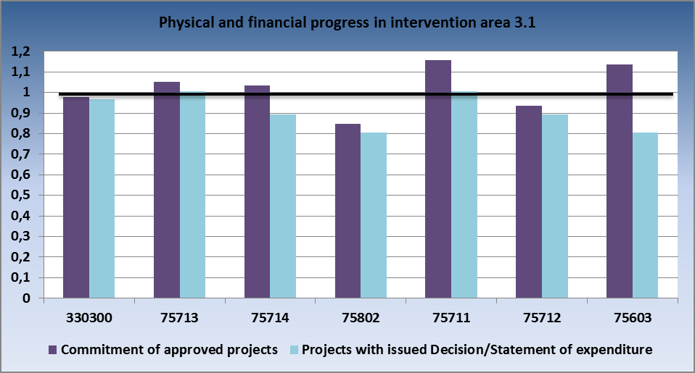
Source: IS Monit7+ as of 1 Apr 2014

- Comparison of physical and financial progress in intervention area 3.2
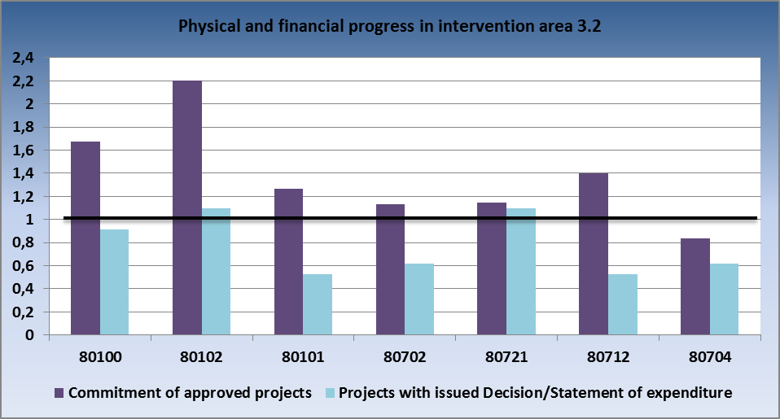
Source: IS Monit7+ as of 1 Apr 2014

- Comparison of physical and financial progress in intervention area 3.3
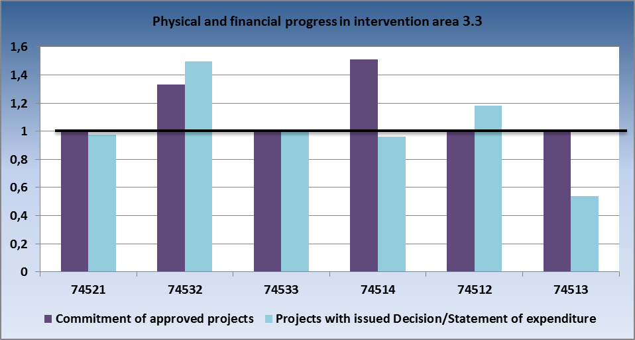
Source: IS Monit7+ as of 1 Apr 2014

- Comparison of physical and financial progress in intervention area 3.4

Source: IS Monit7+ as of 1 Apr 2014

3.3.4 Problems and measures taken

Intervention area 3.1

Problem
Risk of nonfulfillment of n+3/n+2 rule and failure to absorb the allocation
On account of the to date development of IOP implementation (delays in the launch of implementation, later commencement of project implementation, underestimation of the time necessary for investment projects, impacts of the amendment to Public Procurement Act, etc.) problems with the fulfilment of n+2/n+3 rule were indicated in the monitored period. Main reasons are especially the delays in timetables of implemented projects (e.g. due to delays in conduct of tenders, necessity to cancel tenders and publish new calls for tenders, prolongation of construction works, acquisition of a building permit).

Measures taken
Delays that occurred at the beginning of programme implementation could not be fully eliminated, the MoLSA CR takes measures for support of absorption through which it tries to minimise the potential negative effects on the implementation in intervention areas within its remit.

In the monitored period, the MoLSA CR IB in line with the IOP MA measures adopted the following measures with the view to safeguard the fulfilment of n+3/n+2 rule:

- Duration of stages in projects was controlled and modified so as to reflect the continuous absorption of funds;

- Stages of individual projects were adjusted in cooperation with beneficiaries, modifications in the timetable of implementation of activities were consulted in order to facilitate maximum absorption,

- MoLSA CR held e-mail and one-to-one consultations with beneficiaries with the view to individually address complications in projects and prevent delays in administration. Support for one-to-one consultations was reinforced in activity 3.1 c), which seems to be challenging due to the difficult elaboration of the part of project application concerning the benefits of project implementation for the target group and market environment, and elaboration of the business plan. In the monitored period, individual discussions with applicants and beneficiaries and with the National centre for support of the transformation of social services were held in activity 3.1 a). In the 7th call for activity 3.1 a), the timetable and overview of projects in this activity is monthly updated and reported to the IOP MA. Thanks to that the MoLSA CR IB is kept posted on developments in projects well ahead and can promptly seek suitable solutions to problems emerging in project implementation;

- In activity 3.1 a), the preparation of the pipeline of projects was finished and 14 projects were submitted to the Selection Committee convened on 24 Jan 2014. The SC recommended for financing 7 projects in the total amount of CZK 104 333 123. The projects in the pipeline under 3.1 a) will be approached in the order given by the SC, in dependence on the development of absorption in 2014 and 2015. In activity 3.1 c), focusing on investment support for social economy, the pipeline of projects is being prepared. Altogether 28 project applications will be submitted for consideration of the Selection Committee in May 2014,

- In activity 3.1 a), on 16 Jan 2014 the implementation period of projects under call No 7 was extended from 30 June 2015 to 30 Nov 2015. The extension of implementation will be allowed only on condition that it is duly justified by the aid beneficiary and approved by MoLSA CR and IOP MA,

- The MoLSA CR evaluates the submitted notifications of a change (modification) in projects, the causes of delays in project implementation and transfer of funds from 2014 to 2015. The MoLSA CR set out conditions for approval of the transfer of funds. One of them is the monthly reporting of adherence to the timetable which will facilitate the evaluation of the state of play of project implementation, and where necessary, adoption of adequate corrective measures,

- Continuous monitoring of individual steps of administration and monitoring of implementation of individual projects in IA 3.1 takes place. Starting with January 2014, the Director General of the EU Funds section has been informed on observance and violation of deadlines in project administration,

- At the 12th meeting of the IOP Monitoring Committee, the revision of the Programming Documents was approved, an integral part of which was the decrease of allocation for Intervention area 3.1. The MoLSA CR works hard to fully absorb the allocation for IA 3.1 by implementing the maximum number of submitted projects. At present, the whole allocation for IA 3.1 has been committed. The expected savings made in the course of administration of project (through withdrawal of projects, lower price resulting from the tender, or difference between the submitted and approved AP due to ineligible expenditure), were offered to projects from the List of substitute projects in IA 3.1 activity a).

2. Extension of administration during the implementation of projects, risk of a withdrawal of projects from implementation by beneficiaries in IA 3.1
Extended administration of projects causes delays in the submission of applications for payment, which is why the forecasts are not fulfilled. The reasons behind the lengthy administration of projects are problems in the building permit procedure and tenders (including the controls of tenders). In IA 3.1, also a risk was identified of a withdrawal of projects by many beneficiaries due to the impossibility to transfer the absorption of funds to the following years.
Measures taken

The MA approved the extension of the deadline for implementation of projects from the 7th call for IA 3.1 a) from 30 Jun 2015 to 30 Nov 2015. It is a call with an enumerative list of applicants/beneficiaries, whose project applications were not selected in a completion, hence the extension of the call did not bring about any discrimination of applicants.

Intervention area 3.2

Problem
Postponements in implementation of projects
In majority of projects supported under Intervention area 3.2, the timetables of implementation are postponed. This shift is caused especially by complications in tenders, namely due to submission of one or no bids, or by only one bid proceeding to evaluation. The beneficiary has to repeat the tender and the timetable of projects is therefore delayed.
Measures taken
An obligatory division of projects into stages was introduced – where certain parts of tenders have to be repeated the beneficiary shall divide the project into stages, with the parts to be repeated included I the second stage. This way, at least a partial absorption of funds is achieved.

Intervention area 3.3

1. Risk of a failure to fulfil the n+3/n+2 rule and to absorb the allocation
On account of the to date development of IOP implementation (delays in the launch of implementation, later commencement of project implementation, underestimation of the time necessary for investment projects, impacts of the amendment to Public Procurement Act, etc.) problems in the absorption of allocated funds are indicated. Main reasons are especially the delays in timetables of implemented projects, e.g. due to delays in conduct of tenders, necessity to cancel tenders and publish new calls for tenders, prolongation of construction works, acquisition of a building permit.

The preparation and implementation of investment projects was also prolonged by transformation of the LO CR. With account taken to the delays, following the completion of transformation of the LO CR the central administration of tenders under the competence of the GD LO CR was opted for (it concerned particularly 3 tenders for 10 projects). The General Directorate of the LO CR failed to organise the tenders within the planned deadline, technical problems emerged in the tender for the administrator and the tender has to be repeated. In 2013, the supplier of the project documentation that had won the centrally administered tender, Arc Design, s.r.o., withdrew from implementation of 5 projects and the repeated call for tenders for the project documentation supplier brought about a considerable delay in the implementation of these projects.

Measures taken
The MoLSA CR by its measures to support absorption seeks to reduce the negative effects on the implementation of intervention areas within its remit.

In line with the IOP MA measures, the MoLSA CR IB adopted the following measures to ensure the fulfilment of n+3/n+2 rule:
- Duration of stages in projects was controlled and modified so as to reflect the continuous absorption of funds. Stages of individual projects were adjusted in cooperation with beneficiaries, modifications in the timetable of implementation of activities were consulted,
- MoLSA CR held e-mail and one-to-one consultations with beneficiaries with the view to individually address complications in projects. As a part of methodological support, on 2 Oct 2013 a workshop was held for applicants under call No 4 with the aim to prepare the applicants for submission of project applications in order to avoid later delays in administration,
- In the monitored period regular meetings with competent representatives of the GD LO CR Prague were held in order to determine the steps to intensify the work of all stakeholders and to speed up the administration of projects in activities 3.3 a) and b).
- Thanks to the certification of eligible expenditure of the project “LO CR Prague – purchase of the office building” in the amount of CZK 236 617 409 in November 2013 the loss of allocation due to the non-fulfilment n+3/n+2 rule was substantially decreased. The submission and approval of this project was conditioned by the inclusion of expenditure in certification in 2013,
- The MoLSA CR assesses the submitted notifications of a change, causes of delays in individual projects and changes which lead to the transfer of funds from 2014 to 2015. The MoLSA CR set out the conditions for approval of the transfer of funds. One of them is the monthly reporting about the observance of the timetable which will allow for evaluation of the state of play of implementation of the project, and where necessary, the adoption of adequate corrective measures,
- On 29 Nov 2013, the deadline for submission of project applications in call No 4 for activity 3.3 a), b) was extended until 31 Mar 2014 and facilitated the submission of 2 new project applications, to be specific “LO CR – Mimoň – reconstruction of the building“, and “LO CR – Semily – reconstruction of the building“. Both the projects successfully passed the evaluation and were recommended for financing by the SC, namely in the total volume of CZK 26 951 000 of eligible expenditure. The completion of projects is foreseen on 31 Aug 2014 and 31 Dec 2014. The MoLSA CR is currently not aware of any delays in the timetable of implementation of these projects, the projects are not included in centrally administered tenders conducted by the GD LO CR. The MoLSA CR does not expect any delays in administration of these projects in the future either.
- The MoLSA CR has established intensive communication with aid beneficiaries and the GD LO Prague. The timetable of implementation of projects in activity 3.3 a) and b) is regularly updated with the view to identify bottlenecks in project implementation and to adopt measures to accelerate the whole process.
- Individual steps of administration and implementation of projects in IA 3.3 are continuously monitored. The Director General of the EU Funds section has been ever since January 2014 kept posted on the observance and violation of deadlines in the administration of projects.
- The LO CR was called upon to identify and submit substitute projects for the purchase of office buildings that could be financed from IA 3.3 of IOP and implemented in 2014. It resulted in the submission of projects on 4 buildings that could not be recommended for implementation, primarily on account of poor technical status of buildings, the necessity of costly and extensive reconstruction, the implementation of which would not be feasible within the required deadline, or due to the existence of multiple liens and warrants of distress against the respective building.

2. Reservations made by the European Commission about the project “LO CR Prague – purchase of the office building“

Due to its importance the project was on agenda of the meeting of the IOP Monitoring Committee held on 26 Nov 2013, which was attended by the representatives of the EU, LO CR and MoLSA CR. The MoLSA CR continuously consults the development of the project with the IOP MA staff. The European Commission (hereinafter referred to as the “EC”) made reservations about the referred to project with regard to the insufficient benefit of the purchase of the building in Prague (i.e. in the region ineligible under IOP) for the Convergence objective. The EC perceives the purchase of the building in Prague as a support for the LO CR as an employer in Prague, not as a support to increase the quality of employment services in other Regions of the CR, and thus challenges the purpose of the purchase of the building.

Measures taken
With account taken of these facts the MoLSA CR adopted the following measures in order to eliminate the risk of ineligibility of expenditure:
- In collaboration with the IOP MA, a supporting document for the response to the EC letter was drawn up, in which the misunderstanding of the importance of the newly purchased building of the LO CR for development of employment services was explained and the role of the GD LO vis-à-vis the Regional branches and the LO CR contact points was clarified,
- The MoLSA CR together with the LO CR fully cooperates with the MRD CR with the view to defend the project. There is an imminent risk that the EC will not consider the presented arguments sufficient to justify the whole investment and for this reason will not accept the request to reimburse the application for payment related to the ineligible part of the project,
- In the presented document, the MoLSA CR requests to hold a face-to-face meeting of top officials of IOP MA, MoLSA CR and LO CR in Brussels and to be able to explain the EC representatives the reasons for implementation of the project,
- Bearing in mind the gravity of the situation, if necessary, the MoLSA CR will consider taking further steps (e.g. a letter of the minister expressing the concerns about the EC arguments),
- Apart from addressing the reservations of the European Commission, the LO CR shall ensure the adherence to the timetable, the conduct of tenders in particular, so that the project is successfully completed within the set deadline. In this respect the MoLSA CR takes actions vis-à-vis the beneficiaries.

3. A risk threatening the completion of implementation of projects by 30 Jun 2015
The current situation in Intervention area 3.3 a) and b) indicates that a number of projects face difficulties consisting in delays in tenders, postponements in project timetables, which results in extending the project implementation and in extreme cases in jeopardising the project implementation. The most risky are primarily the large projects “LO CR - Pardubice – construction of the building and of the training centre“ and “LO CR - Liberec – construction, purchase and reconstruction of the office building“. On 29 Nov 2013, the IOP MA approved the extension of implementation period of both the projects until 30 Nov 2015. In the LO CR Liberec project, an error was made in tender documentation and an objection was filed with the OPC. The tender had to be repeated so that the project can continue, and it is unrealistic to complete the project implementation before the end of 2015. The implementation of this project will most likely be terminated soon.

Measures taken
The MoLSA CR communicates with aid beneficiaries and the GD LO CR. It regularly updates the timetable of implementation of projects in activity 3.3 a) and b) with the view to identify the bottlenecks of project administration and take steps to accelerate the process. The MoLSA CR informs the IOP MA on the actual status of project implementation at a regular monthly interval.

Intervention area 3.4

Problem
Prolongation of timetables of projects due to obstructive behaviour of unsuccessful bidders in public tenders.

Measures taken
The IOP MA holds regular discussions with the beneficiaries on the state of play of projects and deals with the problems. The CRD CR oversees the quality of documents before the call for tenders is advertised.

Problem
Delay in implementation of the umbrella project of the National Information System of the Integrated Rescue System (NIS IRS) and the follow-up projects of the 11th call due to the selection of the general (prime) contractor of the system.

Measures taken
The IOP MA regularly attends the meetings of the Steering Committee of the IS IRS Programme, where it exerts efforts to speed up the implementation of projects in order to observe the timetable of absorption and the planned completion of project implementation.

Problem
Transfers of funds to later stages, extension of the deadlines for the completion of implementation of the project. A repeated implementation of centrally conducted tenders and a postponement of their deadlines.

Measures taken
- Consultations on preparation and implementation of tenders at CRD HQ,
- Use of experts for assessing the public contracts,
- Monitoring the submitted tender documentation and status of contract award procedures,
- Regular meetings of the Steering committee of the IRS Programme,
- Coordination of administration of projects at CRD HQ,
- Transfer of administration of MR/AP to the CRD HQ,
- Controls of tenders at CRD HQ in selected projects,
- Control and opinions on the content by an expert person responsible,
- Publishing of call No 20 (Major projects of FRS, PCR) and call No 21 (MoI CR, FRS, PCR), preparation of a new call No 23 (EMS).

3.3.5 Example of a project

Intervention area: 3.1 Social integration services, activity b) Investment support for ensuring the accessibility of services that will facilitate the return of members of socially excluded Roma localities at highest risk to the labour market and society
Name of the project, registration number: “Multifunctional centre for social services in Kobylá nad Vidnavkou“, Reg. No CZ.1.06/3.1.00/03.06924
Beneficiary: Municipality of Kobylá nad Vidnavkou
Project funding: total budget – CZK 1 594 651 (SF contribution - CZK 1 355 453, SB contribution - CZK 239 198)

The purpose of the project called Multifunctional centre for social services in Kobylá nad Vidnavkou was to reconstruct and appropriately furnish the premises in the Municipal Authority building. By implementing the project the municipality of Kobylá nad Vidnavkou has created facilities for the provision of quality social services and activities in socially excluded Roma locality and has taken an important step towards the integration of target groups of inhabitants in the society and the labour market.

Thanks to the reconstruction, the necessary facilities have been created for the provision of social services and activities for children and youth as well as adults and their families – outreach work, social mobilising services for families with children, a low-threshold centre for children and youth, and optional activities- crime prevention, debt advice or employment counselling. The children and youth in the low-threshold facility for children and youth are offered non-stereotypical leisure time activities from which they can draw inspiration and motivation and which provide them with the opportunity to use their skills and dedicate their time to interests that they cannot fully develop in the miserable conditions of their homes. To this end the spaces were equipped with the necessary aids and resources. Also a car was purchased to be used in outreach work.

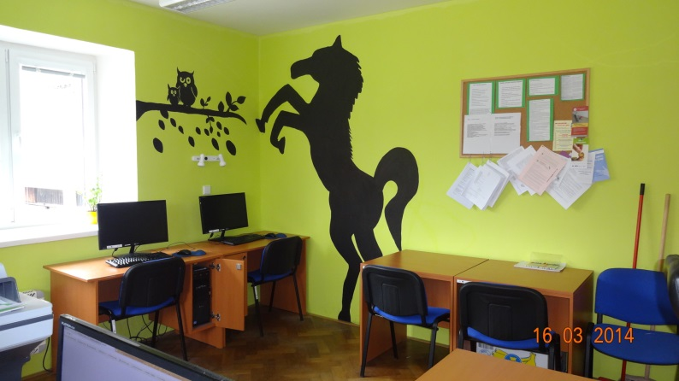

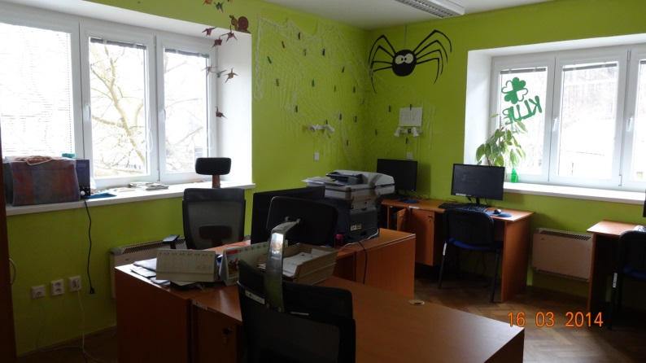
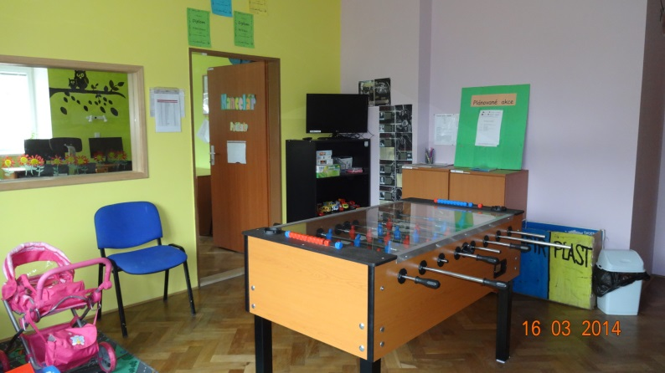

Intervention area: 3.2 Public health services
Name of the project, registration number: Completion of upgrading the laundry technology in Hamza Treatment Centre Luže Košumberk CZ.1.06/3.2.01/10.08253
Beneficiary: Hamza specialised treatment centre for children and adults
Project funding: total budget - CZK 11 596 359 (SF contribution: CZK 9 383 405)

The project aims to minimise the health risks, i.e. to reduce the risk of a potential spread of nosocomial infections, namely in patients and staff. Nosocomial infections, i.e. the infections acquired by the patient only in the hospital itself, oftentimes through dirty and contaminated laundry, represent an undesirable complication for health care in hospitals. They can lead to longer stays in hospitals, higher costs of treatment, but also to death. The greatest risk of nosocomial infections is faced by intensive care patients.
Under the project the ironer, including the folding and feeding machine, dryer, washer extractors, steam-air dummy, ironing press, two carousel presses and carts for clean and dirty laundry were put into operation. The built-in technology satisfies the most stringent European hygiene criteria.
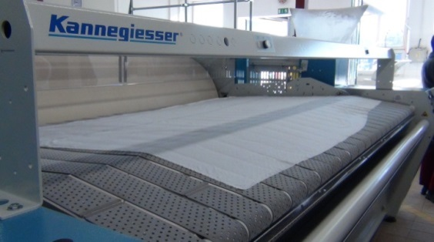
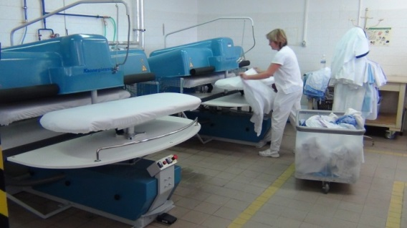

Intervention area: 3.3 Employment services, activity a) (Investment) support for transformation and fostering of employment services
Name of the project, registration number: LO CR Semily – reconstruction of the building, reg. No CZ.1.06/3.3.00/04.09257
Beneficiary: Labour Office of the Czech Republic
Project funding: total budget in CZK (SF contribution, SB contribution) CZK 20 000 000
(SF – CZK 17 000 000, SB – CZK 3 000 000)

The aim of the project is to take necessary steps to successfully reconstruct the building of the LO CR in Semily with the seat in Bořkovská 572, Semily. The reconstruction will improve the quality and accessibility of provided employment services. The project fully complies with the supported activity 3.3 a) (Investment) support for transformation and fostering of employment services in the CR.

The reconstruction will make the environment for clients of employment services user-friendly and comfortable, namely at reasonable running costs. The reconstruction will secure modern offices for 35 employees. Especially the information and consultancy centre will undergo a major remodelling, its floor area will expand and it will be refurbished to meet the requirements of employment services' clients. These are largely the job applicants and primary school pupils. This is why it is necessary to reinforce the comprehensive provision of advisory services in order to achieve their better employability in the labour market and to facilitate a career change.

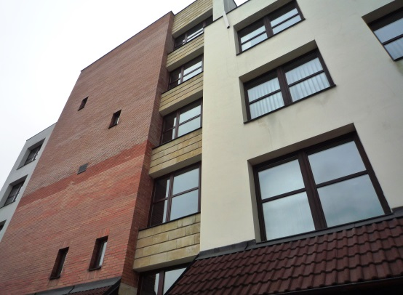

Intervention area: 3.4 Services in security, risk prevention and management
Name of the project, registration number: Contact and Coordination Centres II. – Regional Police Directorate of Hradec Králové Region, CZ.1.06/3.4.00/05.06261
Beneficiary: Regional Police Directorate of Hradec Králové Region
Project funding: total budget - CZK 13 910 123 (SF contribution - CZK 11 823 605, SB contribution- CZK 2 086 518)

The project implementation focuses on developing contact and coordination centres, the so called "front offices" that will collect the basic information on prevention or on measures to prevent or eliminate the consequences of risks in case of an emergency or disaster and provide it to the citizens. It consists of the development of 6 fully operational contact and coordination centres with up-to-date design (dignified and socially appropriate environment) and useful facilities (e.g. reception, waiting rooms, sanitary facilities, a meeting room, an area for non-stop service, a wheelchair access, advanced ICT).

3.4 Priority axis 4a, 4b – National support of tourism

3.4.1 Focus of priority axes/intervention areas

The aim of Priority axes 4a, 4b is to support the formation of basic environment and conditions necessary for tourism development at the national level. To achieve its effective development it is necessary to manage and coordinate some tourism activities from the national level, which helps create suitable conditions for the development of business, increased competitiveness and employment in the this area.

The priority axis covers the Convergence objective (4a) and the Regional Competitiveness and Employment objective (4b).

Specific goals:

- Increase of the number of entities connected to the reservation (booking) system in tourism sector,
- To improve the quality of services provided in tourism, their uniform certification and standardisation,
- To improve the tourism statistics and information,
- To increase the number of publicity and marketing products of tourism.

Supported activities:
  - establishment of a national information and reservation (booking) system,
  - introduction and information support of national and international standards in tourism services,
  - support of nationwide marketing and creation of source databases,
  - presentation and promotion of cultural and natural wealth, culture industry and services used for tourism on the national level,
  - support of the promotion of the CR as a tourism destination.

Beneficiaries:

- government agencies and semi-budgetary organisations established by them (activities a, b, c, e),
- non-governmental non-profit organisations and interest associations of legal persons with national scope of activities in tourism (activity d).

3.4.2 Progress achieved in implementation of priority axes/intervention areas

Of the total allocation for the IA, CZK 360 million remains to be absorbed. The IOP MA expects that the last project applications for the residual allocation will be submitted no later than in the 4th quarter of 2014. The IOP MA continues to stress the prevention of non-fulfilment of forecasts of absorption in the given period. For the next period, the implementation of the project, or the stage, can be postponed until August 2014 at the latest.

- Cumulative progress at the level of Intervention area 4.1a and 4.1b (in million CZK/EUR)
4.1a | 2007-2013 allocation |  | Submitted applications |  |  |  | Projects with issued Decision/signed Contract |  |  |  | Funds paid to beneficiaries |  |  | Funds included in aggregate payment claims accounted for by the PCA |  |  | Certified expenditure submitted to the EC
 | CZK (a) | EUR | number | CZK (b) | % (b/a) | EUR | number | CZK (c) | % (c/a) | EUR | CZK (d) | % (d/a) | EUR | CZK (e) | % (e/a) | EUR | CZK (f) | % (f/a) | EUR
Current MC | 1605,89 | 60,57 | 91 | 3427,39 | 213% | 124,98 | 44 | 1452,99 | 90% | 52,98 | 715,57 | 45% | 26,09 | 709,40 | 44% | 27,88 | 694,54 | 43% | 27,26
Previous MC | 1547,45 | 60,57 | 88 | 3340,98 | 216% | 121,83 | 39 | 1414,48 | 91% | 51,58 | 312,04 | 20% | 11,38 | 274,13 | 18% | 11,00 | 176,83 | 11% | 7,17
4.1.b | 2007-2013 allocation |  | Submitted applications |  |  |  | Projects with issued Decision/signed Contract |  |  |  | Funds paid to beneficiaries |  |  | Funds included in aggregate payment claims accounted for by the PCA |  |  | Certified expenditure submitted to the EC
 | CZK (a) | EUR | number | CZK (b) | % (b/a) | EUR | number | CZK (c) | % (c/a) | EUR | CZK (d) | % (d/a) | EUR | CZK (e) | % (e/a) | EUR | CZK (f) | % (f/a) | EUR
Current MC | 123,53 | 4,66 | 91 | 263,62 | 213% | 9,61 | 44 | 111,76 | 90% | 4,08 | 55,04 | 45% | 2,01 | 54,57 | 44% | 2,14 | 53,43 | 43% | 2,10
Previous MC | 119,04 | 4,66 | 88 | 256,97 | 216% | 9,37 | 39 | 108,80 | 91% | 3,97 | 24,00 | 20% | 0,88 | 21,09 | 18% | 0,85 | 13,60 | 11% | 0,55
Source: Current MC – MSC2007 as of 3 Apr 2014
Previous MC – MSC2007 as of 2 Oct 2013
CZK/EUR exchange rate: Current MC – 27.423
Previous MC – 25.690
Source of funding –public funds total

Overview of ongoing calls

In Intervention area 4.1, the call No 12 with the allocation of EUR 59.7 million is under way. A total of 54 project applications in the total volume of EUR 75.7 million were submitted, 36 projects in the amount of EUR 51.5 million were approved.

- Overview of ongoing calls in the period from 1 Oct 2013 to 31 Mar 2014
in Priority axis 4a and 4b
Order of the call | Num-ber of the call | Submission of project applications |  | Type of the call | IA | Allocation for the call | Submitted applications for support |  | Projects with issued Decision/signed Contract
 |  | Opening date of the call | Closing date of the call |  |  | in EUR | number | in EUR | number | in EUR
44 | 12 | 7.9.2011 | 31.12.2015 | Continuous | 4.1. | 55 598 605 | 27 | 66 735 035 | 18 | 47 817 958
 |  |  |  |  |  | 4 172 213 | 27 | 8 976 033 | 18 | 3 677 610
 |  |  |  | Call total |  | 59 770 818 | 54 | 75 711 068 | 36 | 51 495 568
CONV total |  |  |  |  |  | 55 598 605 | 27 | 66 735 035 | 18 | 47 817 958
RCE total |  |  |  |  |  | 4 172 213 | 27 | 8 976 033 | 18 | 3 677 610
PA 4 total |  |  |  |  |  | 59 770 818 | 54 | 75 711 068 | 36 | 51 495 568
Source: IS Monit7+ as of 1 Apr 2014
CZK/EUR exchange rate: 27.423
Source of funding – public funds total

3.4.3 Fulfilment of indicators

Indicator No 413320 “Number of newly classified and certified entities operating in tourism” is the result indicator of the project called National system of quality of tourism services in the Czech Republic. The target value of the indicator is to be reported by the beneficiary as at the date of completion of project implementation on 30 Dec 2015. The target value of the indicator (2000) is high and this indicator is considered to be the most risky since the number of certified entities increases only at a very slow pace.

The value of indicator No 410302 “Number of created publicity or marketing products for tourism” has reached the required commitment of 300 %. The achieved value of the indicator is directly linked to the number of approved projects in activity d) and e). The originally set value of indicator No 410302 disregarded the fact that activity d) and e) show the highest absorption capacity and the mentioned indicator was chosen by all the applicants.

In 2013 and later in the monitored period, the number of projects focused on tourism development increased, which was manifested by an increase in the achieved value of indicator No 410100 “Number of projects focused on tourism development”. The value rose from 14 to 36. It means a major increase in the number of projects focused on tourism development. By the end of the implementation period of the IA, the IOP MA reckons with the submission of a few more projects so that the number of projects is as close as possible to the target value of 44 projects.

- Output indicators
Code | Name of the indicator | Unit of measurement | Baseline value | Target value  CONV | Target value  RCE | Commitment of approved projects CONV | Commitment of approved projects RCE | Achieved value as of 2 Apr 2014
410100 Core 34 | Number of projects focused on tourism development | Number | 0 | 44 | 0 |  |  | 16
413305 | Number of newly introduced information and reservation systems in tourism | Number | 0 | 1 | 1 | 0,93 | 0,07 | 0
413315 | Number of introduced standards in tourism services | Number | 0 | 5 | 0 | 4,64 | 0,36 | 5
410304 | Number of marketing and statistical surveys | Number | 0 | 6 | 0 | 11,15 | 0,85 | 3
410303 | Number of publicity campaigns promoting tourism products | Number | 0 | 32 | 0 | 42,74 | 3,26 | 22
Source: MSC2007as of 2 Apr 2014

- Result indicators
Code | Name of the indicator | Unit of measurement | Baseline value | Target value  CONV | Target value  RCE | Commitment of approved projects CONV | Commitment of approved projects RCE | Achieved value as of 2 Apr 2014
413311 | Share of entities operating in tourism in the CR, which will be connected to the reservation system | % | 0 | 50 | 50 | 50 | 50 | 0
413320 | Number of newly classified and certified entities operating in tourism | Number | 0 | 1720 | 280 | 2000 | 280 | 389
413321 | Number of created source databases | Number | 0 | 6 | 0 | 6,51 | 0,49 | 0
410302 | Number of created publicity or marketing products for tourism | Number | 0 | 10 | 0 | 28,81 | 2,19 | 17
Source: MSC2007 as of 2 Apr 2014

- Comparison of physical and financial progress in intervention area 4.1
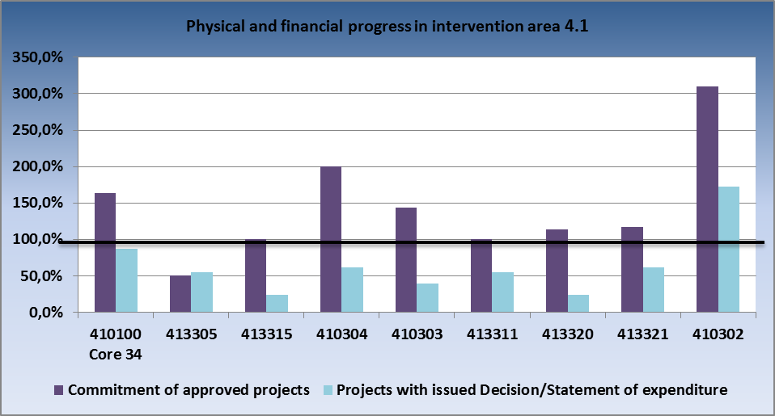
Source: IS Monit7+ as of 1 Apr 2014

3.4.4 Problems and measures taken

Problem
In the monitored period, the essential problem dealt with in this intervention area continued to be the fulfilment of n+3/n+2 rule.

Measures taken
- Regular monthly meetings with beneficiaries

Due to high turnover of staff in project teams of the Czech Headquarters of Tourism – CzechTourism, the IOP MA meets with beneficiaries, together with the CRD CR, to discuss the current issues faced by individual projects. The same approach has been pursued also towards the representatives of the Tourism Department of the MRD CR.

- Control reports from Monit 7+ information system

The reports transparently and clearly describe the state of play of individual projects, links between the tenders and applications for payment, etc. which makes it possible to easily control the timetables of implementation and to use the table as a source document for joint meetings between the IOP MA, CRD CR and beneficiaries. The beneficiaries shall also provide additional information on tenders in order to facilitate a clear analysis of causes of delays and to establish whether it was a matter of negligence on the part of the beneficiary, or whether the problems are caused by a third party.

- To continue in forwarding reports to the top officials of the ministry about the progress made in the implementation of projects

In 2013, the IOP MA submitted to the top officials of the Ministry for Regional Development six pieces of information on the current state of play of implementation and problems faced in IA 4.1, with focus on projects of the Tourism Department and CzT, which constitute roughly 85 % of committed funds.

3.4.5 Example of a project

Intervention area: 4.1 National support of tourism
Name of the project, registration number: The Czech Republic tastes great, CZ.1.06/4.1.00/12.08895 a CZ.1.06/4.1.00/12.08896
Beneficiary: Czech Headquarters of Tourism
Project funding: total budget - CZK 2 112 404.00,- (SF contribution - CZK 1 795 543,- , SB contribution - CZK 316 860,-).

The project strives to enhance the awareness of regional cuisine in a comprehensive and innovative manner through the Czech Specials brand. The initial activity of the project shall zoom in to improve the content on the Czech Specials website, to modify its design and to enrich it by an interactive map and applications. Once the new website is launched, a few episodes of a TV programme focused on gastronomy will be created that shall reach additional target groups of the project.

3.5 Priority axis 5 – National support of territorial development

3.5.1 Focus of priority axes/intervention areas

The interventions aim to create the basic environment that will be complemented by interventions from Regional Operational Programmes. The intervention areas are:
- 5.1 – National support for utilising the cultural heritage potential
- 5.2 – Improving the environment in problematic housing estates
- 5.3 Modernisation and development of systems for creating territorial policies

Specific goals:
- Improvement of services for owners of the monuments in the field of care of the cultural heritage, more intensive use of cultural heritage in the CR and presentation of culture to the public,
- Enhancing the quality of life and environment for inhabitants of problematic housing estates in large towns over 20 000 inhabitants by means of revitalisation of the environment of these estates and regeneration of residential buildings in the housing estates, including energy savings,
- Enforcing the management of sustainable development of the territory with the use of territorial plans of municipalities and better analytical planning materials to reduce regional disparities.

Beneficiaries:
- Government agencies and semi-budgetary organisations established by them,
- Municipalities and organisations established by them, unions of municipalities,
- Non-governmental non-profit organisations and interest associations of legal persons
- Owners of residential, or non-residential premises,
- Regions.

3.5.2 Progress achieved in implementation of priority axes/intervention areas

In Intervention area 5.1, a total of 22 projects in the volume of EUR 196.1 million were approved. The projects with issued Decision account for 95 % of the allocation for this intervention area. In the given period the beneficiaries were paid EUR 17.7 million (9 % of the allocation) and the total amount reimbursed is EUR 104.1 million (43 % of the allocation). The certified expenditure equals EUR 95.06 million, i.e. 43 % as against 20 % of the previous monitoring period.

- Cumulative progress at the level of Intervention area 5.1 (in million CZK/EUR)
5.1. | 2007-2013 allocation |  | Submitted applications |  |  |  | Projects with issued Decision/signed Contract |  |  |  | Funds paid to beneficiaries |  |  | Funds included in aggregate payment claims accounted for by the PCA |  |  | Certified expenditure submitted to the EC
 | CZK (a) | EUR | num-ber | CZK (b) | % (b/a) | EUR | num-ber | CZK (c) | % (c/a) | EUR | CZK (d) | % (d/a) | EUR | CZK (e) | % (e/a) | EUR | CZK (f) | % (f/a) | EUR
Current MC | 5680,64 | 213,74 | 51 | 13420,06 | 236% | 489,37 | 22 | 5378,54 | 95% | 196,13 | 2451,06 | 43% | 89,38 | 2438,89 | 43% | 95,52 | 2427,42 | 43% | 95,06
Previous MC | 5880,78 | 230,30 | 51 | 13420,06 | 228% | 489,37 | 22 | 5509,25 | 94% | 200,90 | 1963,55 | 33% | 71,60 | 1625,84 | 28% | 64,68 | 1163,25 | 20% | 46,59

In Intervention area 5.2, the forecasts of absorption are regularly fulfilled. In the monitored period, the IOP MA distributed the residual allocation to those towns with IUDPs that avail of absorption capacity for the activity Revitalisation of public spaces.

- Cumulative progress at the level of Intervention area 5.2 (in million CZK/EUR)
5.2. | 2007-2013 allocation |  | Submitted applications |  |  |  | Projects with issued Decision/signed Contract |  |  |  | Funds paid to beneficiaries |  |  | Funds included in aggregate payment claims accounted for by the PCA |  |  | Certified expenditure submitted to the EC
 | CZK (a) | EUR | num-ber | CZK (b) | % (b/a) | EUR | num-ber | CZK (c) | % (c/a) | EUR | CZK (d) | % (d/a) | EUR | CZK (e) | % (e/a) | EUR | CZK (f) | % (f/a) | EUR
Current MC | 5526,89 | 213,38 | 1 436 | 5795,77 | 105% | 211,35 | 1 383 | 4967,81 | 90% | 181,15 | 3626,47 | 66% | 132,24 | 3536,09 | 64% | 140,78 | 5091,41 | 92% | 135,00
Previous MC | 5391,76 | 213,38 | 1 415 | 5582,88 | 104% | 203,58 | 1 213 | 4512,39 | 84% | 164,55 | 3143,30 | 58% | 114,62 | 3135,87 | 58% | 125,57 | 1891,26 | 35% | 76,32

In Intervention area 5.3, 8 projects in the volume of EUR 0.14 million were approved in the monitored period. The total volume of projects with issued Decision equals 101 % of the allocation for this intervention area. The amount of EUR 0.51 million was paid to beneficiaries in the given period, the amount reimbursed thus totals EUR 13.84 million (95 % of the allocation). The certified expenditure is EUR 14.46 million (85 % of ERDF share), i.e. 93 % as against the previous monitoring period when the certified expenditure reached 89 %.

- Cumulative progress at the level of Intervention area 5.3 (in million CZK/EUR)
5.3. | 2007-2013  allocation |  | Submitted applications |  |  |  | Projects with issued Decision/signed Contract |  |  |  | Funds paid to beneficiaries |  |  | Funds included in aggregate payment claims accounted for by the PCA |  |  | Certified expenditure submitted to the EC
 | CZK (a) | EUR | num-ber | CZK (b) | % (b/a) | EUR | num-ber | CZK (c) | % (c/a) | EUR | CZK (d) | % (d/a) | EUR | CZK (e) | % (e/a) | EUR | CZK (f) | % (f/a) | EUR
Current MC | 399,81 | 15,53 | 700 | 498,69 | 125% | 18,19 | 592 | 402,87 | 101% | 14,69 | 379,62 | 95% | 13,84 | 377,69 | 94% | 14,72 | 370,67 | 93% | 14,46
Previous MC | 398,11 | 15,53 | 700 | 498,69 | 125% | 18,19 | 584 | 398,90 | 100% | 14,55 | 365,44 | 92% | 13,33 | 363,65 | 91% | 14,19 | 355,65 | 89% | 13,87

The following is applicable to all the tables above:
Source: Current MC – MSC2007 as of 3 Apr 2014
Previous MC – MSC2007 as of 2 Oct 2013
CZK/EUR exchange rate: Current MC – 27.423
Previous MC – 25.690
Source of funding –public funds total

Overview of ongoing calls

In Priority axis 5, the project applications continued to be submitted under call No 07 for Intervention area 5.2. In total, 1 435 project applications in the volume of EUR 238.2 million have been submitted. 1 382 projects in the amount of EUR 208.5 million have been approved.

- Overview of ongoing calls in the period from 1 Oct 2013 to 31 Mar 2014 in Priority axis 5
Order of the call | Num-ber of the call | Submission of project applications |  | Type of the call | IA | Allocation for the call | Submitted applications for support |  | Projects with issued Decision/
 |  |  |  |  |  |  |  |  | Signed Contract
 |  | Opening date of the call | Closing date of the call |  |  | in EUR | number | in EUR | number | in EUR
16 | 7 | 22.5.2009 | 31.12.2015 | continuous | 5.2. | 175 558 219 | 1 435 | 238 212 709 | 1 382 | 208 531 354
PA 5 total |  |  |  |  |  | 175 558 219 | 1 435 | 238 212 709 | 1 382 | 208 531 354
Source: IS Monit7+ as of 1 Apr 2014
CZK/EUR exchange rate: 27.423
Source of funding – public funds total

IUDP implementation
Status of IUDP implementation

The Integrated Urban Development Plans have been implemented in 41 towns. Before 31 Mar 2014, a total of 258 calls were announced in all the towns, of which 207 calls were closed and the remaining 51 calls, mostly continuous, are still under way.

- Number of calls announced for IUDP
Activity 5. 2. | Number of calls announced before 31 Mar 2014
 | Number of calls total | Of which closed calls | Of which open calls
a) revitalisation of public spaces | 62 | 26 | 36
b) regeneration of residential buildings | 173 | 163 | 10
c) pilot projects | 11 | 9 | 2
Combined calls for a) + b) | 9 | 8 | 1
Combined calls for a) + b) + c) | 3 | 1 | 2
Total | 258 | 207 | 51
Source: IOP MA as of 31 Mar 2014

- Information on the status of absorption of IUDP allocation for Intervention area 5.2
Name of the applicant | Approved assistance from IOP (from ERDF) | Submitted projects  (ERDF) | Status of absorption as at the end of 2011 | Status of absorption as at the end of 2012 | Status of absorption as at the end of 2013 | Status of absorption as of 31 Mar 2014
 | in EUR | in EUR | (in %) | (in %) | (in %) | (in %)
Bohumín | 2 581 191 | 3 315 071 | 53,41 | 65,60 | 83,96 | 2 581 191
Brno | 5 258 220 | 5 193 744 | 44,53 | 57,29 | 58,12 | 5 258 220
Břeclav | 2 090 289 | 1 902 890 | 58,49 | 54,18 | 54,22 | 2 090 289
České Budějovice | 6 849 922 | 8 049 016 | 71,15 | 64,01 | 64,05 | 6 849 922
Český Těšín | 4 078 349 | 3 831 665 | 68,08 | 76,36 | 78,50 | 4 078 349
Děčín | 2 948 794 | 3 051 504 | 14,76 | 32,04 | 36,70 | 2 948 794
Frýdek-Místek | 5 237 029 | 4 138 622 | 43,44 | 66,06 | 66,11 | 5 237 029
Havířov | 6 835 603 | 7 029 454 | 45,35 | 81,41 | 65,38 | 6 835 603
Hodonín | 3 099 232 | 2 718 732 | 64,35 | 64,18 | 64,22 | 3 099 232
Hradec Králové | 6 633 156 | 5 213 913 | 44,96 | 51,93 | 54,05 | 6 633 156
Cheb | 3 329 848 | 2 198 870 | 19,76 | 26,06 | 33,44 | 3 329 848
Chomutov | 6 489 612 | 4 859 706 | 40,97 | 53,99 | 54,63 | 6 489 612
Chrudim | 3 217 388 | 3 690 114 | 59,29 | 67,36 | 72,18 | 3 217 388
Jablonec nad Nisou | 4 393 360 | 3 870 342 | 48,22 | 51,88 | 57,79 | 4 393 360
Jirkov | 4 006 329 | 3 697 881 | 84,70 | 89,45 | 94,83 | 4 006 329
Karlovy Vary | 3 243 289 | 2 565 364 | 53,23 | 53,80 | 57,08 | 3 243 289
Karviná | 5 750 823 | 4 875 351 | 64,19 | 65,61 | 71,17 | 5 750 823
Kladno | 6 213 506 | 5 923 878 | 76,39 | 72,95 | 73,00 | 6 213 506
Kopřivnice | 3 799 948 | 3 832 612 | 51,35 | 60,80 | 60,84 | 3 799 948
Kroměříž | 3 816 513 | 3 976 993 | 68,62 | 72,96 | 77,38 | 3 816 513
Liberec | 6 020 554 | 5 018 635 | 45,88 | 58,16 | 67,01 | 6 020 554
Litvínov | 3 336 657 | 2 933 872 | 44,64 | 68,98 | 75,10 | 3 336 657
Mladá Boleslav | 3 836 636 | 5 750 488 | 77,71 | 78,07 | 79,61 | 3 836 636
Most | 4 954 049 | 3 434 856 | 14,50 | 56,05 | 58,98 | 4 954 049
Náchod | 4 233 175 | 3 877 681 | 56,52 | 55,78 | 66,09 | 4 233 175
Nový Jičín | 3 666 244 | 3 864 923 | 71,79 | 83,43 | 86,53 | 3 666 244
Olomouc | 7 179 511 | 6 122 444 | 42,09 | 62,53 | 65,81 | 7 179 511
Opava | 6 440 187 | 6 499 488 | 61,47 | 79,11 | 79,75 | 6 440 187
Orlová | 3 197 484 | 2 479 806 | 58,26 | 61,03 | 61,08 | 3 197 484
Ostrava | 5 772 313 | 5 564 768 | 24,10 | 39,00 | 60,71 | 5 772 313
Pardubice | 6 237 014 | 5 641 833 | 51,19 | 56,53 | 61,22 | 6 237 014
Písek | 3 938 336 | 3 450 970 | 45,71 | 44,03 | 45,42 | 3 938 336
Přerov | 3 479 083 | 2 867 575 | 31,64 | 51,04 | 59,91 | 3 479 083
Příbram | 5 099 733 | 5 483 371 | 69,47 | 66,89 | 75,10 | 5 099 733
Strakonice | 4 776 436 | 3 813 570 | 56,00 | 65,64 | 78,56 | 4 776 436
Tábor | 4 161 657 | 4 602 246 | 58,23 | 70,25 | 70,30 | 4 161 657
Třebíč | 3 902 239 | 3 663 370 | 36,45 | 69,45 | 76,04 | 3 902 239
Uherské Hradiště | 3 553 928 | 3 012 644 | 27,13 | 63,36 | 68,94 | 3 553 928
Ústí nad Labem | 5 221 274 | 2 779 286 | 45,26 | 41,93 | 41,96 | 5 221 274
Vsetín | 3 903 030 | 3 478 396 | 52,54 | 55,50 | 69,55 | 3 903 030
Znojmo | 3 669 656 | 2 314 841 | 36,01 | 43,44 | 43,47 | 3 669 656
Total | 186 451 597 | 170 590 784 | 50,44 | 61,55 | 65,27 | 186 451 597
Source: IS Monit7+ as of 1 Apr 2014
CZK/EUR exchange rate: 27.423

Status of implementation of projects under activity 5.2

In the monitored period, the total number of submitted project applications in Intervention area 5.2 was 1 370, of which 1 105 projects were already successfully completed and 265 projects are under implementation. Starting from 1 Jan 2014, project applications can be submitted only under the activity Revitalisation of public spaces. The IOP MA redistributed the residual allocation to those towns that satisfied the conditions and avail of absorption capacity in the activity Revitalisation of public spaces. Submission of additional projects is anticipated in the second quarter of 2014 and in the first quarter of 2015.

Status of implementation of pilot projects

Calls for the submission of projects are currently announced in all the six towns. As of 31 Mar 2014, a total of 67 submitted projects are registered under activity 5.2c). The investment projects are complementary to the projects on social inclusion financed mostly from OP HRE, Intervention area 3.2 Support for social integration of members of Roma communities, 5.1 International cooperation (exchange of experience with social inclusion), and Intervention area 3.1b of IOP. Moreover, implemented within the pilot projects are also the projects from the Operational Programme Education for Competitiveness, which fall under Intervention area 1.2 Equal opportunities for children and pupils. The IOP MA in cooperation with OP HRE endeavours to ensure the maximum consistency in the administration of pilot projects and OP HRE projects.

3.5.3 Fulfilment of indicators

In Intervention area 5.1, the value of indicator No 410401 “Number of regenerated immovable cultural monuments” grew in 2013 from 8 to 19 as against 3 Oct 2013, e.g. thanks to the project called Revitalisation of Jewish monuments in the CR. The commitment of approved projects decreased by 1 due to the withdrawal of the project Stone and light – revitalisation of the interior of the church of Saint Barbara in Kutná Hora. The value of indicator No 410404 “Number of created methodologies in the cultural heritage area” is zero since the projects focusing on methodological centres of cultural heritage have not been completed as yet. The methodologies shall be created within one year after the completion of the project. The value of indicator No 410411 “Increase in the number of visitors to monuments and cultural facilities” has been constantly growing as against the status as of 3 Oct 2013, when it was 107 %.

In Intervention area 5.2, the progress in fulfilment of indicator No 331300 “Area of revitalised territory” is influenced by the fact that due to financial crisis the towns did not avail of adequate volume of funds which could be used to pre-finance and co-finance the often financially demanding projects. Bearing in mind the fact that starting from 1 Jan 2014 only the projects on Revitalisation of public spaces will be implemented, the IOP MA reckons with a major increase of this MI.
The indicator No 330103 “Number of projects improving the attractiveness of housing in the territory” reports an overfulfillment. When the indicators were set in the Programming Document, the IOP MA assumed that individual projects on revitalisation of public spaces will be implemented as a single project in the whole territory of the IUDP. The towns, however, implement individual projects separately due to which the number of projects is higher than the target value of the indicator. The number of summary projects at the level of IUDP corresponds to the target value of the indicator.

In Intervention area 5.3 in activity a) the commitment of approved projects has been attained and expenditure of all the projects in activity a) has already been certified. The target value of indicator No 330400 relating to projects of Regions has almost been achieved. In line with the anticipated target value of the number of projects creating planning analytical materials for Regions, 10 project applications have been submitted, one project has been rejected during its administration. In case of projects on creation of planning analytical materials for municipalities with extended powers, the target values of indicators No 330401 and 330415 have been exceeded. When the target value of indicator No 330415 was set, the calculation was based on the anticipated value of indicator No 330401. The area was calculated as the area of 140 smallest municipalities with extended powers, but in the end 170 applications submitted by the municipalities have been supported and the area of territory covered by planning analytical documents fulfilled the indicator No 330415 to the level of 200 %.

The achieved value of indicators in activity b) as at the cut-off date was exceeded in all the cases. When the indicator No 330411 was set, the calculations were made based on the much higher price of territorial plans valid at the time of preparation of the Programming Document. The calculations considered the maximum price of CZK 4 million per 1 territorial plan, including the expert opinions, but the average application for support claims CZK 800 thousand, which resulted in exceeding the target value by more than five times. When the target value of indicator No 330416 was set, the calculations were made based on the anticipated value of indicator No 330411. The area was calculated as the area of 60 smallest municipalities with more than 500 inhabitants, which complied with the conditions of the prepared calls for 5.3b). The achieved value of indicator No 330418 has many times exceeded the target value for reasons stated in indicators No 330411 and 330416 (output indicators) on which it is based.

- Output indicators
Code | Name of the indicator | Unit of measurement | Baseline value | Target value | Commitment of approved projects | Value achieved as of  2 Apr 2014
410401 | Number of regenerated immovable cultural monuments | Number | 0 | 70 | 102 | 19
410402 | Number of newly built or modernised cultural facilities | Number | 0 | 5 | 4 | 0
330100 Core 39 | Number of projects improving the attractiveness of towns | Number | 0 | 1000 | 1354 | 1 106
330103 | Number of projects improving the attractiveness of housing in the territory | Number | 0 | 41 | 172 | 172
330101 | Number of projects improving the conditions of rental houses (residential buildings) | Number | 0 | 950 | 882 | 882
330102 | Number of pilot projects – support for selected Roma localities | Number | 0 | 7 | 6 | 6
330400 | Number of projects on creating planning analytical materials of Regions | Number | 0 | 10 | 9 | 9
330401 | Number of assisted projects on creating planning analytical materials of municipalities | Number | 0 | 140 | 170 | 170
330411 | Number of assisted projects on creating new or updating the existing territorial plans | Number | 0 | 60 | 354 | 354
330415 | Area of municipalities covered by the planning analytical materials of municipalities | km2 | 0 | 34 800 | 63 398,03 | 63 398,03
330416 | Area of municipalities covered by the new territorial plan | km2 | 0 | 140 | 10 214,82 | 9 057,65
Source: MSC2007 as of 2 Apr 2014

- Result indicators
Code | Name of the indicator | Unit of measurement | Baseline value | Target value | Commitment of approved projects | Value achieved as of 2 Apr 2014
410404 | Number of created methodologies in the cultural heritage area | Number | 0 | 13 | 13 | 0
410411 | Increase in the number of visitors to monuments and cultural facilities | % | 100 | 161 | 159,32 | 128,9
331200 | Number of renovated apartments | Number | 0 | 24 500 | 56 914 | 45 928
331300 | Area of revitalised territory | m2 | 0 | 4 108 000 | 3 689 216 | 3 176 387
331500 | Energy savings in rental houses (residential buildings) | % | 0 | 20 | 28,4 | 28,4
331000 | Number of created Urban Development Funds | Number | 0 | 1 | 1 | 0
330418 | Increase in the area of development areas, development axes and specific areas covered by new territorial plans | % | 0 | 0,18 | 24,48 | 24,48
330417 | Increase in the area of the CR which will be covered by planning analytical materials of municipalities | % | 0 | 18,5 | 80,3 | 80,3
Source: MSC2007 as of 2 Apr 2014

- Comparison of physical and financial progress in intervention area 5.1
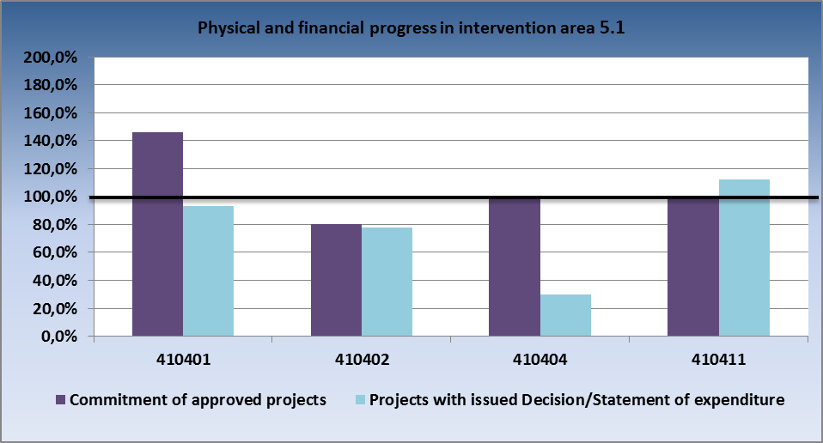
Source: IS Monit7+ as of 1 Apr 2014

- Comparison of physical and financial progress in intervention area 5.2
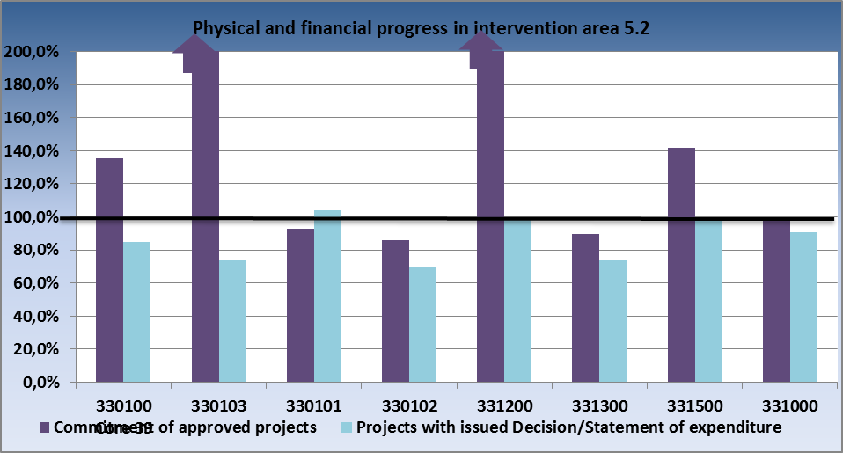
Source: IS Monit7+ as of 1 Apr 2014

- Comparison of physical and financial progress in intervention area 5.3
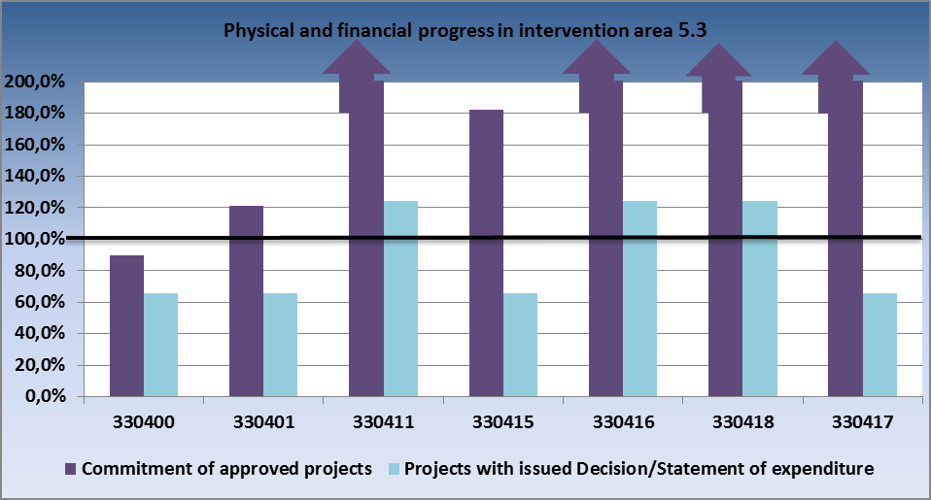
Source: IS Monit7+ as of 1 Apr 2014

3.5.4 Problems and measures taken

Intervention area 5.1

Problem
Unsatisfactory state of play of implementation, low absorption of funds in particular

Measures taken

- Change in delegated activities of the MoC CR

As of 1 Nov 2013, pursuant to Government Resolution No 567/2013, the delegated activities of the MoC CR IB were transferred back to the MRD CR due to unsatisfactory state of play of implementation of Intervention area 5.1 National support for utilising the cultural heritage potential. The reasons behind this measure were especially the low absorption, making unrealistic absorption forecasts (in 2012 fulfilled to the level of 46 %); extension of the deadlines of many administrative processes (e.g. control of contract award procedures, approval of extra work and invoices); frequent changes in staffing accompanied by changes in opinions and standpoints to the same issue; disrespecting the opinions of the IOP Managing Authority; lack of cooperation with beneficiaries in the field of public contracts which leads to high error rate in contract award procedures and slowing down of project implementation. As of 1 Nov 2013, the role of the Intermediate Body for IA 5.1 has been played by the CRD CR.
- Simplified reimbursement procedures
The new simplified procedures, applied by the IOP MA and CRD CR starting from 1 Nov 2013, lead to a faster reimbursement of invoices to the contractors.

Problem
State aid
Intervention area 5.1 faces the risk of provision of unauthorised state aid.

Measures taken
In revisions of Handbooks for Applicants and Beneficiaries for IA 5.1 of IOP following 1 Nov 2013 the state aid matters were explained in detail and supplemented with examples and recommendations. An obligatory use of checklists for state aid for the purpose of risk analysis of the project was introduced. The CRD CR staff checks all the project activities with respect to the state aid rules.

Problem
Award of public contracts.
Challenging contract award or tender procedures, delays in their implementation, appeals filed by unsuccessful bidders with the OPC, high error rate and lengthy process of tendering caused by poor knowledge of beneficiaries and complexity of legislation.

Measures taken
Throughout the contract award or tender procedure the CRD CR and, where necessary, an external expert conduct controls to minimise the referred to risks.

Problem
Withdrawal of the project “Stone and light – revitalisation of the interior of the church of Saint Barbara in Kutná Hora“, CZ.1.06/5.1.00/03.08093, in January 2014 (support of CZK 153 million)

Measures taken
In March 2014, the IOP MA organised a survey of absorption capacity in the field of cultural monuments. Based on the results of the survey it decided to publish a new call for available allocation for IA 5.1 for activities a) and b).

Intervention area 5.2

Problem
Risk of a failure to absorb the funds

The risk of a failure to fully absorb the funds was identified also in the monitored period. The reason is high savings in tenders for a building contractor reaching almost 30 % on average. An important factor was also the CNB intervention with respect to the CZK/EUR exchange rate which was conducive to a major increase of residual allocation for IA 5.2 by approximately CZK 120 million.

Measures taken
The IOP MA called upon the towns to create a project budget reflecting the actual prices based on the public contracts and experience gained from the implementation of previous public contracts at the time of IUDP implementation. Moreover, the IOP MA recommended responding to potential savings made in the final stage of implementation of IUDP by preparing projects that can be implemented in a short period of time, including their necessary administration. By 31 Dec 2013, the IOP MA conducted an analysis of the residual absorption capacity in towns implementing the IUDP under IOP and offered the remaining funds to towns with absorption capacity for activity 5.2a) Revitalisation of public spaces. The towns expressed adequate demand for an increase of ERDF allocation so that the full amount of the residual allocation can be redistributed. An enhancement of absorption capacity was also brought about by the adoption of the Methodological Guideline No 46 of IOP MA, by which the deadline for eligibility of expenditure was extended until 31 Dec 2015. With regard to this change, the IOP MA made a change in the Agreement on ensuring the implementation of IUDP. By the Addendum to the Agreement on ensuring the implementation of IUDP the deadline for completion of IUDP implementation was modified. The projects can now be implemented until 31 Dec 2015 and the AP can be submitted within twenty working days.

Intervention area 5.3

Problem
The intervention of the Czech National Bank in November 2013 resulted in an increase of the allocation.

Measures taken
Since there was a full pipeline of substitute projects from the 17th call, the IOP Managing Authority decided to offer the available funds to substitute projects. At the end of 2013 and at the beginning of 2014 the applicants from the 17th call, who had not received the support because the allocation to the call had already been absorbed, were approached and asked whether they would be interested in implementing their projects. A part of these applicants agreed to implement their projects and their project applications were continuously administered. As of 1 Apr 2014, the legal acts were being prepared for three projects from the call No 17 amounting to a total of CZK 1.3 million. In the course of the monitored period, support was smoothly paid to beneficiaries and the expenditure was certified.

3.5.5 Example of a project

Intervention area: 5.1 National support for utilising the cultural heritage potential
Name of the project, registration number: Architectural Heritage Centre in Plasy, CZ.1.06/5.1.00/01.05477
Beneficiary: National Technical Museum
Project funding: total budget – CZK 393 310 858 (SF contribution – CZK 333 494 914, SB contribution – CZK 26 796 985)

The purpose of the project is to renovate and optimally use the national cultural monument, the former Cistercian monastery in Plasy (Plzeň district – North), and thus to exploit the potential of this cultural heritage of outstanding value. Within the project implementation, majority of farm buildings of the monastery (the farm yard with a sheepfold, brewery with the brewmaster's house and the monastery mill) with the total area of over 4 000 m2 and 8 000 m2 of outdoor spaces will be renovated. The reconstructed premises will become the seat of the Architectural Heritage Centre that will operate a study repository, a specialised library and hold a number of workshops, seminars, conferences and other events in these unique premises.
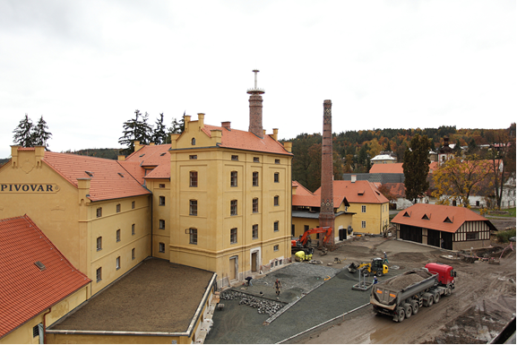
Intervention area: 5.2 Improving the environment in problematic housing estates
Name of the project, registration number: CZ.1.06/5.2.00/07.08102 Safe living in Orlová-Poruba
Beneficiary: Town of Orlová
Project funding: total budget – CZK 4 152 678,- (ERDF 3 529 776 + SB 622 901)

The implementation of the project aims to improve the quality of life of residents of a problematic housing estate by revitalising the environment in Poruba city district. This city zone represents a part of the city with the widest negative disproportions and a high concentration of social problems. It is one of the activities fulfilling the main aim of IUDP Orlová – to create an attractive and pleasant place for living that will meet the requirements for modern living and leisure time activities for all generations of inhabitants.

Intervention area: 5.3 – Modernisation and development of systems for territorial policy development
Name of the project, registration number: Territorial plan of the town of Sušice, CZ.1.06/5.3.00/17.08527
Beneficiary: Town of Sušice
Project funding: total budget – CZK 580 497, (SF contribution – CZK 493 422, SB contribution - CZK 87 075)

The subject matter of the project is the elaboration of the territorial plan of the town of Sušice in compliance with all the legislation and standards related to the subject matter, particularly with Act No 183/2006 Coll., on Spatial Planning and the Building Code, as amended. It is complemented by surveys and analyses, cooperation on the preparation of the terms of reference of the territorial plan and modification of the proposal for the territorial plan following its discussion are not included in the project.
The project financing has been completed and the expenditure has been certified.

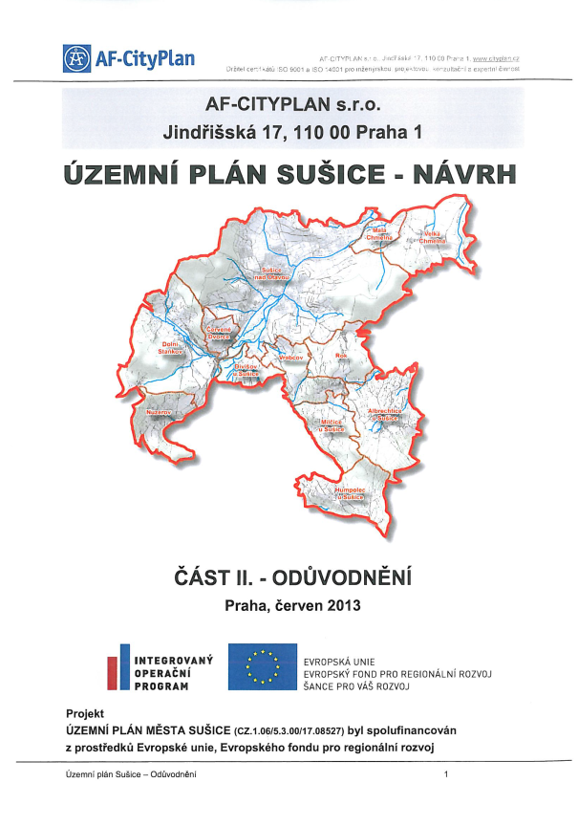

3.6 Priority axis 6a, 6b – Technical assistance

3.6.1 Focus of priority axes/intervention areas

The priority axes comprise activities which are inseparable as to their geographical scope and which have an impact on the whole territory of the CR. Their content is therefore identical, regardless their classification by objective. Priority axes 6a and 6b focus on the support of effective management of the Integrated Operational Programme throughout the programming period 2007 – 2013.

The Priority axis covers the Convergence objective (6a) and the Regional Competitiveness and Employment objective (6b).

Specific goals:
- Reinforcing administrative capacities involved in programme implementation at the level of the Managing Authority and Intermediate Bodies,
- Ensuring effective management, monitoring, evaluation, controls and absorption capacity in implementing the operational programme at the level of the Managing Authority and Intermediate Bodies.

Beneficiaries:
- Managing Authority,
- Intermediate Bodies.

3.6.2 Progress achieved in implementation of priority axes/intervention areas

In Intervention areas 6.1a and 6.1b, in the monitored period 6 new project applications in the amount of EUR 4.12 million were submitted. As of 1 Apr 2014, a total 48 project applications in the amount of EUR 39.77 million were submitted, which represents 152 % of the allocation. In the monitored period, funds in the amount of EUR 3.24 million were paid to beneficiaries. As compared to the previous period, there was a marked increase in the amount of certified expenditure by EUR 7.18 million. The certified expenditure reached the amount of EUR 16.88 million, which represents 59 % of the allocation.

- Cumulative progress at the level of Intervention area 6.1a and 6.1b (in million CZK/EUR)
6.1.a | 2007-2013 allocation |  | Submitted applications |  |  |  | Projects with issued Decision/signed Contract |  |  |  | Funds paid to beneficiaries |  |  | Funds included in aggregate payment claims accounted for by the PCA |  |  | Certified expenditure submitted to the EC
 | CZK (a) | EUR | num-ber | CZK (b) | % (b/a) | EUR | num-ber | CZK (c) | % (c/a) | EUR | CZK (d) | % (d/a) | EUR | CZK (e) | % (e/a) | EUR | CZK (f) | % (f/a) | EUR
Current MC | 706,13 | 27,18 | 48 | 1070,90 | 152% | 39,05 | 46 | 752,76 | 107% | 27,45 | 459,00 | 65% | 16,74 | 447,06 | 63% | 17,73 | 418,63 | 59% | 16,58
Previous MC | 689,53 | 27,18 | 42 | 959,84 | 139% | 35,00 | 42 | 691,49 | 100% | 25,22 | 371,75 | 54% | 13,56 | 345,44 | 50% | 13,78 | 237,48 | 34% | 9,53
6.1.b | 2007-2013 allocation |  | Submitted applications |  |  |  | Projects with issued Decision/signed Contract |  |  |  | Funds paid to beneficiaries |  |  | Funds included in aggregate payment claims accounted for by the PCA |  |  | Certified expenditure submitted to the EC
 | CZK (a) | EUR | num-ber | CZK (b) | % (b/a) | EUR | num-ber | CZK (c) | % (c/a) | EUR | CZK (d) | % (d/a) | EUR | CZK (e) | % (e/a) | EUR | CZK (f) | % (f/a) | EUR
Current MC | 12,98 | 0,50 | 0 | 19,69 | 152% | 0,72 | 0 | 13,84 | 107% | 0,50 | 8,44 | 65% | 0,31 | 8,22 | 63% | 0,33 | 7,70 | 59% | 0,30
Previous MC | 12,68 | 0,50 | 0 | 17,65 | 139% | 0,64 | 0 | 12,71 | 100% | 0,46 | 6,84 | 54% | 0,25 | 6,35 | 50% | 0,25 | 4,37 | 34% | 0,18

In Intervention area 6.2a and 6.2b, a total of 73 project applications in the amount of EUR 12.62 million has been submitted. The number of projects with issued Decision on providing a grant increased from 65 to 68 and the amount grew by EUR 0.1 million to the total amount of EUR 6.65 million (99 %). The funds paid to beneficiaries reached EUR 3.36 million (50 %) and the funds included in the aggregate payment claims accounted for by the PCA equalled EUR 3.66 million (50 %). The certified expenditure represents EUR 3.52 million.

- Cumulative progress at the level of Intervention area 6.2a and 6.2b (in million CZK/EUR) 8
6.2.a | 2007-2013 allocation |  | Submitted applications |  |  |  | Projects with issued Decision/signed Contract |  |  |  | Funds paid to beneficiaries |  |  | Funds included in aggregate payment claims accounted for by the PCA |  |  | Certified expenditure submitted to the EC
 | CZK (a) | EUR | num-ber | CZK (b) | % (b/a) | EUR | num-ber | CZK (c) | % (c/a) | EUR | CZK (d) | % (d/a) | EUR | CZK (e) | % (e/a) | EUR | CZK (f) | % (f/a) | EUR
Current MC | 181,13 | 6,90 | 73 | 339,71 | 188% | 12,39 | 68 | 178,99 | 99% | 6,53 | 90,54 | 50% | 3,30 | 90,54 | 50% | 3,59 | 87,09 | 48% | 3,46
Previous MC | 456,89 | 17,86 | 67 | 331,61 | 73% | 12,09 | 65 | 176,30 | 39% | 6,43 | 87,52 | 19% | 3,19 | 83,78 | 18% | 3,34 | 64,78 | 14% | 2,59
6.2.b | 2007-2013 allocation |  | Submitted applications |  |  |  | Projects with issued Decision/signed Contract |  |  |  | Funds paid to beneficiaries |  |  | Funds included in aggregate payment claims accounted for by the PCA |  |  | Certified expenditure submitted to the EC
 | CZK (a) | EUR | num-ber | CZK (b) | % (b/a) | EUR | num-ber | CZK (c) | % (c/a) | EUR | CZK (d) | % (d/a) | EUR | CZK (e) | % (e/a) | EUR | CZK (f) | % (f/a) | EUR
Current MC | 3,33 | 0,13 | 0 | 6,25 | 188% | 0,23 | 0 | 3,29 | 99% | 0,12 | 1,67 | 50% | 0,06 | 1,67 | 50% | 0,07 | 1,60 | 48% | 0,06
Previous MC | 8,40 | 0,33 | 0 | 6,10 | 73% | 0,22 | 0 | 3,24 | 39% | 0,12 | 1,61 | 19% | 0,06 | 1,54 | 18% | 0,06 | 1,19 | 14% | 0,05

The following is applicable to all the tables above:
Source: Current MC – MSC2007 as of 3 Apr 2014
Previous MC – MSC2007 as of 2 Oct 2013
CZK/EUR exchange rate: Current MC – 27.423
Previous MC – 25.690
Source of funding –public funds total

Overview of ongoing calls

In Intervention area 6.1, applications continued to be submitted under the continuous call No 01 with the allocation of EUR 29.7 million. Under this call, 48 project applications in the amount of EUR 29.7 million were submitted. 45 projects totalling EUR 43.2 million were approved.

In Intervention area 6.2, call No 10 with the allocation of EUR 11.7 million was under way. Under this call, 49 projects in the amount of EUR 5.8 million were submitted. Altogether 45 project applications in the amount of EUR 4.5 million were approved.

- Overview of ongoing calls in the period from 1 Oct 2013 to 31 Mar 2014 in Priority axis 6
Order of the call | Num-ber of the call | Submission of project applications |  | Type of the call | IA | Allocation for the call  in EUR | Submitted applications for support |  | Projects with issued Decision/
 |  |  |  |  |  |  |  |  | signed Contract
 |  | Opening date of the call | Closing date of the call |  |  | in EUR | number | in EUR | number | in EUR
5 | 1 | 5.6.2008 | 30.9.2015 | continuous | 6.1. | 29 218 512 | 48 | 47 623 001 | 45 | 42 411 393
 |  |  |  |  |  | 537 236 |  | 875 536 |  | 779 722
 |  |  |  | Call total |  | 29 755 749 | 48 | 48 498 537 | 45 | 43 191 116
37 | 10 | 27.9.2010 | 30.9.2015 | continuous | 6.2. | 11 458 354 | 49 | 5 747 397 | 45 | 4 470 068
 |  |  |  |  |  | 210 683 |  | 105 664 |  | 82 181
 |  |  |  | Call total |  | 11 669 037 | 49 | 5 853 061 | 45 | 4 552 249
CONV total |  |  |  |  |  | 40 676 866 | 97 | 53 370 398 | 90 | 46 881 462
RCE total |  |  |  |  |  | 747 919 |  | 981 200 |  | 861 903
PA 6 total |  |  |  |  |  | 41 424 785 | 97 | 54 351 597 | 90 | 47 743 364
Source: IS Monit7+ as of 1 Apr 2014
CZK/EUR exchange rate: 27.423
Source of funding – public funds total

3.6.3 Fulfilment of indicators

The achieved value as of 31 Mar 2014 and the commitments of approved projects in Intervention areas 6.1 and 6.2 correspond to the rate of absorption of IOP TA funds. They cannot be compared against the target values that were set out based on the original methodology of IOP TA indicators. The commitments of approved projects in IOP TA were set out in line with the revised methodological sheets of indicators of 2009.

- Output indicators
Code | Name of indicator | Unit of measurement | Baseline value | Target value  CONV | Target value RCE | Commit-ment of approved projects CONV | Commit-ment of approved projects RCE | Achieved value as of  2 Apr 2014
480500 | Number of elaborated studies and reports (incl. evaluation ones) | Number | 0 | 13 | 1 | 1175 | 0 | 1099
480700 | Number of developed methodological and technical and information materials | Number | 0 | 82 | 2 | 315 | 0 | 258
481100 | Number of held training courses, seminars, workshops, conferences and other similar activities | Number | 0 | 69 | 1 | 428 | 0 | 317
481600 | Number of persons who attended the educational courses in the framework of technical assistance | Number | 0 | 1372 | 28 | 8439 | 0 | 7731
480800 | Implemented cooperation with mass media and communication with the general public | Number | 0 | 29 | 1 | 147 | 0 | 142
480900 | Number of organised information and publicity activities | Number | 0 | 30 | 2 | 187 | 0 | 146
483100 | Number of full-time employees of the implementation structure | Number | 0 | 89 | 1 | 643,52 | 0 | 512,14
Source: MSC2007 as of 2 Apr 2014

- Result indicators
Code | Name of indicator | Unit of measurement | Baseline value | Target value  CONV | Target value RCE | Commit-ment of approved projects CONV | Commit-ment of approved projects RCE | Achieved value as of  2 Apr 2014
481900 | Number of trained persons – total | Number | 0 | 1 078 | 22 | 4937 | 0 | 3839
480300 | Number of meetings of (monitoring, advisory and management) committees | Number | 0 | 13 | 1 | 17 | 0 | 15
482500 | Number of performed controls | Number | 0 | 1 323 | 27 | 7844 | 0 | 7461
Source: MSC2007 as of 2 Apr 2014

3.6.4 Problems and measures taken

Problem
Financing of the administrative capacities until the end of the programming period

The main issue addressed by the IOP MA in the monitored period was the need to decide well ahead on financing of the administrative capacities until the end of 2015, to ensure the administrative capacities for monitoring the sustainability of projects from 2016 on, and to ensure the administrative capacities for successful closure of IOP.

Measures taken
In order to ensure the financing of all expenditure covered from IOP TA, the IOP MA made a change in calls No 2 and 10, under which the eligibility of expenditure was extended until 31 Dec 2015 and the implementation of projects until 30 Nov 2015.

Concurrently, as of 28 Feb 2014, the Handbook for Applicants and Beneficiaries for Priority axis 6a, 6b Technical assistance was revised.

Key points of the revision:
- Extension of eligibility of expenditure until 31 Dec 2015;
- Simplification of evidencing the expenditure lower than CZK 10 000,- to a single accounting document.

4 ADMINISTRATION OF THE PROGRAMME

4.1 Information on the Conduct and Results of Audits and Financial Controls

Audits of the European Commission

System audit of the European Commission No 2012/CZ/REGIO/J4/1173/1

In the previous Report on Implementation of IOP, the Managing Authority informed about the audit of the European Commission conducted in the period from 8 to 12 Apr 2013 at the Audit Authority, the Paying and Certifying Authority, at the National Coordination Authority of NSRF and in selected operational programmes. The audit focused on effectiveness of functioning of management and control systems. The audit was carried out at the Managing Authority of IOP and at selected Intermediate Bodies (i.e. at the MoH CR, CRD CR and MoI CR). As of 31 Mar 2014, the audit was not completed.

Audit of the European Commission No 2013/CZ/REGIO/C4/1309/1
In the period from 18 to 22 November 2013, the audit of the European Commission No 2013/CZ/REGIO/C4/1309/1 was carried out at the Paying and Certifying Authority. The audit focused especially on verification of processes at the level of PCA and concerned also the activities of the IOP Managing Authority. The IOP MA provided the auditors with requested information in accordance with Annex 3 to the Implementing Regulation, with information on irregularities and the annual statement of amounts as defined in Article 20 (2) of the Implementing Regulation. Based on the available information of IOP MA, as of 31 Mar 2014 the audit was not completed.

Audits conducted by the Supreme Audit Office

Audit No 13/12 of SAO
The SAO Board on its meeting held on 2 Dec 2013 approved the audit conclusion from audit No 13/12 - “Funds spent on the preparation, implementation and operation of the system of basic registers“. The audit focused on project No CZ.1.06/1.1.00/03.05889 – Register of Inhabitants (hereinafter referred to as “ROI”), on project No CZ.1.06/1.1.00/03.05890 - Register of Rights and Obligations (hereinafter referred to as the “RPO“) and on project No CZ.1.06/1.1.00/03.05891 - Information System of Basis Registers” (hereinafter referred to as “ISBR“). The audit concentrated on procedures of preparation, implementation, operation and administration of the referred to projects. As of 30 Jun 2013, the MoI CR and the National Registers Authority (hereinafter referred to as the “NRA”) spent a total of CZK 1 602 925 637 on the referred to activities and expenditure amounting to CZK 1 556 655 928 was audited.

According to the SAO, the MoI CR caused a delay in the launch of operation of basic registers by drawing up addenda to tender documentation, providing additional information and by concluding a contract on implementation of ISBR only after a year following the issuance of the decision on selection of the best bid, by which it violated Act No 137/2006 Coll., on Public Contracts (Public Procurement Act). The delays were also brought about by decisions of the Office for the Protection of Competition, which revoked the decisions of the Evaluation Committees on selection of the best bids for ROI and RRO.
The SAO believes that the expert evaluation of technological solution of projects on basic registers suggested that risky in the implementation of basic register projects were the requirements of suppliers for the provision of data centres. The MoI CR, despite the referred to warning, during the implementation of projects on ISBR (ISZR), ROI (ROB) and RRO (RPP) failed to provide the suppliers with the data centres within the deadlines set in the concluded contracts. For this reason the dates of acceptance of completed projects were postponed. Another reason of delays were the shortcomings in the management of projects on ISBR, ROI and RRO.

According to the SAO, the MoI CR delegated to the NRA the responsibility for ensuring data centres, where the technology of basic registers should be placed. The NRA was pressed for time when it concluded contracts on provision of services of data centres due to the necessity to observe the deadline for the basic registers going live. The NRA did not examine whether or not the use of other centres would be more cost-effective.
The SAO also identified a risk concerning the use of the system of basic registers, namely that as of 30 Jun 2013 a total of 15 % of municipalities with extended powers failed to satisfactorily notify their powers in the registered agendas. Without the notification of powers in the registered agenda the public authorities cannot access the data in basic registers.

The way of financing the operation of basic registers in 2013 - 2015 period was approved by Resolution No 661 of the CR Government of 12 September 2012 on providing financial support to the operation of basic registers in 2013-2015 period. As to the conditions for financing from the EU funds, the sustainability of basic registers projects for the period of five years following the completion of project implementation shall be ensured. By the end of the SAO audit, the way of financing of the operation of basic registers in 2016 - 2018 period in order to ensure the project sustainability has not been identified. After a one year of operation of basic registers, the ISBR performed its function, i.e. facilitated an access to basic registers and the use of data stored therein; the ROI kept the data on natural persons; RRO was prepared in keeping with the concept of managing the access of all agenda information systems and their users to the basic registers' services. Nonetheless, the RRO failed to meet the objectives of its reference section since it could not use the reference data on legislation obtained from the inputs of eCollection project or the information helping to optimise the public administration processes obtained from the project called Process modelling of agendas because these projects have not yet been completed.
Opinion of the MoI CR on the audit conclusion of SAO

The MoI disagrees with the statement that the project management showed deficiencies that resulted in delays in the implementation of projects. Even though the number of posts at the persons responsible for the project was not increased as originally planned, the projects were seamlessly managed by a small team of employees and headed clearly to the development of registers. Also the activities performed by a higher level of project management, especially the Coordination Board of the Basic Registers, went well. The MoI also disagrees with the generalising conclusion that the main reason of extension of deadlines for the acceptance of completed projects was the failure to provide the data centres within the deadlines set in the concluded contracts. Although a part of the purchased HW was for about a half a year placed in substitute data centres, the equipment and data were moved to the designated data centres before 1 July 2012. In this context, the MoI stresses the fact that the System of basic registers was granted the ”The Best IT project in 2012” award by the Czech Association of Chief Information Officers.

The notification of powers in agendas is in accordance with the Act on Basic Registers the responsibility of individual municipalities. Since the enforceability of the notification of powers in agendas is not stipulated in the legislation, the NRA, beyond the scope of its obligations, decided to hold a number of seminars in the course of 2013 for municipalities with extended powers and other bodies with the view to improve their awareness of obligations ensuing from the Act on Basic Registers.

By Government Resolution No 661 of 12 September 2012 concerning the financing of support for the operation of basic registers in the period from 2013 to 2015, the budgetary chapters of administrators and operators of basic registers were topped up. Since the increase equals 50 % of the total payment for services associated with the operation of basic registers and no discount was negotiated with Česká pošta, s.p. (Czech Post), or Státní tiskárna cenin, s.p. (Security Printed Works), there is a risk of reducing the creation and development of additional services and projects envisaged by the eGovernment 2014+ strategy.

The SAO agreed with the MoI finding that the operation of projects on ROI (ROB), RRO (RPP) and ISBR (ISZR) was at the time of the control fully functional and fulfilled the expectations in terms of impacts and effectiveness. The operation of basic registers in compliance with the Act on Basic Registers was launched on 1 July 2012 and at present the basic registers, together with the information system of data boxes and the Czech POINT system, constitute indispensable components of the Czech eGovernment.

Controls of basic registers carried out by the MoI CR and IOP MA
The IOP MA and the MoI CR Intermediate Body carried out controls of all projects of basic registers. In 2013, the MoI CR imposed financial corrections in the course of controls of tenders for an implementor of RRO, ROI and ISBR. The finding was confirmed by the Audit Authority within the audit of operations 2013.
Based on the results of the control of contract award procedures at the MoI CR, the IOP MA decided to carry out a control of all approved contracts as a control of completeness of documents in 267 tenders and a physical check in a total of 244 tenders (letter with Ref. No MV-81657-1/OSF-2013 of 1 July 2013). By the end of 2013, those tenders were checked the funds of which were certified in 2013 (altogether 129 tenders). If an error was identified, financial corrections were applied. In 2013, a total of 142 checks of public contracts were commenced, in 32 cases administrative errors were detected and in 11 public contracts an error was identified, which resulted in an application of financial correction.
MoI CR controls all tender documentation before the launch of the contract award or tender procedure in the amount of CZK 200 000 or more; therefore it tries hard to prevent the occurrence of ineligible expenditure. It checks the documentation before the contract is signed with the contractor if the expected value of delivery exceeds the amount of CZK 499 999.9 and after the contract with the contractor is signed.
Audit No 13/24 SAO
The SAO audit No 13/24 was commenced on 12 Jun 2013 at the project No CZ.1.06/1.1.00/07.06384 National infrastructure for electronic public procurement, the beneficiary of which is the MRD CR. As of 31 Mar 2014, the SAO audit was not completed since the SAO did not issue the audit conclusion approved by the SAO Board.

Audit No 13/32 SAO
The SAO audit No 13/32 called “Funds earmarked for tourism development“ was commenced at the MRD CR on 17 Sep 2013. As of 31 Mar 2014, the SAO audit was not completed since the SAO did not issue the audit conclusion approved by the SAO Board.

Audit No 14/05
In January 2014, the SAO audit No 14/05 called “Funds earmarked for financing the selected programmes under the responsibility of MoLSA” was commenced at the MoLSA CR IB. According to the MoLSA information the audit concerns also the IOP. As of 31 Mar 2014, the audit was not completed.

Audit of the Audit Authority

Audit of the system of implementation of IOP
Since September 2013 the audit of the system of implementation of the Integrated Operational Programme No IOP/2013/S has been carried out at the IOP MA and the IOP Intermediate Bodies. As of 31 Mar 2014, the audit was not completed by the Audit Authority of the MoF CR.

Follow-up audit of the system No IT/2014/S/01-18
On 4 Feb 2014, the Audit Authority of the MoF CR commenced a system audit at the IOP MA, focused on acting upon the corrective measures ensuing from the Action Plan of the previous system audit No 451/10/SYS, focused on the audit of the monitoring system of the SF and CF for the programming period 2007-2013. As of 31 Mar 2014, the audit was not completed.

Controls conducted by the Paying and Certifying Authority

Control of the PCA at the MoI CR
On 30 Jul 2013, the Paying and Certifying Authority of the MoF CR commenced a control at the Ministry of Interior of the CR. The control focused predominantly on the administration of technical assistance projects, irregularities and activities of the financial section. As of 31 Mar 2014, the control was not completed.

Checks conducted by the Managing Authority (management verifications)

Checks of delegated activities

In the monitored period, checks of delegated activities (hereinafter referred to as the “CDA”), commenced in the previous period, were under way and focused on the verification of compliance of activities performed by the IBs with procedures set out in the IOP Operational Manual, IB manuals and Handbooks for Applicants and Beneficiaries, namely during the control of eligibility, control of formal requisites, evaluation of quality of projects, ex-ante risk analysis and ex-ante control of projects and administration of applications for payment. Also verified is the observance of procedures for entering the data in IS Monit7+ and their archiving. Most of the controls were conducted in the form administrative checks or monitoring visits, which constitute a more flexible tool for an early imposition of corrective measures, and a major stress was also put on time-consuming on-the-spot public administration checks.

In the period from 1 Oct 2013 to 31 Mar 2014, the IOP MA commenced 26 checks of delegated activities at the CRD CR, MoI CR, MoLSA CR, MoC CR and MoH CR. An overview of all the checks, their status and results is given in Table No 48. In the monitored period, 13 checks were commenced and 13 checks were completed, of which 6 with no finding and 7 with a finding. The identified findings concerned primarily the non-compliance with public procurement legislation, labour costs, and formal errors. In the framework of these checks, the expenditure totalling CZK 2 242 014.00 was subject to checks and no ineligible expenditure was identified.

In the monitored period, a total of 26 checks of delegated activities were completed, of which 13 checks were commenced in previous periods (1 in 2012 and 12 in the 1st to 3rd quarter of 2013).

With respect to the error rate identified during the checks of delegated activities performed by the Managing Authority and other control bodies, the IOP MA identified the risk of inadequate number of checks of delegated activities, which especially in the past was brought about by the IOP MA understaffing. In the monitored period, the IOP MA used external suppliers who supplemented the control teams of IOP MA, thanks to which the number of checks as against the past increased. The external suppliers provide a support in the conduct of controls and certainly do not replace the conduct of controls by the IOP MA. Simultaneously, the plan of IOP MA controls for 2013 and also for 2014 specified in detail the risks at each IB, on which the checks of delegated activities focus in 2013 and 2014.

- Summary of checks of delegated activities conducted at IBs in the period from 1 Oct 2013 to 31 Mar 2014
No | Date of commencement | Type of the check | Number of the check | Name of the check | Status of the completed check | Finding | Date of closing/commencement
1. | 1.10.2013 | Administrative check | 51/2013/I | Reporting irregularities at MoI CR, completion of the Individual Report of Irregularity | Completed - Negative (with a finding) | Individual Reports of Irregularity at IOP MA were not properly completed, documents were not sent to the IOP MA in line with the IOP OM, notification of the cuts of the AP was not sent to the Tax Office. | 4.11.2013
2. | 3.10.2013 | Administrative public administration check | 61/2013/I | Check of delegated activities at CRD focused on steps taken in case the application for payment was cut | Completed - Negative (with a finding) | Duplicate correction of expenditure in the amount of CZK 78 004.06 in the AP. IB was asked to pay the amount concerned to the beneficiary as a supplementary payment. | 22.10.2013
3. | 10.10.2013 | Administrative public administration check | 64/2013/I | Revision of CRD control findings with respect to the AP | Completed - Positive  (no finding) |  | 18.10.2013
4. | 10.10.2013 | Administrative public administration check | 43/2013/I | Administrative public administration check – check of deadlines in administration | Completed - Positive  (no finding) |  | 29.10.2013
5. | 11.10.2013 | Administrative public administration check | 63/2013/I | Revision of CRD opinion on the public contract | Completed - Positive  (no finding) |  | 23.10.2013
6. | 17.10.2013 | Administrative public administration check | 62/2013/I | Check of CRD steps taken with respect to tender No 078 in project No %6285 | Completed - Negative (with a finding) | The correction set by the CRD was not confirmed by the IOP MA check. | 25.10.2013
7. | 22.10.2013 | Administrative check | 67/2013/I | Check of administration of the AP - MoI | Commenced |  | 22.10.2013
8. | 1.11.2013 | Administrative public administration check | 68/2013/I | Revision of CRD opinion on the tender | Completed - Negative (with a finding) | The IOP MA control authority did not confirm the finding No 2, listed in the Record of the administrative public administration check No 68/2013/I, ensuing from the administrative check of the AP No 01/07388, conducted by the controlled entity - CRD. | 13.11.2013
9. | 6.11.2013 | Administrative public administration check | 70/2013/I | Revision of CRD steps taken with respect to the tender | Completed - Negative (with a finding) | The IOP MA control authority agrees with the CRD finding in line with the Conditions part III, point 2, and cuts in line with the Conditions para 16.5.12, but disagrees with the amount of correction set by the CRD. | 15.11.2013
10. | 6.11.2013 | Administrative check | 71/2013/I | Check of the administration of the AP – MoI | Commenced |  | 6.11.2013
11. | 8.11.2013 | Public administration on-the-spot check | 72/2013/I | Check of delegated activities – check of the evaluation and selection of projects | Commenced |  | 8.11.2013
12. | 13.11.2013 | Administrative check | 74/2013/I | Check of the administration of the AP – MoI | Commenced |  | 13.11.2013
13. | 19.11.2013 | Administrative check | 82/2013/I | Interim administrative check of supporting documents for the aggregate payment claim of the MoH IB projects | Completed - Positive  (no finding) |  | 20.12.2013
14. | 21.11.2013 | Administrative check | 84/2013/I | Check of the administration of the AP – MoI | Commenced |  | 21.11.2013
15. | 22.11.2013 | Administrative public administration check | 83/2013/I | Revision of CRD steps taken in the evaluation of the project application | Completed - Negative (with a finding) | IOP MA disagrees with the results of evaluation of formal criteria of the project application conducted by the CRD branch – Brno. | 2.1.2014
16. | 9.12.2013 | Administrative check | 86/2013/I | Check focused on ensuring and checking the sustainability of projects | Completed - Negative (with a finding) | The annual plan for 2013 was not updated, the conducted ex-post checks failed to control the monitoring of fulfilment of objectives and results of projects and other requirements, the design of ex-post risk analyses fails to determine an adequate sample of projects for an ex-post check. | 23.12.2013
17. | 19.12.2013 | Administrative public administration check | 88/2013/I | Check – sustainability of projects | Commenced |  | 19.12.2013
18. | 17.1.2014 | Administrative check | 2/2014/I | Check of the administration of the AP – MoI | Commenced |  | 17.1.2014
19. | 23.1.2014 | Monitoring visit | 24/2012/I | Monitoring visit – verification of the manner of control of the observance of publicity rules | Completed - Positive  (no finding) |  | 6.2.2014
20. | 3.2.2014 | Administrative check | 9/2014/I | Check of the administration of the AP – MoI | Commenced |  | 3.2.2014
21. | 7.2.2014 | Administrative check | 10/2014/I | Check of the administration of the AP – MoI | Commenced |  | 7.2.2014
22. | 18.2.2014 | Administrative check | 15/2014/I | Check of the administration of the AP – MoI | Commenced |  | 18.2.2014
23. | 27.2.2014 | Administrative check | 19/2014/I | Administrative check of supporting documents for the aggregate payment claim of MoH IB projects | Completed - Positive  (no finding) |  | 24.3.2014
24. | 7.3.2014 | Administrative check | 21/2014/I | Check of the administration of the AP – MoI | Commenced |  | 7.3.2014
25. | 19.3.2014 | Public administration on-the-spot check | 22/2014/I | Check of delegated activities of CRD | Commenced |  | 27.3.2014
26. | 21.3.2014 | Administrative check | 24/2014/I | Check of the administration of the AP – MoI | Commenced |  | 21.3.2014

Checks of projects conducted by the IOP MA

The IOP MA carries out the checks (verifications) of projects (COP), especially upon initiatives of the IBs, beneficiaries and other bodies and based on the risk analyses of individual IBs. In the period from 1 Oct 2013 to 31 Mar 2014, the MA commenced 27 checks of projects directed mainly at public procurement procedures, eligibility of expenditure, and observance of deadlines. Of 27 commenced checks, the IOP MA completed 17 checks, of which 9 with a finding and 8 with no finding. The IOP MA verified the expenditure amounting to CZK 18 637 978.90, of which CZK 2 353 413.00 was ineligible expenditure.

In the monitored period, a total of 21 checks were completed, of which 4 checks from the previous periods. The expenditure totalling CZK 68 810 020.24 was checked and ineligible expenditure in the amount of CZK 2 353 413.00 was identified.

Other checks of the IOP MA – Priority axis 6

In the monitored period, the IOP MA completed one check of delegated activities in Intervention area 6.1, which had been commenced in 2013. Expenditure amounting to CZK 765 143.56 was checked and no ineligible expenditure was identified.

- Overview of IOP MA checks completed in the previous periods
Monitored period | Checks completed in the monitored period |  |  | Checked commenced and completed in the monitored period
 | Checks of delegated activities | Check of projects | Total | Checks of delegated activities | Check of the project | Total
1.10.2013 – 31.3.2014 | 26 | 21 | 47 | 13 | 17 | 30
1.4.2013 – 30.9.2013 | 37 | 11 | 48 | 14 | 9 | 23
1.10.2012 – 31.3.2013 | 31 | 20 | 51 | 21 | 3 | 24
1.4.2012 – 30.9.2012 | 11 | 3 | 14 | 3 | 1 | 4
1.10.2011 – 31.3.2012 | 20 | 17 | 37 | 4 | 4 | 8
1.4.2011 – 30.9.2011 | 10 | 19 | 29 | 4 | 13 | 17
1.10.2010 – 31.3.2011 | 7 | 4 | 11 | 2 | 1 | 3
1.4.2010 – 30.9.2010 | 4 | 3 | 7 | 3 | 1 | 4
Source: MA as of 1 Apr 2014

The Budget Department completed a total of 9 administrative checks in Intervention area 6.1 and 6.2 (5 in IA 6.1 and 4 in IA 6.2), all with a positive result – no finding. Expenditure totalling CZK 21 203 925.00 was verified and no ineligible expenditure was identified.

Checks (verifications) of projects of individual Intermediate Bodies
The checks of projects are the responsibility of the IOP MA who based on a contract delegates the conduct of checks, with the exception of a part of Technical Assistance projects, to the individual Intermediate Bodies, see the table called Overview of bodies conducting the checks of projects. The MA is entitled to carry out its own checks of any of the projects during all stages of project administration. The IOP MA also used the assistance of experts during the checks of physical implementation of projects under the NCA project for support of the conduct of controls and also the assistance ensuing from the framework contract with Cautor company, the winner of the tender. In accordance with Article 13 of Commission Regulation (EC) No 1828/2006, the verifications shall cover administrative, financial, technical and physical aspects of operations, as appropriate. The IOP Operational Manual lays down the minimum requirements for all the Intermediate Bodies concerning the procedures during the checks of projects and the minimum scope of the sample for checks pursuant to Article 13 of Commission Regulation (EC) No 1828/2006. The Intermediate Bodies in line with the IOP Operational Manual have elaborated the detailed procedures for the conduct of checks, including the set methodology for selection of a sample of projects for on-the-spot checks, in case the on-the-spot check is not conducted in 100 % of projects.

- Overview of bodies conducting the checks of projects
Intervention area | Ex-ante check |  | Interim check |  | Ex-post check
 | administrative | on-the-spot | administrative | on-the-spot | administrative | on-the-spot
1.1 | MoI | MoI | MoI | MoI | MoI | MoI
2.1* | CRD,  MoI | MoI | CRD | CRD,  MoI | CRD | CRD,  MoI
3.1 | CRD,  MoLSA | MoLSA | CRD | CRD,  MoLSA | CRD | CRD,  MoLSA
3.2 | MoH | MoH | MoH | MoH | MoH | MoH
3.3 | CRD,  MoLSA | MoLSA | CRD | CRD,  MoLSA | CRD | CRD,  MoLSA
3.4* | CRD,  MoI | MoI | CRD | CRD,  MoI | CRD | CRD,  MoI
4.1 | CRD,  MA | CRD,  MA | CRD | CRD,  MA | CRD | CRD,  MA
5.1** | MoC | MoC | MoC | MoC | MoC | MoC
5.2 | CRD,  MA | CRD,  MA | CRD | CRD,  MA | CRD | CRD,  MA
5.3 | CRD,  MA | CRD,  MA | CRD | CRD,  MA | CRD | CRD,  MA
6.1 | CRD,  MA | - | CRD,  MA | MA | CRD,  MA | MA
6.2 | CRD,  MA | - | CRD,  MA | MA | CRD,  MA | MA
Source: MA as of 1 Apr 2014
* since 1 Jul 2012 all the checks have been conducted by the CRD; ** since 1 Nov 2013 the checks have been conducted by the CRD

In the period from 1 Oct 2013 to 31 Mar 2014, the Intermediate Bodies commenced a total of 759 checks at applicants and beneficiaries. A more detailed breakdown of checks by the form and stage of their conduct in the monitored period is given in the tables below.

- Overview of checks conducted in the period from 1 Oct 2013 to 31 Mar 2014 broken down by intervention area
Row heading | Ex-ante admin. check | Interim admin. check | Ex-post admin. check | Ex-ante physical on-the-spot check | Interim physical on-the-spot check | Interim physical check with reimbursement | Ex-post physical on-the-spot check | Sum total
1.1- MoI | 0 | 1 | 0 | 0 | 2 | 0 | 2 | 5
2.1-MoI* | - | - | - | - | - | - | - | -
2.1-CRD | 1 | 22 | 0 | 0 | 7 | 8 | 27 | 65
3.1 MoLSA | 11 | 15 | 0 | 8 | 0 | 0 | 5 | 39
3.1-CRD | 0 | 28 | 0 | 0 | 2 | 7 | 2 | 39
3.2-MoH | 1 | 1 | 0 | 4 | 21 | 0 | 4 | 31
3.3 MoLSA | 1 | 20 | 0 | 0 | 2 | 0 | 0 | 23
3.3-CRD | 0 | 3 | 0 | 0 | 0 | 0 | 0 | 3
3.4-MoI* | - | - | - | - | - | - | - | -
3.4-CRD | 0 | 45 | 0 | 0 | 4 | 13 | 1 | 63
4.1-CRD | 0 | 36 | 0 | 0 | 4 | 12 | 6 | 58
5.1-MoC/ CRD* * | 0 | 28 | 0 | 0 | 15 | 0 | 0 | 43
5.2-CRD | 9 | 212 | 1 | 0 | 17 | 18 | 63 | 320
5.3-CRD | 0 | 20 | 0 | 0 | 2 | 4 | 21 | 47
6.1-CRD | 0 | 10 | 0 | 0 | 4 | 0 | 0 | 14
6.2-CRD | 0 | 7 | 0 | 0 | 0 | 0 | 2 | 9
Sum total | 23 | 448 | 1 | 12 | 80 | 62 | 133 | 759
Source: MA as of 1 Apr 2014
* since 1 Jul 2012 all the checks have been conducted by the CRD only; ** since 1 Nov 2013 the checks have been conducted by the CRD

Of the total number of checks conducted in the monitored period, 287 were on-the-spot checks. According to the following overview, of the total of 759 checks 138 checks were completed with a negative result (with a finding), 549 checks with a positive result (no finding). In checks completed with a negative result (with a finding), the most frequent error consisted in non-compliance with public procurement legislation, ineligible activities and expenditure (e.g. implementation of activities not planned in the project, implementation of activities in a scope bigger than planned, temporal discrepancy of eligibility of expenditure). In multiple checks deficiencies in the archiving of documents, late submission of applications for payment or violation of conditions of support were identified. There were also errors identified in the process of evaluation of project applications.

- Overview of checks conducted in the period from 1 Oct 2013 to 31 Mar 2014 broken down by check status
Row heading | Check was cancelled | Completed - negative (with a finding) | Completed - positive (no finding) | Corrective measure imposed | Commenced | Scheduled | Sum total
1.1- MoI | 0 | 2 | 2 | 0 | 1 | 0 | 5
2.1-MoI* | - | - | - | - | - | - | -
2.1-CRD | 0 | 9 | 51 | 0 | 5 | 0 | 65
3.1 MoLSA | 0 | 2 | 21 | 0 | 16 | 0 | 39
3.1-CRD | 0 | 13 | 23 | 0 | 0 | 3 | 39
3.2-MoH | 0 | 3 | 26 | 1 | 1 | 0 | 31
3.3 MoLSA | 0 | 1 | 21 | 0 | 1 | 0 | 23
3.3-CRD | 0 | 0 | 3 | 0 | 0 | 0 | 3
3.4-MoI* | - | - | - | - | - | - | -
3.4-CRD | 0 | 9 | 32 | 0 | 22 | 0 | 63
4.1-CRD | 0 | 14 | 42 | 0 | 2 | 0 | 58
5.1-MoC/ CRD** | 0 | 0 | 43 | 0 | 0 | 0 | 43
5.2-CRD | 0 | 84 | 222 | 0 | 14 | 0 | 320
5.3-CRD | 0 | 0 | 47 | 0 | 0 | 0 | 47
6.1-CRD | 0 | 1 | 9 | 0 | 4 | 0 | 14
6.2-CRD | 0 | 0 | 7 | 0 | 2 | 0 | 9
Sum total | 0 | 138 | 549 | 1 | 68 | 3 | 759
Source: MA as of 1 Apr 2014
* since 1 Jul 2012 all the checks have been conducted by the CRD only; ** since 1 Nov 2013 the checks have been conducted by the CRD

The breakdown by the number of checks conducted by individual Intermediate Bodies under the respective intervention areas is presented in the following table.

- Overview of checks conducted in the period from 1 Oct 2013 to 31 Mar 2014 broken down by number of checks per IB
Control Authority | Intervention area |  |  |  |  |  |  |  |  |  |  |  | Sum total
 | 1.1 | 2.1 | 3.1 | 3.2 | 3.3 | 3.4 | 4.1 | 5.1 | 5.2 | 5.3 | 6.1 | 6.2
CRD CR | 0 | 65 | 40 | 0 | 3 | 57 | 57 | 43 | 323 | 47 | 15 | 11 | 661
Ministry of Culture CR | - | - | - | - | - | - | - | - | - | - | - | - | -
Ministry of Labour and Social Affairs | - | - | 39 | - | 23 | - | - | - | - | - | - | - | 62
Ministry of Interior CR | 5 | - | - | - | - | - | - | - | - | - | - | - | 5
Ministry of Health CR | - | - | - | 31 | - | - | - | - | - | - | - | - | 31
Sum total | 5 | 65 | 79 | 31 | 26 | 57 | 57 | 43 | 323 | 47 | 15 | 11 | 759
Source: IS Monit7+ IOP as of 1 Apr 2014
Checks of projects by intervention area

- Overview of checks conducted in the period from 1 Oct 2013 to 31 Mar 2014 in IA 1.1
IA | Ex-ante admin. check | Interim admin. check | Ex-post admin. check | Ex-ante physical on-the-spot check | Interim physical on-the-spot check | Interim physical check with reimbursement | Ex-post physical on-the-spot check | Sum total of commenced checks | Completed negative (with a finding) | Completed positive (no finding)
1.1 – MoI | 0 | 1 | 0 | 0 | 2 | 0 | 2 | 5 | 2 | 2
Source: IS Monit7+ IOP as of 1 Apr 2014

In the monitored period the introduction of controls of contract award/tender procedures prior to signing the contract with the contractor proved positive. Majority of errors made by beneficiaries was detected at the stage when they could still be remedied. No ineligible expenditure was thus incurred. Based on the result of the IOP MA check, the Ministry of Interior conducted a repeated check of public contracts No 5/2012/I. Other findings concerned the unjustified award of bonuses to the members of implementation teams.

In total, expenditure in the amount of CZK 417 466 015.00 was verified in Intervention area 1.1 and CZK 850 029.00 was identified as ineligible expenditure.

- Overview of checks conducted in the period from 1 Oct 2013 to 31 Mar 2014 in IA 3.1 and 3.3
IA | Ex-ante admin. check | Interim admin. check | Ex-post admin. check | Ex-ante physical on-the-spot check | Interim physical on-the-spot check | Interim physical check with reimbursement | Ex-post physical on-the-spot check | Sum total of commenced checks | Completed negative (with a finding) | Completed positive (no finding)
3.1 – MoLSA | 11 | 15 | 0 | 8 | 0 | 0 | 5 | 39 | 2 | 21
3.3 – MoLSA | 1 | 20 | 0 | 0 | 2 | 0 | 0 | 23 | 1 | 21
Source: IS Monit7+ IOP as of 1 Apr 2014

A large proportion of projects in these intervention areas are under implementation, which is why the interim administrative checks prevailed. Many other checks were ex-ante administrative checks which were related to the evaluation of quality of project applications. The checks were largely completed as positive with no finding. In checks completed as negative, especially unauthorised reimbursement of ineligible expenditure was detected. Where corrected measures were imposed, all were accomplished within the monitored period.

With regard to a small number of findings, the Intermediate Body did not have to adopt any radical measures. The checks continuously focused on controls of projects at the time of sustainability.

In total, in Intervention area 3.1 expenditure amounting to CZK 49 494 030.00 was verified and CZK 2 416 398.00 was identified as ineligible expenditure. In Intervention area 3.3, expenditure in the amount of CZK 90 338 332.00 was verified and no ineligible expenditure was identified.

- Overview of checks conducted in the period from 1 Oct 2013 to 31 Mar 2014 in IA 3.2
IA | Ex-ante admin. check | Interim admin. check | Ex-post admin. check | Ex-ante physical on-the-spot check | Interim physical on-the-spot check | Interim physical check with reimbursement | Ex-post physical on-the-spot check | Sum total of commenced checks | Completed negative (with a finding) | Completed positive (no finding)
3.2 – MoH | 1 | 1 | 0 | 4 | 21 | 0 | 4 | 31 | 3 | 26
Source: IS Monit7+ IOP as of 1 Apr 2014

In this intervention area interim monitoring visits prevailed, made usually prior to the approval of the monitoring report and application for payment. A higher number of monitoring visits is closely related to the number of projects stages nearing their completion. A total of 3 checks were completed as negative with a finding, the imposed corrective measures concerned the update of data in contracts for management services and update of the website consisting in adding the information on the project. Corrective measures were accomplished within the set deadline.

In total, in Intervention area 3.2 expenditure amounting to CZK 332 958 190.25 was verified and CZK 1 935 946.63 was identified as ineligible expenditure.

- Overview of checks conducted in the period from 1 Oct 2013 to 31 Mar 2014 by CRD
IA | Ex-ante admin. check | Interim admin. check | Ex-post admin. check | Ex-ante physical on-the-spot check | Interim physical on-the-spot check | Interim physical check with reimbursement | Ex-post physical on-the-spot check | Sum total of commenced checks | Completed negative (with a finding) | Completed positive (no finding)
2.1 – CRD | 1 | 22 | 0 | 0 | 7 | 8 | 27 | 65 | 9 | 51
3.1 – CRD | 0 | 28 | 0 | 0 | 2 | 7 | 2 | 39 | 13 | 23
3.3 – CRD | 0 | 3 | 0 | 0 | 0 | 0 | 0 | 3 | 0 | 3
3.4 – CRD | 0 | 45 | 0 | 0 | 4 | 13 | 1 | 63 | 9 | 32
4.1 – CRD | 0 | 36 | 0 | 0 | 4 | 12 | 6 | 58 | 14 | 42
5.1 – MoC/  CRD | 0 | 28 | 0 | 0 | 15 | 0 | 0 | 43 | 0 | 43
5.2 – CRD | 9 | 212 | 1 | 0 | 17 | 18 | 63 | 320 | 84 | 222
5.3 – CRD | 0 | 20 | 0 | 0 | 2 | 4 | 21 | 47 | 0 | 47
6.1 – CRD | 0 | 10 | 0 | 0 | 4 | 0 | 0 | 14 | 1 | 9
6.2 – CRD | 0 | 7 | 0 | 0 | 0 | 0 | 2 | 9 | 0 | 7
Source: IS Monit7+ IOP a of 1 Apr 2014

The most frequent findings identified during the checks conducted by the CRD CR are errors in tenders that resulted in corrections of eligible expenditure. Other findings consisted in the violation of Conditions for the Decision on providing a grant such as a late submission of the monitoring report, applications for payment, no or late submission of the Notification of changes (modifications) in projects, or errors in these notifications resulting in extension of administration.

In order to prevent a repeated occurrence of the most frequent findings, the CRD CR published on its website the most frequently asked questions (FAQ) and the respective answers, holds training courses for its branches and updates the checklists. Moreover, it offers consultations at CRD CR branches, seminars for applicants and beneficiaries on completion of the MR/AP in selected beneficiaries so as to reduce the error rate.
In Intervention area 3.4, the CRD CR measures are directed at consultations and preparation and implementation of tenders at branches, exploitation of experts for evaluation of public contracts, and checks of submitted tender documentation and status of implementation of public contracts.
In Intervention area 4.1, the experts are used for matters related to the state aid and marketing and elaboration of opinions of consultants with respect to 3E. The submitted tender documentation, status of tendering and implementation of the contract award procedures are monitored.

Intervention area 5.1 is subject to intensified monitoring of the implementation of projects. After the agenda was transferred from the Ministry of Culture to the CRD CR, meetings were held with individual beneficiaries and at each beneficiary a monitoring visit took place. In November 2013, a seminar was held for beneficiaries about the change in the grant provider and its impacts on beneficiaries. Physical on-the-spot checks are carried out at least twice a year in each project, together with the verification of feasibility of the financing plan for the given stage with a link to the conduct of tenders. Assistance of experts is also used to support the control of public contracts, assessment of frequent extra work and construction changes in projects, which arise in connection with the implementation of extensive projects on renovation of monuments.

In Intervention area 5.2, the beneficiaries show small experience with projects, which is why a number of published questions (FAQ) and answers is intended for these beneficiaries.

With regard to Intervention areas 6.1 and 6.2, consultations are offered at the CRD CR branch, and the Working group for technical assistance has been set up. Efforts are exerted to simplify the evidencing requirements.

In Intervention area 2.1, expenditure totalling CZK 532 640 407.48 was verified by the CRD CR and CZK 5 177 657.11 was identified as ineligible expenditure.

In Intervention area 3.1, expenditure in the amount of CZK 78 272 680.06 was verified and CZK 340 707.00 was identified as ineligible expenditure.

In Intervention area 3.3, expenditure in the amount of CZK 274 231 843.00 was verified and no ineligible expenditure was identified.

In Intervention area 3.4, expenditure in the amount of CZK 819 871 422.86 was verified and CZK 472 031.76 was identified as ineligible expenditure.

In Intervention area 4.1, expenditure in the amount of CZK 671 503 259.81 was verified and CZK 515 279.26 was identified as ineligible expenditure.

In Intervention area 5.1, expenditure in the amount of CZK 454 911 540.50 was verified and no ineligible expenditure was identified.

In Intervention area 5.2, expenditure in the amount of CZK 1 780 442 296.48 was verified and CZK 38 301 844.72 was identified as ineligible expenditure.

In Intervention area 5.3, expenditure in the amount of CZK 27 547 071.00 was verified and no ineligible expenditure was identified.

In Intervention area 6.1, expenditure in the amount of CZK 39 401 378.89 was verified and CZK 905 637.74 was identified as ineligible expenditure.

In Intervention area 6.2, expenditure in the amount of CZK 5 267 155.01 was verified and CZK 49 548.12 was identified as ineligible expenditure.

In total, the Intermediate Bodies in the monitored period verified CZK 5 574 345 622.34 and the checks identified CZK 50 965 079.34 of ineligible expenditure.

- Overview of verified expenditure in the period from 1 Oct 2013 to 31 Mar 2014 broken down by IB
Row heading | Volume of verified expenditure in CZK | Volume of expenditure identified in verifications as ineligible in CZK
1.1- MoI | 417 466 015,00 | 850 029,00
2.1-MoI* | - | -
2.1-CRD | 532 640 407,48 | 5 177 657,11
3.1 MoLSA | 49 494 030,00 | 2 416 398,00
3.1-CRD | 78 272 680,06 | 340 707,00
3.2-MoH | 332 958 190,25 | 1 935 946,63
3.3 MoLSA | 90 338 332,00 | 0,00
3.3-CRD | 274 231 843,00 | 0,00
3.4-MoI* | - | -
3.4-CRD | 819 871 422,86 | 472 031,76
4.1-CRD | 671 503 259,81 | 515 279,26
5.1-MoC/ CRD** | 454 911 540,50 | 0,00
5.2-CRD | 1 780 442 296,48 | 38 301 844,72
5.3-CRD | 27 547 071,00 | 0,00
6.1-CRD | 39 401 378,89 | 905 637,74
6.2-CRD | 5 267 155,01 | 49 548,12
Sum total | 5 574 345 622,34 | 50 965 079,34
Source: IS Monit7+ IOP as of 1 Apr 2014

4.2 Implementation of the Communication Plan and Publicity Activities

The text below gives a description of selected publicity activities of IOP that took place in the monitored period. A detailed list of all the performed activities is included in Annex No 1.

IOP 2013 Annual Conference: Experience and Outlook

The one-day conference organised by the IOP MA took place at the Jindřichův Hradec State Castle and Chateau on 10 October. On the agenda of the conference was the presentation of the to date experience and best practice from the preparation and implementation of projects, supported from the European Union under the Integrated Operational Programme, and information on the preparation of the Integrated Regional Operational Programme 2014-2020.
After the conclusion of the conference agenda the participants visited the project National Museum of Photography and Tapestry Workshop in Jindřichův Hradec.
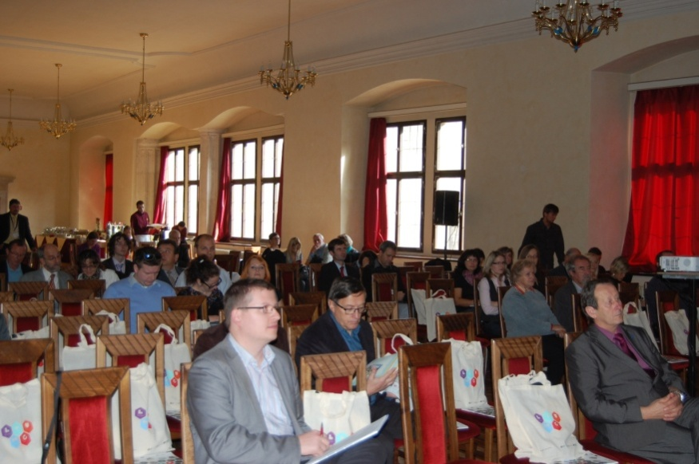
Funding from the IOP TA: CZK 242 000,-
Target group: professional public, mass media, general public

IOP communication campaign on the Czech Radio

In the period from 1 November to 31 December 2013, the IOP communication campaign took place on the Czech Radio and altogether 27 reports on selected IOP projects were recorded and aired. The projects were selected so as to equally represent the CR regions and individual intervention areas. The reports were aired on all 11 regional stations of the Czech Radio, on Radiožurnál and Dvojka.

You can listen to the programmes on the following website: http://www.strukturalni-fondy.cz/cs/Microsites/Integrovany-OP/Novinky_article/Pamatky,-socialni-podniky,-hasicska-technika-a-dal. Together with the reports, 2 518 sponsor's messages were aired on the Czech Radio.

Funding from IOP TA: CZK 3 024 431,-
Target group: general public

IOP pod lupou (Under the Magnifying Glass) Newsletter

In the monitored period, the IOP MA published two issues of the IOP pod lupou quarterly (November 2013 and February 2014). The Newsletter regularly offers the latest information on developments in the Integrated Operational Programme and brings attention to the principal events and successful projects. All the issues are available on the following website: http://www.strukturalni-fondy.cz/cs/Microsites/Integrovany-OP/Informacni-materialy/Newsletter-IOP-pod-lupou.

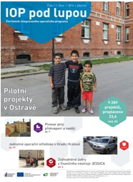
Funding from IOP TA: CZK 64 117,-
Target group: general public

The list of aid beneficiaries under the IOP is published and monthly updated on:

http://www.strukturalni-fondy.cz/cs/Microsites/Integrovany-OP/Zadatele-a-prijemci/Seznam-podporenych-projektu

4.3 Conducted Evaluations and Studies

In the period from October 2013 to March 2014, three internal evaluations of the IOP MA from the Evaluation Plan of IOP for 2013 were completed. The outputs of these evaluations are the final reports which are posted on http://www.strukturalni-fondy.cz/cs/Microsites/Integrovany-OP/O-programu/Dokumenty in the Evaluation and analyses section. No evaluation from the Evaluation Plan of IOP for 2014 was completed in the monitored period, the completion dates are delayed as against the Evaluation Plan.

4.3.1 Evaluations of the Managing Authority

Analysis of administrative capacities and outsourcing in IOP implementation structure 2013
The aim was to determine the actual total costs spent on programme management during the monitored period from 7/2012 to 6/2013 and to compare them with the costs spent in the previous periods.

The analysis followed up on the Analysis of administrative capacities and outsourcing of IOP Intermediate Bodies 2011 and the Analysis of administrative capacities and outsourcing in IOP implementation structure 2012. The monitored period covers 2.5 year from 1 Jan 2011. This longer time span as against the previous analysis allows for preventing the effects of incidental and irregular expenditure and differences in the stage of implementation. The same methodology was employed in order to facilitate comparisons of progress made in individual monitored periods of six months.

Implementation period: July – December 2013
Type of evaluation: internal
Evaluator: IOP MA in cooperation with IBs

Brief summary of conclusions:
By comparing the total financial costs of all IOP implementation structure bodies, as ascertained through the Analysis of the period from 2nd half of 2012 to 1st half of 2013, and the costs ascertained by the Analysis of the previous period, it can be concluded that the total expenditure of the IOP implementation structure slightly decreased primarily thanks to the decrease in the share of expenditure on outsourced services. In the monitored period, the expenditure on services dropped by 6 percentage points (from 15 % in the 1st half of 2012 to 9 % in the 1st half of 2013).

The monitoring of expenditure on education and training of the IOP implementation structure staff reveals major differences in expenditure, which is why the systems of education were evaluated by the Evaluation of the system of education and training of IOP implementation structure staff 2013.

Another indicator is the administrative capacity, namely both in terms of the number of FTE, structure and costs of these FTEs, and the efficiency vis-à-vis the allocation.

- Total number of FTE implementing the IOP as of 30 Jun 2013
and turnover rate in the first half of 2013
 | FTE of skeleton staff  as of 30 Jun 2013 | FTE working on AWP /AWA  as of 30 Jun 2013 | Total number of FTE | Turnover rate (%)
MA | 58,33 | 4,00 | 62,33 | 19,09
CRD | 45,56 | 5,04 | 50,60 | 6,92
MoC | 16,75 | 0,00 | 16,75 | 35,82
MoLSA | 22,05 | 0,00 | 22,05 | 4,54
MoH | 21,00 | 1,50 | 22,50 | 4,44
MoI | 22,63 | 1,65 | 24,28 | 24,71
IOP total | 186,32 | 12,19 | 198,51 | 14,81
Source: Analysis of administrative capacities and outsourcing in IOP implementation structure

The principal part of the analysis consists in assessing the efficiency of individual Intermediate Bodies by comparing the financial costs to the actual performance of administration.

- Total financial costs of administration for the monitored period of 1 year and performance of administration in the period from 7/2012 to 6/2013
From  1 Jul 2012 to  30 Jun 2013 | Total financial costs of administra-tion (CZK) | Number of submitted projects | Number of approved projects | Number of approved applications for payment | Average costs in CZK per 1 submitted project | Average costs in CZK per 1 approved project | Average costs in CZK per 1 approved application for payment
CRD | 36 551 172 | 464 | 556 | 446 | 78 774 | 65 740 | 81 953
MoC | 13 253 899 | 0 | 5 | 49 | NR | 2 650 780 | 270 488
MoLSA | 9 861 420 | 160 | 76 | 48 | 61 634 | 129 756 | NR
MoH | 13 618 516 | 40 | 41 | 24 | 340 463 | 332 158,93 | 567 438,17
MoI | 16 018 529 | 8 | 18 | 46 | 2 002 316 | 889 918 | 348 229
Source: Analysis of administrative capacities and outsourcing in IOP implementation structure

The projects administered by individual IBs differ predominantly in the volume of financial resources and the number and value of controlled public contracts. For the sake of higher objectivity, the annual costs of the volume of submitted and approved projects are compared against the volume of approved applications for payment. In submitted projects the annual costs, as against the volume of projects, are the lowest at MoLSA CR (CZK 5 223), the highest on the contrary at MoI CR (CZK 26 775), whereas the MoC CR spent no funds on the submitted projects. The costs per CZK 1 million in approved projects are the lowest at MoLSA CR (CZK 5 345) and the highest at the MoH CR (CZK 14 423). The costs per CZK 1 million in approved applications for payment are the lowest at the MoC CR (CZK 761), whereas they are the highest at the MoH CR (CZK 15 755).

Another indicator of the performance of administration is the number and value of controlled public contracts.

The largest number of public contracts was in the monitored period approved by the CRD – a total of 2 496 contracts of all types. The largest volume of approved contracts (CZK 2.1 billion) at the CRD is reported in the category of contracts outside the scope of Act No 137/2006 Coll. (a total of 443 contracts). At the MoC CR, the largest volume of above-the-threshold contracts was subject to control (approx. CZK 2.5 billion) - 61 contracts.

The summarising and comprehensive indicator compares the annual financial costs with the earmarked allocation. The highest costs of administration of the received allocation in the monitored period are reported by MoLSA.

- Financial costs of administration as against the allocation in the monitored period
 | 2nd half of 2012 | 1st half of 2013 | SF allocation according to the PD 2007 (CZK) | Semi-annual costs per CZK 1 million of allocation (2nd half of 2012) | Semi-annual costs per CZK 1 million of allocation (1st half of 2013)
CRD | CZK 16 765 095 | CZK 19 786 077 | 19 033 131 769 | 880,84 | 1039,56
MoC | CZK 5 207 334 | CZK 7 046 565 | 5 757 596 250 | 904,43 | 1 223,87
MoLSA | CZK 4 772 556 | CZK 5 088 864 | 1 824 011 028 | 2 616,52 | 2 789,93
MoH | CZK 5 720 767 | CZK 7 897 749 | 6 212 042 650 | 920,92 | 1 271,36
MoI | CZK 9 172 731 | CZK 6 845 798 | 7 840 311 294 | 1169,95 | 873,15
Source: Analysis of administrative capacities and outsourcing in IOP implementation structure
Note: The SF allocation in EUR was converted at the exchange rate of € 1= CZK 25, the financial costs of CRD were increased by 30 % of the MA costs in line with the methodology in Chapter 1.3

The aim of the analysis was to ascertain the total costs of Programme management. In December 2011, the total annual costs of IOP reached the value of CZK 132.8 million, in December 2012 they equalled CZK 118.8 million. Since the total annual costs in 2012 were by CZK 14 million lower than in 2011, it can be stated that the to date rate of absorption complies with the available volume of funds allocated to technical assistance of the Programme, and if the existing trend continues until the end of the programming period, there is no risk of excessive absorption of the IOP TA allocation.

Evaluation of consistency of monitoring indicators with IOP objectives
The aim was to identify the risky areas and to propose to include in the set of indicators the data sources which will facilitate evaluation of accomplishment of individual objectives of intervention areas. The evaluation was triggered by the SAO audit during the control of consistency of monitoring indicators with objectives of Intervention area 5.1 of IOP. Based on this audit, the IOP MA decided to carry out an internal analysis of this consistency in all intervention areas.

Implementation period: December 2012 – December 2013
Type of evaluation: internal
Evaluator: IOP MA

Brief summary of conclusions:
There is no need to modify the monitoring indicators. The methodology of calculation and reporting of indicators, stated in the methodological sheets of indicators, have to be explained or aligned in individual areas. The modified methodology of calculation shall be tried and tested in projects, and where a different method of calculation is used, a change in the value of the monitoring indicator, given in the Decision on providing a grant, shall be initiated.

The indicators which currently achieve less than 50 % of the target value shall be subject to examination.

The Final Report of IOP shall describe changes that occurred throughout the programming period and the associated non-fulfilment or excessive fulfilment of specific indicators.

Evaluation of the system of education and training of IOP implementation structure staff
The Evaluation of the system of education and training of IOP implementation structure staff aimed to check the status of the system of education at the IOP MA and IOP IBs and to propose improvements in the area of planning, implementing and evaluating the educational needs. A partial goal was to assess the consistency of the educational system applied in the IOP with the educational systems of individual institutions within the authority of which the IOP MA and IOP IBs operate, and with the educational activities of the NCA. The implementation of recommendations will lead to enhancing the efficiency of the system, standardisation of education at all levels of implementation, and better planning and reporting of educational activities.

Implementation period: May 2013 – December 2013
Type of evaluation: internal
Evaluator: IOP MA

Brief summary of conclusions:
The evaluation was carried out with the methodological support of an external evaluator. The respondents were all the IOP Intermediate Bodies.

The education plans of employees shall be drawn up with respect to requirements placed on individual job positions and preference shall be given to specialised educational activities over the so called soft motivation training courses.

Majority of employees fail to fully adhere to the education plans, which reduces the chance to apply the knowledge in practice, and thus also the efficiency of the entire system of education. The overall effect of the system of education is also impaired by the high turnover of staff, which results in the loss of acquired skills and experience of the leaving employees.

Evaluation of communication and publicity activities for 2013
In accordance with Commission Regulation (EC) No 1828/2006 setting out rules for the implementation of Council Regulation (EC) No 1083/2006, in 2010 the IOP MA conducted an evaluation of information and publicity measures for the period 2007 – 2010.
One of the recommendations from the given evaluation is to introduce an annual external evaluation of communication activities and based on these evaluations to create the “strategic background” that will be partly evaluated internally and partly externally, always in the following year. On the basis of another recommendation from the Evaluation of communication and publicity activities of IOP 2007 – 2010, the IOP MA, in cooperation with the creative supervisor, developed a concept for the provision of information to the general public on how and by what means the activities supported from IOP improve and enhance the quality of life. Due to introduction of the concept and the Internet campaign run in 2012, it is efficient to perform the evaluation in 2014

Type of evaluation: internal and external
Implementation period: December 2013 – March 2014
Budget: CZK 200 000,- net of VAT
Person responsible: IOP MA

In November 2013, the NCA conducted a questionnaire survey which is available to all the operational programmes. Therefore, the operational programmes do not have to carry out more evaluations. The conduct of an evaluation for individual operational programmes is envisaged in 2015 or 2016.

Evaluation of the implementation of JESSICA financial instrument with respect to its applicability in the programming period 2014 - 2020
The decision on carrying out this evaluation was adopted at the 11th meeting of the IOP Monitoring Committee held on 6 June 2013. It aims to evaluate the additional inclusion of JESSICA financial instrument in the Integrated Operational Programme, to assess the implementation structure of the financial instrument and the suitability of supported activities. The IOP MA will launch the evaluation, after the contract with the HF is signed and when the UDF administrator submits the business plan and starts to provide the first loans.

Type of evaluation: internal
Implementation period: December 2013 – March 2014
Evaluator: IOP MA

The preparation of its conduct has been commenced. The date of its completion is delayed as against the planned timetable. The anticipated date of completion is the end of April 2014.

Ex-ante evaluation of IROP for 2014 – 2020 programming period

The commissioning of the ex-ante evaluation is based on Article 48 of the Common Provisions Regulation, its conduct is the obligation of the authority responsible for the preparation of the programme. The ex-ante evaluation shall be submitted to the Commission at the same time as the programme, together with an executive summary. The evaluation shall be carried out by experts independent of the Managing Authority or the author of the draft programme.

Implementation period: October 2013 – May 2014
Type of evaluation: external
Budget: 290 000,- net of VAT
Evaluator: Deloitte Advisory s.r.o

The external evaluator has commenced the evaluation. The initial report and the first interim report from ex-ante evaluation of IROP have already been submitted.

Environmental Impact Assessment of IROP in the 2014- 2020 programming period

The elaboration of assessment of impacts of the programme on the environment and on public health and NATURA 2000 is based not only on provisions of Article 48 (4) of the Proposal for Common Provisions Regulation, but also on Act No 100/2001 Coll., on the Environmental Impact Assessment, as amended, by which the Directive 2001/42/EC of the European Parliament and of the Council of 27 June 2001 is transposed into the Czech body of law.

Implementation period: September 2013 – May 2014
Type of evaluation: external
Budget: 300 000,- net of VAT
Evaluator: Integra Consulting s.ro.

The conclusions from the screening procedure conducted in the framework of SEA of IROP have been submitted.

4.3.2 Evaluation and Studies of the Intermediate Bodies

Audit of implementation of projects from the 4th, 5th and 8th call for Intervention area 3.2 of the Integrated Operational Programme
The MoH in 2011 developed a project under IA 6.1 Technical assistance – Audits of the 4th, 5th and 8th call of the Ministry of Health, the implementation of which was approved by the IOP TA Selection Committee. The evaluation follows up on the Audit of implementation of projects from the 1st call for Intervention area 3.2 of the Integrated Operational Programme, carried out at the beginning of 2011. The aim of the audit is to control and evaluate the course of the contract award procedures of all grant projects from the 4th, 5th and 8th call for Intervention area 3.2 of IOP. Based on the control, the contractor will perform an analysis of efficiency of tenders primarily in terms of the achievement of prices common at the given place and time. It also aims to assess the administrative procedures and processes of the European Funds Department pursued in the administration of projects, and to verify the adherence to the set out procedures by the employees of the Department.

Its implementation was divided into three parts which proceed in line with the date of completion of projects in individual calls. At present, the Part 1 Audit of implementation of projects from the 4th call for Intervention area 3.2 of the Integrated Operational Programme takes place.

Anticipated implementation period: October 2013 – June 2014
Value of the contract: 154 880 VAT inclusive

Even though the contract is called audit, it can also be considered an evaluation which will result in the evaluation of the implementation system of IB in the administration of projects and particularly the recommendations for its modification – especially the modifications of the Operational Manual of the of the MoH CR as the IB for the Global Grant, modification of specific work procedures of the European Funds Department, proposals for improvement of communication and transfer of information. The output will also consist in recommendations for the implementation of contracts in the Czech health sector.

Evaluation of Intervention area 3.2 with respect to the achievement of defined objectives and experience with the implementation of support in the Czech health sector
In 2014, the MoH CR intends to conduct an evaluation of the to date and foreseen fulfilment of objectives in Intervention area 3.2 on the basis of implemented projects in the context of current social and economic development and first and foremost of the expected situation in the Czech health sector. An emphasis will be put on the achievement of the global objective: “Ensuring the accessibility and quality of standardised health care, including the development of the efficient system of health risk prevention and modernisation of processes of quality and cost management in the system of provision of public health services.“

With account taken of the status of implementation of the intervention area, the evaluation outputs will be used primarily as a source analysis for the preparation of the EU economic, social and territorial cohesion policy in the programming period 2014 – 2020.

Type of evaluation: internal and external
Implementation period: March 2014 – June 2014
Budget: it will be determined based on the particular assignment
Person responsible: Ministry of Health

4.4 Other Activities of the Managing Authority and the Monitoring Committee

4.4.1 Activities of the Managing Authority

4.4.1.1 Crisis Plan

On 4 Jul 2012, the Government by its Resolution No 498 approved the document submitted by the National Coordination Authority called “Risky Operational Programmes – Proposed Measures Promoting the Accomplishment of Objectives of the National Strategic Reference Framework“. This document was followed by two Resolutions of the CR Government, namely Resolution No 387 of 22 May 2013 on the Evaluation of the management of risky operational programmes, and the subsequent Resolution No 726 of 18 September 2013 on the Analysis of the state of play of the European Funds in 2007 – 2013 period, and by proposals for measures.

The above mentioned Resolution No 726 laid down the plan of actions, the so called Action Plan of the Integrated Operational Programme (IOP), and the Minister for Regional Development was tasked to inform the Government of the CR on the state of play of fulfilment of tasks laid down in this Action Plan.

The IOP Action Plan comprises five monitored areas of implementation:

1. Fulfilment of n+3/n+2 rule
2. Absorption capacity
3. Implementation of IOP
4. Administrative capacity
5. Management and control system

The CR Government and the NCA were continuously informed on the state of play in risk management, namely through a document providing information to the Government on the status as at 10 July 2013 and 10 November 2013. The absolute majority of tasks was accomplished in the course of 2013, but the certification of expenditure was not relaunched by the EC. Detailed information on accomplishment of individual tasks throughout 2013 is given in Annex No 2: Action Plan for the Integrated Operational Programme.

Following up on the Resolution of the CR Government No 94 of 10 February 2014, the risks of IOP implementation in relation to the closure of the programming period were analysed. This crisis plan was approved by the Government Resolution No 144/2014, which repealed the IOP MA obligation to monitor the accomplishment of tasks pursuant to Government Resolutions No 387/2013 and 726/2013, and laid down the obligations for monitoring and reporting the progress of implementation of the programme for the upcoming period. A detailed description of risks is included in Annex No 2 Crisis Plan for IOP laid down by Government Resolution No 144/2014.
4.4.1.2 Meetings of Deputy Ministers implementing the IOP

With regard to the status of implementation of the programme and addressed problems, which many times went beyond the competence of individual IOP IB Directors, the top officials of MRD CR decided to convene a meeting at the level of Ministers and Deputy Ministers involved in the implementation of IOP. Based on the meeting of Ministers held on 29 June 2010, the Interministerial Commission of Deputy Ministers implementing the IOP was established.

In the monitored period, the meeting of the Deputy Ministers took place at the Ministry for Regional Development on 31 Jan 2014.

Conclusions from the meeting of the Interministerial Commission of the Deputy Ministers implementing the IOP:

- The IBs shall check the estimated forecast values for individual months in 2014 and 2015 and will send an opinion concerning the fulfilment of forecasts to the IOP MA before 21 Feb 2014,
- The IOP MA shall carry out an analysis of the so far applied practice in conducting audits and controls in IOP. The IOP MA shall send to the IBs a supporting document containing their experience and observations from audits and controls conducted in projects and during the programming.
4.4.1.3 Bilateral meetings between the IOP MA and IOP IBs

In the period from 1 Oct 2013 to 31 Mar 2014, the following bilateral meetings took place:
- 5x with the Centre for Regional Development of the CR on the CzechTourism projects in Intervention area 4.1,
- 5x with the Centre for Regional Development of the CR on the projects of the Tourism Department of the MRD CR in Intervention area 4.1,
- 6x with the Ministry of Labour and Social Affairs of the CR,
- 3x with the Ministry of Interior of the CR.

The following topical issues were addressed:
- Status of absorption in intervention areas of the respective IOP IB,
- Outputs from meetings with beneficiaries,
- Revision and preparation of calls,
- Tasks assigned by the IOP MC,
- Sleeping and high-risk projects,
- Simplification of administrative procedures,
- Division of projects into stages,
- Changes of MI,
- Revision of the HAB,
- Meeting on the transfer of delegated activities from the MoC CR IB to MRD CR and CRD CR.

4.4.1.4 Education and training

- Overview of conducted education and training activities
Evaluation of education plans / Activity | Role of the MA | Comments
Education and training organised by the Managing Authority for Intermediate Bodies | Organisation of education and training activities which reflect topical issues in IOP implementation and topics which are not covered by external training courses offered in the market. | In the period from 1 Oct 2013 to 31 Mar 2014, the MA held a total of 5 education and training events during which 44 persons were trained. The education and training events focused on the topics of IOP legislation, IOP information systems, financial management, and financial and management control.  In the period from October to December 2013, due to the busiest period with respect to the fulfilment of n+3/n+2 rule, the education and training events were phased out.
Education and training of the MA | Organisation of education and training activities based on the individual education plans of MA staff, or the IOP annual plan. | In the period from 1 Oct 2013 to 31 Mar 2014, altogether 168 members of IOP MA staff were trained during 42 education and training events. The education and training events focused on the topics of financial and management control, financial management, information systems in IOP, communication and presentation skills, EU legislation related to the IOP, IOP legislation, computer skills, obligatory training courses of IOP MA, preparation and management of projects, state aid, public procurement, initial introductory education at MRD, initial follow-up education at MRD.

4.4.1.5 Meetings with the EC

The annual meeting of the NCA and IOP MA with the EC 2013 took place on 11 December 2013. The agenda of the meeting covered apart from other things also the fulfilment of n+3/n+2 rule and risks and problems faced in the implementation, IOP major projects, measures directed at Roma communities under the IOP, and JESSICA FI.

4.4.2 Activities of the Monitoring Committee

On 26 Nov 2013, the 12th regular meeting of the IOP Monitoring Committee took place.

On the occasion of the 12th meeting, the Evaluation Plan for 2014 was submitted to the IOP MC members for approval and the Report on acting upon the conclusions from the 11th meeting of the IOP Monitoring Committee and the Report on Implementation of IOP as of 30 Sep 2013 were presented for information. The IOP MC assigned the tasks to the MoI CR and MoLSA CR (for more details see Annex No 3).

4.4.3 Activities of the Working Groups

Working groups represent a tool for communication on topical themes or problems. Minutes are taken from their meetings and the WGs are subject to evaluation by the MA. In collaboration with WG members the evaluation considers the frequency of meetings in the year concerned, the attendance, the fulfilment of tasks assigned at the working group meetings, the involvement and activity of members, the satisfaction of members with the organisation of the WG and its benefits.

Working groups can respond in a flexible fashion to the emerging problems in IOP implementation. They are also used as a tool of education and training.

Main conclusions from meetings of the working groups

WG for communication

In the monitored period the WG met on 19 Nov 2013. The MA summed up the accomplishment of the communication plan. Ranking among the topical ongoing activities were the communication campaign on the Czech Radio with the view to make the successful projects of the Integrated Operational Programme visible through 27 radio reports on regional and national stations of the Czech Radio. On 30 November, the geocaching contest called “Search and Win” was closed. The winners were drawn before the end of 2013. The main prize was a wellness stay in Kramářova tourist lodge on Suchý vrch in the Orlické Mountains. Also two smaller contests were prepared.

WG PILOT

Since the implementation of pilot projects was smooth in the monitored period, the WG met only once, namely on 10 Dec 2013. All the planned projects are implemented in line with their timetable.

WG Technical assistance

The Working Group on technical assistance did not convene in the monitored period.

WG Financial management

The WG Financial management meets at monthly intervals and was convened five times in the monitored period: 29 Oct 2013, 22 Jan 2013, 28 Jan, 28 Feb and 27 Mar 2014.

The meeting that took place on 22 Jan 2013 assumed the form of a training course. A lady expert in the field of state aid presented examples relevant for IOP.

The WG looked into the design of monitoring of forecasts of absorption and fulfilment of n+2 rule for 2014 and the possibility to fully absorb the IOP allocation in 2015, and the potential over-commitment of individual IAs.

WG for evaluation

The Working Group did not meet in the monitored period.

WG IS and monitoring

In the monitored period the WG met on 18 Oct 2013 and 8 Nov 2013. The meetings focused on training of IS Monit7+ IOP users concerning output reports and the possibility to obtain data from the IS and their use for monitoring of programme implementation and identifying the potential problems and bottlenecks.

WG for 5.2

In 2013, no significant problems occurred in the implementation of Intervention area 5.2, which is why the MA did not convene the working group. Two information seminars for IUDP managers took place, as stated in Annex No 2 Publicity activities in 2013.

WG for risk management

In the monitored period, the Working Group for risk management met on 7 Oct 2013. The main topic on the agenda was a discussion on the evaluation of implemented corrective measures and provision of information on future steps in the current IOP stage.

WG for public contracts
The Working Group for public contracts met on 29 Jan 2014. The main topic on the agenda was the procedure responding to the newly issued guidelines of the European Commission for determining financial corrections for non-compliance with the rules on public procurement (hereinafter referred to as the “new EC guidelines“), which is annexed to the Decision of the European Commission C(2013) 9527. The WG also agreed to draw up a “best practice“ questionnaire for a market survey for the purpose of determining the expected value of the contract.

WG JESSICA

The WG JESSICA met for the last time on 18 Jun 2012 and due to the ongoing implementation of this financial instrument is not convened. Technical meetings are held between the IOP MA and HF SHDF, where necessary. In the monitored period, the technical meetings concentrated on the tender for the Urban Development Fund (UDF) administrator, on the UDF Business plan, management and controls systems of the HF, eligibility of expenditure, publicity and changes in staffing at the SHDF.

WG for risk reduction in Smart Administration

The WG for risk reduction in Smart Administration now does not meet regularly, the meetings are convened to deal with specific matters, as necessary. Its activities also concentrated on work with particular beneficiaries who implement projects classified as high-risk or sleeping.

4.5 Administrative Capacity of the Programme's Implementation Structure Bodies

The MA monitors and registers the administrative capacity of bodies involved in the IOP implementation. The following tables of administrative capacity were elaborated by the IOP MA and IBs pursuant to the NCA guideline for drafting the report on implementation.

The table includes all the units and their employees involved in IOP implementation, expressed in full time equivalent. Apart from the Managing Authority and Intermediate Bodies staff, it also comprises those MRD technical sections that cooperate with the Managing Authority in the field of tourism, territorial (spatial) planning and housing support, and Financial and Human Resources Section of the MRD.

The table presents the structure of bodies involved in IOP implementation. The “Number of employees” column gives the number of employees involved in IOP implementation expressed in full time equivalent (FTE). An employee with a full-time position (who spends 100 % of his working time on IOP implementation) is assigned the value of 1.0 FTE, while an employee with a quarter-time position who spends 25 % of his time on IOP implementation is assigned the value of 0.25 FTE.

- Status of administrative capacity of IOP implementation structure
Authority | Department | Unit | Number of employees (FTE) | Total for the authority (FTE)
Managing Authority | Operational Programmes Management Department | Director of the Department and the Secretariat to the Department | 2,00 | 67,90
 |  | Management Unit | 7,00
 |  | Methodology Unit | 10,975
 |  | Monitoring Unit | 4,00
 |  | Control Unit | 13,00
 |  | Cross-sectional Activities Unit | 6,725
 | Budget Department | EU Programmes Administration Unit | 16,70
 |  | Programme Financing Unit | 1,00
Persons responsible in the Technical sections of the MRD CR | Housing Policy Department | National Programme Administration and IOP Unit | 2,00
 | Tourism Department | Integration and Tourism Competitiveness Unit | 1,00
 | Human Resources Department | Salaries and HR Agenda Unit | 0,30
Financial Section | Accounting and Financial Services Department | European Funds Accounting Unit and Budgetary Chapter Accounting Unit | 3,20
Ministry of Health CR | European Funds Department | Methodology Unit | 5,00 | 24,00
 |  | Project Management Unit | 5,00
 |  | Project Financing Unit | 5,00
 |  | Monitoring, Control and Technical Assistance Unit | 5,00
 |  | Director, assistant, administrative officers | 4,00
Ministry of Interior CR | Structural Funds Department | Publicity and TA Unit + director | 5,41 | 24,27
 |  | Methodology and Project Evaluation Unit | 2,63
 |  | IOP Implementation Unit | 9,95
 |  | Project Control Unit | 5,65
 | Financial Department of MOI CR | Financial Management of Payments Unit | 0,63
Ministry of Labour and Social Affairs CR | Other Funds Department | ERDF Unit | 10,18 | 20,68
 | Programme Financing Department | Financial Management of Assistance and IOP Unit | 8,50
 |  | Financial Management of GA Unit | 1,70
 |  | Other MoLSA units involved in IOP implementation | 0,30
Centre for Regional Development CR |  | IOP and OPTA Administration Management Section | 15,50 | 54,05
 |  | Public Contracts Administration Management Section | 5,50
 |  | Regional Branches Section | 33,05
Total |  |  | 190,90 | 190,90
Source: MA and IBs as of 31 Mar 2014

The following table contains comparisons of the current status of IOP administrative capacity and the status as of 30 Sep 2013, and the target number of employees until the end of 2015.

- Monitoring of the status of administrative capacity in the programming period 2007 – 2013
 | FTE as of 30 Sep 2013 | FTE –  as of 31 Mar 2014 | Target FTE  for 2014 | Target FTE  for 2015
Managing Authority | 55,225 | 61,40 | 62,00 | 62,00
Persons responsible in technical sections of MRD CR | 4,40 | 3,30 | 1,00 | 1,00
Financial Section | 3,20 | 3,20 | 3,20 | 3,20
Ministry of Culture CR | 15,75 | 0,00 | 0,00 | 0,00
Ministry of Health CR | 23,50 | 24,00 | 25,00 | 25,00
Ministry of Interior CR | 23,82 | 24,27 | 24,68 | 24,68
Ministry of Labour and Social Affairs CR | 20,00 | 20,68 | 22,05 | 22,05
Centre for Regional Development CR | 46,55 | 54,05 | 57,05 | 57,05
Total | 192,445 | 190,90 | 194,98 | 194,98
Source: MA and IBs as of 31 Mar 2014

Comments on administrative capacity of individual IOP bodies are presented in the following table.
Managing Authority | - The number of employees of the IOP Managing Authority has increased for the following reasons:  - As of 1 Sep 2013, the number of employees has increased by two in order to strengthen the capacity for the preparation of the new programming period.  - The number of IOP MA staff expressed in FTE has increased by 6 in relation to the transfer of delegated activities from the MoC CR.  - The number of employees of IOP MA expressed in FTE as of 31 Mar 2014 includes also those employees who work under AWA (FTE – 4).
Centre for Regional Development of the CR | - The number of employees of CRD CR IB expressed in FTE equals the number of employees set and budgeted by the founder – the MRD. In the course of September 2013, the administrative capacity started to get ready for the transfer of agenda from the MoC CR to the CRD CR. Altogether 12 posts expressed in FTE have been transferred to the CRD CR.
Ministry of Interior of the CR | The administrative capacity of the MoI CR IB is maintained at the stable level of 24.68 FTE. In the monitored period, 2 employment contracts were terminated, of which the post of the head of the Methodology and Evaluation Unit remained vacant. The staff working under AWA is used only to complement the employees working under the employment contract and their number remains the same.
Ministry of Culture of the CR | - In accordance with Resolution of the CR Government No567/2013 and the Addendum No 1 to the Agreement on delegating the tasks of the IOP MA to the MoC CR as the Intermediate Body in the framework of IOP implementation for the period 2007-2013 signed on 25 Sep 2013, with effect from 31 Oct 2013 the agenda was transferred from the MoC CR to the MRD CR and CRD CR and the MoC CR IB ceased to exist.
Ministry of Labour and Social Affairs of the CR | - The decline in the number of FTE at the MoLSA IB as of 31 Mar 2014 is caused primarily by leaving of a project manager as of 31 Dec 2013 (this post is still vacant), as of the same date the employment contract of an administrative officer was terminated and this post also remained vacant. Due to the restructuring three post of senior officers were removed from the IOP implementation structure at MoLSA as of 1 Mar 2014.  - In the course of the monitored period, two ladies were hired to fill in the post of project manager.
Ministry of Health of the CR | - In the monitored period the number of staff expressed in FTE grew from 23.5 to 24. In the course of the monitored period, two employees left (one for a maternity leave, the other terminated the employment contract), two new full-time employees were hired and an agreement on work activities was signed with one external officer for a half-time job.

The following table monitors the turnover rate of staff by post.

- Monitoring of the turnover rate by post and implementation body
Turnover of employees of OP implementation structure by post | Number of employees at the given post by share of their involvement in implementation as of 30 Sep 2013 |  | Number of employees at the given post by share of their involvement in implementation as of 31 Mar 2014 |  | Number of terminated/chan-ged employment contracts at the given post by share* of their involvement in OP implementation |  | Number of terminated/changed employment contracts at the given post by share* of their involvement in OP implementation (only maternal leave, retirement, death, etc.) |  | Number of commenced employment contracts at the given post by share* of their involvement in OP implementation
 | MA | IB | MA | IB | MA | IB | MA | IB | MA | IB
Administrator of the monitoring system | 4,00 |  | 3,00 |  | 1,00 |  | 1,00 |  | 1,00
Administrative officer | 4,50 | 4,66 | 4,50 | 3,30 |  | 0,20
OP analyst |  | 0,50 |  | 1,00 | 0,50 |  |  |  |  | 0,50
Financial manager | 14,20 | 30,03 | 18,50 | 25,20 |  |  |  |  | 5,00
Communication officer | 1,725 | 2,39 | 1,725 | 0,50
Controller | 10,50 | 6,63 | 11,00 | 3,50 |  |  |  |  | 1,00
Coordinator of evaluation | 0,50 |  | 1,00 |  |  |  |  |  | 1,00
Coordinator of controls and irregularities |  | 0,50 |  | 0,50
Coordinator of technical assistance | 2,00 | 3,00 | 2,00 | 1,00
Coordinator of education and training | 1,00 |  | 1,00
Methodologist of OP management | 7,375 | 9,50 | 9,975 | 5,50 | 1,00 |  | 1,00 | 1,00 | 4,00 | 2,00
Lawyer |  | 4,26 |  | 1,00
Project manager |  | 48,93 |  | 45,00 |  | 2,63 |  |  |  | 4,63
Senior officer | 6,00 | 17,72 | 6,00 | 12,33 |  | 1,33
Other posts | 11,025 | 1,50 |  |  | 1,50 |  | 1,00 |  | 1,00
Total number of employees | 62,825 | 129,62 | 58,70 | 98,83 | 4,00 | 4,16 | 3,00 | 1,00 | 13,00 | 7,13
Source: MA and other implementation bodies as of 31 Mar 2014
Note: *In case the employee devoted less than 100 % of his time to work activities related to programme implementation, the share of his work devoted to the programme is given

5 MAIN CONCLUSIONS

In the period from 1 Oct 2013 to 31 Mar 2014, the project applications were submitted under 12 calls. In these calls, a total of 1 643 applications in the amount of EUR 599.92 million were submitted. As of 31 Mar 2014, 8 277 projects in the amount of EUR 1 696.81 million were approved, i.e. 93 % of the allocation. The beneficiaries were paid EUR 968.17 million, representing 53 % of the programme allocation. Funds totalling EUR 1 026.4 million, i.e. 52 % of the allocation, were included in aggregate payment claims accounted for by the PCA. Expenditure amounting to EUR 987.28 million was certified, which represents 50 % of the programme allocation.

In the monitored period, the IOP MA dealt with fulfilment of n+3 and n+2 rule by 31 Dec 2013. Thanks to a number of measures, the imminent loss due to the failure to achieve the absorption target was minimised to EUR 1 - 2.17 million under the Regional Competitiveness and Employment objective. There was no loss of allocation under the Convergence objective. The resulting loss will become obvious only after the application of Article 95 of the General Regulation is considered by the European Commission.

Also the revision of the IOP Programming Document was completed and its was approved by the EC on 16 Dec 2013.

The IOP MA submitted to the EC the applications for two major projects (“Preparedness of the Fire Rescue Service of the Czech Republic for floods” and ”Increasing flood preparedness of the Police of the CR to save lives and property“). Two rounds of comments presented by the EC to the submitted applications took place and meetings between the IOP Ma and the EC continue to be held.

Due to the unsatisfactory situation in Intervention area 5.1, low absorption of funds in particular, pursuant to the Government Resolution No 567/2013 the delegated activites were transferred from the MoC CR IB to the MRD CR and CRD CR. The role of the Intermediate Body for IA 5.1 has as of 1 Nov 2013 been performed by the CRD CR.

According to the absorption forecasts, there is a risk of the loss of allocation in the amount of EUR 51.9 million in 2014. The IOP MA applies similar measures to minimise the loss of allocation as in 2013. Since the beginning of 2014, the IOP MA has been analysing the possibility to fully absorb the programme allocation, takes into account the available allocation, the amount of potential future savings in projects, the risk of the CZK/EUR exchange rate depreciation, the imminent loss of allocation in 2014 and the possibility to use the 10% flexibility between the priority axes, which can be applied during the closure of the programme. Based on these factors it determines the rate of over-commitment of the programme with the view to fully absorb the programme allocation. In keeping with the conclusions of the analysis of absorption and in response to the decisions of individual Intermediate Bodies on the rate of over-commitment, the MA published additional calls and in case of a release of additional funds increases the allocations for the ongoing calls.

LIST OF ABBREVIATIONS
AA | Audit Authority
ACR | Annual Control Report
AP | Action Plan
AP | Application for payment
ARS | Aid Registration System
ASOA | Administration of State-Owned Assets
AWA | Agreement on work activities
AWP | Agreement on work performance
BRIS | Basic Register Information System
CCR | Central Contract Register
Conv. | Convergence objective
CoP | Communication Plan
COSMC | Czech Office for Surveying, Mapping and Cadastre
CP | Classification of the payment
CR | Czech Republic
CRD | Centre for Regional Development
CZK | Czech Crown – currency
DOZP/HPD | Home for people with disabilities
DPG | Decision on providing a grant
DSS/SCH | Social care home
EC | European Commission
ERDF | European Regional Development Fund
ESF | European Social Fund
EU | European Union
EUR | Euro – currency
FEA | Final evaluation of the action
FI | Financial instrument
GA | Government Agency
GCIS | Government Council for Information Society
GD FRS HZS | General Directorate of the Fire Rescue Service
GFD | General Financial Directorate
HAB | Handbook for Applicants and Beneficiaries
HF | Holding Fund
HQ | Headquarters
HWP | Handbook of Work Procedures
IB | Intermediate Body
ICT | Information and communication technologies
IOP | Integrated Operational Programme
IOP MC | IOP Monitoring Committee
IOP OM | IOP Operational Manual
IRS | Integrated Rescue System
IS IRS | Information System of the Integrated Rescue System
IUDP | Integrated Urban Development Fund
MA | Managing Authority
MIP | Manual of Internal Procedures
MMR | Monthly Monitoring Report
MoC | Ministry of Culture
MoH | Ministry of Health
MoI | Ministry of Interior
MoI PMD | Programme Management Department of Ministry of Interior
MoLSA | Ministry of Labour and Social Affairs
MR | Monitoring Report
MRD | Ministry for Regional Development
NCA | National Coordination Authority
NCT | National Centre for Support of the Transformation of Social Services
NIS IRS | National Information System of the Integrated Rescue System
NSRF | National Strategic Reference Framework
OP | Operational Programme
OP HRE | Operational Programme Human Resources and Employment
OP T | Operational Programme Transport
OPC | Office for the Protection of Competition
OPTA | Operational Programme Technical Assistance
PA | Priority axis / priority area
PCA | Paying and Certifying Authority - National Fund
RA | Registration of the action
RAC | Regional Administrative Court
RCE | Regional Competitiveness and Employment objective
ROP | Regional Operational Programme
SA | Smart Administration
SA | State aid
SAC | Supreme Administrative Court
SAO | Supreme Audit Office
SAPD | Strategy and Aid Policy Department of the Ministry of Culture
SB | State budget
SCC | Social Care Centre
SF | Structural Funds
SFD | Structural Funds Department
SHDF | State Housing Development Fund
SMR | Stage Monitoring Report
T | Tourism
T | Tender
TA | Technical assistance
TD | Tender documentation
TEE | Total eligible expenditure
TFA | Territorial Financial Authority
TO | Tax Office
UDF | Urban Development Fund
WG | Working Group

ANNEXES

Annex No 1 – Publicity Activities in the Period from 1 Oct 2013 to 31 Mar 2014
Annex No 2 – Action Plans
Annex No 3 – Summary of measures adopted in response to conclusions from the 12th meeting of IOP MC

Annex No 1 – Publicity activities in the period from 1 Oct 2013 to 31 Mar 2014
MA/IB | Name |  | Topic | Target group | Funds from IOP TA (EUR) | More information
MA | www.strukturalni-fondy.cz/iop and www.kvalitazivota.eu |  | On-going publishing of information, updating of the website and launch of the new website | Applicants and beneficiaries  general public, evaluators, implementation bodies, mass media | 0 | Update of the website throughout the whole period.
MA | IOP pod lupou newsletter |  | Topical information on IOP, successful projects, calls, FAQ, etc. | Applicants and beneficiaries,  general public, implementation bodies,  mass media | CZK 64 117,- VAT inclusive | In the given period 2 issues of the newsletter were published, dedicated to the current developments in IOP.
MA in cooperation with IBs | kvalitazivota.eu microsites |  | On-going publishing of information on IOP projects | General public | CZK 8 005,- VAT inclusive | Microsites provide information on implemented IOP projects. They are updated by the MA and IBs.
MA | Geocaching contest “Discover the European projects and win“ running from 1 Jun to 30 Nov 2013 |  | A contest held in the places where IOP supported projects are implemented. | General public | CZK 178 000,- | The contest took place from 3 Jun 2013 to 30 Nov 2013. The caches were hidden at ten places in Bohemia and Moravia and the contestants could choose five places to visit.  Number of participants: 21
MA | Publicity campaign on Kvalita života (Quality of Life) microsite |  | Modification of texts and visual image of Kvalita života microsite. | General public | CZK 181 500,- | Campaign was running from May to November 2013 in the form of SEO optimisation of texts, creation of banners, update of Facebook. The output was the initial analysis, monthly reports and the final report.
MA | Taking photographs of the Integrated Operational Programme projects |  | Photographs will correspond to their purpose (publication, exhibition). | General public, beneficiaries, applicants | CZK 192 000,- | Photographs will be taken in 25 projects. The photographer will take 5 or more different photographs of each project, suitable for large-format print.
MA | IOP Annual Conference |  | IOP 2013: Experience and Outlook | Professional public, mass media, general public | CZK 242 000,- | 10 October 2013, Jindřichův Hradec.  Number of participants: 60
MA | Advertisements in Všudybyl periodical |  | Radio campaign on IOP | General public | CZK 87 846,- | A full-page advertisement on the second cover page of Issue No 8, 2013.
MA | Enquiries sent via iop@mmr.cz |  | IOP enquiries | General public, beneficiaries, applicants | 0 | Number of replies to enquiries: 14
MA | IOP information campaign on the Czech Radio |  | Making the successful projects and positive impacts of the Integrated Operational Programme in the Czech Republic more visible | General public | CZK 3 024 431,- | The subject matter of the contract was the implementation of an information campaign aimed to make more visible the successful projects and positive impacts of the Integrated Operational Programme, run on the Czech Radio stations. The contractor was selected pursuant to the derogation stipulated in Section 18 (2) (d) of Act No 137/2006 Coll., on Public Contracts, as amended. The contract is concluded based on the approved project Ref. No 26298/2013-26. A total of 27 reports were aired in November and December 2013 on regional and national stations of the Czech Radio.
MA | Seminars for IUDP managers |  | Information for IUDP managers | Beneficiaries | CZK 13 705,67 | 7 Nov 2013 Prague.  13 Nov 2013 Olomouc
MA | Promotional merchandise |  | Promotional and presentation merchandise | Participants in seminars,  general public,  Monitoring Committee,  implementation bodies | Part 1: CZK 354 819,-Part 2: CZK 239 169,- (not invoiced as yet)  Part 3: CZK 35 356,- | The contract, composed of three parts, was awarded through a simplified below-the-threshold procedure. The purchase agreement for part one was concluded on 4 Dec 2013, for part three on 25 Nov 2013, and for part two it was concluded in February 2014.
CRD | Specialised PR article |  | Support available from IOP IA 5.2 (Integrated Urban Development Plans)  Topic: “European assistance helps improve the environment of the Czech housing estates“ | Beneficiaries and applicants, professional public, general public | 0 | Article called “European assistance helps improve the environment of the Czech housing estates“  – Panelák journal Issue No 43 (Ostrava, Karviná, Český Těšín, February 2014)
CRD | Specialised PR article |  | Support available from IOP IA 5.2 (Integrated Urban Development Plans)  Topic: “Renovation of Czech housing estates with support from the European Structural Funds“ | Beneficiaries and applicants, professional public, general public | 0 | Published in Výstavba měst a obcí journal, Issue No 4/2013, p. 4-5.
CRD | Photo documentation of IUDP projects in IOP |  | Photo documentation of IUDP projects in IOP | General public | CZK 124.900 (supplier is not a VAT payer) | The small-scale public contract was published in April 2013, implemented from May to October. Delivery of the public contract was completed in November. In line with the signed contract for work done the Centre for Regional Development of the CR received 41 sets of 5 photographs (to be exact altogether 224 photos in three copies delivered on a DVD in jpg and tiff format).
CRD | www.crr.cz and www.risy.cz websites |  | On-going publishing of information on IOP, continuous update of the overview of projects implemented with EU support on RIS website | Applicants and beneficiaries, general public, implementation bodies, mass media | 0 | Websites are updated throughout the year.
CRD | Information and publicity printed materials |  | Publicity printed materials providing information on progress made in the implementation of IUDP in IOP | General public | CZK 56.751,42 VAT inclusive | Production of 500 pcs of a desk calendar and 600 pcs of Find a pair game with the topic “IUDP in IOP: Revitalisation of housing estates“. The newly taken photos were used.
CRD | Seminars on Intervention area 5.1 |  | Transfer of administration from MoC CR to MRD/CRD | Applicants and beneficiaries | 0 | 14 Nov 2013 Prague.  Number of participants: 40
CRD | Consultancy services |  | Enquiries concerning IOP | General public, beneficiaries, applicants | 0 | Approximately 1400 unregistered e-mail enquiries, 1300 telephone enquiries and 200 one-to-one consultations
CRD | CRD Newsletter |  | Preparation and implementation of projects, attractive projects | Applicants and beneficiaries,  general public | CZK 32.645,80 VAT inclusive | Special issue of CRD newsletter No 10 dedicated to the Integrated Operational Programme – the topic of the transfer of IA 5.1 of IOP and presentation of projects on cultural heritage, progress in administration of regeneration of housing estates in under IA 5.2 of IOP, news in public procurement, sustainability of projects, and preparation of the new programme - IROP; total circulation 2000 copies.
CRD | Presentation in daily press |  | Example of projects implemented in IA 5.2 of IOP | General public | CZK 190.067 VAT inclusive | An advertisements on IUDP projects in IOP published in MF DNES daily, using the photos of projects taken in 2013. A total of twelve advertisements were published in regional versions of MF DNES daily (except for Prague, where IUDP support is not applied, and Plzeň Region, where IUDP is not implemented in any town), published on Monday 2 Dec 2013 in the form of a colourful advertisement covering 1/4 of the page.
CRD | Participation in a specialised trade fair Pragointerier / Prefabricated building and flat |  | Presentation of progress achieved in revitalisation of housing estates supported from IUDP/IOP | General public | CZK 0 | Participation in a specialised trade fair Pragointerier / Prefabricated building and flat held in the Prague Exhibition Grounds Holešovice on March 14 – 16, 2014. The CRD CR will arrange for a stand where it will hand out information materials and provide professional consultancy on renovation of housing estates supported from IOP.
MoLSA | www.mpsv.cz website | General information on Intervention areas 3.1 and 3.3 |  | Applicants and beneficiaries,  general public,  mass media | 0 | Update of the website throughout the year
MoLSA | Number of replies to enquiries | Enquiries on IOP IA 3.1 and 3.3 |  | General public, beneficiaries, applicants | 0 | Number of replies to e-mail enquiries:  IA 3.1 – 283  IA 3.3 – 260  Number of replies to telephone enquiries:  IA 3.3 – 248
MoLSA | One-to-one consultations with applicants and beneficiaries | One-to-one consultations on IOP 3.1 and 3.3 |  | Beneficiaries, applicants | 0 | Number of one-to-one consultations:  IA 3.1 – 20  IA 3.3 – 24
MoLSA | Seminars for beneficiaries and applicants under IA 3.3. | Information on calls and news in IA 3.3 |  | Beneficiaries, applicants | CZK 750 | 1 seminar for beneficiaries and applicants  Number of participants: 12
MoI | www.osf-mvcr.cz website | Ongoing publishing of information and updating of the website |  | Applicants and beneficiaries,  general public, evaluators, implementation bodies,  mass media | 76 840 | Two modifications of the website – a new design of the homepage, a new module for a videocontest
MoI | projekty.osf-mvcr.cz website | Database of presentations of successful projects |  | Applicants and beneficiaries, general public, mass media | 2 058 | 1 modification of the website – a new design of the homepage
MoI | Twitter | Continuous publishing of SFD news |  | General public,  mass media | 0 | Twitter account was launched in September 2011, the current number of followers:134
MoI | Number of replies to enquiries | IOP related enquiries |  | General public, beneficiaries, applicants | 0 | Number of replies to enquiries: 4 000 (qualified estimate) – telephone and e-mail enquiries, one-to-one consultations, on-line advisory centre
MoI | Provision of PR services for the general public – press releases | Information on basic registers |  | General public, mass media | 0 | Press release: 1  1. Additional ten strategic projects on Smart Administration have a chance to receive almost 600 million from IOP (20 Dec 2013)
MoI | Regular distribution and creation of the newsletter | Provision of information on SFD activities, on successful projects, statistical data. |  | Professional public | 0 | Electronic form, disseminated via e-mail to approx. 1 136 addresses, downloadable from SFD website.  A quarterly: Issue No 4/2013 and Issue No 1/2014
MoI | PR articles | Various topics related to IOP support and successful projects |  | General public, mass media | 0 | 2 PR articles were posted on SFD website
MoI | Contest for the general public | Video contest for the general public on SFD website |  | General public | 8 000 | Video contest to win 3 e-book readers and e-books; competing videos are posted on the SFD website – the winner will be chosen by the public and professional jury vote
MoI | Media communication | Advertisements – printed, colourful – to publicize the videocontest |  | General public | 0 | 3 advertisements in Veřejná správa journal (No 21, 22, 23), 1 advertisement in IOP pod lupou newsletter (No 4)
MoI | Presentation at a specialised event in the form of an information stand | National conference on quality in public administration held in Hradec Králové (18 Feb 2014) |  | Professional public | 2 286 | Handing out information materials, publications and promotional merchandise to the participants
MoI | Promotional merchandise | Various types of promotional merchandise bearing the IOP visual identity elements |  | Applicants and beneficiaries,  professional public,  IBs and implementation structure | 0 | 2014 diary 100 pcs, paper folders 1 000 pcs  Covered from MoI resources, distributed within the implementation structure
MoH | www.mzcr.cz website | Ongoing publishing and updating of information on Intervention area 3.2 |  | Applicants and beneficiaries,  general public | 0 | Update of the website throughout the year.
MoH | www.kvalitazivota.eu website | Ongoing publishing of examples of successful projects in IA 3.2 |  | General public | 0 | Update of the website throughout the year.
MoH | Seminars and training courses for applicants (2x) | Provision of information for applicants under the 17th and 18th call (introduction to the application, project financing, system of evaluation, etc.) |  | Applicants and beneficiaries, general public, EF Department | CZK 12 948 | Seminar for applicants – 17th and 18th call held in Prague on 11 Dec 2013 and 13 Jan 2014  Number of participants: 28
MoH | Training course for evaluators (2x) | Provision of information for project evaluators under the 18th call |  | Evaluators | CZK 0 | A training course for evaluators under the 18th call of IOP held in Prague on 25 Feb and 27 Feb 2014.  Number of participants: 6
MoH | Seminars and training courses for beneficiaries (2x) | Provision of information to applicants under the 13th and 14th call and a training course on public procurement |  | Applicants and beneficiaries, general public, EF Department | CZK 32 060 | A seminar for applicants held in Prague on 13 Jan 2014 and 6 Feb 2014 – 13th and 14th call, a seminar on public procurement.  Number of participants: 63
MoH | Training course for the EF Department employees | Act on public contracts (Dynamic Purchasing System - DNS, Technical amendment), Ethics for civil servants |  | Employees of the EF Department | CZK 45 230 | 7 Nov 2013 in Prague. 12 Nov 2013 in Liberec.  Number of participants: 34
MoH | Promotional calendar for 2014 | Promotional merchandise |  | Applicants and beneficiaries general public, EF Department | CZK 19 780 | The design and print of photographs will be covered from the EF Department budget.

Annex No 2 – Action Plans

Crisis Plan for IOP laid down by Government Resolution No 144/2014
Number of the risk | Measure | Person responsible | Cooperation | Deadline | Status of accomplishment of the measure as of 31 March 2014
Cross-cutting risks
1. Loss of allocation in 2013
1.1 | MRD-NCA in cooperation with the respective Managing Authorities of the operational programmes will commence discussions with the EC on the final amount of unabsorbed funds as at the end of 2013. | MRD-NCA | MoE, MRD-IOP, MRD-OPTA, MoEYS, MoLSA | By 31 March 2014 | NOT APPLICABLE
1.2 | To revise the operational programmes based on agreement with the EC on the final amount of unabsorbed funds as at the end of 2013. | MoE, MoEYS, MoLSA, MRD-IOP, MRD-OPTA | MRD-NCA | By 30 September 2014
2. Revision of operational programmes
2.1 | MRD-NCA in cooperation with the Managing Authorities of the operational programmes shall prepare an overview of planned revisions of operational programmes before the end of 2015 and shall submit this overview to the EC to facilitate the planning the capacities | MRD-NCA | Managing Authorities of OPs | By 30 June 2014 | NOT APPLICABLE
3. Approval of major projects, or their division to stages
3.1 | To discuss with the EC the possibility of a simplified mechanism for approval of major projects and to ensure greater flexibility on the part of the EC. | MRD-NCA | Managing Authorities, of OPs (OPT, OPRDI, OPE, IOP) | By 31 March 2014 | NOT APPLICABLE
4. Application of Article 95/96 of the General Regulation in 2014 and 2015
4.1 | To prepare and send to the MRD-NCA supporting documents for application of Article 95, or 96 of the General Regulation. | Managing Authorities of OPs |  | By 31 October 2014
4.2 | To discuss with the EC the possibilities and conditions for application of Article 95, or 96 of the General Regulation to the relevant operational programmes in 2014 and 2015. | MRD-NCA | Managing Authorities of OPs | By 30 November 2014 | NOT APPLICABLE
5. Resolving the outstanding issues related to the EC audits
5.1 | To prepare a summary of open EC audits with a timetable for sending the responses and discuss it with the EC with the view to close the open audits within the nearest possible deadline, and thus to reduce the risk of non-fulfilment of the target absorption in 2014. | MRD-NCA | MoF-AA | By 30 April 2014 | NOT APPLICABLE
6. Decision making of the Office for the Protection of Competition
6.1 | Setting up of a working team on the OPC related matters with the aim to propose measures conducive to reducing the amount of motions filed with the OPC and cutting short the periods necessary for settling the cases, including the relevant amendments to national legislation. | MRD | MoF and OPC | By 31 March 2014 | NOT APPLICABLE
7. Controls and audits
7.1 | To prepare a concept for sharing experience among implementation structure bodies through the Database of audit/control findings, decisions of the Office for the Protection of Competition/Czech courts with respect to public contracts, and other court decisions | MRD-NCA | MoF | By 30 April 2014 | NOT APPLICABLE
7.2 | To enhance the effectiveness of controls and audits by consistent training of employees in order to eliminate the risk of diverse assessment of identical findings and to prevent the subsequent reconsideration of original conclusions. | Managing Authorities of operational programmes, MoF | IB | Continuously
7.3 | To update the methodology called Binding procedures for the award of contracts co-financed from the EU funds, falling outside the scope of application of Act No 137/2006 Coll., on Public Contracts, in the programming period 2007–2013. | MRD |  | By 30 April 2014 | NOT APPLICABLE
7.4 | To submit to the CR Government a proposal for Act on management and control system in public administration. | MoF |  | By 31 December 2014 | NOT APPLICABLE
8. Managing the allocation and impacts on the budget
8.1 | To map the absorption capacity and available allocation (including the demand of applicants, division of projects into stages, creation and implementation of projects in the pipeline, mapping the savings, corrections, changes or increase in the Decision / Contract on providing a grant in justified cases, exchange rate risk, reduction of allocation due to automatic de-commitment, division of projects into stages, etc.), subsequently to consider how to purposefully exploit the flexibility in order to offset the slower absorption in problematic priority axes, and to effectively absorb the allocation. | Managing Authorities of operational programmes |  | By 31 March 2014
8.2 | To draw up a document proposing measures to reduce the impacts of the exchange rate risk on the commitment of the residual allocation of operational programmes and on the state budget, and to submit this document to the CR Government. | MoF-PCA | Managing Authorities of operational programmes | By 31 May 2014 | NOT APPLICABLE
8.3 | To propose a suitable strategy for full absorption of funds earmarked to the operational programmes at the level of priority axis and following the discussions with the MRD-NCA and MoF-PCA to submit it to the Government for information. | Managing Authorities of operational programmes |  | By 31 May 2014
9. Sustainability of investments
9.1 | To draft a strategy for sustainability of projects within the operational programmes and to discuss the strategy with the MRD-NCA and MoF-PCA prior to its submission to the Government. | MoT, MoEYS, MRD-IOP, MIT |  | By 31 March 2014
10. Environmental Impact Assessment (EIA)
10.1 | To proceed in accordance with the Action Plan for the ex-ante conditionality of 2014–2020 period. EIA transposition is addressed within the ex-ante conditionalities of the programming period 2014–2020. | MoE |  | In line with the Action Plan | NOT APPLICABLE
11. Church property restitutions
11.1 | To conduct a screening as to whether and to what extent they are exposed to this risk. | Managing Authorities of operational programmes |  | By 31 March 2014
11.2 | To provide a methodological interpretation of these matters. | MRD-NCA |  | By 30 April 2014 | NOT APPLICABLE
12. Human resources
12.1 | The Managing Authorities of the operational programmes shall distribute their staffing capacity in order to sufficiently cover both the periods. The Managing Authorities shall update the accomplishment of measure No 7.1 from the "Roadmap to smoother implementation of the programming period 2007-2013" and send to the MRD-NCA an analysis of allocating the staffing capacity to activities of the programming periods 2007-2013 and 2014-2020. Human resources shall focus on key activities, continuity and stability of teams, which was a challenge that had a negative impact on programme implementation in recent years and also adversely impacted the timely absorption of funds. | Managing Authorities of operational programmes |  | By 31 May 2014
13. Division of projects into stages
13.1 | The Ministries of Transport, Environment, Education, Youth and Sports, and the Ministry for Regional Development shall analyse the state of play of implementation of their major projects and adopt decisions concerning the potential division of projects into stages. The persons responsible will inform the MRD-NCA within the deadline on the status of major projects and their potential division into stages. | MoT, MoEYS, MoE, MRD-IOP |  | By 31 March 2014
13.2 | To commence discussions with the EC on division of major projects into stages. Unless the ministries get actively engaged in addressing the division into stages, there is a risk of a loss of allocation as at the end of the programming period. | MoT, MoEYS, MoE, MRD-IOP |  | By 31 May 2014
13.3 | The MRD-NCA shall arrange for a technical meeting with the EC to discuss the division of major projects into stages and the division of the pilot major project of OP T into stages. | MRD-NCA | MoT | By 31 March 2014 | NOT APPLICABLE
Major risks
Integrated operational programme
OP IOP.1 | To carry out a thorough internal analysis of absorption of the remaining funds of the programme in 2014 and 2015, with measures for individual intervention areas. To send the analysis to the MRD-NCA by the deadline. | MA |  | By 10 March 2014
OP IOP.2 | To submit to the Government the document on sleeping and high-risk projects in IOP with the view to promptly eliminate the barriers to implementation or completion of projects. | MA |  | By 20 March 2014
OP IOP.3 | To ensure the approval of two major projects implemented in Intervention area 3.4 Services in security, risk prevention and management by the EC. | MA |  | By 31 May 2014
OP IOP.4 | To ensure the observance of timetables of implementation of major projects, to continuously monitor the risks and the progress, and to inform about them the MRD-NCA. To complete the implementation of major projects within the stated deadline. | MA |  | By 30 June 2015
OP IOP.5 | To find out about the existence of such risks. Subsequently, to define the strategy and the steps to be taken. To narrow the scope of delegated activities. In case of unsatisfactory state of play of administrative capacity in Intermediate Bodies to narrow the agenda delegated to these bodies. | MA |  | By 31 December 2014

Annex No 3 – Summary of measures adopted in response to conclusions from the 12th meeting of IOP MC
Task assigned | Number of the conclusion / task | Deadline for accomplishment | Status of accomplishment
MoI CR | C/1 To promptly finalise the preparation of tenders in major projects and to remove potential administrative barriers at the MoI CR that could cause delays in publishing the tenders. The MoI CR shall inform the IOP MA before 16 Dec 2013. | By 16 Dec 2013 | Accomplished on 28 Jan 2014
MoLSA CR | C/2 To immediately finalise the preparation of a pipeline of projects in 3.1a). |  | Accomplished on 28 Jan 2014. The MoLSA sent the pipeline of projects to the IOP MA.

Number of submitted applications and number of Projects with issued Decision/signed Contract in multi-objective priority axes are given only in intervention areas related to the Convergence objective (a). In intervention areas falling under the Regional competitiveness and employment objective (b) the number is zero (except for Priority axis 4).
Number of submitted applications and number of Projects with issued Decision/signed Contract in multi-objective priority axes are given only in intervention areas related to the Convergence objective (a). In intervention areas falling under the Regional competitiveness and employment objective (b) the number is zero (except for Priority axis 4).
Pursuant to Government Resolution No 567 of 31 July 2013, the performance of the duty of the Intermediate Body and grant provider for Intervention area 5.1 of IOP was as of 1 November 2013 transferred from the Ministry of Culture to the Ministry for Regional Development.
Corrections relate to the grant provider of the Ministry for Regional Development, even though the role of the Intermediate Body, and thus also the conduct of controls, is within the remit of the CRD.
For the purpose of monitoring the statistical data on rejected projects it is essential to distinguish between the rejected and denied projects. Rejected projects = all projects in negative statuses. Denied projects = all projects in negative statuses with the exception of status N5 Project application withdrawn by the applicant and status N7 Project not completed/withdrawn. There is a difference between the case of a project rejected by the administrator or withdrawn by the applicant/beneficiary himself.
Number of submitted applications and number of Projects with issued Decision/signed Contract is due to the multiobjective nature of these priority axes given only in intervention areas related to the Convergence objective (a). In intervention areas falling under the Regional competitiveness and employment objective (b) the number is zero.
Number of submitted applications and number of Projects with issued Decision/signed Contract in multi-objective priority axes are given only in intervention areas related to the Convergence objective (a). In intervention areas falling under the Regional competitiveness and employment objective (b) the number is zero.
FTE = full time equivalent – FTE equals one year of work of one employee whose activities are dedicated to the given activity to the degree of 100 %. Turnover rate = the number of terminated employment contracts in the 1st half of 2013/FTE as at the 1st half of 2013*100

